DDRC SRL DIAGNOSTICS PRIVATE LIMITED

Survey No.32/4P,Building Nos.13/361-1,13/361-3 Irijalakuda Main Road,Koorkenchery,Thrissur.Pin-680007. Mail : [koorkenchery@ddrcsrl.com,](mailto:koorkenchery@ddrcsrl.com) Phone : 7994430849 CIN:U85190MH2006PTC161480

Name : TINTO JOY

Age/Sex : 31/ Male

# SRD No. : RY21179567

Referred by :OTHERS(COUNTER CASH) Sample Collected At : 25-01-2022 05:54 PM Ref. No. :

Institution: COUNTER CASH Report On :

26-01-2022 06:33 AM

IP/OP/SRF No:

Nationality: INDIAN **SRF No: 170/EKM/20211294908 Phone No: 9995938504**

**Test Description Value Observed Reference Range**

**DEPARTMENT OF GENETICS**

**COVID-19 RT PCR**

Specimen Nasopharyngeal / oropharyngeal Swab

N Gene NOT DETECTED

ORF1/RDRP NOT DETECTED

Result SARS CoV-2 RNA NOT DETECTED

Final Report NEGATIVE

# Notes:

ICMR Reg No : DDRCE001, Test Performed at DDRC SRL, Panampilly Nagar, Ernakulam ICMR approved

Method: Real-time PCR, This is a real-time RT-PCR test intended for the qualitative detection of nucleic acid from the 2019-nCoV in upper and lower respiratory specimens (such as nasopharyngeal or oropharyngeal swabs, sputum, lower respiratory tract aspirates, bronchoalveolar lavage, and nasopharyngeal wash/aspirate or nasal aspirate) collected from individuals who meet 2019-nCoV clinical and/or epidemiological criteria. The assay uses RNA extracted from clinical samples. Using the RNA extracted, the assay performs the RT-PCR reaction by dividing it into two assays for accurate detection of SARS-CoV-2. Each assay amplifies E gene and the COVID -19 specific target, RdRp gene, if present; thus it is designed for both the screening and specific detection of 2019-nCoV.

Pathogen information: Coronaviruses are non-segmented positive-stranded RNA viruses with a roughly 30 kb genome surrounded by a protein envelope. Most coronaviruses cause diseases in their particular host species; those that can infect humans through cross-species transmission have become an important threat to public health. Since December, 2019, severe acute respiratory syndrome coronavirus 2 (SARS-CoV-2) hasbeen recognised as the causal factor in a series of severe cases of pneumonia originating in Wuhan in Hubei province, China. This disease has been named coronavirus disease 2019 (COVID-19) by WHO. Severe acute respiratory syndrome-related coronavirus (SARSr-CoV) is a species of coronavirus that infects humans, bats and certain other mammals. It is a member of the genus Betacoronavirus and subgenus sarbecoronavirus. Two strains of the virus have caused outbreaks of severe respiratory diseases in humans: SARS-CoV , which caused the 2002-2004 outbreak of severe acute respiratory syndrome (SARS), and SARS-CoV-2, which is causing the 2019–20 pandemic of coronavirus disease 2019 (COVID-19). Other strains of Sarbecovirus are only known to infect non-human species: bats are a major reservoir of many strains.

Interpretation: Positive results are indicative of the presence of SARS-CoV-2 RNA; clinical correlation with patient history and other diagnostic information is necessary to determine patient infection status. Positive results do not rule out bacterial infection or co-infection with other viruses.

Negative results do not preclude SARS-CoV-2 infection and should not be used as the sole basis for patient management decisions. Negative results must be combined with clinical observations, patient history, and epidemiological information. A false negative result may occur, if inadequate number of organisms are present in the specimen due to improper collection, transport or handling. False negative results may also occur if amplification inhibitors are present in the specimen. A single negative test result, particularly if this is from an upper respiratory tract specimen, does not exclude infection.

Repeat sampling and testing of lower respiratory specimen is strongly recommended in severe or progressive disease. The repeat specimens may be considered after a gap of 2 – 4 days after the collection of the first specimen for additional testing if required.

For inconclusive results, repeat testing is recommended on a fresh specimen after three days for further confirmation

DDRC SRL cannot guarantee the integrity of Covid19 specimens collected or sourced from outside DDRC SRL collection centres .It is the responsibility of those collection points to ensure proper methods of sample collection and transportation.

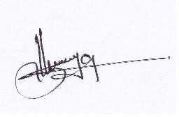

Status : FINAL REPORT **\*\* End Of Report \*\***

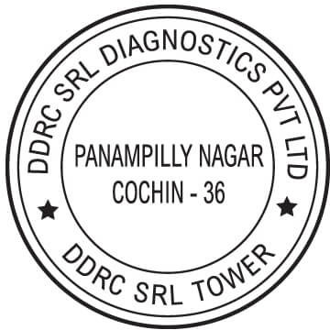

# SREEJA S

Senior Biotechnologist Dept Of Genetics

DDRC SRL Panampilly,EKM,Ph-9496005112

# Approved By



**DR.KRISHNACHANDRAN R**

PhD (Biotechnology) Molecular Geneticist

DDRC SRL Panampilly,EKM,Ph-9496398078

# Reviewed By

**Page 1 of 1**