1 |Introduction
This project is an application of ATM-Bank system created with the concept of networking. Just like in a real life scenario, this project contains:

ATM program (Client)

Bank program (Server)

Admin program (Admin and managing banking data)
The Bank program or the Bank server will be specified computer in possession of the bank and the ATM client can run on multiple computers, just like a real ATM, which are on the same network as of the server. Here networking task is achieved by socket programming.
The Admin program will have a restricted access and the person in the possession of a specific pendrive can only access this file. This program provides a detailed info on the banking history in a structured format.
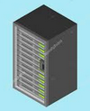
2 |Structure

ATM 1
ATM 2
Bank Server
Bank can support multiple clients even if on different PCs

2.1 |Bank Server

2.1.1 |Bank.py

2.1.1.1 |Source code:

https://github.com/jerinjtitus/ATM-Project/blob/master/Bank/Bank.py
2.1.1.2 |Functions and classes
- createsocket()
- bindsocket()
- multiclient()
- listConnection()
- getmacid()
- save()
- admin()
- randomString()
- main()

2.1.1.3 |Details
(a) __main__
(i) In __main__ , firstly contains imported modules.
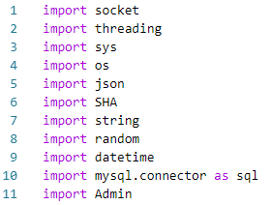

(Code snippet 1.1)
- Socket: is been used make to banking network
- Threading: is used for multitaskings purposes
- sys, os: is used to access the internal systems of windows
- json: is used with purpose to handle json files
- SHA: is module created to be used as a encryption tool
- string: is used for for handling string data
- random: is used for many purposes but mainly for OTP generation
- datetime: is used to handle date and time related data
- mysql.connector: is used to create connection with mysql database named as ‘bank’
- Admin: is Admin.py as specified in Section 2.1.2 . It’s purpose in Bank.py will be provided later in this section.
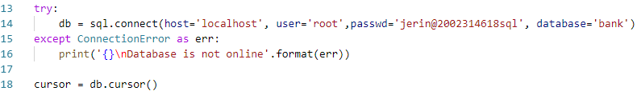
(ii) Line 13-18 creates a sql connection
(Code snippet 1.2)
(iii) Line 20-22 initializes three lists namely:
- allConnections: contains the connection objects.
- allAddress: contains a tuple as it’s each element containing the IP address and the port number used by the atm client to establish a connection.
- allMachineID: contains, generally a 4 digit number in form of a string which is a sort of unique id for each of the atm machines.
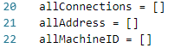

(Code snippet 1.3)
Elements of these lists sharing same the index are representing the same connection with the a specific client.
For example: A client ATM machine having IP address as 192.168.1.1 and port number as 44587, with a machine id 1234 with represented in those lists as follows:

allConnections = [.....,<connection-object>,.....]
allAddress = [.....,('192.168.1.1',44587),.....]
allMachineID = [.....,'1234',.....]
(Example 1.1)
Here connection-object, address tuple and machineID will be at a same index position to represent they are of the client connection.
(iv) Further in __main__, at the end of the program, all functions are called and their detailed functionality will be explained in later sections.
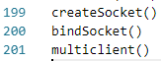

(Code snippet 1.4)

(b) createSocket()
The bank is connected to the network with the use of a socket. Then this socket is used to establish a connection with IP address of the localhost (the server) and with a port number 25589 as specified in line numbers 28 and 29 in Section 2.1.1.1. A snippet of that code is provided below
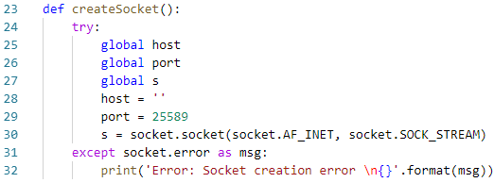
(Code snippet 1.5)
The creation of the socket is done in Line 30. Here a socket instance is made and passed it two parameters. The first parameter is AF_INET and the second one is SOCK_STREAM. AF_INET refers to the address family ipv4. The SOCK_STREAM means connection oriented TCP protocol. All this is encapsulated in a try except block in order to catch exceptions if in case it raises when failing to create a socket due to some system problems.
(c) bindSocket()
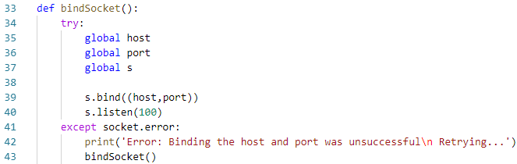
This function binds the host and port together which is a necessity for establishing communication on both the sides. (See Line 40)
(Code snippet 1.6)
As we can notice it is a recursive function. It will call itself if a socket.error
exception rises. A detail of s.listen() and s.error from python docs is given below:
exception socket.error
This exception is raised for socket-related errors. The accompanying value is either a string telling what went wrong or a pair (errno, string) representing an error returned by a system call, similar to the value accompanying os.error.
socket.listen(backlog)
Listen for connections made to the socket. The backlog argument specifies the maximum number of queued connections and should be at least 0.

Reference: https://docs.python.org/2/library/socket.html
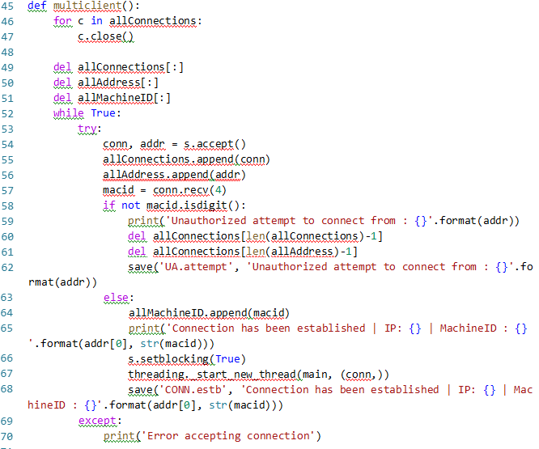
(d) multiclient()
multiclient() function is used to handle multiple client at the same. We can see that in Lines 54-56 server is accepting connection using socket.accept() function and then appending the connection object, it’s address (IP address and port number) in the lists allConnections and allAddress as already mentioned in Section 2.1.1.3 (a)(iii).
For security reason, we can see after receiving machineID (macid) in Line 57, it is not directly appended in the allMachineID list, rather it is first validated and if turns out to be invalid then the connection will be closed and an unauthorized attempt (defined by me as UA.attempt)(see Table 1.1) will be registered in the file ‘activites.info’, which is holds whole banking history. For more about ‘activites.info ‘ file, check out Section 2.1.1.3 (g). If it is a valid macid then it will be appended and a connection established command is printed on the console (see Line 65).
In Lines 62 and 68, a function named save() is used. For more details refer to Section 2.1.1.3 (g).
In Line 66, s.setblocking(True) sets a blocking mode for the connection. Its details are shown below:
socket.setblocking(flag)
Set blocking or non-blocking mode of the socket: if flag is 0, the socket is set to non-blocking, else to blocking mode. Initially all sockets are in blocking mode. In non-blocking mode, if a recv() call doesn’t find any data, or if a send() call can’t immediately dispose of the data.

Reference: https://docs.python.org/2/library/socket.html
In Line 67, a new thread is initialized to run the main() function (see Section 2.1.1.3 (j)) for the current connection accepted. This concept of using a thread is what making multitasking possible. To get an idea for threads, imagine them as different room or spaces contain a copy or say an instance of the function main(), all of which are running independently of each others. Each function instances receive one parameter conn which is a connection object. In each room or space as we imagined before are running different instances of the same function taking different conn parameters, each corresponding to a new connection.
The threads are initialized by the following syntax:
Reference: VSCode python docs
def start_new_thread(function: Callable[..., Any], args: Tuple[Any, ...], kwargs: Dict[str, Any]=...)
start_new_thread(function, args[, kwargs]) (start_new() is an obsolete synonym)
Start a new thread and return its identifier. The thread will call the function with positional arguments from the tuple args and keyword arguments taken from the optional dictionary kwargs. The thread exits when the function returns; the return value is ignored. The thread will also exit when the function raises an unhandled exception; a stack trace will be printed unless the exception is SystemExit.

In Lines 69-70, there is a except block if in case there any exceptions raised while accepting new connection (Line 54).
(e) listConnection()
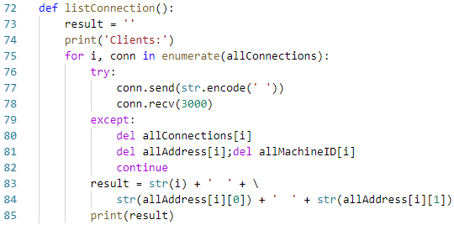
(Code snippet 1.8)
listConnection() print a string containing list of active clients. It does so by sending all clients in the list allConnections a string: ‘ ‘ (see Line 77) and if the client responds to the message send then it classifies it as an active connection. If the sending the message wasn’t successful when the except block will be executed (Line 79-82) and the connection is removed from all the lists.
(f) getmacid()
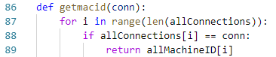

(Code snippet 1.9)
getmacid() will iterate through all the connections and finds if the connection passed matches with some connection in the list. Then it will print its corresponding machine ID.
(g) save()save() function saves every activities happening the banking network in file activities.info. A short glimpse of the file is given below
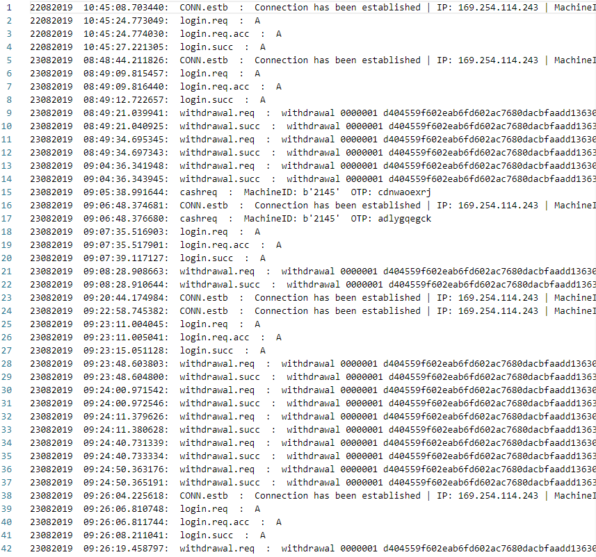
It saves an activity in a specific format (see Line 92) first date, then time of act, then type of act and finally extra description. Various types of acts and tabulated below:
Activities | Meaning
CONN.estb | Connection established
UA.attpemt | Unauthorized attempt
login.req | Login request from client
login.req.acc | Login request accepted
login.succ | Login successful
login.succ.fail | Login Failed
withdrawal.req | Withdrawal request
withdrawal.succ | Withdrawal successful
deposit.req | Deposit request
deposit.succ | Deposit successful
cashreq | Cashvault refill request
(Table 1.1)
All tabulated activities are kind of obvious, but still one act cashreq has not been talked before. Every ATM machine has a cashvault so does this program (ATM.py). Whenever cash is withdrawn from an account, the same amount of cash is also deduced from the ATM’s cashvault. So whenever the cash in cashvault is less than a specific amount then it sends a cashreq aka cash request to the bank. More detailed explanation of its working is provided in Section 2.2.1.3 (e).
(h) admin()
admin() was a function used for admin uses but this function was later replaced by Admin.py file.
(i) randomString()
(Code snippet 1.10)
It is used to generate OTP for cashreq send by the ATM. More detailed explanation for its purpose is provided in Section 2.2.1.3 (e).
(j) main()
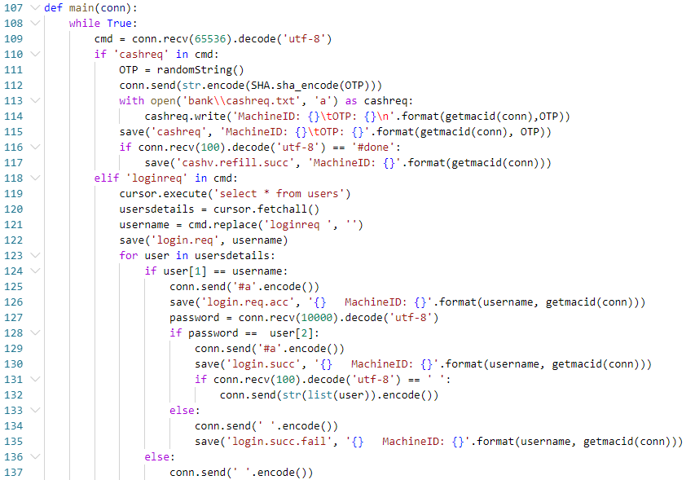
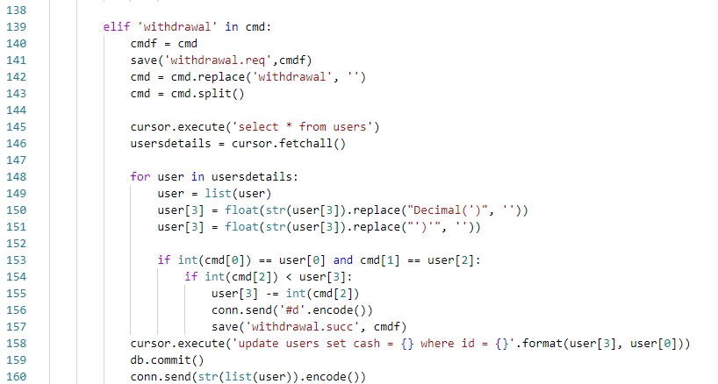
main() function is the master function in the whole program. It is where the other function are called.
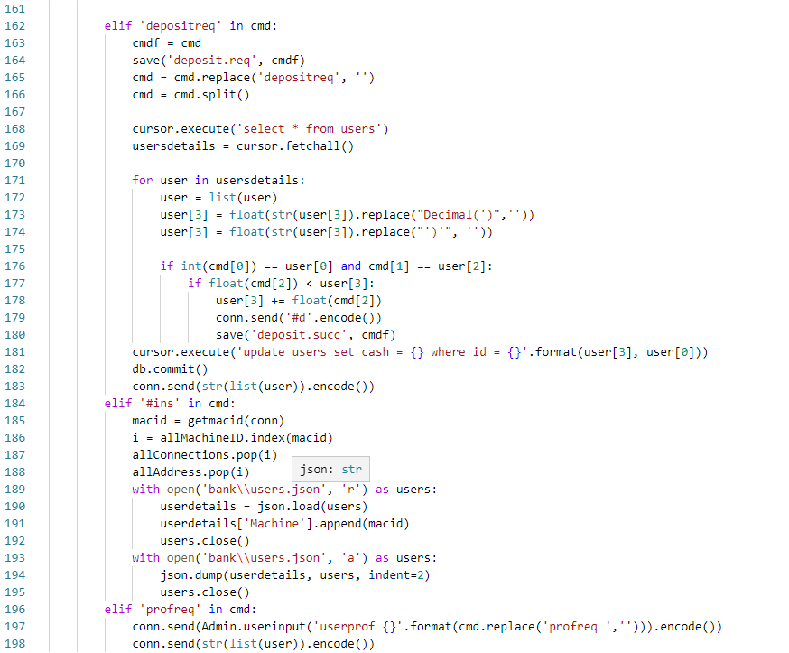
(Code Snippet 1.11)
It is executed inside an infinite loop. It receives the request form the client (see Line 109) and saves it in variable cmd.
socket.recv(bufsize[, flags])
Receive data from the socket. The return value is a bytes object representing the data received. The maximum amount of data to be received at once is specified by bufsize. See the Unix manual page recv(2) for the meaning of the optional argument flags; it defaults to zero.
Reference: https://docs.python.org/2/library/socket.html
Various requests received are tabulated below:
Requests | Aim
cashreq | Request for cashvault refill
loginreq | Request for login
withdrawal | Request for withdrawal
depositreq | Request for deposit
#ins | Machine installation signal (not a request) (See table 1.3)
profreq | Request for user profile
(Table 1.2)
- cashreq: See Section 2.2.1.3 (e).
- loginreq block (Lines 118-137): First a list of user details are taken from the database using cursor.execute() and then and signal #a is send to the client to confirm access granted. Then server receives a password send from the ATM and if the password turns out to be valid then another signal #a will be send to confirm login. For bank to make sure the client received the signal, another signal ‘ ‘ (blank space) send by the client confirms that.
- withdrawal block (Lines 139-160): Handles withdrawal request. A new type of signal #d can be seen in Line 156. It confirms withdrawal successful.
- depositreq block (Lines 162-183): Handles deposit request. The signal #d (see Line 156) confirms deposit successful.
- profreq block (Lines 196-198): Here we can an indirect use of Admin.py. It is used to generate a user profile as requested by the ATM.

Signal | Meaning
#a | Equivalent to access granted
#d | Equivalent to task done
#ins | Installation of ATM machine successful
(Table 1.3)

2.1.2 |Admin.py

2.1.2.1 |Source code
https://github.com/jerinjtitus/ATM-Project/blob/master/Bank/Admin.py

2.1.2.2 |Functions and classes
- Statsclass (a) __init__()
(b) getuserdetails()
(c) datafunc()
(d) stats()
- Admin
(a) __init__()
(b) drive()
(c)adminaccess()
- cashamt()
- logtype()
- resultprint()
- main()
- userinput()
2.1.2.3 |Details
(a) __main__
See Line 266. The code means if the namespace (__name__) of the program when runned is equal to __main__, then only execute main() function (function in Admin). Since python does not have a main() like in C++ (here main() doesn’t refer to anything in the Admin.py), __name__ can be used to check whether the current script is being run on its own or being imported somewhere else by combining it with if statement. __name__ is a built-in variable which evaluates to the name of the current module. If the source file is executed as the main program, the interpreter sets the __name__ variable to have a value “__main__”. If this file is being imported from another module, __name__ will be set to the module’s name.
(b) Statsclass() class
This class contains the function for generating organized data from activities.info file and also for making user profiles. It includes function as given below:
(i) __init__()
In Python the __init__() method is called the constructor and is always called when an object is created. Constructors are generally used for instantiating an object. The task of constructors is to initialize (assign values) to the data members of the class when an object of class is created. Here it is used to initialize a SQL connection using cursor (See Line 9-11).
(Code snippet 1.12)

(ii) getuserdetails()
Return user details of the user from SQL passed as parameter.
(iii) datafunc()
It converts the data provided in form of string into a list of dictionaries having keys date, time, type, act.
(iv) stats()
It is a function which returns segregated data as asked by the admin through the $AdminShell> or as asked by a user through the ATM (but will have only restricted access).

$AdminShell> :
The admin shell is similar to a query language. The query syntax are given below:
(a) stats
Enter into the statistics mode of admin shell.
(1) userstat
Usage: userstat [history type] [user]
Options:
History type: For login history: /l
For withdrawal history: /w
For deposit history: /d
This option is compulsory to provide or else no output will be shown user: /u [username or userid]
This option is not compulsory. If not provided it give all data of all users
(2) userprof
Return user profile
Usage: userprof [user]
Options:
User: [username]
(3) quit
Quits stats mode
(b) quit
Quits admin shell

(c) Admin() class
Admin class is the one responsible for maintain security of the program. For making it only admin accessible, the program will only run when an admin pendrive will be inserted into the computer. For additional security purposes, a password will be asked from the user for accessing the program. This specific password is not stored in some variable inside the program or in its folder. This password’s SHA 512 hash is stored in the pendrive. So when the user enters a password, the password is converted into a SHA 512 hash by using SHA.py program . If the hash matches with the hash in the pendrive, then only access will be granted. For more details refer to Section 2.1.3

2.2 |ATM Client
2.2.1 |ATM
2.2.1.1 |Source code:
https://github.com/jerinjtitus/ATM-Project/blob/master/ATM/ATM.py
2.2.1.2 |Functions and classes
- connectf()
- admin()
- drive()
- install()
- macid()
- cash()
- cashwd()
- vaultrefillcheck()
- fill()
- vaultrefill()
- login()
- main()

2.2.1.3 |Details
(a)__main__
See Lines 11-13, these lines initializes a socket object. We earlier have discussed about sockets and other related things in the Section 2.1.1.3.
One thing to notice is that in the bank server we send and receive data using the connection object and in the ATM client we send and receive data using directly the socket object. The reason is that a server can have multiple clients, so it creates connection objects to handle different clients. But a client can connect will only with one server at a time, so it directly uses the socket object.
(b) install()
This only runs we the ATM lacks a macid.info file. So it will proceed to install the ATM. Also this installation process can only take place if the admin pendrive is connected.
(c) cash()
Return the value of cash in the cashvault.
(d) cashwd()
Change the value of the cash in the cashvault when cash is deposited or withdrawn.
(e) vaultrefillcheck()
This function will check if the cash become less that 10000 in the vault. If cash is less then it send cash request: cashreq to the server (See Line 91). The server will then send back the OTP for refilling.
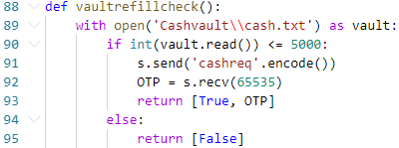
(Code snippet 2.1)
(f) fill()
This will check if the output of the vaultrefillcheck() ‘s return value is true then will call vaultrefill() to refill cash.
(g) vaultrefill()
This function will first ask for OTP to enter. If the OTP is right then the some amount of cash will be added to the vault.
(h) main()
This function option to select options: Login or Launch admin shell.
(i) login()
It will first ask for a username and if, after sending the username, receives an accept signal #a (See table 1.3) then it will ask for a password. The password is validated if the client receives a #a signal back from the bank. Then it will start an infinite loop providing the following options.
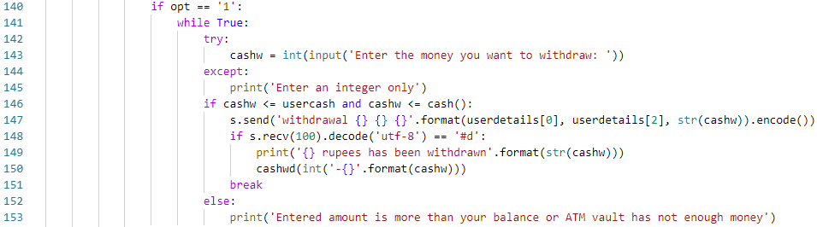
- Withdraw: For withdrawing cash from ATM.
(Code snippet 2.2)
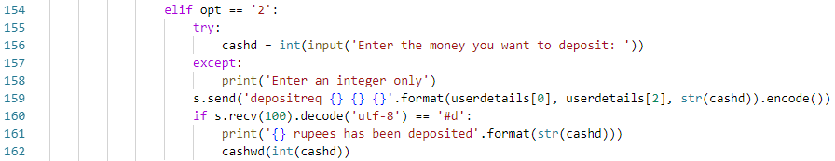
- Deposit: For depositing cash.
(Code snippet 2.3)

- User Profile: For requesting a user profile.
(Code snippet 2.4)
- Log out: Log out from the session

Inside login() function user details are constantly updated by receiving the updated details at the end of every iteration (See Line 170).
Caution: Passwords entered will not be displayed on the terminal for security reasons. Keep on typing even if no characters are shown while entering passwords. This functionality is added using getpass module’s getpass() function. This function is written in place of input(). (See Line 119)
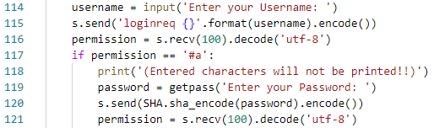
(Code snippet 2.5)

2.3 |SHA.py
It is available both in Bank and ATM and it is used as an encryption tool.
2.3.1 |Source code
https://github.com/jerinjtitus/ATM-Project/blob/master/Bank/SHA.py
https://github.com/jerinjtitus/ATM-Project/blob/master/ATM/SHA.py
2.3.2 |Functions and classes
- sha_encode()
2.3.3 |Details
This is used to convert the password into its hash by using the SHA 512 algorithm. Converting password into a hash is a trapdoor function. This means that it is possible to convert a password into a hash, not possible to convert a hash back into the original password. All companies stores passwords in hashed format so that even the company’s employees couldn’t access accounts even if they have the hash. For example a password is ‘pass’, then its hash will be:
ef96c3670bd34ec90bb8028e05a684bce4de1ab73fcf49599719bb1583762c95b7092c703d768e802b7162ef527bcbd2a01f59f9e3aa9c9f14b7ede193c75e80
So if you enter the hash in place of password on any website form, then the webpage will convert the entered hash into IT’S hash then compare with the hash in the database and hashes will never match. What I mean by “entered hash into IT’S hash” is the webpage don’t know what you have entered, for it you have entered a string and it will convert the string into a new hash. See the last example where it is given that ‘pass’ hash is
FUN FACT: If we convert this whole documentation until the last line, then it's hash will be:
c0eecf096a2f7e83a45a81278471cd18da6908e6410293c1f3dba938e94a169439329ec2552180357fd381d8fd51b96392dbfcd020df9a3b3a797f128a542f27
And if we add just a single space in front on the document then hash it, it will have a completely different hash:
4d56bbdf13a02d5148c77f3c45cf72bed0f0ac93c0624647a1447896e9e071308c67c3de32c8e2f68f65acfcdaff02b3bb440cf82697fa97fb27383c6e422660

ef96c3670bd34ec90bb8028e05a684bce4de1ab73fcf49599719bb1583762c95b7092c703d768e802b7162ef527bcbd2a01f59f9e3aa9c9f14b7ede193c75e80
But the hash’s (which itself is string) hash will be:
2ba8835ee321e1071d120ac4a37b32748e21d7670d20bc0fa226e3de895cc3f2255c1c8d85965edc8fffe31f03165378a13ba443e4a987a9672cd664e1cbfc4f
One beautiful thing about hashes is that whatever the string length may be the hash will always have a fixed length.
Mathematically, for any password, it will have its unique hash.

3 |Working
ATM.py:
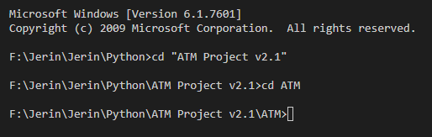

Bank.py:
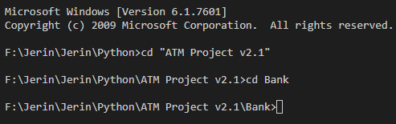

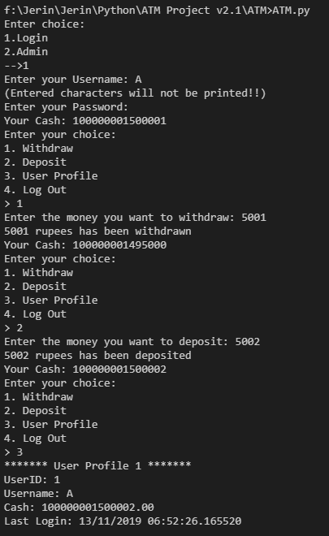
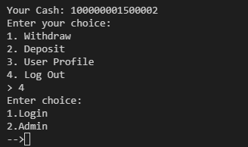
3.1 |Normal Working of ATM.py

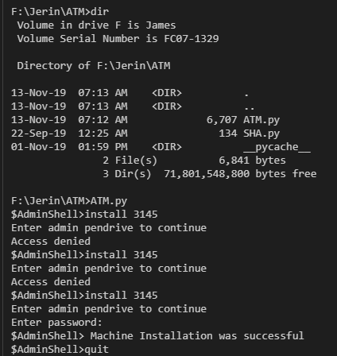
3.2 |Installation of ATM.py
Installation can be done if no macid.info file and Cashvault exists in the ATM folder.

3.3 |Working of Admin.py
Entering Admin pendrive is necessary for accessing the program.
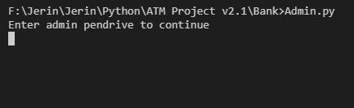

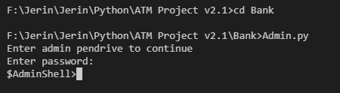
After entering pendrive:

