**EMPLOYEE MANAGEMENT SYSTEM**

**Task:**

1. Login API (Use any authentication techniques)
   1. Only an Admin user should be able to access the APIs for Admin and only Employee should be able to access APIs for Employee
2. Admin User
   1. Employee Page:
      1. Create API
         1. Fields: *Employee Name, Email, Contact Number, Emergency Contact Number, Address, Position, DOB, Martial status, Blood Group, Job Title, work Location, Date of Joining (use pipe for a particular format), Reporting to, Linked In link, Profile picture*
      2. List API
         1. Functionalities: *search, sort*
         2. Show: *Employee id, Employee Name, contact, Email, Designation, Reporting to, Work location*
      3. Detail API
      4. Edit API
         1. Fields: *Employee Name, Email, Contact Number, Emergency Contact Number, Address, Position, DOB, Martial status, Blood Group, Job Title, work Location, Date of Joining, reporting to, Linked In link, Profile picture*
      5. Delete API
   2. Leave Page:
      1. List API to list all employees leave request
         1. Filters: *list all approved leaves, to list pending approval leaves*
         2. Fields: *Employee Name, Apply date, Nature of leave, first day, last day, number of days*
      2. API to approve and reject leave request from employees
3. Employee User
   1. API to list leaves of current employee
      1. Show: *Apply date, Nature of leave, first day, last day, number of days*
      2. Functionalities: *search, sort*
   2. Leave application request API:
      1. Fields: *Apply date (auto populate), Nature of leave, first day, last day, number of days*
4. Logout API

*Note: Use proper validations for fields*

**Requirements**

* Django
* Djangorestframework
* Markdown
* Djagno_filter
* Djangorestframework_simplejwt
* Pillow

**Token**

1. **Token Generation**

* <http://127.0.0.1:8000/api/token/>
* Simple jwt is used for the token generation
* from rest_framework_simplejwt.views import TokenObtainPairView
* URL path “path('api/token/',TokenObtainPairView.as_view()),”
* Enter the registered username and password for generate the token

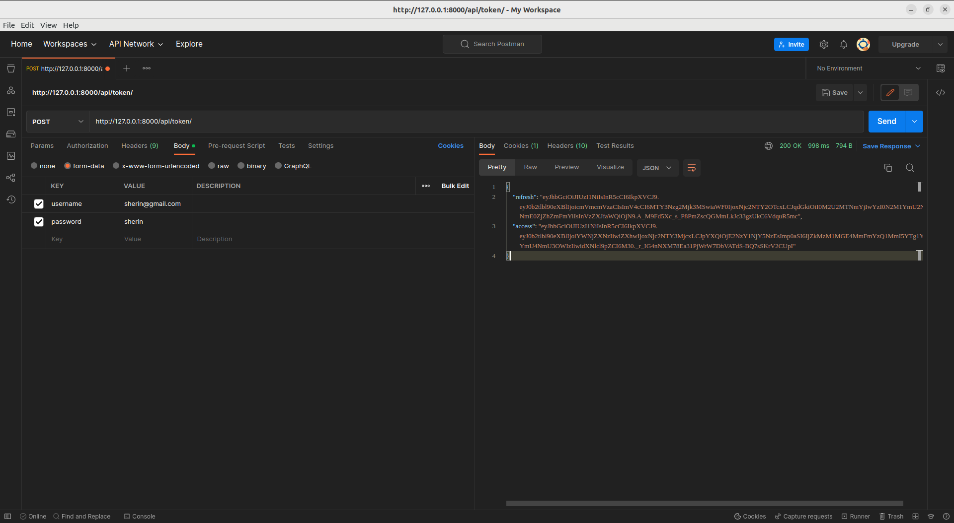

1. **Token Verification**

* <http://127.0.0.1:8000/api/token/verify/>
* Simple jwt is used for the token generation
* from rest_framework_simplejwt.views import TokenRefreshView
* URL path “path ('api/token/refresh/', TokenRefreshView.as_view()),”

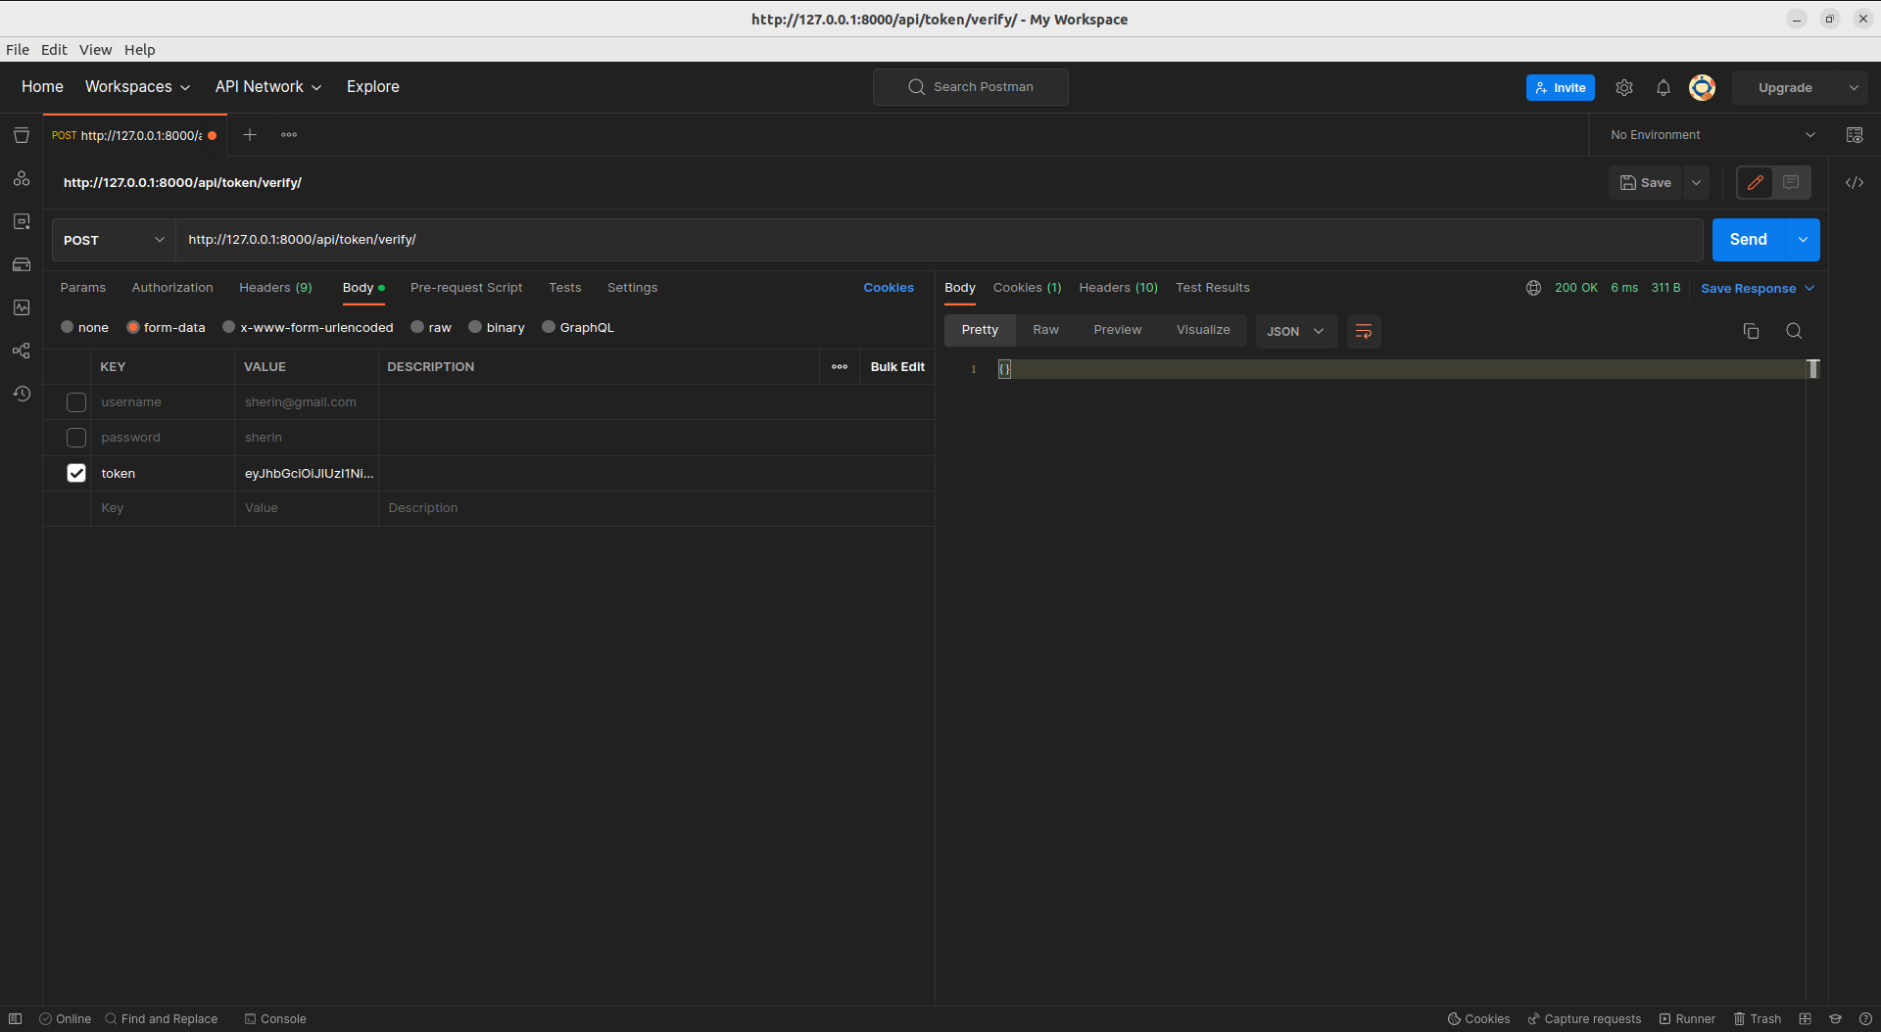

1. **Token Refresh**

* <http://127.0.0.1:8000/api/token/refresh/>
* Simple jwt is used for the token generation
* from rest_framework_simplejwt.views import TokenVerifyView
* URL path “path ('api/token/refresh/', TokenVerifyView.as_view()),”

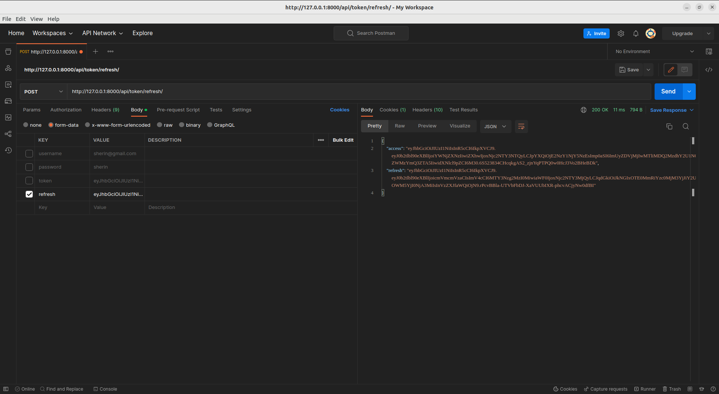

**Login API**

* <http://127.0.0.1:8000/>
* 'rest_framework.urls’ is used for the authentication

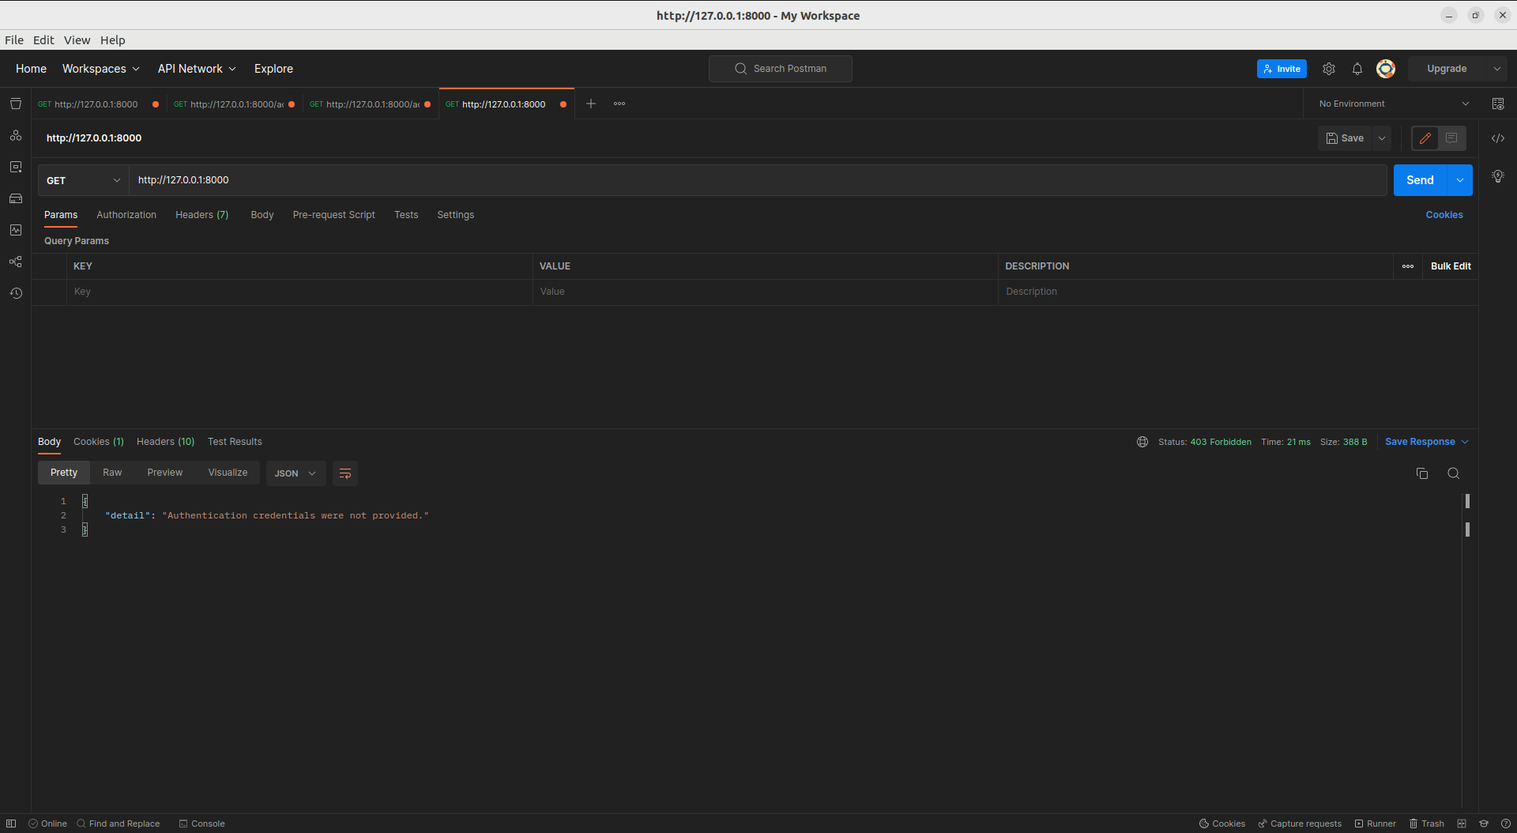

* Enter the correct username and password, it will be redirected to index page

1. **Admin User**
   1. **Index Page**

* It contains the accessible links for current admin user

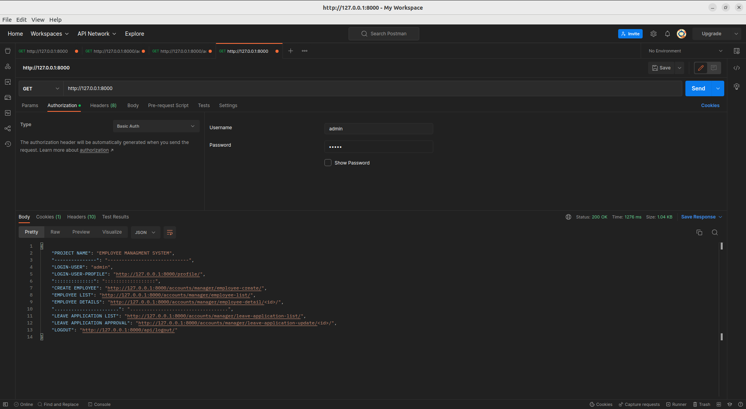

* 1. **Profile Page**
* <http://127.0.0.1:8000/profile/>

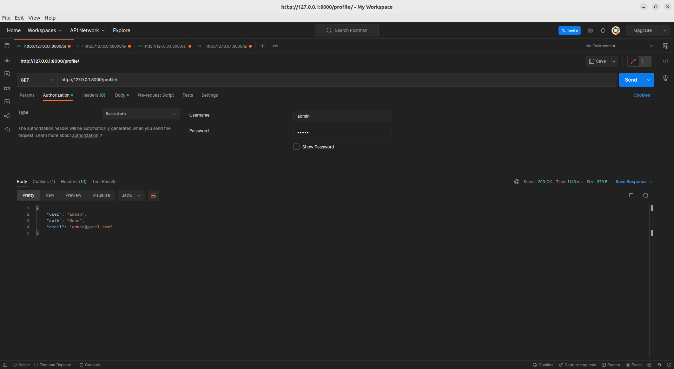

* 1. **Employee API** 
     1. Create Employee API
* <http://127.0.0.1:8000/accounts/manager/employee-create/>

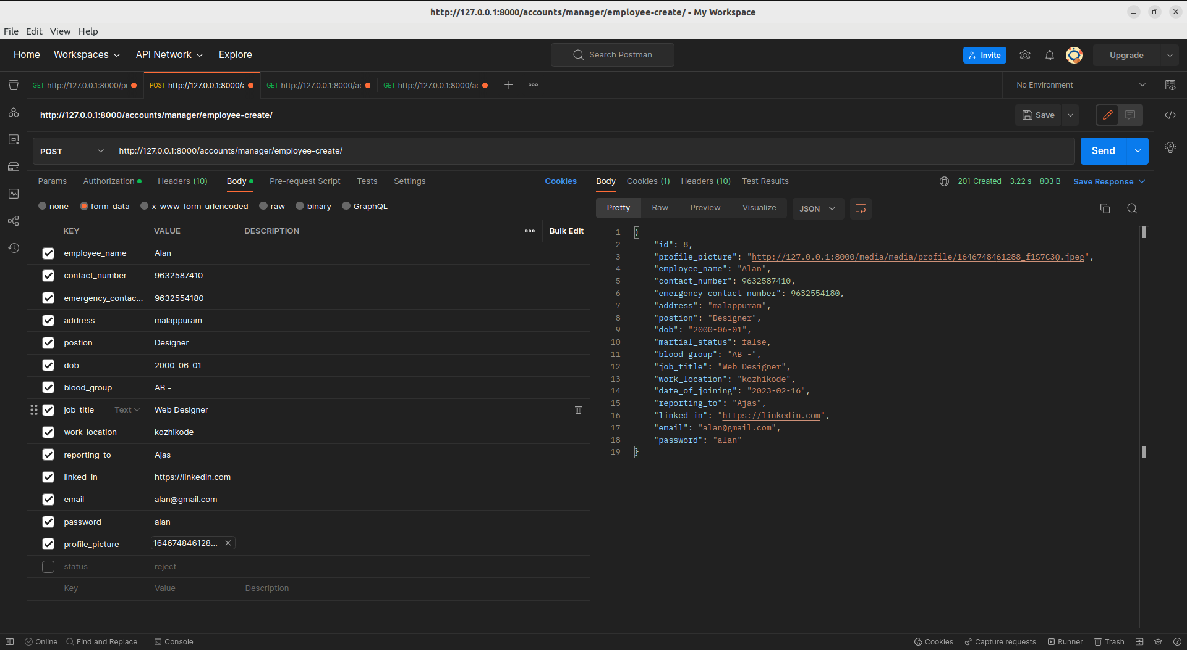

* + 1. Employee List API
* <http://127.0.0.1:8000/accounts/manager/employee-list/>

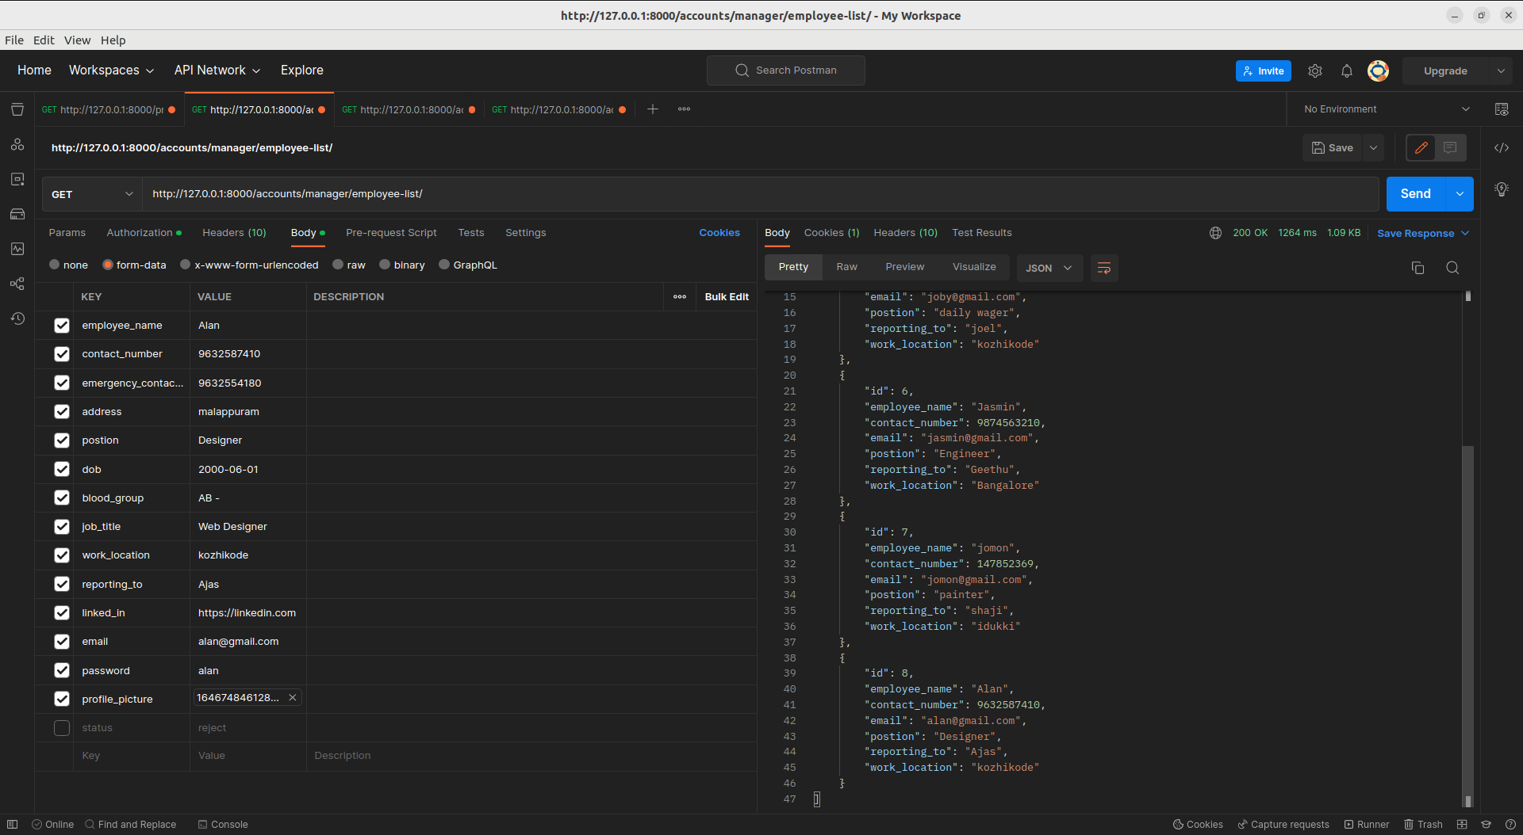

* + 1. Employee Detail
* [http://127.0.0.1:8000/accounts/manager/employee-detail/6/](http://127.0.0.1:8000/accounts/manager/employee-detail/7/)

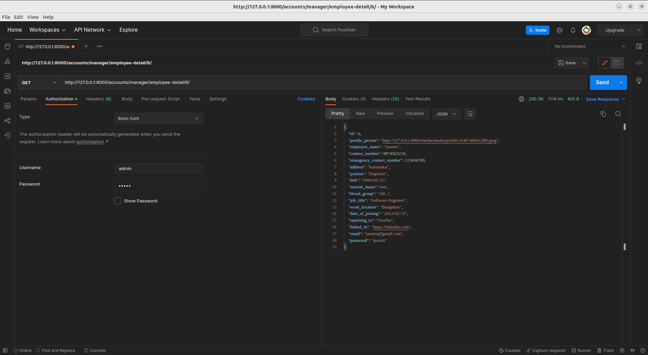

* + 1. Edit/Update Employee
* <http://127.0.0.1:8000/accounts/manager/employee-update/8/>

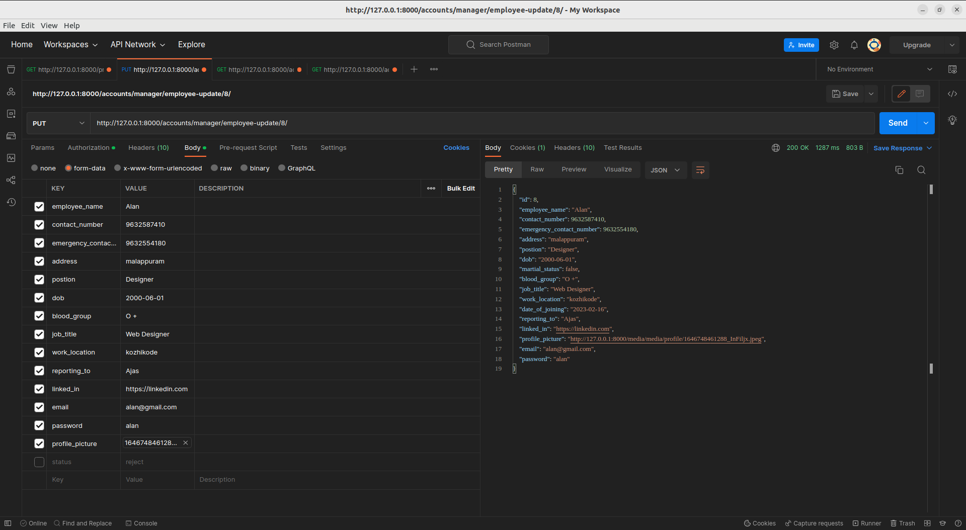

* + 1. Delete Employee
* [http://127.0.0.1:8000/accounts/manager/employee-delete/4/](http://127.0.0.1:8000/accounts/manager/employee-update/8/)

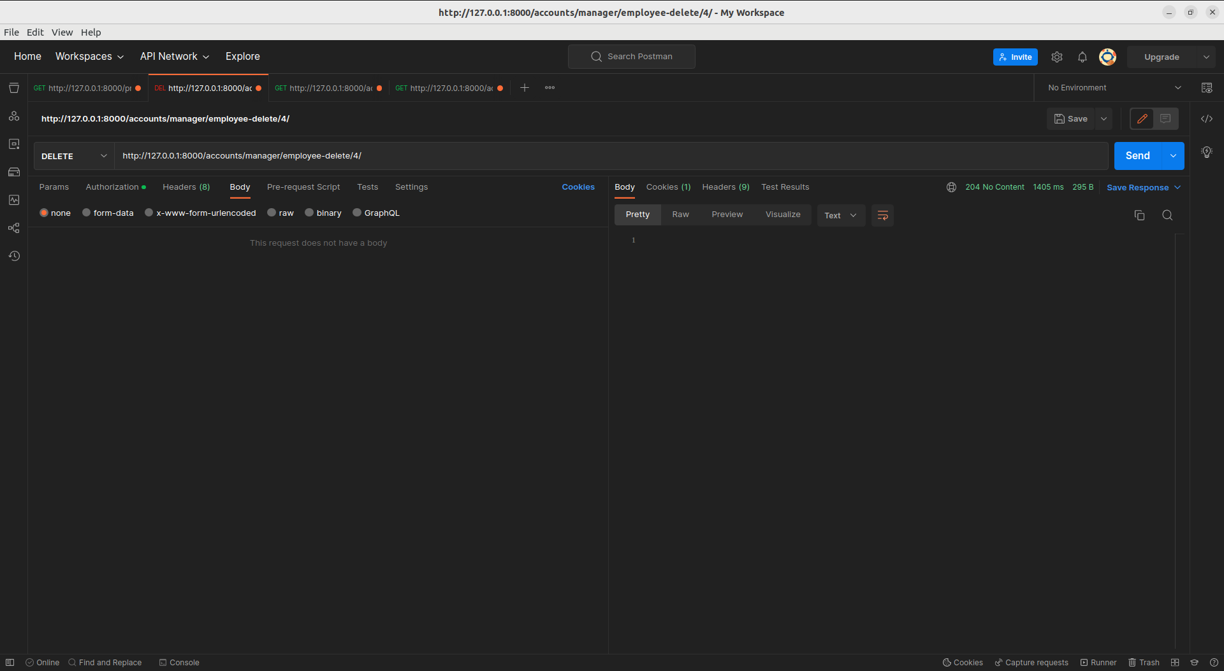

* 1. **Leave Application List page**
     1. List API to list all employees leave request
     2. [http://127.0.0.1:8000/accounts/manager/leave-application-list/](http://127.0.0.1:8000/accounts/manager/leave-application/list/)

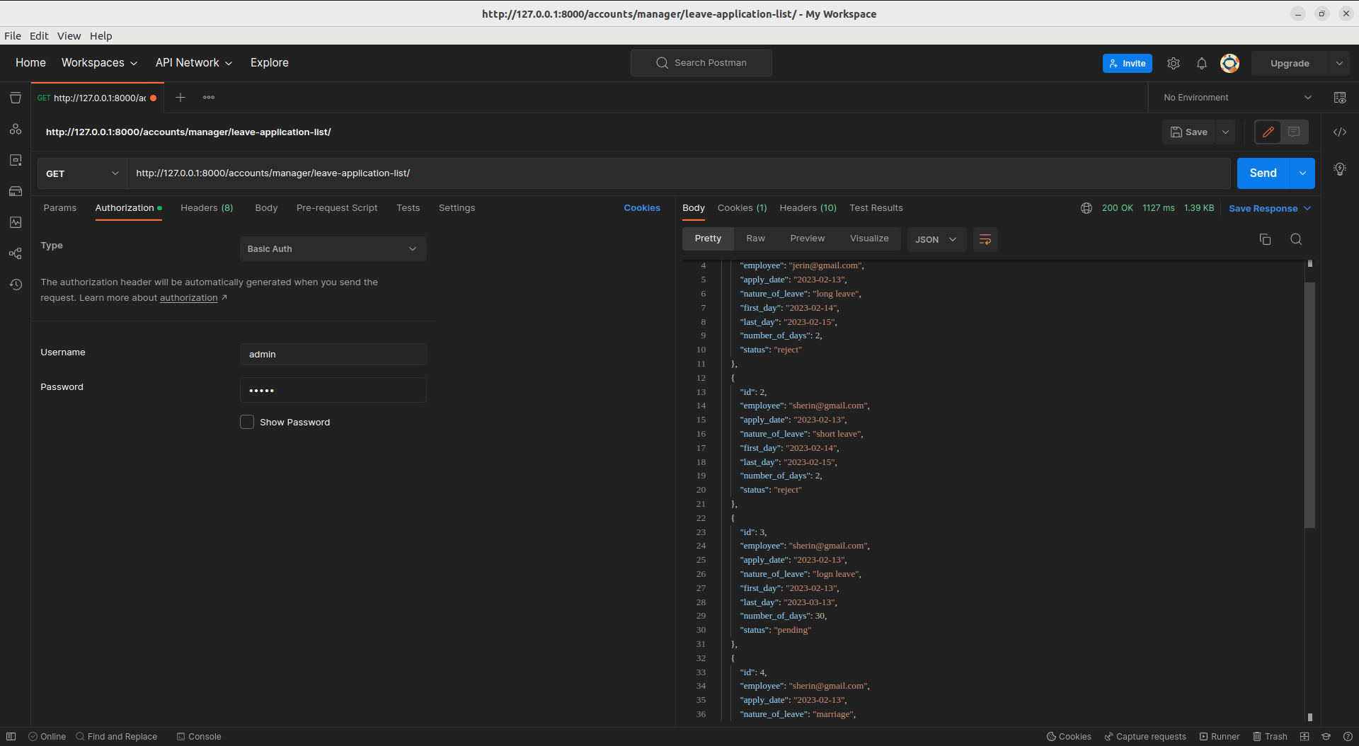

* 1. **Filtering**
* <http://127.0.0.1:8000/accounts/manager/leave-application-list/?status=reject>

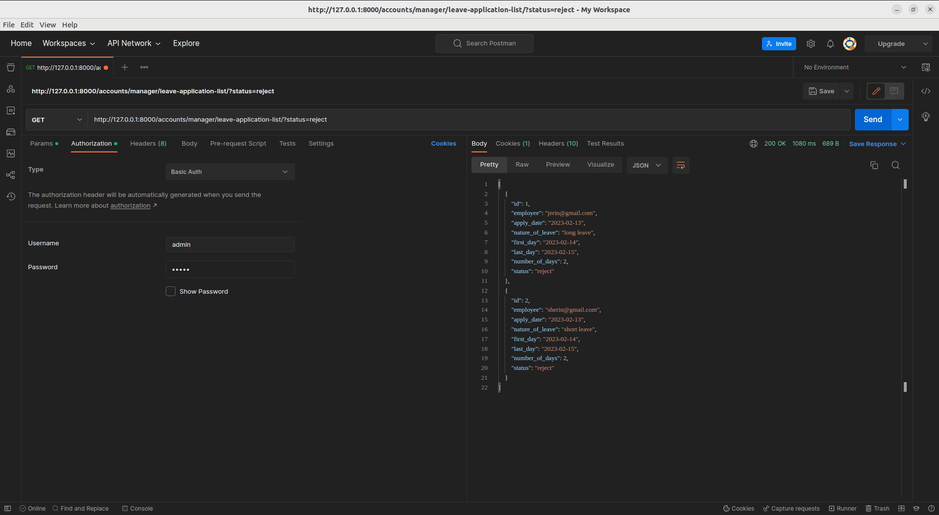

* <http://127.0.0.1:8000/accounts/manager/leave-application-list/?status=approved>

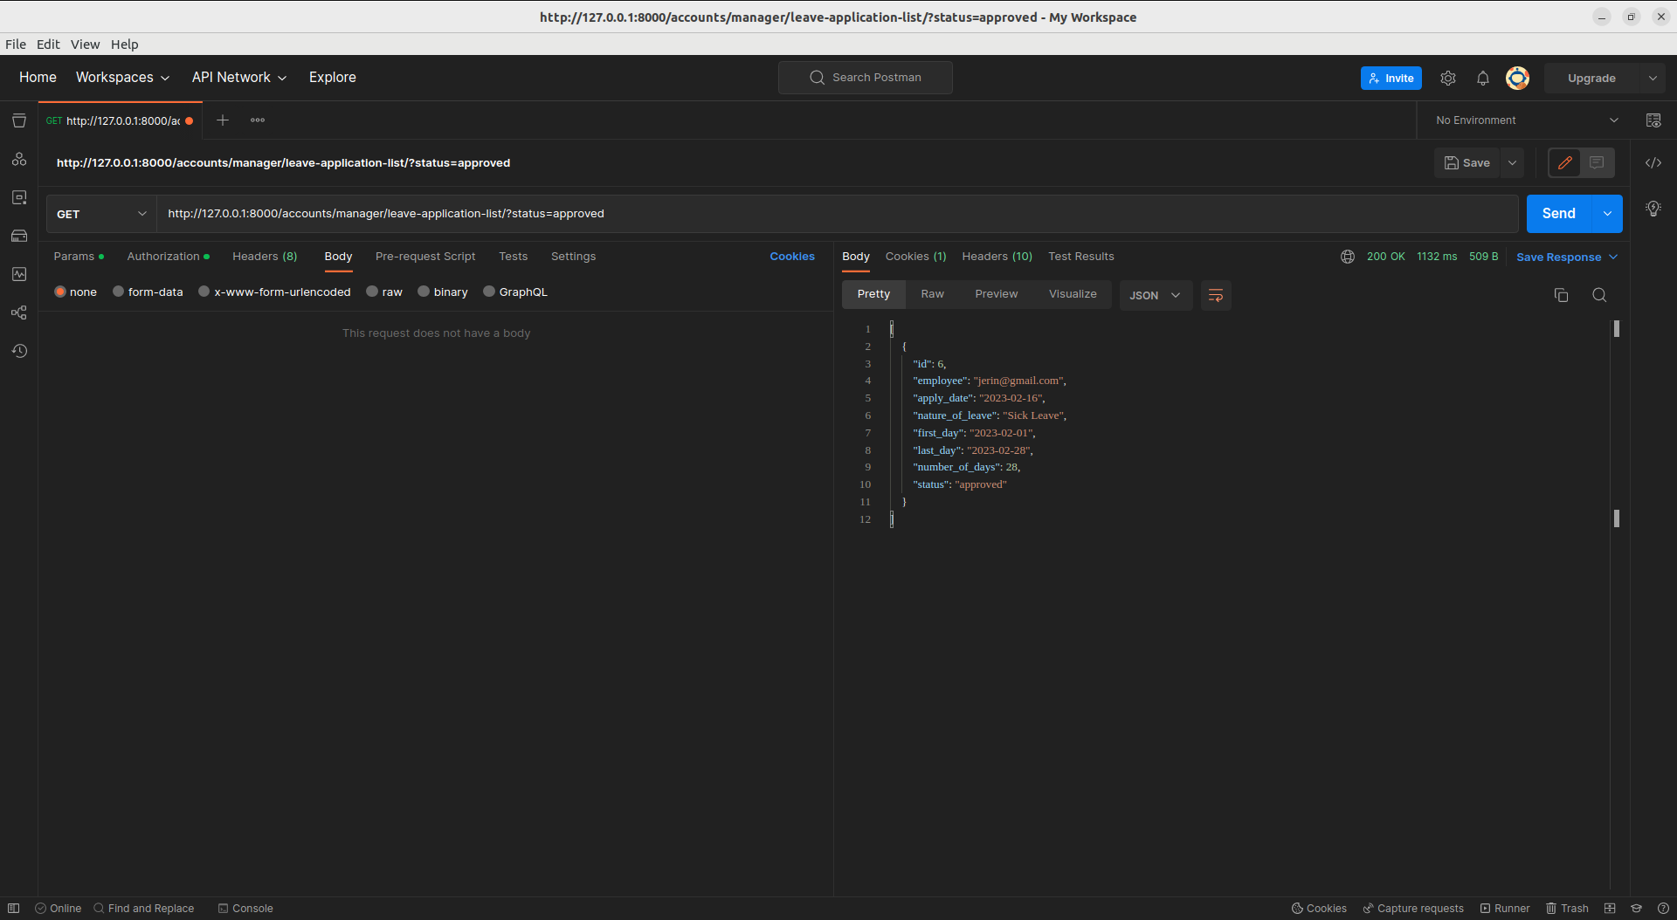

* <http://127.0.0.1:8000/accounts/manager/leave-application-list/?status=pending>

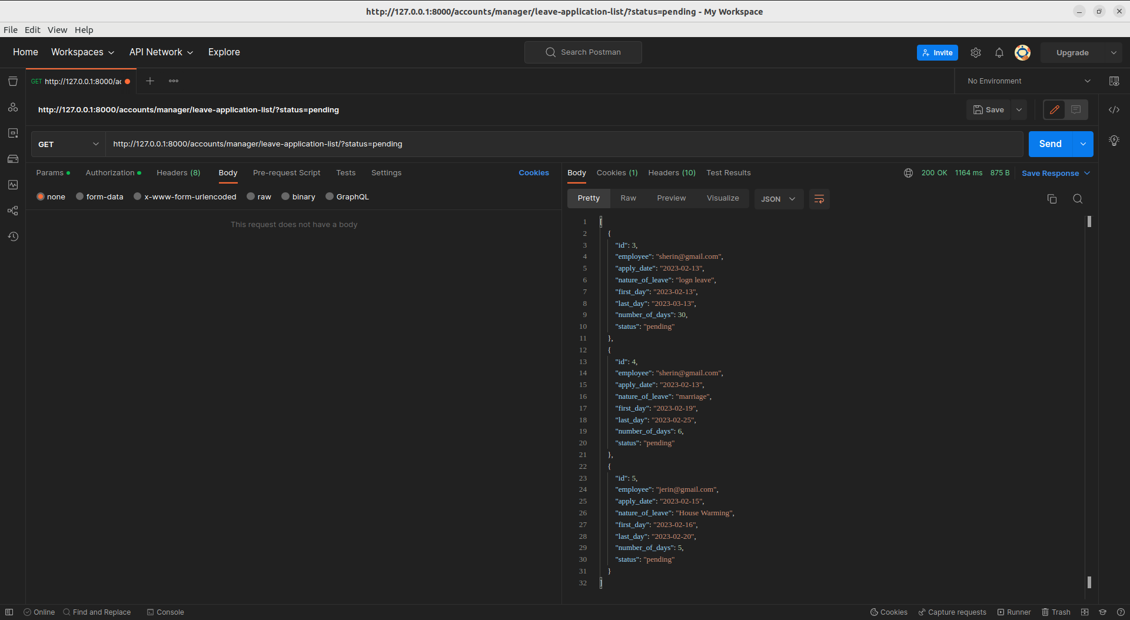

1. **Employee User**
   1. **Login**

* <http://127.0.0.1:8000/>
* Use the email as username and password are provided by the admin

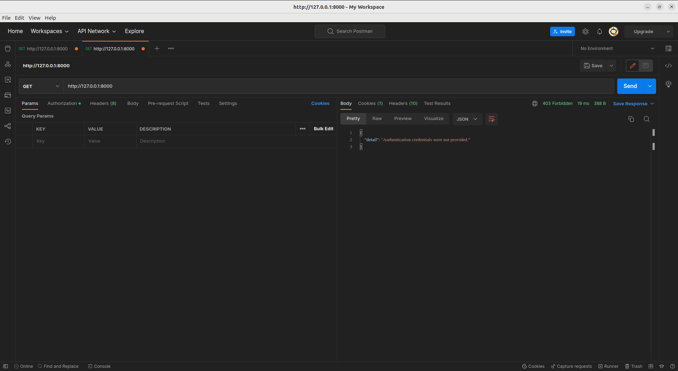

* 1. **Index Page**
* It contains the links that can only accessible by the employee users

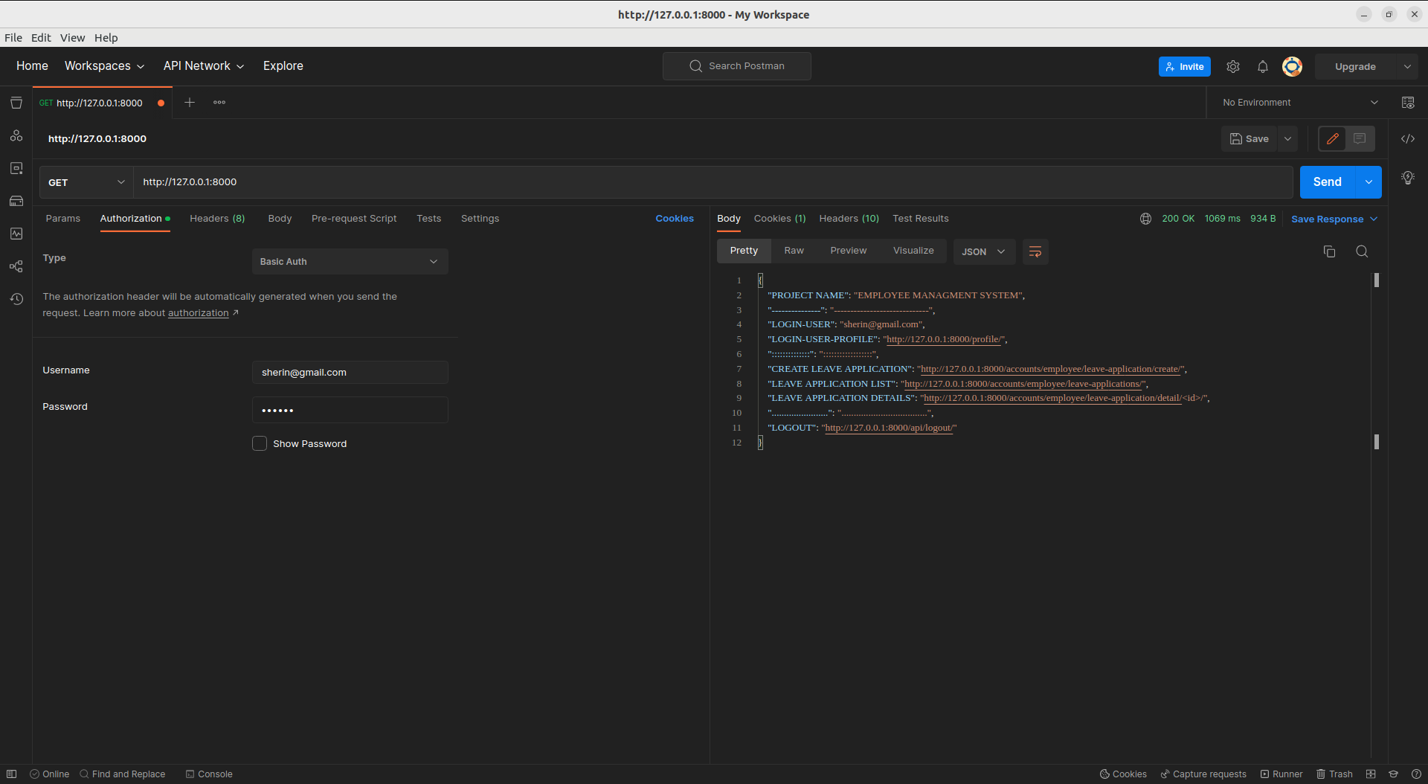

* 1. **Leave Application Create API**
* [http://127.0.0.1:8000/accounts/employee/leave-application/create/](http://127.0.0.1:8000/accounts/employee/leave-applications/create/)

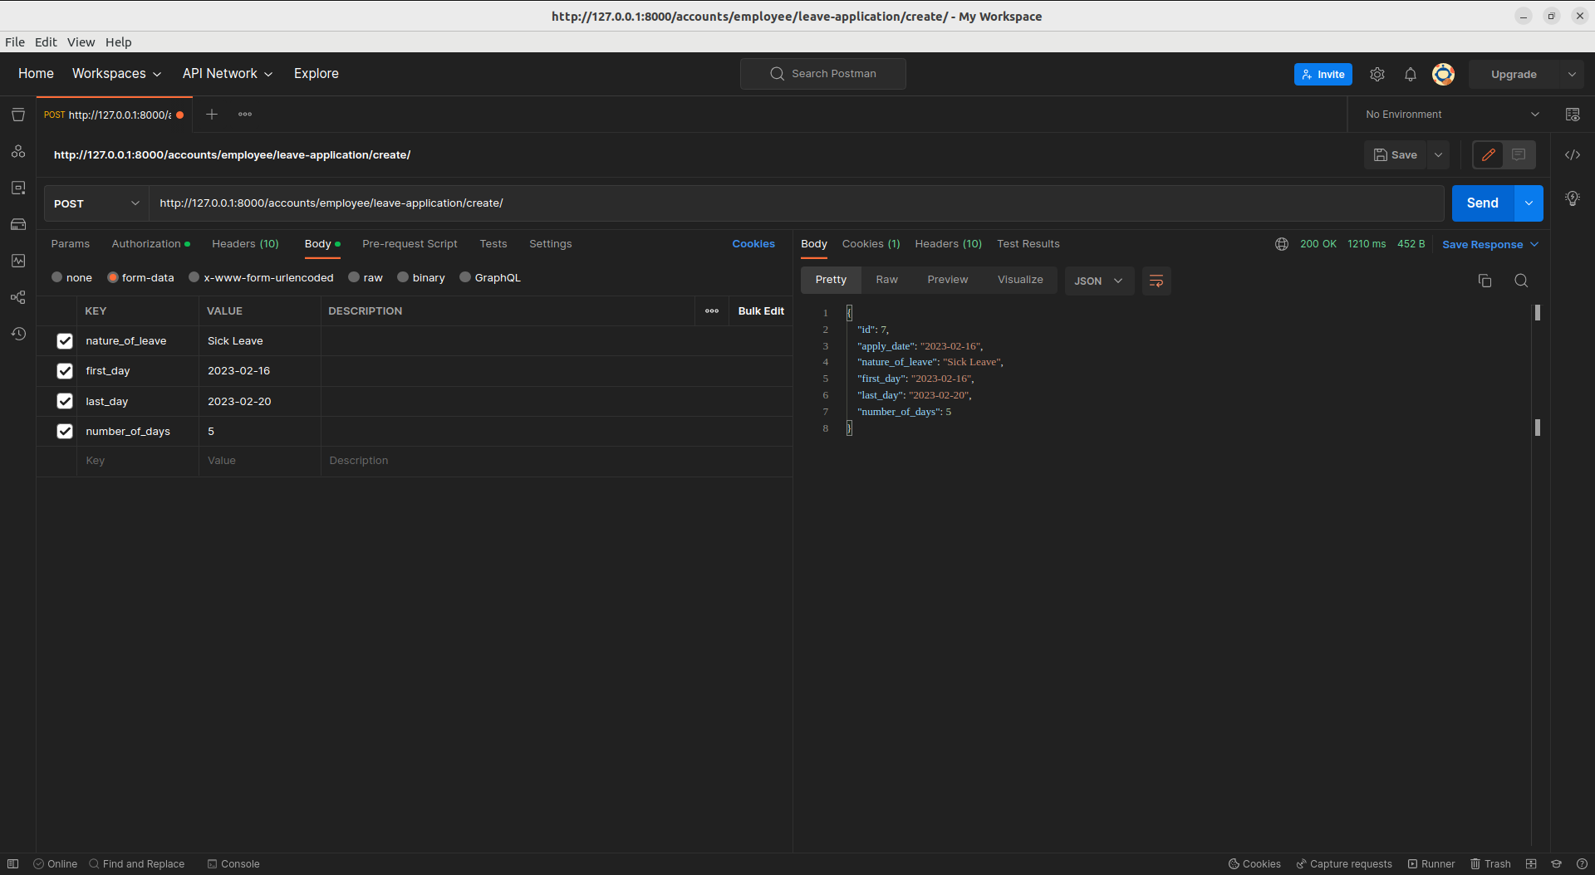

* 1. **List of all Leave Applications for the Current login user**
* <http://127.0.0.1:8000/accounts/employee/leave-applications/>

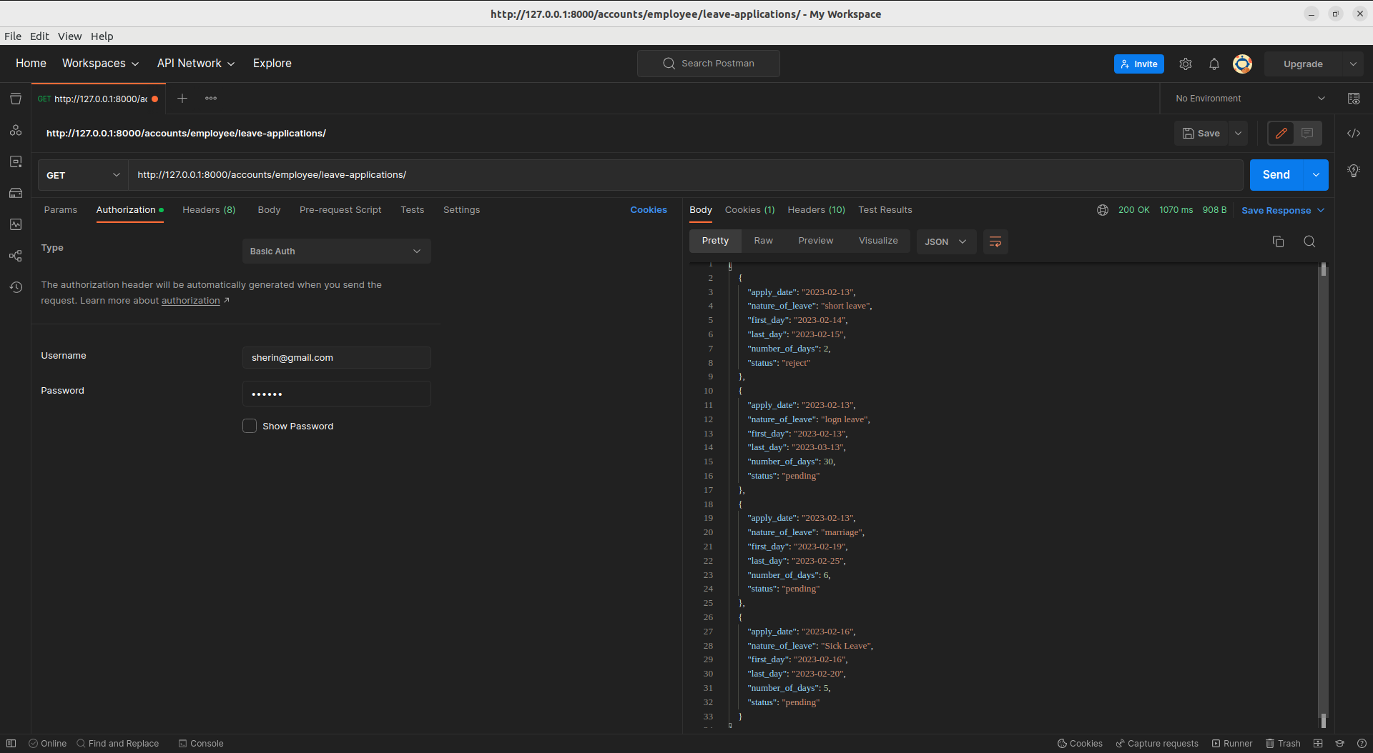

* 1. **Detail view of the particular leave application**

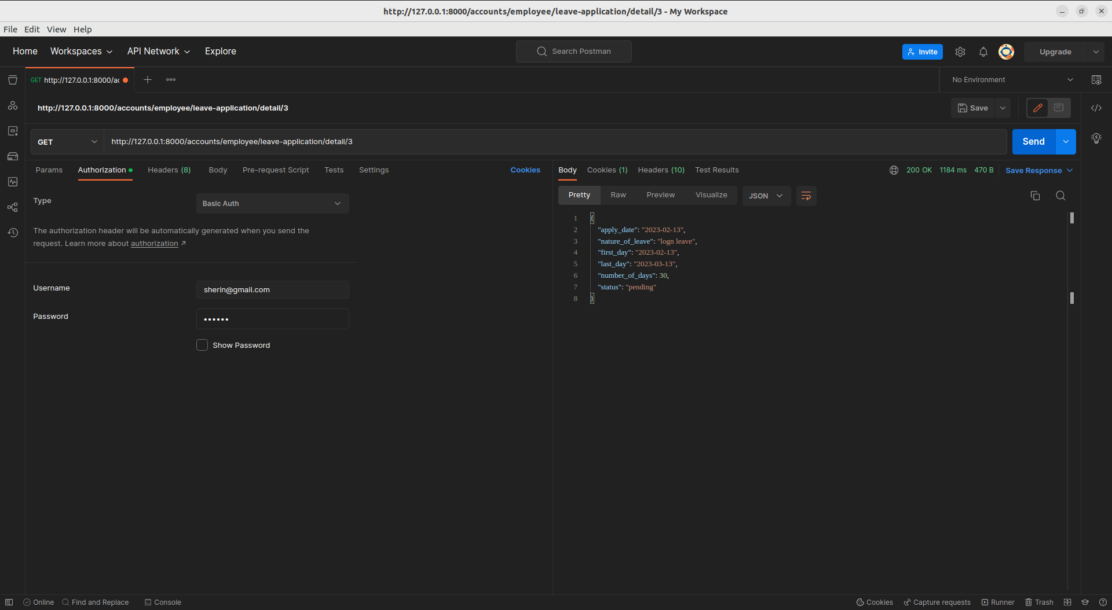

* 1. **Searching, Sorting**
* <http://127.0.0.1:8000/accounts/employee/leave-applications/?search=pending>

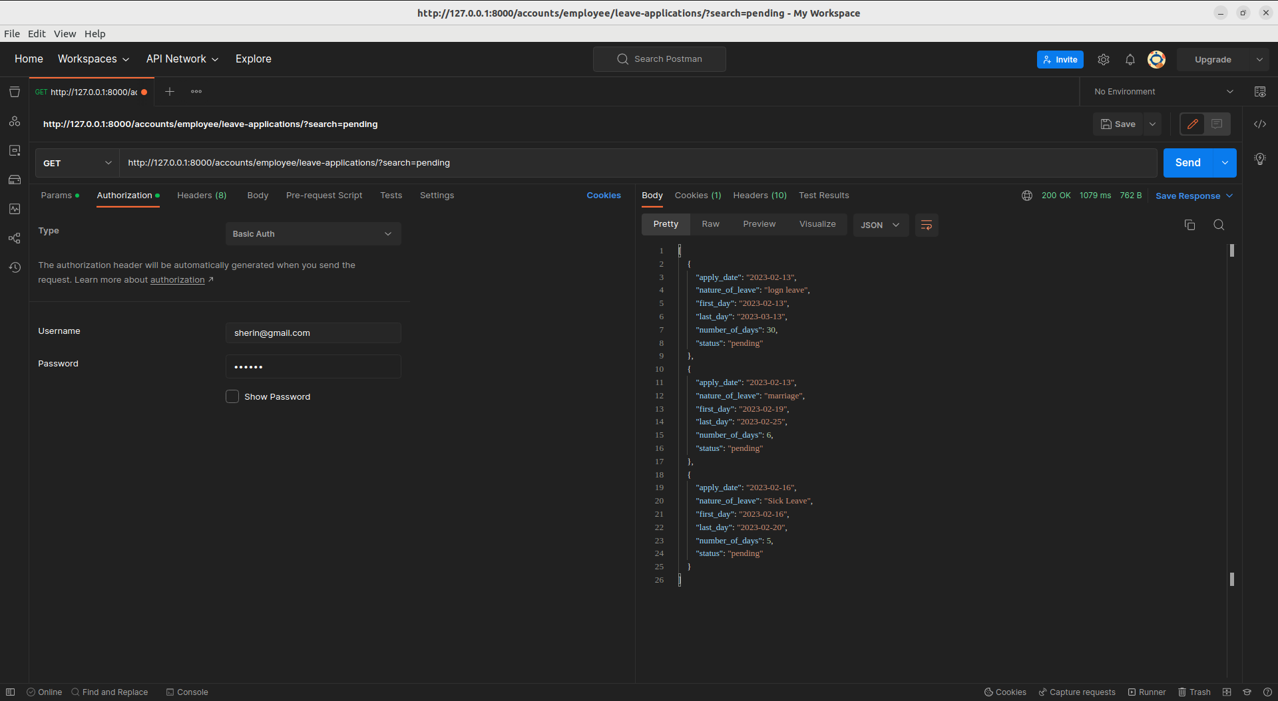

* <http://127.0.0.1:8000/accounts/employee/leave-applications/?search=reject/>

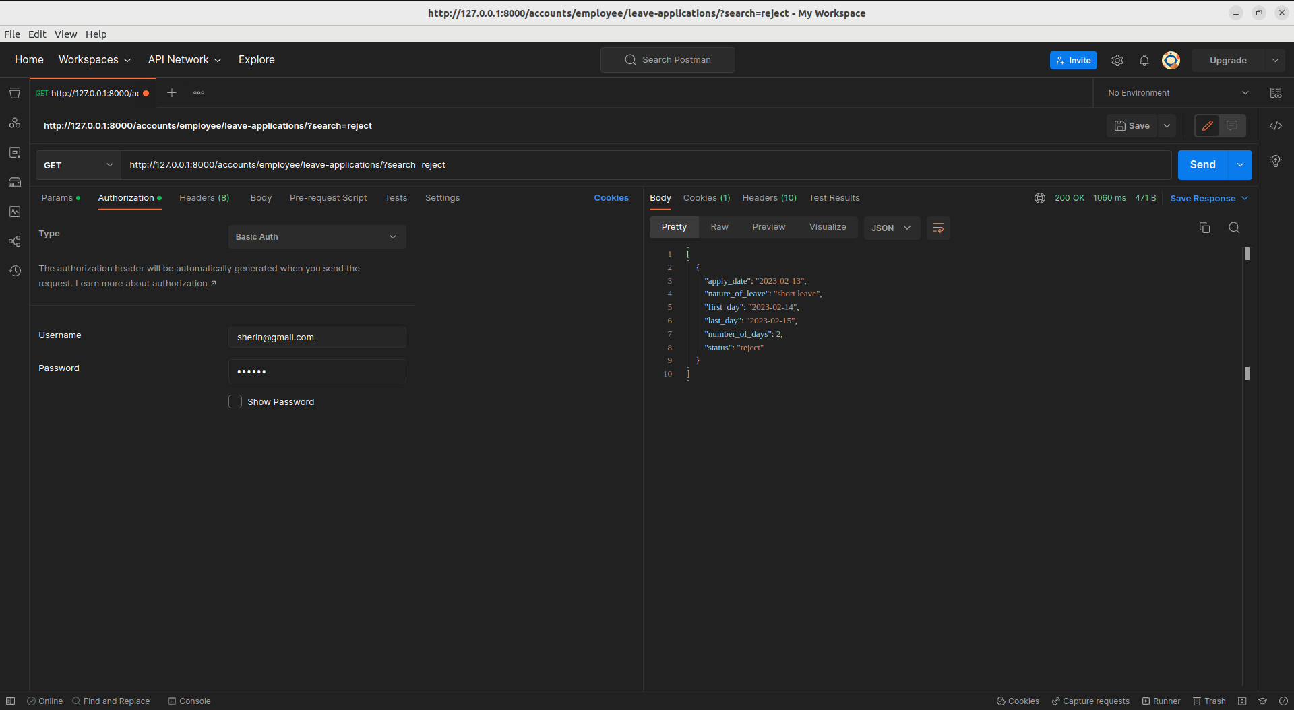

* <http://127.0.0.1:8000/accounts/employee/leave-applications/?ordering=number_of_days>

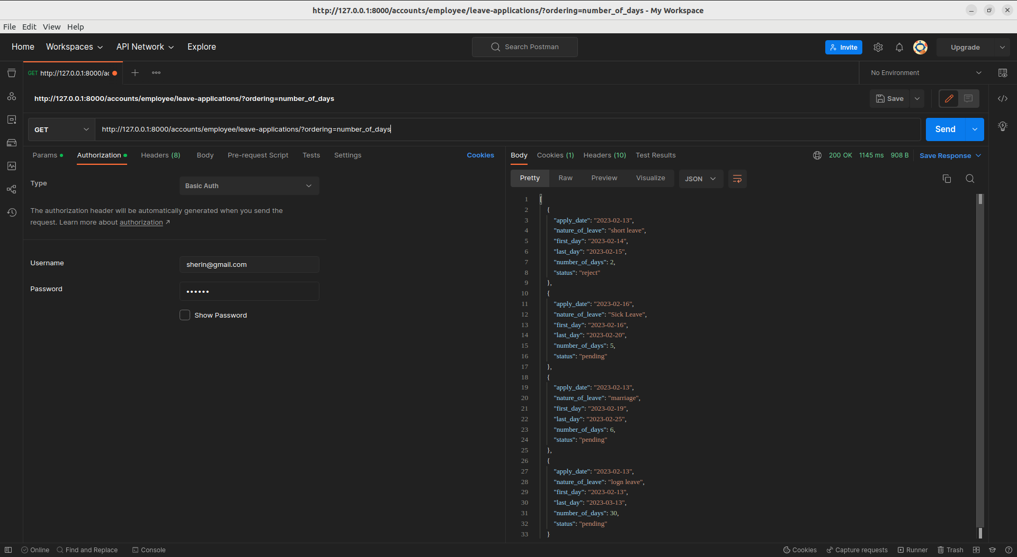

**Logout API**

* <http://127.0.0.1:8000/api/logout/>