**Exp No: 7 Date: 11-11-2024**

**MODEL CLOUD ENVIRONMENT USING CLOUDSIM**

**AIM:**

To model the cloud environment using cloud sim tools.

**PROCEDURE:**

1. Download latest Coudsim from the releases (<https://github.com/Cloudslab/cloudsim>)
2. Unzip the downloaded source code .zip (or) .tar.gz
3. Make sure Maven and Java is installed
4. Navigate to the extracted cloudsim-<version> directory and build “mvn clean install”
5. After successful build, navigate to modules/cloudsim-examples
6. Run the example using maven.

**OUTPUT:**

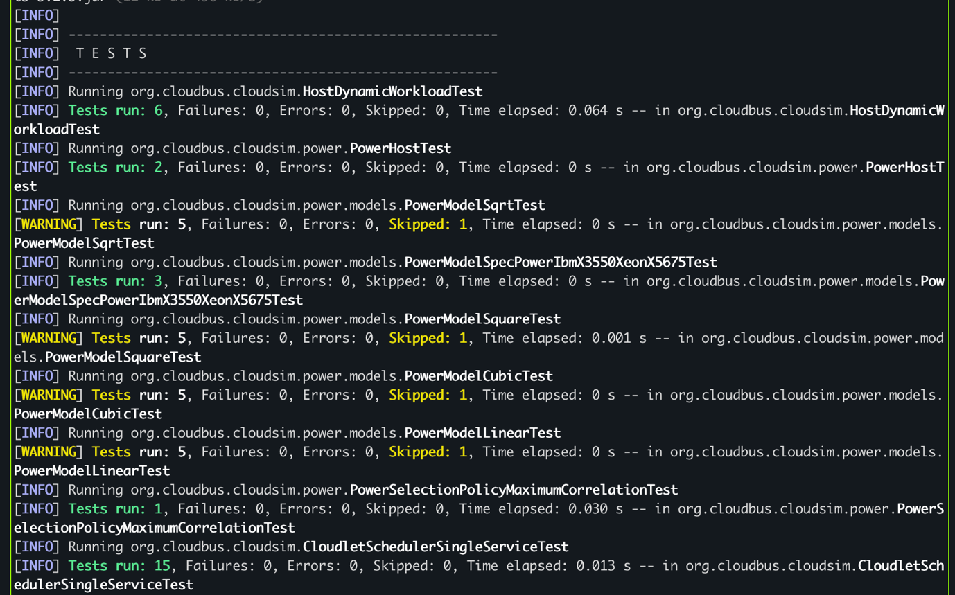

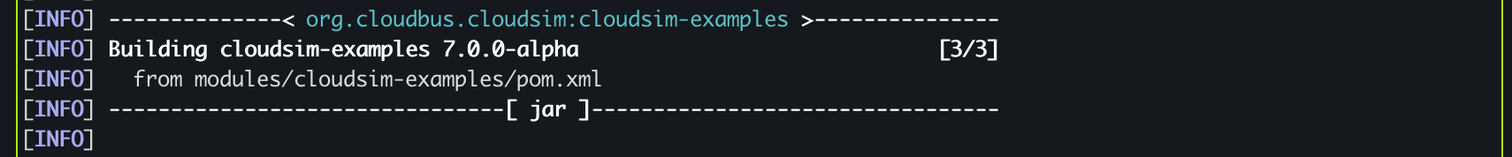

**RESULT:**

Thus a basic cloudsim example is successfully executed.