Experiment-15
File Operations in Java

Source:

import java.io.*;
import java.util.Scanner;

public class FileOperations {
private static final String FILE_NAME = "example.txt";

// Method to write data to a file
public static void writeToFile(String data) {
try (FileWriter writer = new FileWriter(FILE_NAME)) {
writer.write(data);
System.out.println("Data written successfully.");
} catch (IOException e) {
System.out.println("An error occurred while writing to the file.");
e.printStackTrace();
}
}

// Method to append data to a file
public static void appendToFile(String data) {
try (FileWriter writer = new FileWriter(FILE_NAME, true)) {
writer.write(data);
System.out.println("Data appended successfully.");
} catch (IOException e) {
System.out.println("An error occurred while appending to the file.");
e.printStackTrace();
}
}

// Method to read data from a file
public static void readFromFile() {
try (BufferedReader reader = new BufferedReader(new FileReader(FILE_NAME))) {
String line;
System.out.println("File contents:");
while ((line = reader.readLine()) != null) {
System.out.println(line);
}
} catch (IOException e) {
System.out.println("An error occurred while reading the file.");
e.printStackTrace();
}
}

public static void main(String[] args) {
Scanner scanner = new Scanner(System.in);
int choice;
do {
System.out.println("\nFile Operations Menu:");
System.out.println("1. Write to file");
System.out.println("2. Append to file");
System.out.println("3. Read from file");
System.out.println("4. Exit");
System.out.print("Enter your choice: ");
choice = scanner.nextInt();
scanner.nextLine(); // Consume newline

switch (choice) {
case 1:
System.out.print("Enter text to write: ");
String writeData = scanner.nextLine();
writeToFile(writeData + "\n");
break;
case 2:
System.out.print("Enter text to append: ");
String appendData = scanner.nextLine();
appendToFile(appendData + "\n");
break;
case 3:
readFromFile();
break;
case 4:
System.out.println("Exiting...");
break;
default:
System.out.println("Invalid choice. Please try again.");
}
} while (choice != 4);

scanner.close();
}
}

Output:
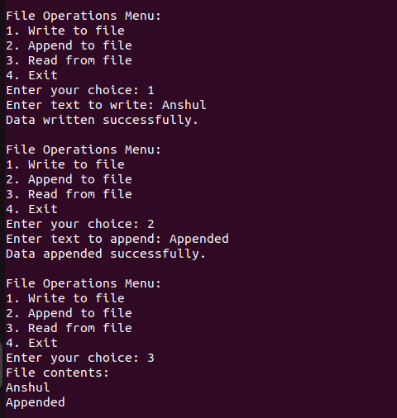

Experiment-16
System-Defined and User-Defined
Exception for Authentication

Source:

import java.io.*;
import java.util.Scanner;

// Custom exception for authentication failures
class AuthenticationException extends Exception {
public AuthenticationException(String message) {
super(message);
}
}

public class ExceptionHandle {

// Method to read a file and print its contents
public static void readFile(String filename) {
try (BufferedReader reader = new BufferedReader(new FileReader(filename))) {
String line;
System.out.println("File contents:");
while ((line = reader.readLine()) != null) {
System.out.println(line);
}
} catch (FileNotFoundException e) {
System.out.println("Error: "+e.getMessage());
} catch (IOException e) {
System.out.println("Error: An I/O error occurred while reading the file."+e.getMessage());
}
}

// Method to authenticate user credentials
public static void authenticate(String username, String password) throws AuthenticationException {
String validUsername = "admin";
String validPassword = "admin123";

if (!username.equals(validUsername) || !password.equals(validPassword)) {
throw new AuthenticationException("Invalid username or password. Access denied.");
}
System.out.println("Authentication successful. Welcome, " + username + "!");
}

public static void main(String[] args) {
Scanner scanner = new Scanner(System.in);

// File reading part
System.out.print("Enter filename to read: ");
String filename = scanner.nextLine();
readFile(filename);

// Authentication part
try {
System.out.print("\nEnter username: ");
String username = scanner.nextLine();

System.out.print("Enter password: ");
String password = scanner.nextLine();

authenticate(username, password);
} catch (AuthenticationException e) {
System.out.println("Authentication failed: " + e.getMessage());
}

scanner.close();
}
}
Output:

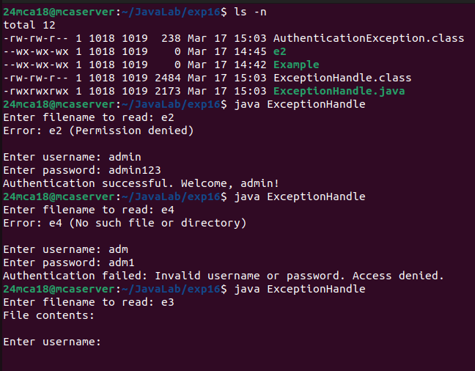
Experiment-17
Multithreading

Source:

import java.util.Scanner;

// Class for generating and displaying multiplication table of 5 (Extending Thread class)
class MultiplicationTable extends Thread {
public void run() {
System.out.println("Multiplication Table of 5:");
for (int i = 1; i <= 10; i++) {
System.out.println("5 x " + i + " = " + (5 * i));
try {
Thread.sleep(500); // Simulating delay
} catch (InterruptedException e) {
System.out.println("Thread interrupted: " + e.getMessage());
}
}
}
}

// Class for printing first N prime numbers (Implementing Runnable interface)
class PrimeNumbers implements Runnable {
private int n;

public PrimeNumbers(int n) {
this.n = n;
}

public void run() {
System.out.println("First " + n + " prime numbers:");
int count = 0, num = 2;
while (count < n) {
if (isPrime(num)) {
System.out.print(num + " ");
count++;
try {
Thread.sleep(300); // Simulating delay
} catch (InterruptedException e) {
System.out.println("Thread interrupted: " + e.getMessage());
}
}
num++;
}
System.out.println();
}

private boolean isPrime(int num) {
if (num < 2) return false;
for (int i = 2; i <= Math.sqrt(num); i++) {
if (num % i == 0) return false;
}
return true;
}
}

public class MultithreadingDemo {
public static void main(String[] args) {
Scanner scanner = new Scanner(System.in);

System.out.print("Enter the number of prime numbers to print: ");
int n = scanner.nextInt();

// Creating thread objects
MultiplicationTable tableThread = new MultiplicationTable();
Thread primeThread = new Thread(new PrimeNumbers(n));

// Starting threads
tableThread.start();
primeThread.start();

// Ensuring both threads complete before exiting main thread
try {
tableThread.join();
primeThread.join();
} catch (InterruptedException e) {
System.out.println("Main thread interrupted: " + e.getMessage());
}

System.out.println("Both tasks completed.");
scanner.close();
}
}

Output:

