Program 1

Aim
Write a python program that prompts the user to enter his first name and last name and then displays

Source Code :

f_name=input("enter your first name : ")
l_name=input("enter your second name : ")
print("greetings ",f_name," ",l_name," !")

Output :

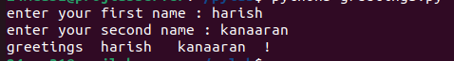
Program 2

Aim
Write a program to demonstarte different number datatypes in python

Source Code :

a,b,c,d=10,11.5,"hi",1+2j
print(a,"is",type(a))
print(b,"is",type(b))
print(c,"is",type(c))
print(d,"is",type(d))

Output :

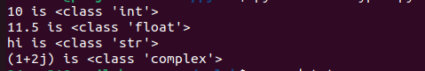
Program 3

Aim
Write a program to calculate the area of a circle by reading inputs from the user

Source Code :

r=int(input("enter radius : "))
print("area of the circle is",3.14*r*r)

Output :

Program 4

Aim
Write a program to calculate the salary of an employee given his basic pay (to be enterd by the user ). HRA=10 percent of the basic pay. TA=5 percent ofthe basic pay

Source Code :

basic_pay=int(input("enter your basic pay : "))
total_amt=basic_pay+(basic_pay*.1)+(basic_pay*.05)
print("your final salary will be ",total_amt)

Output :

Program 5

Aim
Write a program to perform arthemetic operations on two integer numbers

Source Code :

num1=int(input("enter number 1 : "))
num2=int(input("enter number 2 : "))
print("sum is ",num1+num2)
print("difference is ",num1-num2)
print("product is ",num1*num2)
print("division is ",num1/num2)
print("modules is ",num1%num2)
print("power is ",num1**num2)

Output :
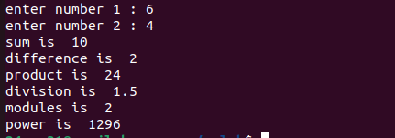
Program 6

Aim
Write a program to get a string which is n (non- negative integer) copies of a given string

Source Code :

str=input("enter the string : ")
n=int(input("enter how much times to be repeated : "))
print("\n\n",str*n)

Output :
