1. The number of absentees in class VIII was recorded in a particular week. Represent this data
on the bar graph
(i) Create a line graph with appropriate Labels and title
(ii) Use blue line color with style dotted
(iii) Points represented in yellow color and diamond shape

Program

import matplotlib.pyplot as plt
import numpy as np

x = np.array(["mon", "tues", "wed", "thu", "fri", "sat"])
y = np.array([130, 120, 135, 130, 150, 180])

plt.title("Absentees")
plt.xlabel("Days")
plt.ylabel("No. Of absentes")

plt.bar(x, y, color='blue')
plt.show()

plt.title("Absentees")
plt.xlabel("Days")
plt.ylabel("No. Of absentes")
plt.plot(x, y, color='blue', linestyle='dotted', marker='*', mec='yellow')
plt.show()

OUTPUT

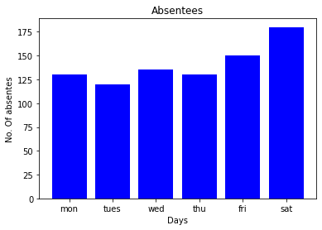

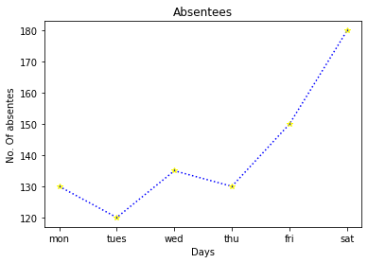

2. Program to print first n prime numbers

num=int(input("Enter limit:"))
print("prime numbers:")
for n in range(1,num):

for i in range(2,n):

if(n%i==0):

break

else:

print(n)

OUTPUT

