The main idea of this task was to compare the satellites launched by different countries. This involves the number of satellites, the purpose of launch and the size of the satellite. I have a total of 4 sheets, first sheet showing the world map; color of the country based on the number of satellites launched. Second sheet shows the timeline showing the number of satellites launched in each year. Third sheet shows the purpose of the launch in a treemap and the fourth sheet shows a histogram based on the mass of the launched satellite.

*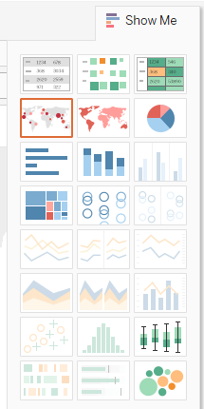The ‘Map’ Sheet*

I wanted to show the countries in a map, so that it is easy for the user to use their existing geographical memory while viewing this visualization. There were two options in Tableau using maps, but the one with size wasn’t looking good since it wasn’t giving a good perception of satellite count by country. It was hard to percieve the size of circles since most of them were very small. The other suggested options are shown to the left. The visualization chosen is shown below.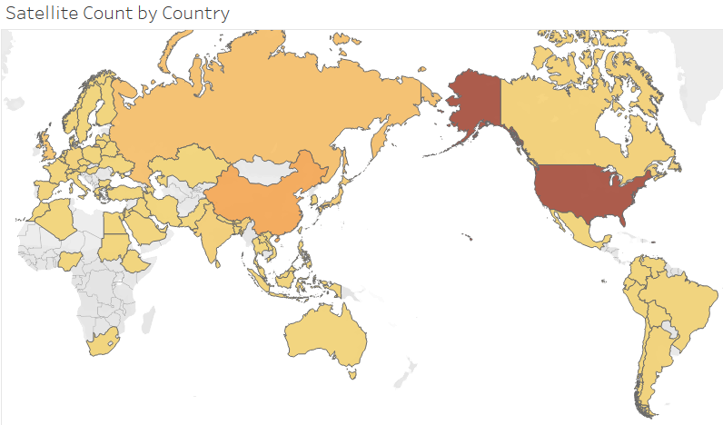

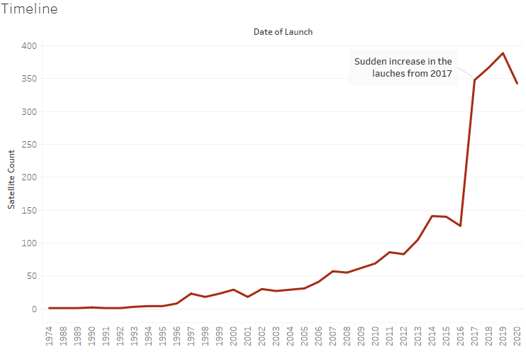*The ‘Timeline’ sheet*

There were several suggestions by Tableau for this visualization. But this was a time-series graph and I wanted to use a simple pre-attentive attribute using lines. By using lines, it can be perceived with a high degree of precision. The spike in launches has been noted in the graph.

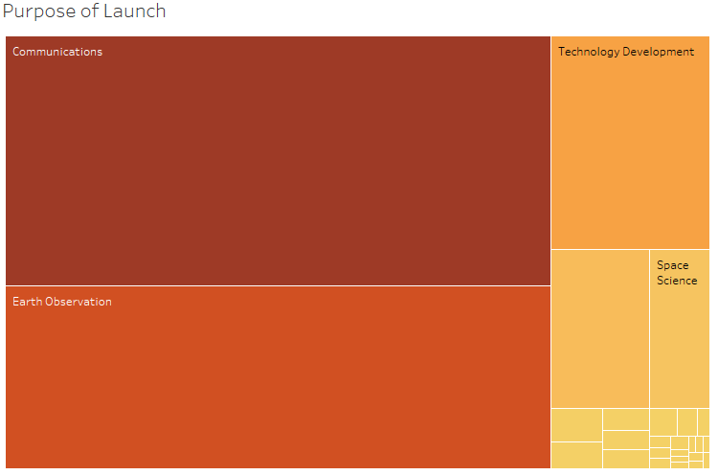

*The ‘Purpose’ sheet*

A treemap was used to show the main purpose of the launch. From the Tableau suggested options, I also considered using the packed bubbles. But treemap was found to be better since the size comparison of rectangles were easier than that of bubbles. Color was also used to show the number size along with the rectangle size.

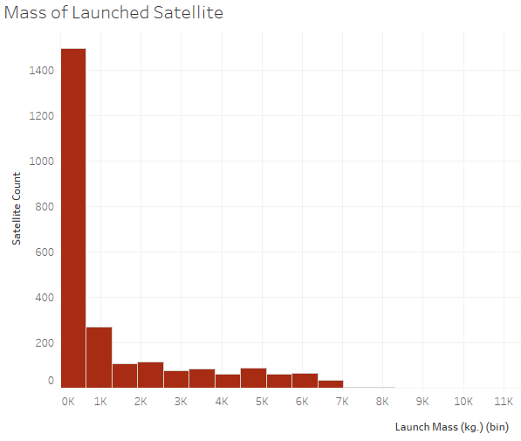

*The ‘LaunchMass’ sheet*

The histogram shows the launch mass of satellite in bins. We are interested in knowing the number of satellites launched within those mass ranges. Even though there were other Tableau suggestions, bar chart was the ideal visualization for a histogram.

*Dashboard*

Dashboard contain all the above sheets and all of them with filters. This would enable the user to cut and dice the information based on the year of launch, country of owner, purpose of satellite and Mass of the satellite.