LEDGERDB
Crash-Safe Accounts and Atomic Transfers with Durable Idempotency
Research Proposal and System Design
Aditya Srivastava (24BCE0511) | Anshith Bhandary (24BCE0429) | Ananta Bose (24BCB0087)
School of Computer Science and Engineering, Vellore Institute of Technology, Vellore

Abstract
Financial applications must preserve balances and transfer outcomes even when a process crashes, a write is interrupted, or a client repeats a request whose earlier result is unknown. If memory is updated before durable storage, acknowledged funds can disappear after restart; if a failed client blindly retries, the same transfer can be applied twice. This project presents LedgerDB, an embedded, single-node ledger written in Go that combines account mutation and idempotency completion in one versioned, checksummed write-ahead-log record. A mutation is returned as successful only after the record has crossed a synchronous durability barrier.
LedgerDB supports account creation, atomic two-account transfers, point reads, checkpoints, and orderly shutdown. It uses 64 account shards and 64 idempotency shards for concurrent access, stable lock ordering to prevent deadlock, and a global commit sequencer to assign monotonically increasing log sequence numbers. Recovery installs a valid checkpoint and replays later WAL records; an incomplete or invalid final record is treated as a torn tail and truncated, while corruption earlier in the log is reported. Fuzzy checkpoints publish checksummed snapshots through sync, rename, and directory-sync ordering before compacting covered WAL segments. The implementation is evaluated through correctness tests, race detection, concurrent invariants, fault injection, recovery tests, and transfer, checkpoint, and idempotency benchmarks. The result is a compact storage component with explicit and testable durability semantics for local financial services.

1. Introduction
A ledger operation has two inseparable responsibilities: it must change account state exactly once, and it must preserve enough evidence to answer a repeated request consistently. These responsibilities become difficult at the crash boundary. A process may write part of a record, the operating system may return an I/O error after an uncertain write, or a client may time out after the database has committed. A design that stores balances and idempotency status separately can leave the two structures disagreeing after recovery.
LedgerDB addresses this boundary by making one WAL record the atomic unit of commitment. The record contains the operation type, LSN, commit timestamp, idempotency key, SHA-256 request fingerprint, serialized request, and serialized result. The implementation applies state in memory only after the complete record has been written and synchronized. Recovery therefore needs redo only: an operation missing from durable storage cannot already have changed recovered account state.

2. Design Goals and Scope
- Atomic transfer: debit and credit become visible together at one commit LSN.
- Durable acknowledgement: success is returned only after File.Sync completes for the WAL record.
- Durable idempotency: the original result is replayed for the same key and fingerprint during the retention window.
- Deterministic recovery: checkpoints and WAL records rebuild state in increasing LSN order.
- Explicit corruption behavior: torn final records are repairable, but mid-log corruption returns ErrCorrupt.
- Bounded concurrency: sharded locks allow unrelated accounts and keys to proceed concurrently while one sequencer preserves commit order.
The first version is intentionally limited to one process and one node. A transaction is either one account creation or one transfer between two accounts of the same currency. Amounts are signed 64-bit minor units; currency codes are exactly three uppercase ASCII letters; currency conversion, replication, multi-process coordination, and arbitrary multi-account transactions are outside the current scope.

3. Proposed System

3.1 Architecture
Applications open a database directory and call the context-aware LedgerDB API. Account state and the idempotency index live in sharded in-memory maps. Mutations enter a single commit sequencer only after request validation and account locking. The sequencer assigns the next LSN and appends to the active WAL segment. A checkpoint manager independently captures a recoverable snapshot and publishes a manifest. At startup, the checkpoint loader and WAL replayer reconstruct both balances and retained responses.
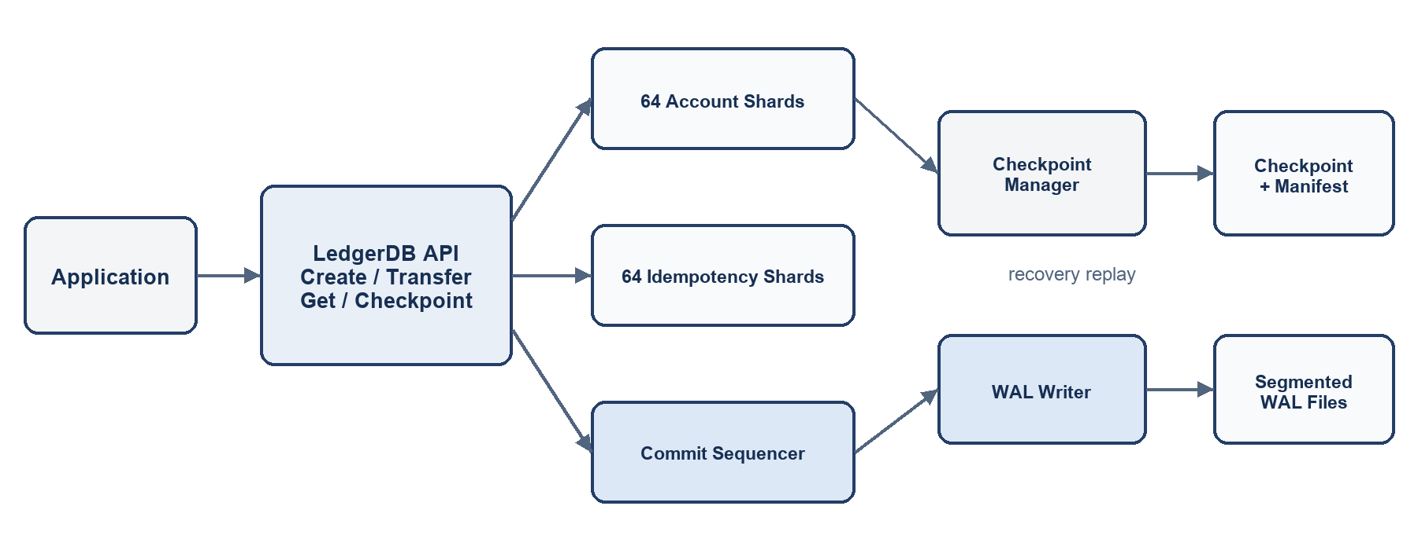
Figure 1. LedgerDB architecture and persistent storage paths.

3.2 Public API and Data Model
Operation | Inputs | Result and guarantee
Open | Directory and Options | Loads a checkpoint, replays WAL, and opens the active segment.
CreateAccount | Key, ID, currency, opening balance | Creates one account and returns its account state and commit LSN.
Transfer | Key, source, destination, amount | Atomically debits and credits two same-currency accounts.
GetAccount | Account ID | Returns the current in-memory balance and last applied LSN.
Checkpoint | Context | Publishes a fuzzy snapshot and compacts fully covered WAL segments.
Close | None | Serializes with checkpoint and commit activity, then closes the writer.

Account records contain an ID, currency, balance, and last-applied LSN. The LSN makes replay idempotent at the object level: a recovery record is applied only when the stored account LSN is older. An idempotency entry contains its state, fingerprint, operation type, encoded result, commit LSN, timestamp, and a channel used by concurrent duplicates to wait for the owning invocation.

3.3 Write-Ahead Log Format
WAL files are named wal-%020d.log and rotate at 64 MiB by default. Each record has a fixed 16-byte little-endian envelope followed by a JSON payload. Segment creation and deletion are followed by a directory sync so their namespace changes are durable.
Field | Size | Purpose
Magic | 4 bytes | LDBW identifies a LedgerDB WAL record.
Version | 2 bytes | Format version 1.
Flags | 2 bytes | Reserved; currently zero.
Payload length | 4 bytes | Unsigned little-endian JSON byte count.
CRC32 | 4 bytes | Checksum of the complete payload.
Payload | Variable | Type, LSN, timestamp, key, fingerprint, request, and result.

3.4 Commit Protocol
The commit path deliberately holds the affected account locks through WAL synchronization and in-memory publication. The global sequencer is also held through publication, so every LSN at or below a captured checkpoint base is present in both the account state and idempotency index before snapshot copying begins.
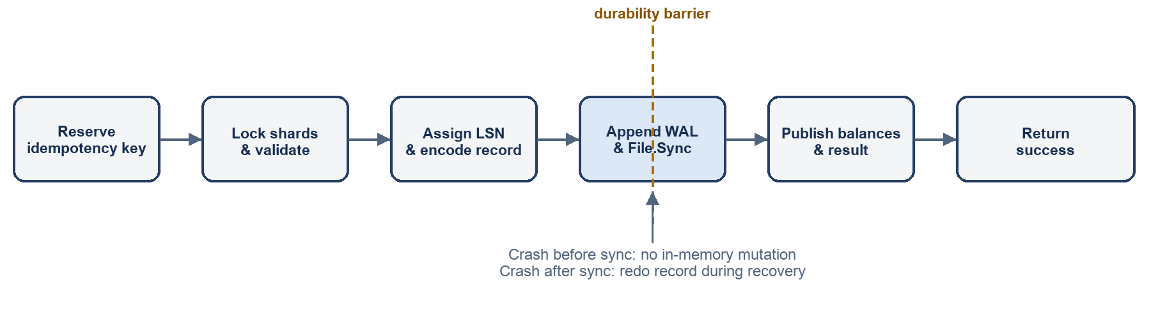
Figure 2. Mutation commit sequence and the synchronous durability barrier.
- Validate context, database state, key length, account identifiers, currency, and amount.
- Compute SHA-256 over the operation name, a zero separator, and the serialized request.
- Reserve the idempotency key; wait if an identical request is in flight or reject a conflicting fingerprint.
- Lock affected account shards in ascending shard order and check existence, currency, funds, and overflow.
- Acquire the commit sequencer, assign nextLSN + 1, serialize the result, and build one WAL record.
- Append the entire record with short-write handling and call File.Sync on the active segment.
- Publish account balances and the committed idempotency result in memory, then return success.

3.5 Idempotency and Concurrent Requests
The idempotency index uses 64 FNV-1a-selected shards. The first caller for a key becomes its owner and installs an in-flight entry. A concurrent caller with the same fingerprint waits on the entry's channel; after commit it receives the stored result without executing again. A different fingerprint immediately returns ErrIdempotencyConflict. Validation or business-rule failures abort the reservation, so the key is not consumed. Committed keys expire after 30 days by default and are omitted from later checkpoints once expired.
Account maps also use 64 shards. Transfers determine both shard indices and acquire them in stable numeric order, avoiding lock-order cycles. Disjoint transfers can validate concurrently, but all successful mutations pass through commitMu to establish a total WAL order. This is a deliberate trade-off: the critical synchronous write is serialized, while reads and pre-commit work remain parallel.

4. Recovery and Checkpointing

4.1 Startup Recovery
- Read MANIFEST and verify its LDBM length-and-CRC envelope.
- Load the named LDBC checkpoint and require matching version and base LSN.
- If no manifest exists, scan newest-first for a valid orphan checkpoint; it is safe because WAL compaction could not yet have followed an unpublished manifest.
- Enumerate WAL segments in numeric order and replay records whose LSN is greater than the checkpoint base.
- Apply a record only to accounts or idempotency entries with an older LSN, then set nextLSN to the maximum recovered value.
- Open the newest segment for append and synchronize directory creation state.

4.2 Torn Tails, Corruption, and Poisoning
Only the newest WAL segment is eligible for torn-tail repair. If the last record has an incomplete header, an incomplete payload, or an invalid final checksum, replay truncates the file to the last verified offset and synchronizes the truncation. The same defect in an earlier segment, a non-monotonic LSN, an unknown record type, or invalid replay references is treated as corruption and surfaced as ErrCorrupt.
A write or sync error during a live mutation makes durability indeterminate. LedgerDB marks the open instance poisoned: reads remain available, but future mutations and checkpoints return ErrPoisoned. The caller must close and reopen the database, then retry the same idempotency key to discover whether the uncertain record became durable. The library does not attempt an unsafe in-process retry after a sync error.

4.3 Fuzzy Checkpoint Protocol
Checkpoint captures the current committed LSN under the sequencer, then releases it and copies account and idempotency shards independently. Because each object carries its own LSN, the snapshot may contain some values newer than the base. Recovery still replays every record after the base and skips updates already reflected by a newer object LSN.
- Encode a versioned LDBC checkpoint containing the base LSN, sorted accounts, and unexpired committed idempotency entries.
- Write checkpoint-<baseLSN>.dat.tmp completely, sync it, close it, rename it to the final name, and sync the database directory.
- Encode and publish MANIFEST with the same temporary-write, sync, rename, and directory-sync ordering.
- Remove only non-active WAL segments whose maximum LSN is at or below the durable checkpoint base, then directory-sync deletions.
- Remove superseded checkpoint files after the new checkpoint and manifest are durable.

5. Implementation Components
Component | Repository location | Responsibility
Database core | db.go | API, validation, sharding, locking, idempotency, commit sequencing, and replay application.
Checkpoint layer | checkpoint.go | Snapshot envelopes, manifest discovery, publish ordering, installation, and compaction.
WAL package | internal/wal/wal.go | Record encoding, CRC validation, segmentation, append/sync, replay, tail repair, and compaction.
Filesystem boundary | fs.go | Portable storage interface and adapters used by production and tests.
Fault injection | internal/failpoint/fs.go | Deterministic failures for open, read, write, sync, truncate, rename, remove, and directory operations.
Public contracts | types.go / errors.go | Requests, results, options, API interface, and stable errors.
Verification | db_test.go / benchmark_test.go | Correctness, crash behavior, concurrency checks, and performance workloads.

6. Verification and Evaluation Plan

6.1 Correctness and Fault Injection
- Account validation: invalid identifiers, currencies, amounts, negative opening balances, missing accounts, same-account transfers, currency mismatch, insufficient funds, and overflow.
- Idempotency: repeated results, conflicting requests, concurrent duplicate rendezvous, lease expiry, and recovery of retained results.
- Concurrency: parallel transfers under disjoint, uniform, and hot-account contention while checking balance invariants with the Go race detector.
- WAL failures: partial header and payload writes, short writes, sync errors, durable-log crashes before memory publication, final-tail corruption, and mid-log corruption.
- Checkpoint failures: write, sync, close, rename, manifest publication, directory sync, orphan discovery, and recovery after segment compaction.

6.2 Benchmarks and Reported Metrics
Benchmark | Workload | Measurements
Transfers | Disjoint, uniform, and hot-account transfers | Operations/second, allocations, and latency percentiles.
Recovery | Repeated open/close after 1,000 persisted accounts | Startup time versus recoverable state and WAL size.
Checkpoint | Repeated checkpoints over 1,000 accounts | Checkpoint duration and impact on concurrent throughput.
Idempotency growth | Unique transfer keys retained in memory | Bytes and allocations per retained completion result.

Published results should record the LedgerDB revision, Go version, operating system and kernel, filesystem and mount options, storage device and firmware, CPU, and memory. Durability conclusions are conditional on the tested stack honoring synchronization requests; results from different machines or filesystems should not be compared without listing those differences.

7. Limitations and Future Work
- Add optional group commit to amortize synchronization cost while preserving a clear acknowledgement boundary.
- Introduce structured multi-account transactions and strict double-entry journal primitives above the current two-account transfer.
- Evaluate Linux filesystems and storage devices with power-loss testing beyond deterministic software fault injection.
- Add online observability for WAL segment growth, checkpoint age, poisoned state, recovery repairs, and idempotency retention pressure.
- Explore read snapshots, backup tooling, encryption at rest, schema migration, and a replication protocol without weakening local crash guarantees.

8. Conclusion
LedgerDB turns a narrow but failure-prone part of financial software into an explicit storage protocol. Its central rule is simple: the balance mutation, its response, and its idempotency completion become one checksummed WAL record, and nothing is acknowledged until that record is synchronized. Sharded state, stable lock ordering, redo-only recovery, torn-tail repair, fuzzy checkpoints, and fail-stop poisoning support that rule across concurrency and crash boundaries. The implementation remains intentionally small and single-node, making its guarantees practical to inspect, test, and benchmark before expanding to more complex ledger functions.

