CONFIDENTIAL  CS/OCT 2026/MAT133

UNIVERSITI TEKNOLOGI MARA
MARKING SCHEME

COURSE :
COURSE CODE :
EXAMINATION :
TIME :
PRE CALCULUS
MAT133
OCTOBER 2026
2 HOURS

MARKING SCHEME NOTES

- This marking scheme accompanies the MAT133 mock paper (October 2026).
Computed answers show working; every answer is produced by the deterministic MAT133 generator and verified by code where possible. No model answer is presented as official.

- Every marking point comes from the generator's worked solution; M1/A1 codes are aligned from the final answer backwards.

- Five questions; total = 67 marks.
- Computed: 15 part(s). Placeholders: 0.
Questions and answers are for local study use only.

- Generated deterministically from the 41 MAT133 past papers; seed 2.

FOR MARKERS' USE ONLY

This marking scheme consists of 5 printed pages

NO | SOLUTION | MARK
1 a) |  | 5 m
  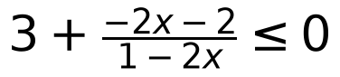 | M1 A1
  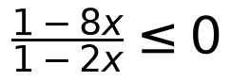 | A1
  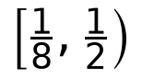 | A1
1 b) |  | 5 m
  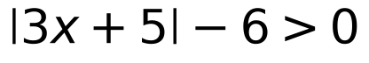 | M1
  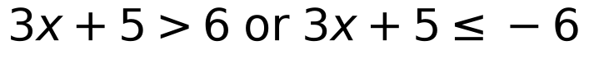 | A1
  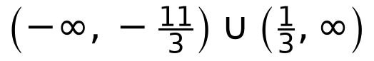 | A1
1 c) | 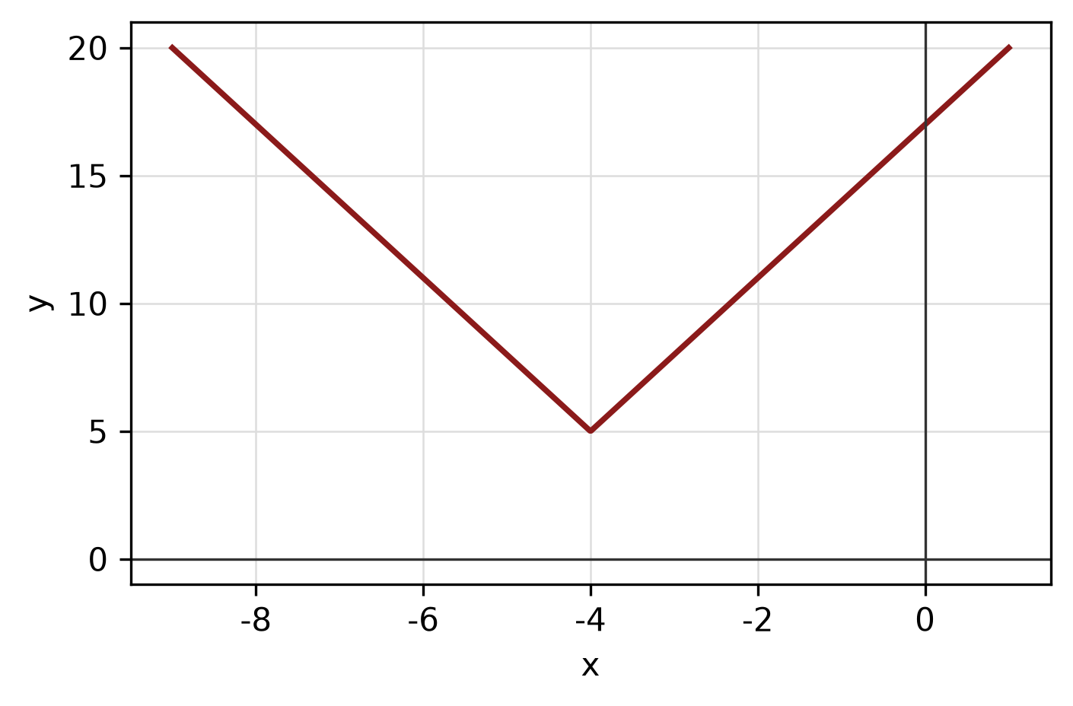 | 5 m
  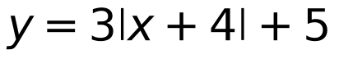 | B1
  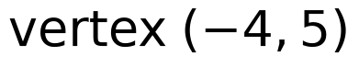 | A1
   | A1
2 a) |  | 4 m
  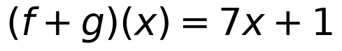 | M1
  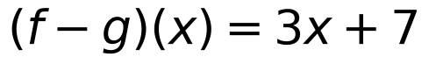 | A1
  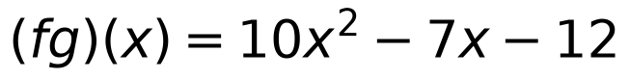 | B1
2 b) |  | 4 m
  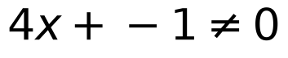 | M1
  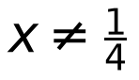 | A1
  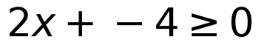 | M1
  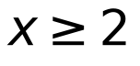 | A1
2 c) | 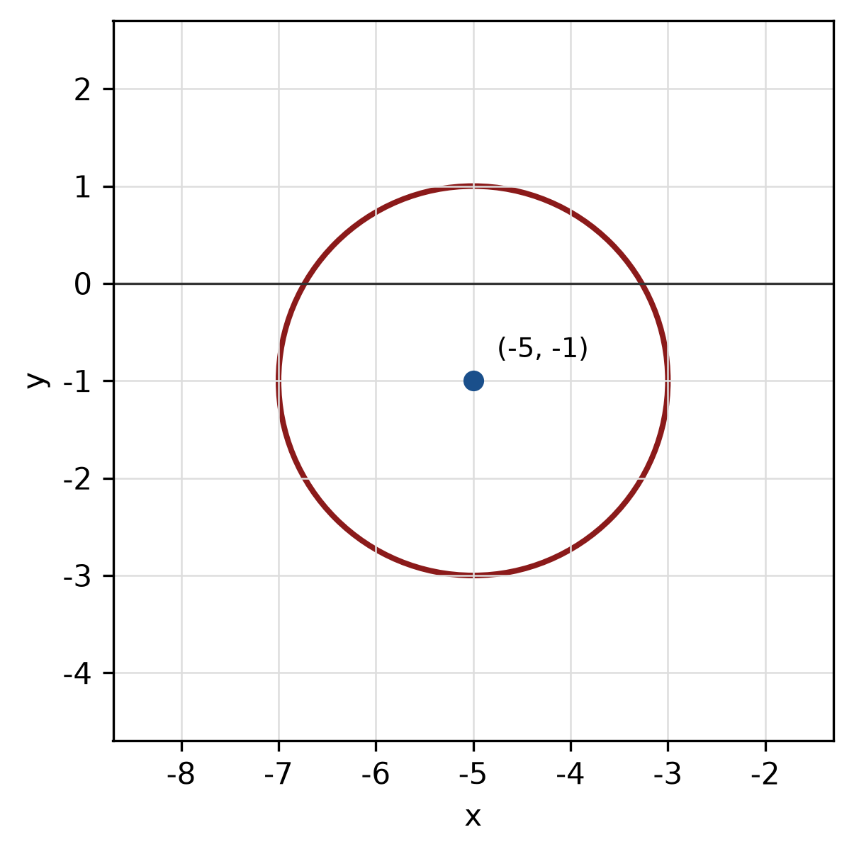 | 5 m
  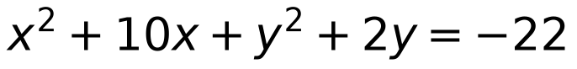 | M1 M1
  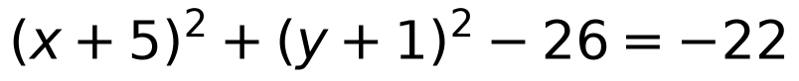 | A1
  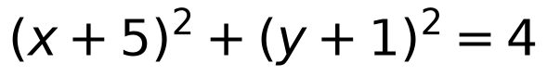 | A1
3 a) |  | 4 m
  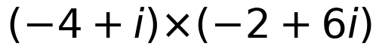 | M1 A1
  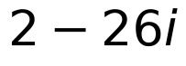 | A1
3 b) |  | 3 m
  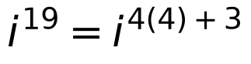 | M1
  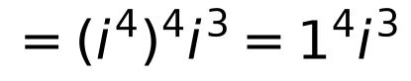 | A1
  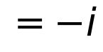 | A1
3 c) |  | 5 m
   | M1 M1 A1
  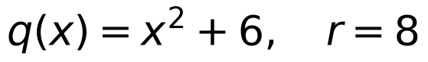 | A1
4 a) |  | 5 m
  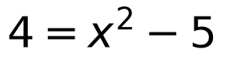 | M1
  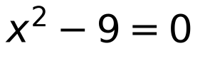 | A1
  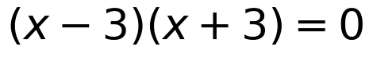
  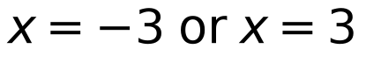
  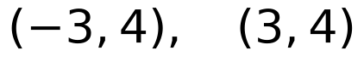 | A1
4 b) | 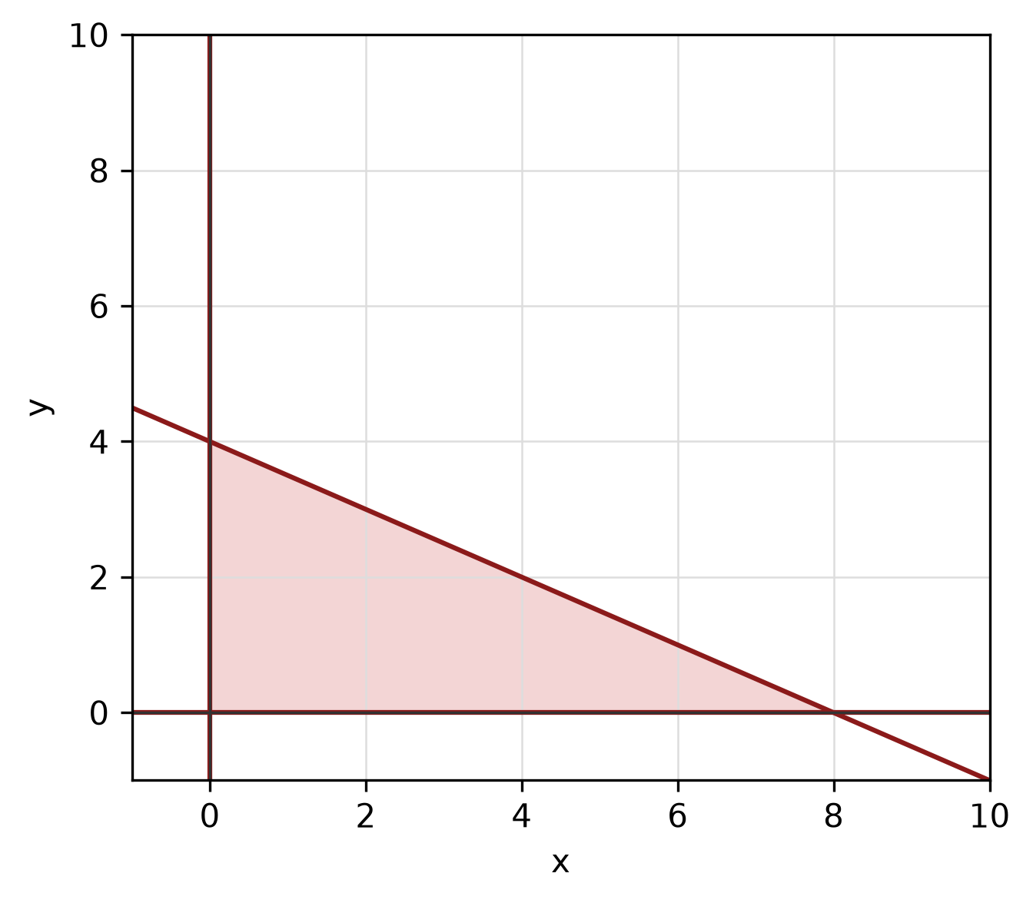 | 5 m
  B1 B1
  A1
4 c) | 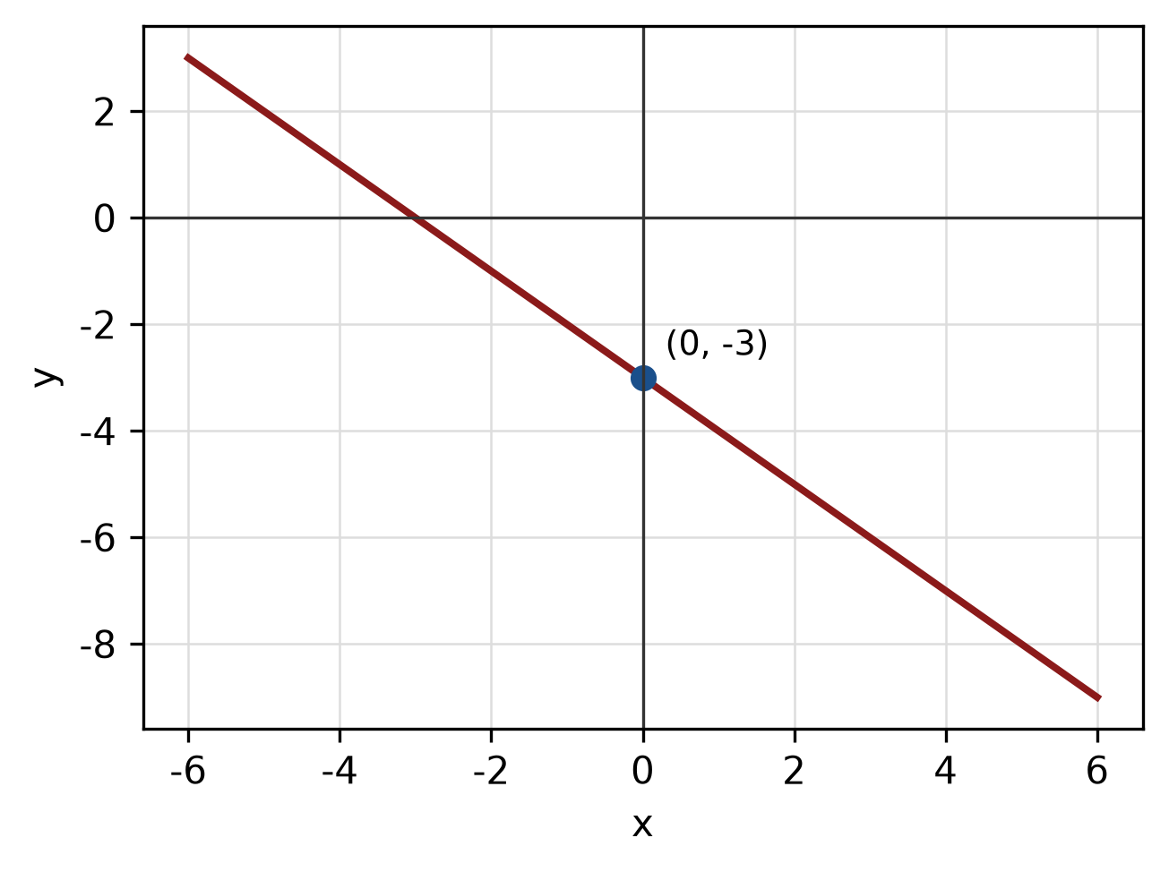 | 5 m
  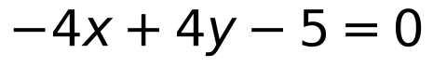 | M1
  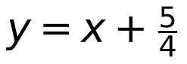 | M1
  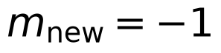
  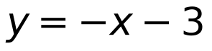 | A1
5 a) |  | 5 m
  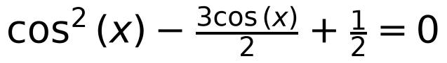 | M1
  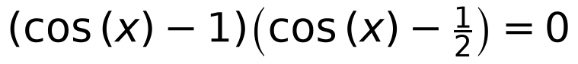 | A1
  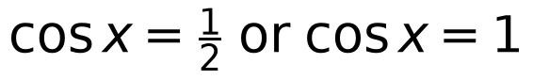
  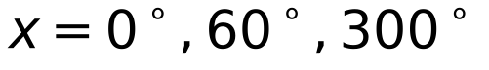 | A1
5 b) |  | 3 m
  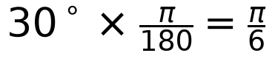 | M1 A1
  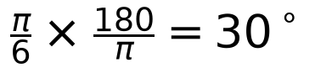 | A1
5 c) | 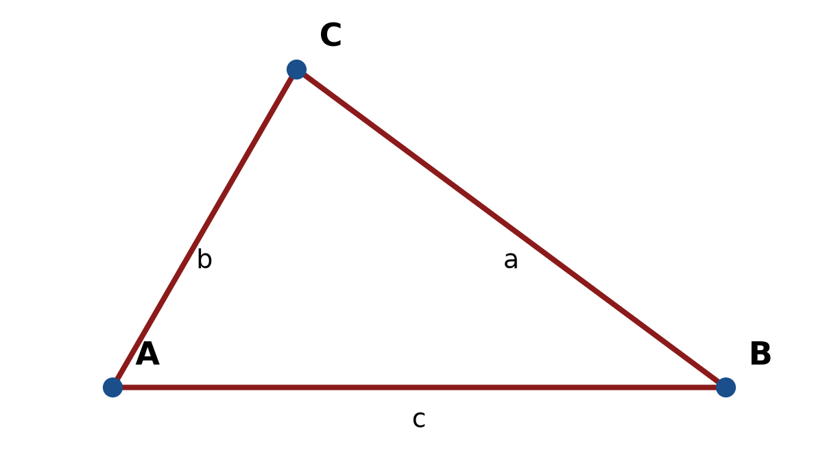 | 4 m
  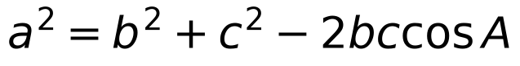 | M1
   | A1
  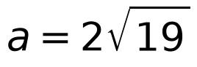 | A1

