CONFIDENTIAL  CS/NOV 2026/ICT450

UNIVERSITI TEKNOLOGI MARA
MARKING SCHEME

COURSE :
COURSE CODE :
EXAMINATION :
TIME :
DATABASE DESIGN AND DEVELOPMENT
ICT450
NOVEMBER 2026 (MOCK)
3 HOURS

MARKING SCHEME NOTES

- This marking scheme accompanies the ICT450 mock paper (November 2026).
Answers are unofficial model answers, not official UTM marking schemes.

- Marking points state the expected answer and the allocation of marks; every question retains its source paper and page reference.

- Five questions x 20 marks; total = 100 marks.
- Real-bank questions: 5. Placeholders: 0.
Questions and answers are for local study use only.

- Structure derived from 12 unique ICT450 past papers; every real question remains traceable to its source page.

FOR MARKERS' USE ONLY

This marking scheme consists of 9 printed pages.
MARKING GUIDE
QUESTION 1 (20 marks)
Source: ICT450-2023-JUL · page [2] · bank id ICT450-2023-JUL-Q1
Reference answer
(a) Two limitations of the file-based approach. [4 marks]
• Extensive programming and program-data dependence — every file needs its own management program, and changing a file structure requires the programs to be rewritten.
• Complex and difficult system administration — each file has its own format, access rules and storage, so administration does not scale well.
• Inadequate security and redundant data — access controls are weak, and independent files tend to store the same data more than once, causing inconsistency.
• Difficult structural change and limited sharing — separate files create islands of information that are hard to change or share safely.
(b) Two basic building blocks of a data model. [4 marks]
• Entity — a distinguishable object, person, place or event about which data is kept, such as STUDENT or COURSE.
• Relationship — an association between entities, such as a STUDENT enrolling in a COURSE.
• Attribute — a property that describes an entity, such as StudID or StudentName.
(c) The art and culture club table. [12 marks]
• i) Three characteristics of a relational table violated by Table 1:
• The table has two columns with the same name, “Name”; every column in a relation must have a unique name.
• The Skill column stores several values in one cell, such as “Modern Dance, Singing”; each cell must contain a single atomic value.
• The StudID column mixes numeric values with the text value 2023455abc; all entries in a column must use the same data type.
• There is no clearly declared primary key and the duplicate Name headings make the structure ambiguous.
• ii) Possible courses of action:
• Rename the two Name columns to FirstName and LastName.
• Move Skill into a separate SKILL table keyed by StudID and Skill, creating a one-to-many relationship with STUDENT.
• Standardise StudID as one data type, validate input and reject values such as 2023455abc.
• Declare StudID as the primary key and enforce entity integrity.
Marking guide
• a) 2 marks for each of two limitations named and explained (2 × 2 = 4).
• b) 2 marks for each of two building blocks named and explained (2 × 2 = 4).
• c)(i) 2 marks for each of three violations identified and explained (3 × 2 = 6).
• c)(ii) 2 marks for each of three suitable actions linked to the violations (3 × 2 = 6).
Provenance: model_unofficial · confidence high · Model-authored from the approved question text, the supplied source assets and the ICT200/ICT450 knowledge base; no official ICT450 marking scheme was supplied.
Knowledge base basis: TOPIC 1 DATABASE CONCEPT (1).pdf; TOPIC 2 DATA MODEL (1).pdf; TOPIC 3 RELATIONAL DATA MODELstu.pdf
Assumptions / notes
• Table 1 is treated as a single relation with the columns shown: StudID, Name, Name and Skill.
• A StudID is assumed to be a numeric identifier; the value 2023455abc is therefore an inconsistent data-type entry.

QUESTION 2 (20 marks)
Source: ICT450-2023-FEB · page [3] · bank id ICT450-2023-FEB-Q2
Reference answer
(a) Four activities in the database initial study. [8 marks]
• Analyse the company situation — study the organisation's structure, mission, operations, data handling and business environment.
• Define the problems and constraints — identify weaknesses, missing or redundant data, security issues and limits such as budget, time or existing systems.
• Define the objectives — state what the database must achieve and check that the objectives match the end users' needs.
• Define the scope and boundaries — decide which business areas, entities, data types and users are inside the database, and what external systems or limits bound it.
(b) Four limitations of mobile databases, with examples. [8 marks]
• Limited bandwidth and intermittent connectivity — a field worker may lose the network while updating a delivery record.
• Limited storage, memory and battery — a smartphone may not hold a full local copy of a large central database.
• Security and privacy risks — a lost or stolen mobile device may expose cached customer data unless it is encrypted.
• Synchronisation and consistency — offline edits from several devices must be merged without overwriting newer data.
• Heterogeneous devices and operating systems increase development and testing effort.
(c) Rows that will fail insertion into the STAFF table. [4 marks]
• Row 3033 (Siti Ziana) will fail because Salary = 11000 is outside the allowed range 3000–10000; this violates the domain or check constraint on Salary.
• Row 3034 (Ahmad Daniel) will fail because Salary = “150a” is not numeric; this violates the data type of the Salary column.
• Rows 3035 and 3036 satisfy the stated data types and range, and all StaffID values are unique.
Marking guide
• a) 2 marks for each of four initial-study activities explained (4 × 2 = 8).
• b) 2 marks for each of four mobile-database limitations with a relevant example (4 × 2 = 8).
• c) 2 marks for row 3033 with the range/domain reason; 2 marks for row 3034 with the data-type reason (2 + 2 = 4).
Provenance: model_unofficial · confidence high · Model-authored from the approved question text, the supplied source assets and the ICT200/ICT450 knowledge base; no official ICT450 marking scheme was supplied.
Knowledge base basis: TOPIC 2 DATA MODEL (1).pdf; TOPIC 6 DATABASE DESIGN (1).pdf
Assumptions / notes
• The staff table has StaffID as its primary key; Salary must be numeric and lie in the stated range 3000–10000; DepartmentID is numeric.

QUESTION 3 (20 marks)
Source: ICT450-2024-JAN · page [4, 5] · bank id ICT450-2024-JAN-Q3
Reference answer
Figure 2 is an employee evaluation report. One employee has several project rows, so the report is an unnormalised relation with a repeating group.
(a) Normal form of Figure 2 and reasons. [3 marks]
The report is in unnormalised form (UNF) because the project rows repeat for the same employee. If it is flattened to one row per project, it is in 1NF, but it still contains partial and transitive dependencies. It is not in 2NF or 3NF.
Unnormalised report relation.
REPORT (EmployeeID, EmployeeName, EmploymentYear, DepartmentID, DepartmentName, Phone, Address, ProjectCode, ProjectName, Location, Grade, SupervisorID, SupervisorName, SupervisorDepartment)
(b) Relational schema, primary keys and dependencies. [6 marks]
The repeated project code ST01 with two locations is a key trap: ProjectCode alone does not identify a project instance. The assignment key is (EmployeeID, ProjectCode, Location).
Relational schema before 3NF.
EMPLOYEE (EmployeeID, EmployeeName, EmploymentYear, DepartmentID, DepartmentName, Phone, Address)
PROJECT (ProjectCode, ProjectName)
PROJECT_LOCATION (ProjectCode, Location)
SUPERVISOR (SupervisorID, SupervisorName, SupervisorDepartment)
ASSIGNMENT (EmployeeID, ProjectCode, Location, Grade, SupervisorID)
Functional dependencies:
Functional dependencies in the report.
EmployeeID → EmployeeName, EmploymentYear, DepartmentID, DepartmentName, Phone, Address
ProjectCode → ProjectName
SupervisorID → SupervisorName, SupervisorDepartment
EmployeeID, ProjectCode, Location → Grade, SupervisorID
DepartmentID → DepartmentName
(c) Normalise to 3NF, showing all steps. [11 marks]
Step 1 — 1NF: one row per employee-project assignment; all cells atomic. Key: (EmployeeID, ProjectCode, Location).
Step 2 — 2NF: remove partial dependencies. Employee data depends on EmployeeID; project data depends on ProjectCode; supervisor data depends on SupervisorID.
2NF relations.
EMPLOYEE (EmployeeID, EmployeeName, EmploymentYear, DepartmentID, DepartmentName, Phone, Address)
PROJECT (ProjectCode, ProjectName)
PROJECT_LOCATION (ProjectCode, Location)
SUPERVISOR (SupervisorID, SupervisorName, SupervisorDepartment)
ASSIGNMENT (EmployeeID, ProjectCode, Location, Grade, SupervisorID)
Step 3 — 3NF: remove transitive dependencies. DepartmentName depends on DepartmentID, and the supervisor's department depends on SupervisorID.
3NF relations.
DEPARTMENT (DepartmentID, DepartmentName)
EMPLOYEE (EmployeeID, EmployeeName, EmploymentYear, DepartmentID, Phone, Address)
PROJECT (ProjectCode, ProjectName)
PROJECT_LOCATION (ProjectCode, Location)
SUPERVISOR (SupervisorID, SupervisorName, DepartmentID)
ASSIGNMENT (EmployeeID, ProjectCode, Location, Grade, SupervisorID)
3NF sample data: EMPLOYEE
EmployeeID | EmployeeName | EmploymentYear | DepartmentID | Phone | Address
303303 | Siti Nur Fadilah | 2000 | S1 | 017 | JC 1234, Bandar Jasin Bestari Seksyen 7, Melaka

3NF sample data: DEPARTMENT
DepartmentID | DepartmentName
S1 | Software Development

3NF sample data: PROJECT and PROJECT_LOCATION
ProjectCode | ProjectName | Location
MD01 | Mobile Apps Development | Kuala Terengganu
WD01 | Website Development | Machang
ST01 | Software Integration | Seremban
ST01 | Software Integration | Tapah

3NF sample data: SUPERVISOR
SupervisorID | SupervisorName | DepartmentID
123123 | Willy | S1
101101 | Mawar | S1

3NF sample data: ASSIGNMENT
EmployeeID | ProjectCode | Location | Grade | SupervisorID
303303 | MD01 | Kuala Terengganu | A | 123123
303303 | WD01 | Machang | A+ | 101101
303303 | ST01 | Seremban | A- | 101101
303303 | ST01 | Tapah | A | 101101

Marking guide
• a) 3 marks: UNF/1NF identified (1), repeating group explained (1), reason why not 2NF/3NF (1).
• b) 6 marks: relations (3), keys (2), dependencies (1).
• c) 11 marks: 1NF (2), 2NF with partial dependencies removed (4), 3NF with transitive dependencies removed and DEPARTMENT split (5).
Provenance: model_unofficial · confidence medium · Model-authored from the approved question text, the supplied source assets and the ICT200/ICT450 knowledge base; no official ICT450 marking scheme was supplied.
Knowledge base basis: TOPIC 5 NORMALIZATION (1).pdf
Assumptions / notes
• The report contains a repeating group of projects for one employee.
• Project code ST01 appears twice with different locations, so the project instance is identified by (ProjectCode, Location).
• Supervisor department names map to DepartmentID values; this supports the 3NF split into DEPARTMENT.

QUESTION 4 (20 marks)
Source: ICT450-2024-JUL · page [5] · bank id ICT450-2024-JUL-Q4
Reference answer
Relational schema used by the question.
STUDENT (StudentID, FirstName, LastName, PhoneNumber, FacultyID*)
CANDIDATE (CandidateID, StudentID*)
VOTING (VotingID, VotingDate, StudID*)
VOTING_DETAILS (VotingID*, CandidateID*, VotingTime)
FACULTY (FacultyID, FacultyName)
(a) Total number of candidates for each faculty. [4 marks]
SELECT f.FacultyID, f.FacultyName,
COUNT(c.CandidateID) AS total_candidates
FROM FACULTY f
JOIN STUDENT s ON s.FacultyID = f.FacultyID
JOIN CANDIDATE c ON c.StudentID = s.StudentID
GROUP BY f.FacultyID, f.FacultyName;
(b) Students who do not vote for any candidate. [4 marks]
SELECT s.*
FROM STUDENT s
WHERE NOT EXISTS (
SELECT 1
FROM VOTING v
JOIN VOTING_DETAILS vd ON vd.VotingID = v.VotingID
WHERE v.StudID = s.StudentID
);
(c) Total number of voters for each faculty. [4 marks]
SELECT f.FacultyID, f.FacultyName,
COUNT(DISTINCT v.StudID) AS total_voters
FROM FACULTY f
JOIN STUDENT s ON s.FacultyID = f.FacultyID
JOIN VOTING v ON v.StudID = s.StudentID
GROUP BY f.FacultyID, f.FacultyName;
(d) Full name of candidates with more than 500 votes. [4 marks]
SELECT c.CandidateID,
CONCAT(s.FirstName, ' ', s.LastName) AS full_name,
COUNT(vd.VotingID) AS total_votes
FROM CANDIDATE c
JOIN STUDENT s ON s.StudentID = c.StudentID
JOIN VOTING_DETAILS vd ON vd.CandidateID = c.CandidateID
GROUP BY c.CandidateID, s.FirstName, s.LastName
HAVING COUNT(vd.VotingID) > 500;
In Oracle, replace CONCAT(...) with s.FirstName || ' ' || s.LastName.
(e) Total number of students who vote for only one candidate. [4 marks]
SELECT COUNT(*) AS students_voting_once
FROM (
SELECT v.StudID
FROM VOTING v
JOIN VOTING_DETAILS vd ON vd.VotingID = v.VotingID
GROUP BY v.StudID
HAVING COUNT(DISTINCT vd.CandidateID) = 1
) AS single_vote;
Marking guide
• a) 4 marks: candidate-student-faculty join (2), COUNT per faculty (2).
• b) 4 marks: anti-join/not-exists on voting details (3), correct student output (1).
• c) 4 marks: faculty-student-voting join (2), COUNT DISTINCT voters (2).
• d) 4 marks: candidate vote join (2), GROUP BY and HAVING > 500 (2).
• e) 4 marks: group votes by student (2), HAVING count = 1 and outer COUNT (2).
Provenance: model_unofficial · confidence high · Model-authored from the approved question text, the supplied source assets and the ICT200/ICT450 knowledge base; no official ICT450 marking scheme was supplied.
Knowledge base basis: TOPIC 7 SQL.pdf
Assumptions / notes
• A candidate's faculty is the faculty of the student who is the candidate.
• A vote is represented by a VOTING row plus its VOTING_DETAILS rows; a student who has no VOTING_DETAILS row has not voted for a candidate.

QUESTION 5 (20 marks)
Source: ICT450-2025-FEB · page [5] · bank id ICT450-2025-FEB-Q5
Reference answer
The ERD separates studios, employees, programs, suppliers, materials and skills. The many-to-many relationships are drawn directly between entities. At implementation they become junction tables: STUDIO_SUPPLIER, SUPPLIER_MATERIAL and EMPLOYEE_SKILL. The PROGRAM subtype attributes are listed below the diagram.
(a) Construct the ERD with Crow's Foot notation. [16 marks]
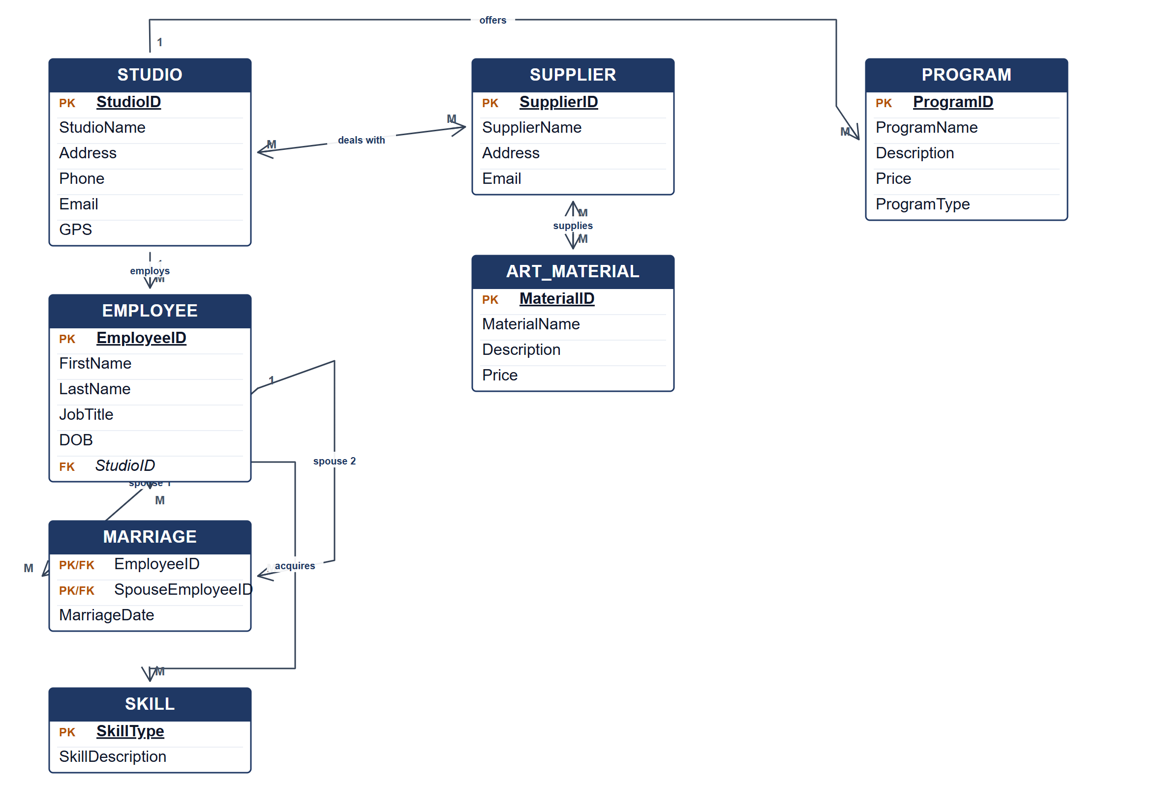
Crow's Foot ERD for the Excellent Art database.
PROGRAM subtype attributes
Program type | Subtype attribute
Visual Art | ClassType
Glass Painting | ProgramLevel (1–5)
Handicraft | CraftData

(b) Two reports from the ERD. [4 marks]
• Studio programme report — list each studio with its programmes, programme type and subtype-specific details such as class type, program level or craft data.
• Supplier and material report — show each studio's suppliers and the art materials each supplier provides, with prices.
• Employee skills report — list employees by studio with their acquired skills.
Marking guide
• a) 16 marks: STUDIO, EMPLOYEE, PROGRAM and SUPPLIER (4); ART_MATERIAL, SKILL and MARRIAGE (3); PROGRAM subtype attributes (2); direct many-to-many relationships and their junction tables (3); keys and Crow's Foot cardinalities (4).
• b) 2 marks for each of two relevant reports explained (2 × 2 = 4).
Provenance: model_unofficial · confidence medium · Model-authored from the approved question text, the supplied source assets and the ICT200/ICT450 knowledge base; no official ICT450 marking scheme was supplied.
Knowledge base basis: TOPIC 4 ERD_stu (2).pdf; TOPIC 3 RELATIONAL DATA MODELstu.pdf
Assumptions / notes
• PROGRAM subtypes share the ProgramID key. Their subtype attributes are listed below the diagram rather than drawn as separate boxes, keeping the ERD readable.
• A marriage is represented as an associative entity linking two EMPLOYEE rows, because it has a marriage date and involves two employees.
• STUDIO deals with many SUPPLIERs, and SUPPLIER supplies many ART_MATERIALs; both many-to-many relationships are drawn directly and become junction tables at implementation.

