
CONFIDENTIAL CS/NOV 2026/ICT450

UNIVERSITI TEKNOLOGI MARA FINAL EXAMINATION

COURSE
COURSE CODE
EXAMINATION TIME
DATABASE DESIGN AND DEVELOPMENT

ICT450
NOVEMBER 2026
3 HOURS

INSTRUCTIONS TO CANDIDATES

- This question paper consists of five (5) questions.

- Answer ALL questions in the Answer Booklet. Start each answer on a new page.

- Do not bring any material into the examination room unless permission is given by the invigilator .
- Please check to make sure that this examination pack consists of: i) the Question Paper
  - an Answer Booklet - provided by the Faculty

- Answer ALL questions in English.

DO NOT TURN THIS PAGE UNTIL YOU ARE TOLD TO DO SO

This examination paper consists of 6 printed pages.

QUESTION 1 (20 marks)
a) Figure 1.0 shows a traditional file system which has many separate and unrelated files.
i) Discuss TWO (2) problems that might arise because of traditional file system as shown in Figure 1.0.
(4 marks)
ii) Problems inherent in file systems cause a need to implement a database system. Redesign the system in Figure 1.0 using database approach.
(4 marks)
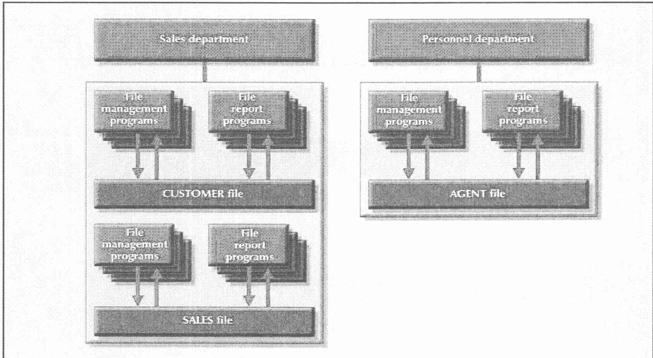
Figure 1.0 : A simple file system
b) Briefly describe TWO (2) characteristics of mobile database and give TWO (2) examples of appropriate mobile database applications that you would recommend to Student Representative Council of UiTM. Give ONE (1) reason why you need those application.
(8 marks)
c) Given the following relational schema :
COURSE (CourseCode, CourseName)
SUBJECT (SubjectCode, SubjectName, TeacherCode)
TEACHER (TeacherCode, FName, LName, DeptCode)
COURSE_SUBJECT (CourseCode, SubjectCode, SubjectType)
i) Identify the primary key for each table
(2 marks)
ii) Briefly explain ONE (1) purpose of having primary key in database.
(2 marks)
QUESTION 2 (20 marks)
a) Database Design phase is the second phase of the Database Life Cycle (DBLC) that focuses on the design of the database model. It consists of three essential stages which are conceptual design, logical design and physical design. Briefly explain the differences among these stages and identify either they are software-dependent or not.
(8 marks)
b) Describe the FOUR (4) characteristic of big data. Give an example for each characteristics.
(8 marks)
c) Spreadsheet application such as Microsoft Excel (shown in Figure 1) can also be used to store data. However, spreadsheet application cannot be considered as a database system because there are several basic database functions that a spreadsheet cannot perform. Explain TWO (2) features of spreadsheet application that are different from database system.
(4 marks)
Table 3: STAFF table
STAFF_ID | STAFF_NAME | COURSE_ID
101 | Ronaldo | 10
102 | Vardy | 30
103 | Toney | 60
104 | Jimenez | 20
105 | Kane | 40
106 | Lukaku | 50
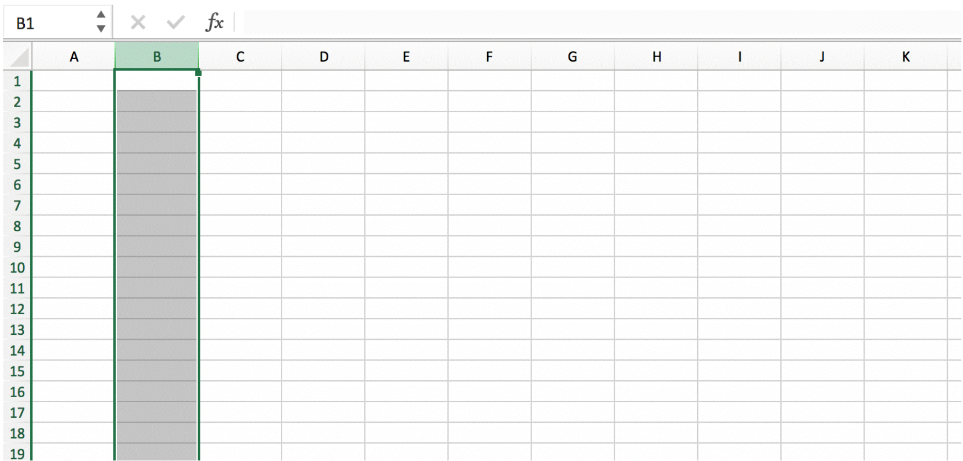
Figure 1: Spreadsheet Application
QUESTION 3 (20 marks)
Based on the given reservation form, answer the following questions:
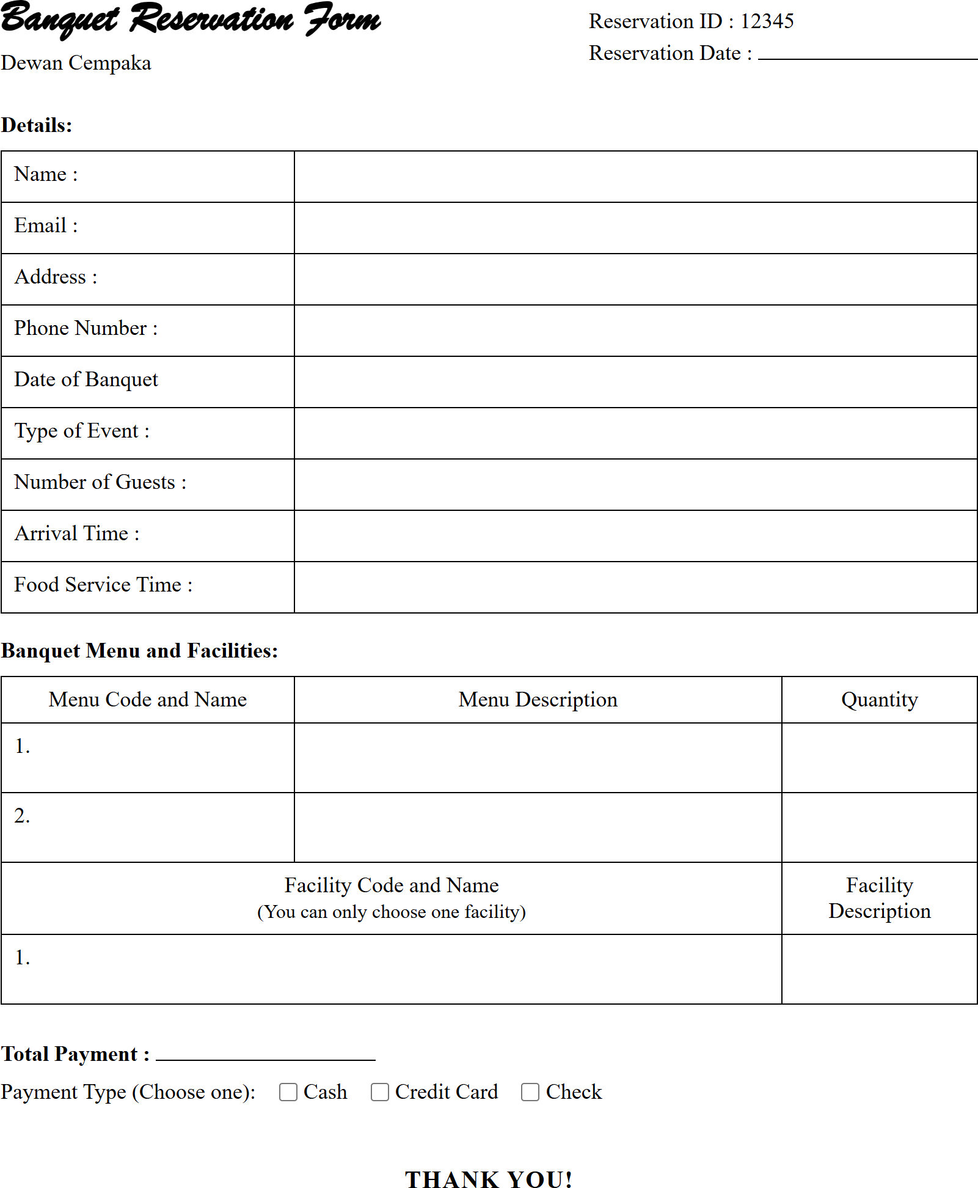
Figure 1 shows an example of banquet reservation form for Dewan Cempaka. Figure 1: Banquet Reservation Form
a) Define normalization and explain the purpose of having normalization in a database table.
(3 marks)
b) Describe THREE (3) effects of a poor database design.
(6 marks)
c) Show all the steps to normalize the structure until third normal form (3NF). The primary key(s), partial dependencies and/or transitive dependencies need to be clearly identified.
(11 marks)
QUESTION 4 (20 marks)
Ninja Package is a new startup company located in Jasin, Melaka. You are hired as a database developer to create a package delivery database based on the given relational schema.
RIDER (riderID, riderName, startDate, hpNum)
CUSTOMER (icNum, custName, custPhone, custAddress)
DELIVERY (packageID, dateDeliver, riderID, icNum, status)
*Status of delivery is either delivered or unsuccessful.
Write SQL statements based on the following requirements.
a) Create table DELIVERY.
(4 marks)
b) Find total number of customers that are successfully received package(s) in November 2022.
(4 marks)
c) Find total number of unsuccessful delivery for each riders.
(4 marks)
d) List name of riders that make a delivery/deliveries any packages.
(4 marks)
e) Write SQL command to produce the output as follows:
(4 marks)
Package ID | Customer Name | Status
p1 | Ayu | delivered
p2 | Ibrahim | delivered
QUESTION 5 (20 marks)
One public university in Arau, Perlis is planning to develop an auxiliary police database system for a better coordination and reporting of summons and security duties. As a database designer, you are tasked to design the database system according to the following requirements:
- Details of each police officer such as their Police ID, name, position and email address.
- Each police officer has been assigned to five main duties. For safety reasons, each duty will be carried out by more than one police officer. The date and time of each assigned duty need to be recorded in the system.
- Each police officer also can issue summons to several students. The date summon issuance need to be recorded by the police officer.
- A summon will be issued if a student violates any rules and regulations.
- Each summon will consist more than one offense. Offense ID, offense name, description, and rate of fees need to be recorded in the system.
Based on the given information:
a) Construct a complete Entity Relationship Diagram (ERD) with all of the required tables, attributes, and relationships using the Crow's Foot notation that reflects all of the given business rules.
(16 marks)
b) Identify TWO (2) relevant information that you can get from the ERD you constructed in (a).
(4 marks)

