
CONFIDENTIAL CS/NOV 2026/ICT450

UNIVERSITI TEKNOLOGI MARA FINAL EXAMINATION

COURSE
COURSE CODE
EXAMINATION TIME
DATABASE DESIGN AND DEVELOPMENT

ICT450
NOVEMBER 2026
3 HOURS

INSTRUCTIONS TO CANDIDATES

- This question paper consists of five (5) questions.

- Answer ALL questions in the Answer Booklet. Start each answer on a new page.

- Do not bring any material into the examination room unless permission is given by the invigilator .
- Please check to make sure that this examination pack consists of: i) the Question Paper
  - an Answer Booklet - provided by the Faculty

- Answer ALL questions in English.

DO NOT TURN THIS PAGE UNTIL YOU ARE TOLD TO DO SO

This examination paper consists of 6 printed pages.

QUESTION 1 (20 marks)
a) Data is a raw fact or a building blocks of information. Identify FOUR (4) examples of data for an online store.
(4 marks)
b) Describe TWO (2) differences between a database and a spreadsheet.
(4 marks)
c) There are three rules of referential integrity which are Insert Rule, Update Rule and Delete Rule. Describe these three rules and illustrate your answer.
(6 marks)
d) Database system is designed based on two design strategies. Explain THREE (3) differences between these two designs.
(6 marks)
QUESTION 2 (20 marks)
a) Briefly describe business rule and state THREE (3) essentials of identifying and documenting business rule to a company.
(8 marks)
b) Explain an importance of index in database.
(2 marks)
c) List FOUR (4) common sources of database failure.
(4 marks)
d) Briefly describe THREE (3) levels of backup that could be performed in database recovery management.
(6 marks)
QUESTION 3 (20 marks)
The following questions are based on Figure 2.0.
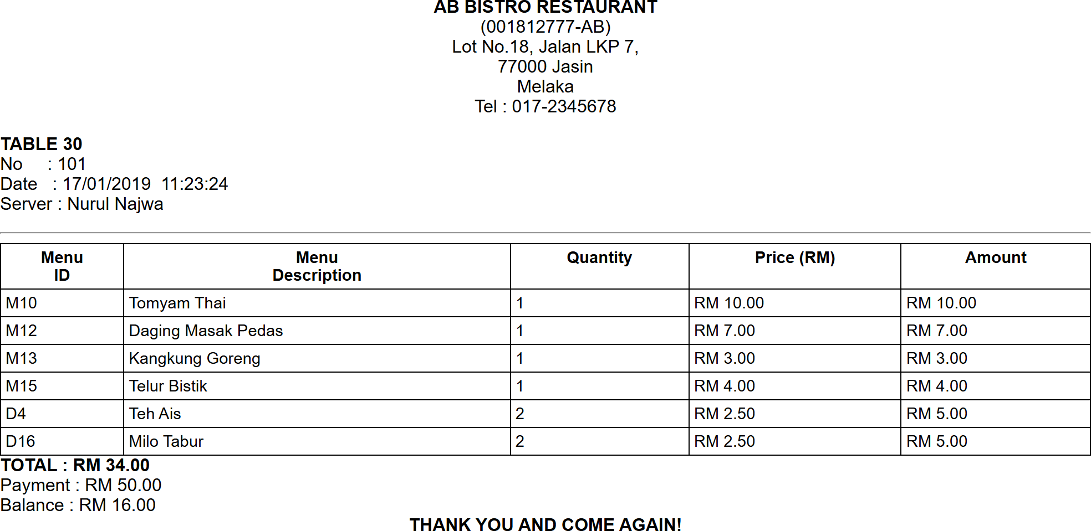
Figure 2.0 : AB Bistro Restaurant Receipt
a) State the normal form of the above receipt. Briefly explain your answer with reasons.
(3 marks)
b) Briefly explain the purpose of normalization in database design.
(3 marks)
c) Normalize Figure 2.0 above until third normal form (3NF). Show all your work for each normalization stage.
(14 marks)
QUESTION 4 (20 marks)
Table 4 shows a relational schema for XY Company, a consulting company that tracks all assigned projects.
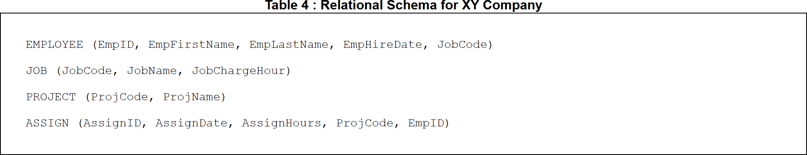
Table 4
Write the SQL statements based on the following requirements:
a) Display the project names that were assigned from January 2025 until April 2025.
(4 marks)
b) Display the total charge for each employee and name the output as "Total Charge".
(5 marks)
c) Display the full names of the employees who have been assigned to more than two projects.
(5 marks)
d) By using a subquery, display the job name that has a charge per hour of RM50 and has more than 10 employees.
(6 marks)
QUESTION 5 (20 marks)
Auto Servis Sdn Bhd launched their first ever automotive company. Auto Servis Sdn Bhd plan to hire a database designer to build their own Car Dealership System (CDS). These requirements are required to model the database of CDS :
Each salesperson is managed by one manager and each manager needs to manage many salespersons. Manager has manager ID, first name and last name. A salesperson has their ID, first name and last name. A salesperson is assigned to more than one customer. Each customer has their customer ID, first name, last name, phone number, address, city, state and country. Each customer can buy more than one vehicle. Every vehicle has its own, unique Vehicle Identification Number (VIN) which also referred to as the body number. Each vehicle can be categorized as Car, Truck and SUV. Car has engine size, truck has tonnage and SUV has number of seats as their attribute respectively. An invoice is issued to customers. It includes a unique invoice number, a salesperson's ID, VIN as well as the date of invoice.
Based on the given information :
a) Construct a complete Entity Relationship Diagram (ERD) with all required entities, attributes, relationships as well as the cardinalities using the Crow's Foot notation and include relevant attributes when necessary.
(16 marks)
b) Briefly describe TWO (2) examples of reports that can be generated from ERD in (a).
(4 marks)

