
CONFIDENTIAL CS/NOV 2026/ICT450

UNIVERSITI TEKNOLOGI MARA FINAL EXAMINATION

COURSE
COURSE CODE
EXAMINATION TIME
DATABASE DESIGN AND DEVELOPMENT

ICT450
NOVEMBER 2026
3 HOURS

INSTRUCTIONS TO CANDIDATES

- This question paper consists of five (5) questions.

- Answer ALL questions in the Answer Booklet. Start each answer on a new page.

- Do not bring any material into the examination room unless permission is given by the invigilator .
- Please check to make sure that this examination pack consists of: i) the Question Paper
  - an Answer Booklet - provided by the Faculty

- Answer ALL questions in English.

DO NOT TURN THIS PAGE UNTIL YOU ARE TOLD TO DO SO

This examination paper consists of 6 printed pages.

QUESTION 1 (20 marks)
a) Database is the best way to store and manage data. Identify FOUR (4) data that will be involved in online purchasing.
(4 marks)
Table 2: COURSE table
COURSE_ID | COURSE_NAME
10 | Networking
20 | Software Developer
30 | Web Designer
40 | Database Developer
50 | Data Analyst
60 | IT Professional
b) Describe the basic features of the relational data model and discuss their importance to the end user and the designer.
(4 marks)
c) Table 1, 2 and 3 show the data in a local IT learning academy that is famous for various computer learning courses. Because of its popularity, there are increasing number of students enrol in the academy. Since then, the academy needs an efficient automated data storage, hence you are required to determine relational keys to ensure each row in the table is uniquely identifiable.
i) Identify THREE (3) possible superkeys, TWO (2) candidate keys and primary key(s) for the STUDENT table. Justify your answer.
(6 marks)
ii) Do the tables display both entity integrity and referential integrity? Answer YES or NO, and then explain your answer for each table.
(6 marks)
Table 1: STUDENT table
STUDENT_IC | STUDENT_ID | FIRST_NAME | LAST_NAME | EMAIL | COURSE_ID
80193939979 | 202587788 | Ahmad | Ali | AA@gmail.com | 40
40122566748 | 202575526 | Haqiem | Rosly | haqiem@gmail.com | 40
20164723670 | 202552244 | Wany | Hazwan | wany@gmail.com | 50
10108990074 | 202536987 | Haliza | Husni | Ha@gmail.com | 50
80116756736 | 202512369 | Heechul | Kim | heechul@gmail.com | 40
90137476323 | 202533969 | James | Reece | james@gmail.com | 20
50143670971 | 202574563 | Canos | Sergi | Ola21@gmail.com | 20
QUESTION 2 (20 marks)
a) The evolution of data models has been driven by the increasing complexity of data storage, management, and analysis needs over time. Match the suitable data models with their correct statements.
(4 marks)
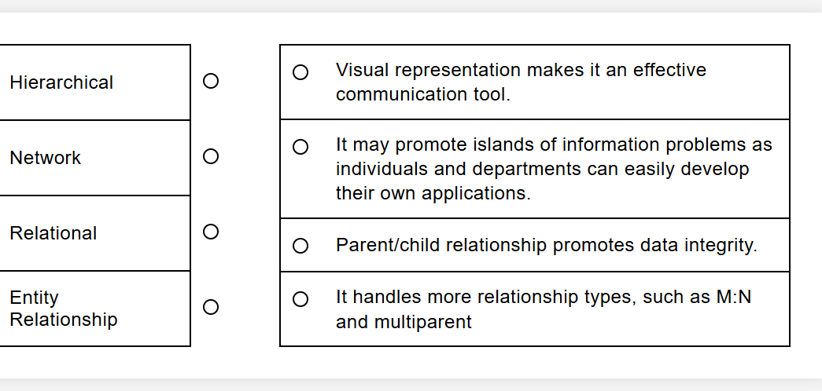
b) The following relational schema provides a basic structure for managing pet sales in a pet shop system. It includes customer information, pet information and purchase transactions.
PETS (PetID, Name, Species, Age, Price, PurchaseID*)
CUSTOMERS (CustomerID, Name, Address, Phone, Email)
PURCHASES (PurchaseID, CustomerID*, PurchaseDate)
Based on the relational schema above, describe TWO (2) related business rules.
(4 marks)
c) Security is a crucial aspect of DBMS. Describe THREE (3) reasons for protecting data from unauthorized users.
(6 marks)
d) Briefly explain THREE (3) challenges in handling multimedia data compared to traditional structured data.
(6 marks)
QUESTION 3 (20 marks)
Based on the given reservation form, answer the following questions:
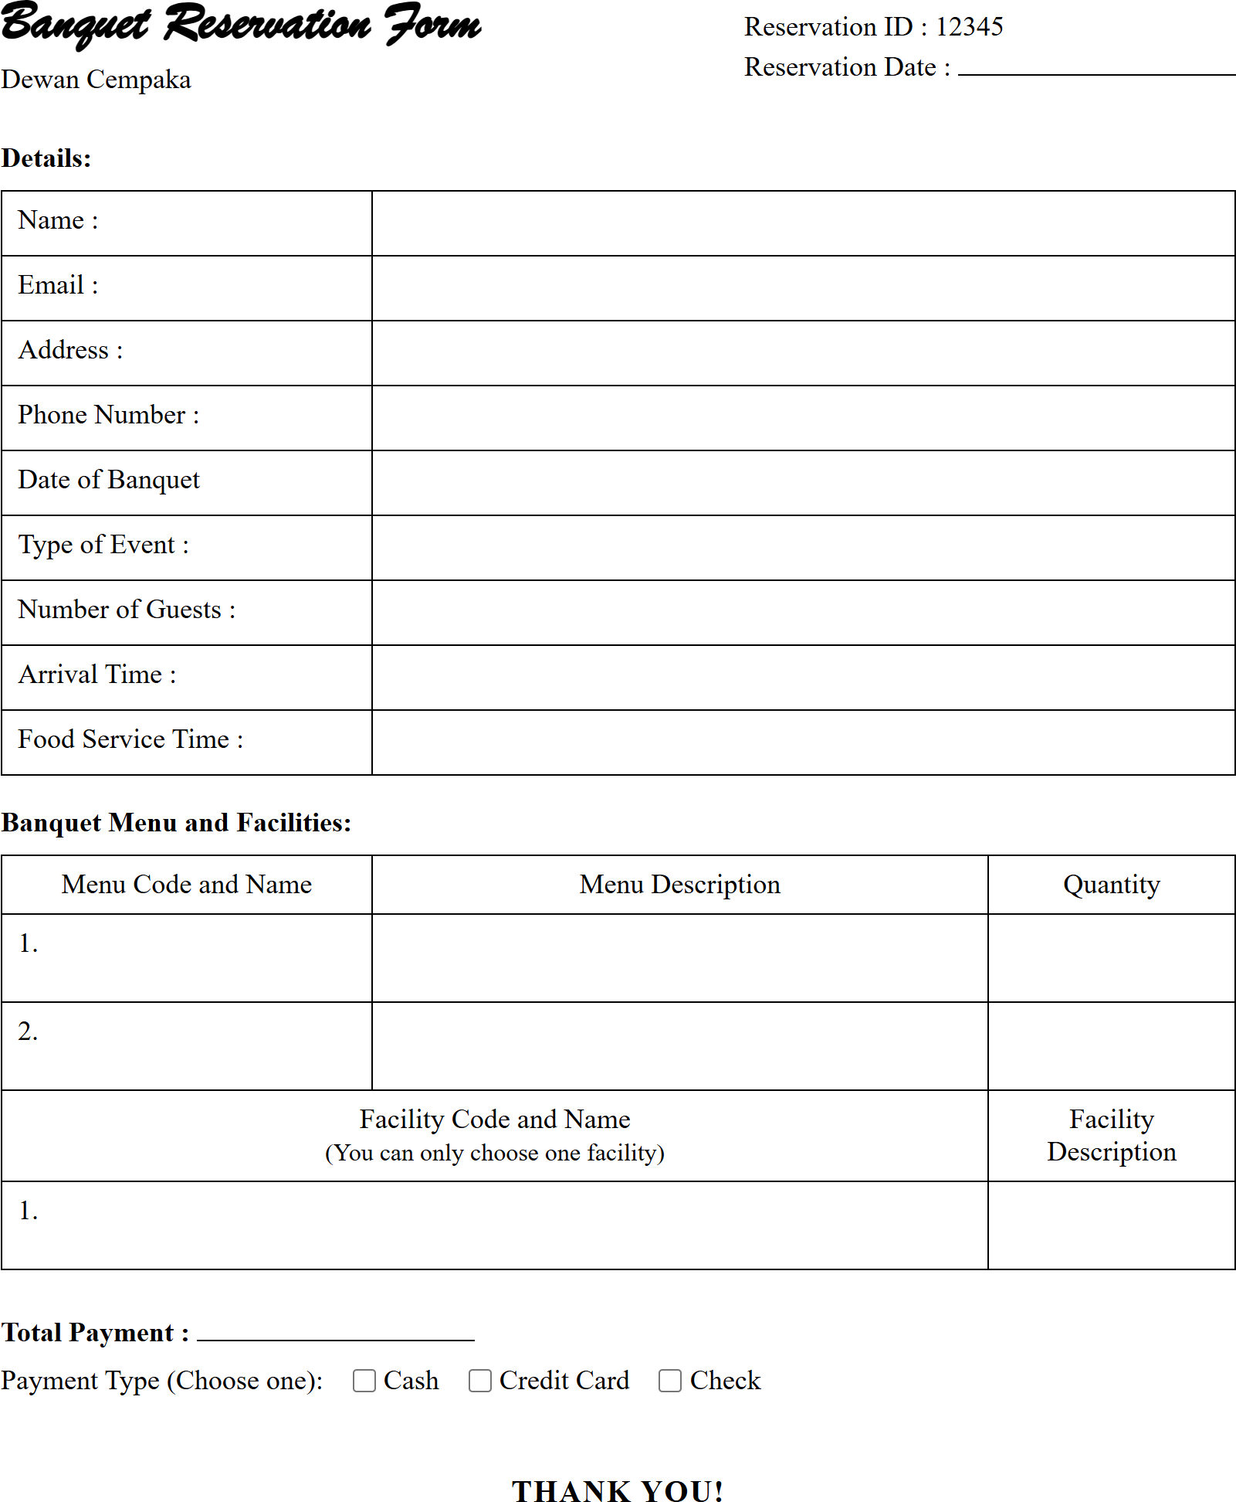
Figure 1 shows an example of banquet reservation form for Dewan Cempaka. Figure 1: Banquet Reservation Form
a) Define normalization and explain the purpose of having normalization in a database table.
(3 marks)
b) Describe THREE (3) effects of a poor database design.
(6 marks)
c) Show all the steps to normalize the structure until third normal form (3NF). The primary key(s), partial dependencies and/or transitive dependencies need to be clearly identified.
(11 marks)
QUESTION 4 (20 marks)
Ninja Package is a new startup company located in Jasin, Melaka. You are hired as a database developer to create a package delivery database based on the given relational schema.
RIDER (riderID, riderName, startDate, hpNum)
CUSTOMER (icNum, custName, custPhone, custAddress)
DELIVERY (packageID, dateDeliver, riderID, icNum, status)
*Status of delivery is either delivered or unsuccessful.
Write SQL statements based on the following requirements.
a) Create table DELIVERY.
(4 marks)
b) Find total number of customers that are successfully received package(s) in November 2022.
(4 marks)
c) Find total number of unsuccessful delivery for each riders.
(4 marks)
d) List name of riders that make a delivery/deliveries any packages.
(4 marks)
e) Write SQL command to produce the output as follows:
(4 marks)
Package ID | Customer Name | Status
p1 | Ayu | delivered
p2 | Ibrahim | delivered
QUESTION 5 (20 marks)
FreshBasket is a new company located in Jasin, Malacca, and operates an online grocery platform. As a database designer, you are tasked with designing a database system based on the following requirements:
- Customers register with their name, email, and address.
- Customers can place multiple orders, and each order belongs to one customer.
- Each order consists of multiple products, and a product can appear in many orders.
- Products have a ProductID, Name, Price, and belong to a Category.
- An invoice is issued for each order, containing the InvoiceNo, Date, and TotalAmount.
- Each order has exactly one invoice.
- Delivery is scheduled through a DeliverySlot (SlotID, Date, Time, Status), and each order must have one delivery slot.
Based on the given information:
a) Construct a complete Entity Relationship Diagram (ERD) with all of the required tables, attributes, and relationships using the Crow's Foot notation that reflects all of the given business rules.
(16 marks)
b) Identify TWO (2) relevant information that you can get from the ERD you constructed in (a).
(4 marks)
The OCR result should be empty, as the image contains only a stylistic horizontal line which must be ignored according to Rule 2. No text or placeholder characters should be output.
(4 marks)

