
CONFIDENTIAL CS/NOV 2026/ICT450

UNIVERSITI TEKNOLOGI MARA FINAL EXAMINATION

COURSE
COURSE CODE
EXAMINATION TIME
DATABASE DESIGN AND DEVELOPMENT

ICT450
NOVEMBER 2026
3 HOURS

INSTRUCTIONS TO CANDIDATES

- This question paper consists of five (5) questions.

- Answer ALL questions in the Answer Booklet. Start each answer on a new page.

- Do not bring any material into the examination room unless permission is given by the invigilator .
- Please check to make sure that this examination pack consists of: i) the Question Paper
  - an Answer Booklet - provided by the Faculty

- Answer ALL questions in English.

DO NOT TURN THIS PAGE UNTIL YOU ARE TOLD TO DO SO

This examination paper consists of 6 printed pages.

QUESTION 1 (20 marks)
a) Briefly describe any FOUR (4) components of database system environment.
(8 marks)
b) Millions of people all over the world access the internet and connect to databases via web browsers or data services. For example, they can use a smartphone application to get weather or traffic information. Briefly describe FOUR (4) characteristics of successful "Internet age" databases.
(8 marks)
c) Briefly describe each of TWO (2) advantages and disadvantages of Entity Relationship Diagram (ERD).
(4 marks)
QUESTION 2 (20 marks)
a) The database life cycle (DBLC) process moves through a series of well-defined phases.
i) Briefly explain what the implementation and loading phase do.
(2 marks)
ii) Describe the THREE (3) levels of backup that used in database recovery management in this phase.
(6 marks)
b) Briefly describe big data and THREE (3) technologies for managing and analyzing the big data.
(8 marks)
c) Briefly describe the key difference between unstructured and structured data. Provide an example for each answer.
(4 marks)
QUESTION 3 (20 marks)
Based on order form shown in Figure 3.0, answer the following questions:
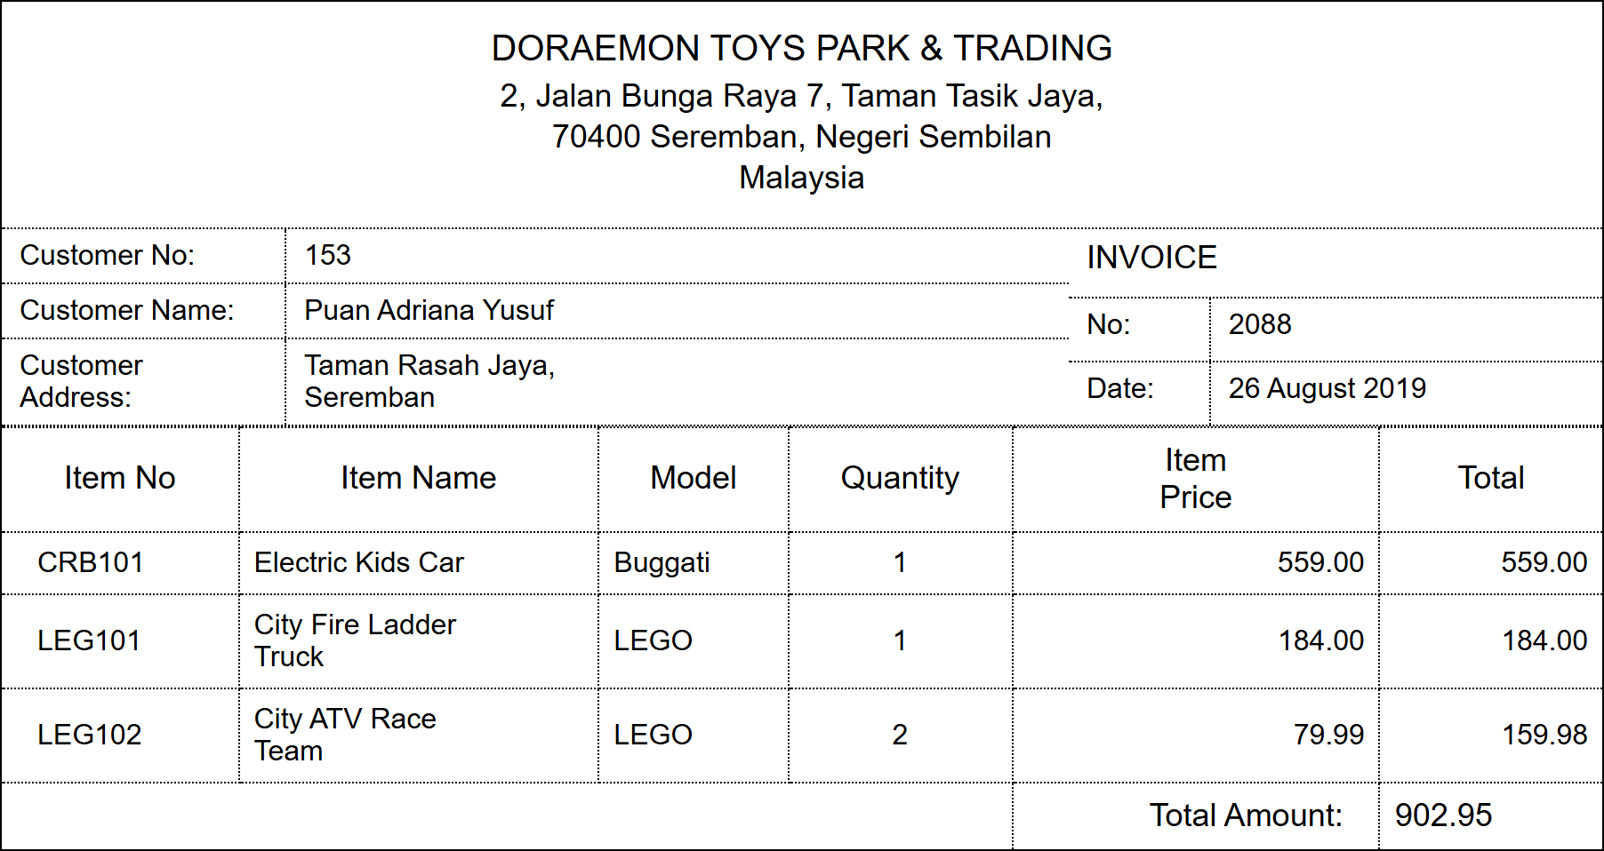
Figure 3.0: Customer invoice for Doraemon Toys Park & Trading
a) Convert the data in Figure 3.0 into a relational schema format.
(2 marks)
b) State the primary key(s) based on (a).
(2 marks)
c) Normalize the table until third normal form (3NF). Show all the steps taken.
(16 marks)
QUESTION 4 (20 marks)
Based on the relational schema used in UiTM Sport Unit, write SQL commands for the following questions.
BRAND (brandID, brandName)
BOOKING (bookID, equipID*, studID* bookDate, returnDate)
STUDENT (studID, studName, studAddr, studPhone)
EQUIPMENT (equipID, equipName, equipPrice, category, brandID*, quantity, supplier)
a) Create BOOKING table.
(3 marks)
b) Increase equipment price by 10% for all equipments in the Sport Unit.
(3 marks)
c) Change the width of student address column to 50 characters.
(3 marks)
d) Display the equipments that are supplied by Al-Ikhsan which fall under the category either racket or ball. Sort the results based on the categories ascendingly.
(3 marks)
e) Find equipments that have not been booked by any student.
(4 marks)
f) Determine how many types of equipment are under each brand and display only the brand that carriers more than five types of equipment.
(4 marks)
QUESTION 5 (20 marks)
S2 football club plans to develop a database management system to facilitate the organization and administration of football tournaments at various levels. The system will be used to manage tournament fixtures, teams, players, match results, and venue information. As a database designer, you have been hired by S2 football club to design the database system according to the following requirements:
- Tournaments store details of a tournament ID, tournament name, start date, end date, and organizer information.
- Team refers to football teams who participate in tournaments which include data about team id, team name and coach name.
- Player represents individual football players. Players' details include player id, player name, date of birth, nationality, and position. One player can join only one team.
- Fixture records the whole schedule of match to be played in the tournament. It includes the fixture ID, kick-off time and tournament ID.
- Match contains information about individual matches which include data for match id, match date, home team ID, away team ID, result and venue.
- Venue stores details of selected venues for each matches including venue id, venue name, location, and seating capacity.
- A tournament can have multiple fixtures, but each fixture belongs to only one tournament.
- A team can have multiple players, but each player belongs to only one team.
- Each fixture consists of multiple matches, but each match is associated with only one fixture.
Based on the given information:
a) Construct an Entity Relationship Diagram (ERD) complete with all the required tables, attributes, relationships as well as the cardinalities using the Crow's Foot notation that reflects all the given business rules.
(16 marks)
b) Identify FOUR (4) relevant information that you can get from the ERD you constructed in (a).
(4 marks)

