
CONFIDENTIAL CS/NOV 2026/ICT450

UNIVERSITI TEKNOLOGI MARA FINAL EXAMINATION

COURSE
COURSE CODE
EXAMINATION TIME
DATABASE DESIGN AND DEVELOPMENT

ICT450
NOVEMBER 2026
3 HOURS

INSTRUCTIONS TO CANDIDATES

- This question paper consists of five (5) questions.

- Answer ALL questions in the Answer Booklet. Start each answer on a new page.

- Do not bring any material into the examination room unless permission is given by the invigilator .
- Please check to make sure that this examination pack consists of: i) the Question Paper
  - an Answer Booklet - provided by the Faculty

- Answer ALL questions in English.

DO NOT TURN THIS PAGE UNTIL YOU ARE TOLD TO DO SO

This examination paper consists of 6 printed pages.

QUESTION 1 (20 marks)
a) Explain TWO (2) limitations of the file-based approach in business environment.
(4 marks)
b) Data models are used as a communication tool between database designers, programmers and users. Identify and briefly explain any TWO (2) basic building blocks used in data models.
(4 marks)
c) Table 1 shows the sample data for an art and culture club in Jasin city.
i) Explain THREE (3) characteristics of a relational table that have been violated in Table 1.
(6 marks)
ii) As a database designer, briefly explain possible courses of action to handle each problem stated in (i).
(6 marks)
Table 1
StudID | Name | Name | Skill
2023123456 | Izyan Mimiey | Ahmad | Modern Dance, Singing
2023456789 | Jeonghan | Lee | Traditional Dance
2023455abc | Hafizal | Azri | Modern Dance, Playing Drum
QUESTION 2 (20 marks)
a) Within a larger information system, the database is subject to a life cycle as well. It is known as Database Life Cycle (DBLC). A properly designed database provides you with access to up-to-date and accurate information. It consists of six phases which are database initial study, database design, implementation & loading, testing & evaluation, operation and maintenance & evolution. Briefly explain FOUR (4) activities in the database initial study.
(8 marks)
b) Describe FOUR (4) limitations of mobile database. Give an example for each limitations.
(8 marks)
c) Table 2 consists of data about staff in Qish Boutique. Data type for StaffID, Salary and DepartmentID is a number. Data type for StaffName is a text. Salary is ranged from 3000-10000. Consider the following data.
Based on the data, there are certain rows will certainly fail to be inserted into database. Identify the rows and give a reason according to table property, why the data cannot be inserted.
(4 marks)
Table 2: STAFF
StaffID | StaffName | Salary | DepartmentID
3033 | Siti Ziana | 11000 | 10
3035 | Fazurah | 3000 | 20
3036 | Haqim Ahmad | 6000 | 20
3034 | Ahmad Daniel | 150a | 10
QUESTION 3 (20 marks)
Figure 2 shows a report of an employee evaluation result in IT Creative Solutions Sdn. Bhd. in Shah Alam. The report contains all information related to one of the employees in this company. Each employee has been assigned to several projects. Meanwhile, each project has been assigned to several employees. Each project has been supervised by one employee (Supervisor). Supervisor also manages several employees.
Based on the information given, answer the following questions:
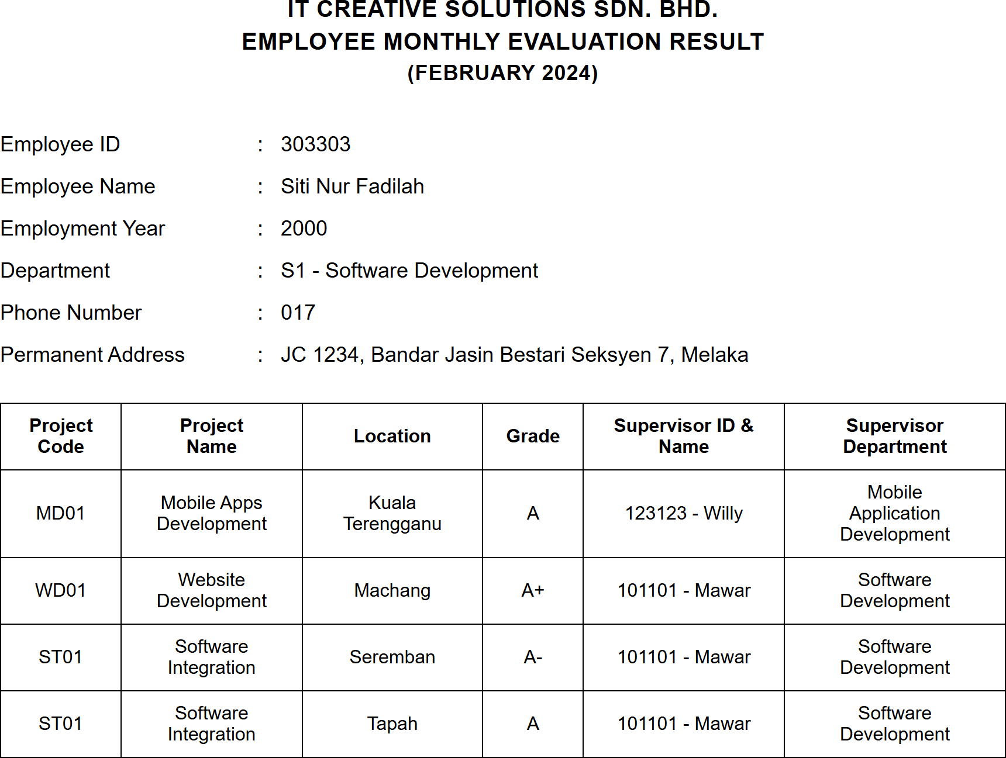
Figure 2 : Employee evaluation report
a) State the normal form of the Figure 2 above. Explain your answer with reasons.
(3 marks)
b) Convert the report into a relational schema. Identify the primary key(s) and partial dependencies and/or transitive dependencies.
(6 marks)
c) Normalize the relational schema in (b) until third normal form (3NF). Show all the steps involved.
(11 marks)
QUESTION 4 (20 marks)
The relational schema below shows the e-Voting database system for one of the local universities in Malaysia. Each student can vote up to two candidates.
STUDENT (StudentID, FirstName, LastName, PhoneNumber, FacultyID*)
CANDIDATE (CandidateID, StudentID*)
VOTING (VotingID, VotingDate, StudID*)
VOTING_DETAILS (VotingID*, CandidateID*, VotingTime)
FACULTY (FacultyID, FacultyName)
Write the SQL statements based on the following requirements:
a) Calculate the total number of candidates for each faculty.
(4 marks)
b) Display the details of student who do not vote for any candidate.
(4 marks)
c) Identify the total number of voters for each faculty.
(4 marks)
d) Display the full name of candidates that get more than 500 votes.
(4 marks)
e) Identify the total number of student that vote only one candidate.
(4 marks)
QUESTION 5 (20 marks)
Excellent Art is a company that provide art training for children who are interested in it. The company mission is to promote creative and innovative thinking in children's life.
- There are about 15 Excellent Art studios around Malaysia. To uniquely identify each art studio, they had been assigned with a unique studio id. Other important information that needs to be kept in the database are studio name, address, phone number, email, and GPS coordinate.
- Each studio deals with many suppliers, which supply a variety of art materials. Art material information need to be recorded are art material id, name, description, and price. The information about the supplier that must be recorded is its unique id, name, address, and email.
- One art studio provides many programs. Each program will uniquely have identified by program id, name, description, and price. The programs are classified to Visual Art, Glass Painting and Handicraft. Each of the program will have their own additional information, such as, Visual Art program will have class type, Glass Painting program will have program level, with value 1 to 5 as it will indicate the technique in glass painting and Handicraft program will need craft data.
- There are about 100 employees all together in the Excellent Art company. Each employee has a unique employee number, first name, last name, job titles and date of birth and is allocated to only one art studio. Each studio has several employees. However, each employee only can work in one studio.
- If an employee currently married to another employee of the same studio, the spouse's employee number and date of marriage is also recorded.
- To be creative, many employees in the studio acquire many skills. Skills data to be recorded are skill type and skill description.
a) Construct an Entity Relationship Diagram (ERD) complete with all the required tables, attributes, relationships as well as the cardinalities using the Crow's Foot notation that reflects all the given business rules.
(16 marks)
b) List TWO (2) example of reports that can be produced from this database system.
(4 marks)

