CONFIDENTIAL  CS/NOV 2026/ICT450

UNIVERSITI TEKNOLOGI MARA
MARKING SCHEME

COURSE :
COURSE CODE :
EXAMINATION :
TIME :
DATABASE DESIGN AND DEVELOPMENT
ICT450
NOVEMBER 2026 (MOCK)
3 HOURS

MARKING SCHEME NOTES

- This marking scheme accompanies the ICT450 mock paper (November 2026).
Answers are unofficial model answers, not official UTM marking schemes.

- Marking points state the expected answer and the allocation of marks; every question retains its source paper and page reference.

- Five questions x 20 marks; total = 100 marks.
- Real-bank questions: 5. Placeholders: 0.
Questions and answers are for local study use only.

- Structure derived from 12 unique ICT450 past papers; every real question remains traceable to its source page.

FOR MARKERS' USE ONLY

This marking scheme consists of 6 printed pages.
MARKING GUIDE
QUESTION 1 (20 marks)
Source: ICT450-2025-FEB · page [2] · bank id ICT450-2025-FEB-Q1
Reference answer
(a) Four data items for an online store. [4 marks]
• Customer name, address, phone and e-mail.
• Product ID, name, description and price.
• Order ID, order date, quantity and total.
• Payment method and delivery status.
(b) Two differences between a database and a spreadsheet. [4 marks]
• A database enforces relationships, keys and constraints; a spreadsheet stores independent cells and formulas.
• A database supports multi-user concurrency, security and recovery; a spreadsheet is mainly single-user and has limited integrity controls.
(c) Insert, update and delete rules of referential integrity. [6 marks]
• Insert rule: a child row cannot be inserted unless its foreign-key value matches an existing parent key or is NULL.
• Update rule: a parent key cannot be changed if dependent child rows would be orphaned, unless the change cascades.
• Delete rule: a parent row cannot be deleted while dependent child rows exist, unless the delete cascades or sets NULL.
• Example: an order cannot reference a customer that does not exist.
(d) Three differences between centralized and decentralized design. [6 marks]
• Data location: one site versus multiple sites.
• Control and administration: central versus local.
• Availability and cost: centralized is simpler but has a single point of failure; decentralized is more resilient but harder to coordinate.
Marking guide
• a) 1 mark for each of four data items (4).
• b) 2 marks for each difference (4).
• c) 2 marks for each referential-integrity rule with example (6).
• d) 2 marks for each difference (6).
Provenance: model_unofficial · confidence high · Model-authored from the approved question text, the supplied source assets and the ICT200/ICT450 knowledge base; no official ICT450 marking scheme was supplied.
Knowledge base basis: TOPIC 1 DATABASE CONCEPT (1).pdf; TOPIC 2 DATA MODEL (1).pdf; TOPIC 3 RELATIONAL DATA MODELstu.pdf

QUESTION 2 (20 marks)
Source: ICT450-2018-DEC · page [2] · bank id ICT450-2018-DEC-Q2
Reference answer
(a) Business rules and three essentials. [8 marks]
• A business rule is a precise statement that describes a policy, constraint or relationship in the organisation's operations and must be reflected in the database.
• Essential 1: the rule must be precise and unambiguous, so every reader derives the same entities, attributes and constraints.
• Essential 2: it must be documented and traceable to its source (policy, procedure, form or interview).
• Essential 3: it must be enforceable in the design through keys, cardinalities, domains or check constraints.
(b) Importance of an index. [2 marks]
• An index provides a fast access path to rows, speeding up searches, joins and sorting; a unique index also enforces uniqueness.
(c) Four common sources of database failure. [4 marks]
• Hardware failure (disk, memory, power).
• Software failure (DBMS or application bug).
• Human error (accidental deletion or bad update).
• Natural disaster, network failure or malicious attack.
(d) Three backup levels. [6 marks]
• Full backup — a complete copy of the database.
• Differential backup — changes since the last full backup.
• Transaction-log backup — the log of individual transactions, allowing point-in-time recovery.
Marking guide
• a) 2 marks for the definition and 2 marks for each of three essentials (2 + 6 = 8).
• b) 2 marks for the indexing benefit.
• c) 1 mark for each of four sources (4).
• d) 2 marks for each of three backup levels (6).
Provenance: model_unofficial · confidence high · Model-authored from the approved question text, the supplied source assets and the ICT200/ICT450 knowledge base; no official ICT450 marking scheme was supplied.
Knowledge base basis: TOPIC 2 DATA MODEL (1).pdf; TOPIC 6 DATABASE DESIGN (1).pdf

QUESTION 3 (20 marks)
Source: ICT450-2019-JUN · page [5] · bank id ICT450-2019-JUN-Q4
Reference answer
The AB Bistro receipt contains one receipt header and a repeating list of menu items. It is flattened to one row per menu line.
(a) Normal form of the receipt. [3 marks]
• The flattened receipt is in 1NF because each cell is atomic and the key (ReceiptNo, MenuID) can be formed.
• It is not in 2NF: receipt date/time/server/table/total depend only on ReceiptNo, while MenuDescription and Price depend only on MenuID.
• It is not in 3NF because ServerName depends transitively on ServerID.
(b) Purpose of normalization. [3 marks]
• Normalization removes redundant data and update anomalies by placing each fact in one table and linking tables with keys.
(c) Normalise to 3NF. [14 marks]
1NF: one row per receipt-menu line; key (ReceiptNo, MenuID).
1NF relation.
RECEIPT_1NF (ReceiptNo, ReceiptDate, ReceiptTime, ServerID, ServerName, TableNo, MenuID, MenuDescription, Quantity, Price, Amount, Total, Payment, Balance)
2NF: remove partial dependencies.
2NF relations.
RECEIPT (ReceiptNo, ReceiptDate, ReceiptTime, ServerID, ServerName, TableNo, Total, Payment, Balance)
MENU (MenuID, MenuDescription, Price)
RECEIPT_ITEM (ReceiptNo, MenuID, Quantity, Amount)
3NF: remove ServerID → ServerName.
3NF relations.
SERVER (ServerID, ServerName)
RECEIPT (ReceiptNo, ReceiptDate, ReceiptTime, ServerID, TableNo, Total, Payment, Balance)
MENU (MenuID, MenuDescription, Price)
RECEIPT_ITEM (ReceiptNo, MenuID, Quantity, Amount)
Sample receipt data
ReceiptNo | Date | Server | Table | Total | Payment | Balance
101 | 17/01/2019 | Nurul Najwa | 30 | 34.00 | 50.00 | 16.00

Sample menu data
MenuID | Description | Price
M10 | Tomyam Thai | 10.00
M12 | Daging Masak Pedas | 7.00
D4 | Teh Ais | 2.50

Marking guide
• a) 3 marks: 1NF identified, with 2NF and 3NF reasons.
• b) 3 marks: redundancy/anomaly purpose.
• c) 14 marks: 1NF (3), 2NF partial dependencies (5), 3NF transitive dependency (6).
Provenance: model_unofficial · confidence high · Model-authored from the approved question text, the supplied source assets and the ICT200/ICT450 knowledge base; no official ICT450 marking scheme was supplied.
Knowledge base basis: TOPIC 5 NORMALIZATION (1).pdf
Assumptions / notes
• The receipt is treated as one header with repeating menu lines; Amount = Quantity × Price.

QUESTION 4 (20 marks)
Source: ICT450-2025-JUL · page [5] · bank id ICT450-2025-JUL-Q4
Reference answer
XY Company schema.
EMPLOYEE (EmpID, EmpFirstName, EmpLastName, EmpHireDate, JobCode)
JOB (JobCode, JobName, JobChargeHour)
PROJECT (ProjCode, ProjName)
ASSIGN (AssignID, AssignDate, AssignHours, ProjCode, EmpID)
(a) Project names assigned from January to April 2025. [4 marks]
SELECT DISTINCT p.ProjName
FROM PROJECT p
JOIN ASSIGN a ON a.ProjCode = p.ProjCode
WHERE a.AssignDate BETWEEN DATE '2025-01-01' AND DATE '2025-04-30';
(b) Total charge for each employee. [5 marks]
SELECT e.EmpID,
e.EmpFirstName || ' ' || e.EmpLastName AS EmployeeName,
SUM(a.AssignHours * j.JobChargeHour) AS "Total Charge"
FROM EMPLOYEE e
JOIN ASSIGN a ON a.EmpID = e.EmpID
JOIN JOB j ON j.JobCode = e.JobCode
GROUP BY e.EmpID, e.EmpFirstName, e.EmpLastName;
(c) Employees assigned to more than two projects. [5 marks]
SELECT e.EmpFirstName, e.EmpLastName
FROM EMPLOYEE e
JOIN ASSIGN a ON a.EmpID = e.EmpID
GROUP BY e.EmpID, e.EmpFirstName, e.EmpLastName
HAVING COUNT(DISTINCT a.ProjCode) > 2;
(d) Job name with charge RM50 and more than 10 employees, using a subquery. [6 marks]
SELECT JobName
FROM JOB
WHERE JobChargeHour = 50
AND JobCode IN (
SELECT JobCode
FROM EMPLOYEE
GROUP BY JobCode
HAVING COUNT(*) > 10
);
Marking guide
• a) 4 marks: project-assign join and date filter.
• b) 5 marks: joins (2), hours × rate (2), alias/grouping (1).
• c) 5 marks: join (2), GROUP BY employee and HAVING count > 2 (3).
• d) 6 marks: job filter (2), subquery grouping (2), HAVING > 10 (2).
Provenance: model_unofficial · confidence high · Model-authored from the approved question text, the supplied source assets and the ICT200/ICT450 knowledge base; no official ICT450 marking scheme was supplied.
Knowledge base basis: TOPIC 7 SQL.pdf
Assumptions / notes
• Total charge is AssignHours multiplied by the employee's JobChargeHour.

QUESTION 5 (20 marks)
Source: ICT450-2019-DEC · page [5] · bank id ICT450-2019-DEC-Q5
Reference answer
The ERD models managers, salespersons, customers, vehicles and invoices. Vehicle is specialised into Car, Truck and SUV.
(a) Construct the ERD with Crow's Foot notation. [16 marks]
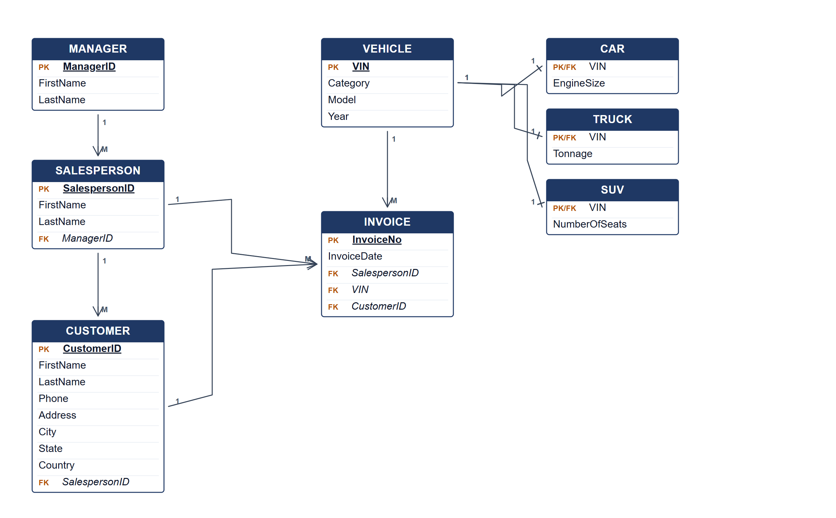
Car Dealership System ERD.
(b) Two reports from the ERD. [4 marks]
• Salesperson performance — invoices and sales value per salesperson, grouped by manager.
• Vehicle category report — number and value of cars, trucks and SUVs sold.
Marking guide
• a) 16 marks: manager/salesperson/customer (5); vehicle and three subtypes (5); invoice and relationships (4); keys (2).
• b) 2 marks for each report (4).
Provenance: model_unofficial · confidence medium · Model-authored from the approved question text, the supplied source assets and the ICT200/ICT450 knowledge base; no official ICT450 marking scheme was supplied.
Knowledge base basis: TOPIC 4 ERD_stu (2).pdf; TOPIC 3 RELATIONAL DATA MODELstu.pdf
Assumptions / notes
• A vehicle is one of Car, Truck or SUV, and an invoice records one vehicle sale.

