
CONFIDENTIAL CS/NOV 2026/ICT450

UNIVERSITI TEKNOLOGI MARA FINAL EXAMINATION

COURSE
COURSE CODE
EXAMINATION TIME
DATABASE DESIGN AND DEVELOPMENT

ICT450
NOVEMBER 2026
3 HOURS

INSTRUCTIONS TO CANDIDATES

- This question paper consists of five (5) questions.

- Answer ALL questions in the Answer Booklet. Start each answer on a new page.

- Do not bring any material into the examination room unless permission is given by the invigilator .
- Please check to make sure that this examination pack consists of: i) the Question Paper
  - an Answer Booklet - provided by the Faculty

- Answer ALL questions in English.

DO NOT TURN THIS PAGE UNTIL YOU ARE TOLD TO DO SO

This examination paper consists of 6 printed pages.

QUESTION 1 (20 marks)
a) Briefly describe any FOUR (4) components of database system environment.
(8 marks)
b) Millions of people all over the world access the internet and connect to databases via web browsers or data services. For example, they can use a smartphone application to get weather or traffic information. Briefly describe FOUR (4) characteristics of successful "Internet age" databases.
(8 marks)
c) Briefly describe each of TWO (2) advantages and disadvantages of Entity Relationship Diagram (ERD).
(4 marks)
QUESTION 2 (20 marks)
a) The database life cycle (DBLC) process moves through a series of well-defined phases.
i) Briefly explain what the implementation and loading phase do.
(2 marks)
ii) Describe the THREE (3) levels of backup that used in database recovery management in this phase.
(6 marks)
b) Briefly describe big data and THREE (3) technologies for managing and analyzing the big data.
(8 marks)
c) Briefly describe the key difference between unstructured and structured data. Provide an example for each answer.
(4 marks)
QUESTION 3 (20 marks)
Based on order form shown in Figure 3.0, answer the following questions:
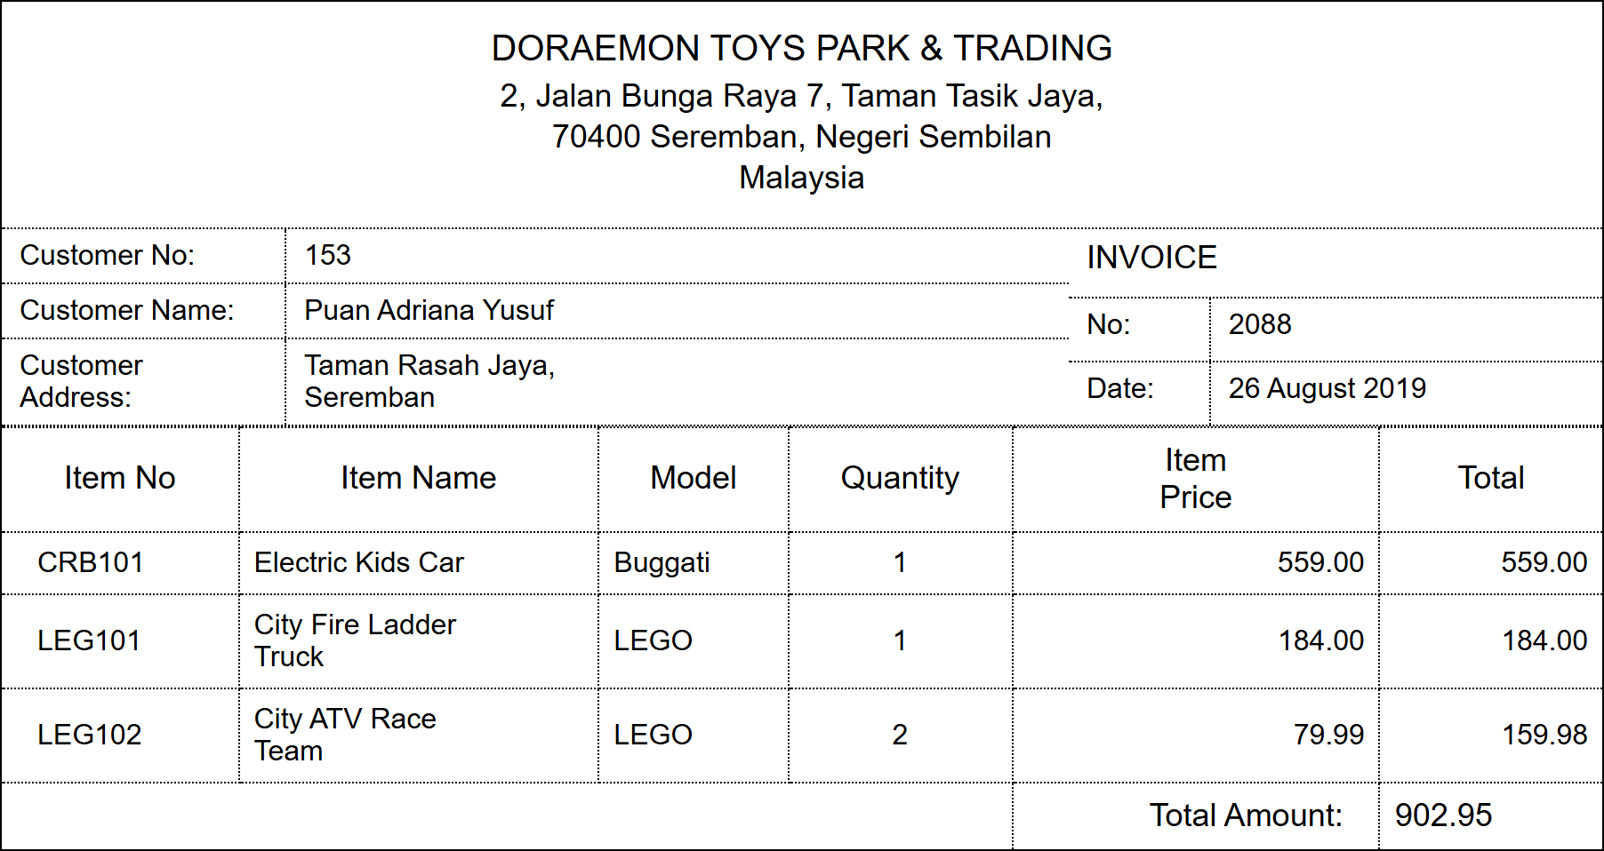
Figure 3.0: Customer invoice for Doraemon Toys Park & Trading
a) Convert the data in Figure 3.0 into a relational schema format.
(2 marks)
b) State the primary key(s) based on (a).
(2 marks)
c) Normalize the table until third normal form (3NF). Show all the steps taken.
(16 marks)
QUESTION 4 (20 marks)
Based on the relational schema used in UiTM Sport Unit, write SQL commands for the following questions.
BRAND (brandID, brandName)
BOOKING (bookID, equipID*, studID* bookDate, returnDate)
STUDENT (studID, studName, studAddr, studPhone)
EQUIPMENT (equipID, equipName, equipPrice, category, brandID*, quantity, supplier)
a) Create BOOKING table.
(3 marks)
b) Increase equipment price by 10% for all equipments in the Sport Unit.
(3 marks)
c) Change the width of student address column to 50 characters.
(3 marks)
d) Display the equipments that are supplied by Al-Ikhsan which fall under the category either racket or ball. Sort the results based on the categories ascendingly.
(3 marks)
e) Find equipments that have not been booked by any student.
(4 marks)
f) Determine how many types of equipment are under each brand and display only the brand that carriers more than five types of equipment.
(4 marks)
QUESTION 5 (20 marks)
UiTM is planning to develop a volunteer management system for a better coordination and reporting for the volunteerism activities. As a database designer, you are assigned to design the database system according to the following requirements:
- Any student or staff can be a volunteer.
- Each student or staff can fill only one entry form. The details are volunteer ID, register date and total hours of working.
- Volunteer can volunteer in more than one projects.
Each assigned project will have details about start date, end date, hours, station and status. Each assigned project also will lead by one faculty.
Each project will have their own project ID and project name such as trash clean up, money donation, animal shelter and others.
Based on the given information:
a) Construct an Entity Relationship Diagram (ERD) complete with all of the required tables, attributes and relationships using the Crow's Foot notation that reflects all of the given business rules.
(16 marks)
b) Identify TWO (2) relevant information that you can get from the ERD you construct in (a). Briefly explain your answer.
(4 marks)

