CONFIDENTIAL  CS/NOV 2026/ICT450

UNIVERSITI TEKNOLOGI MARA
MARKING SCHEME

COURSE :
COURSE CODE :
EXAMINATION :
TIME :
DATABASE DESIGN AND DEVELOPMENT
ICT450
NOVEMBER 2026 (MOCK)
3 HOURS

MARKING SCHEME NOTES

- This marking scheme accompanies the ICT450 mock paper (November 2026).
Answers are unofficial model answers, not official UTM marking schemes.

- Marking points state the expected answer and the allocation of marks; every question retains its source paper and page reference.

- Five questions x 20 marks; total = 100 marks.
- Real-bank questions: 5. Placeholders: 0.
Questions and answers are for local study use only.

- Structure derived from 12 unique ICT450 past papers; every real question remains traceable to its source page.

FOR MARKERS' USE ONLY

This marking scheme consists of 6 printed pages.
MARKING GUIDE
QUESTION 1 (20 marks)
Source: ICT450-2024-JUL · page [2] · bank id ICT450-2024-JUL-Q1
Reference answer
(a) Two DBMS functions for integrity and consistency. [4 marks]
• Integrity enforcement — the DBMS applies primary-key, foreign-key, domain and check constraints.
• Concurrency control — transactions are isolated so simultaneous users do not overwrite each other.
• Backup and recovery also protect consistency after failure.
(b) Four database application areas. [4 marks]
• Banking and finance.
• Airline and hotel reservations.
• University student records.
• E-commerce and online retail.
• Healthcare and hospital records.
(c) Three problems in Gerai 17's table. [6 marks]
• Missing Menu Code for Bihun Goreng — the row cannot be uniquely identified.
• Missing Price for Nasi Ayam — the total and average price cannot be calculated.
• Invalid Price “2.S0” for Laksa — the value is not numeric and violates the price domain.
• The table also mixes menu identity and price data without a clear key.
(d) Centralized versus decentralized design. [6 marks]
• Control: centralized design keeps data and administration at one site; decentralized design distributes control.
• Location: centralized data is stored centrally; decentralized data is stored at multiple sites.
• Cost/failure: centralization has lower duplication but a single point of failure; decentralization improves local availability but increases coordination cost.
Marking guide
• a) 2 marks for each DBMS function (4).
• b) 1 mark for each of four applications (4).
• c) 2 marks for each of three problems with justification (6).
• d) 2 marks for each of three differences (6).
Provenance: model_unofficial · confidence high · Model-authored from the approved question text, the supplied source assets and the ICT200/ICT450 knowledge base; no official ICT450 marking scheme was supplied.
Knowledge base basis: TOPIC 1 DATABASE CONCEPT (1).pdf; TOPIC 2 DATA MODEL (1).pdf; TOPIC 3 RELATIONAL DATA MODELstu.pdf
Assumptions / notes
• Table 1's blank Menu Code and missing/invalid Price are treated as data-entry and domain problems.

QUESTION 2 (20 marks)
Source: ICT450-2025-FEB · page [2] · bank id ICT450-2025-FEB-Q2
Reference answer
(a) Two disadvantages of the hierarchical model. [4 marks]
• It is rigid: each child has only one parent, so many-to-many relationships cannot be represented directly.
• Navigation is pointer-based and programs depend on the physical tree structure, making change difficult.
(b) Four sources of business rules. [4 marks]
• Company policies and procedures.
• Interviews with managers and end users.
• Existing forms, reports and documents.
• Government regulations and industry standards.
(c) Three types of backup. [6 marks]
• Full backup — complete copy of the database.
• Differential backup — changes since the last full backup.
• Transaction-log backup — the transaction log for point-in-time recovery.
(d) Three mobile-database advantages in marketing. [6 marks]
• Location-based promotions can be delivered to customers near a store.
• Sales staff can access customer and product data in real time during visits.
• Campaign performance and customer responses can be captured immediately for analysis.
Marking guide
• a) 2 marks for each disadvantage (4).
• b) 1 mark for each of four sources (4).
• c) 2 marks for each backup type (6).
• d) 2 marks for each advantage (6).
Provenance: model_unofficial · confidence high · Model-authored from the approved question text, the supplied source assets and the ICT200/ICT450 knowledge base; no official ICT450 marking scheme was supplied.
Knowledge base basis: TOPIC 2 DATA MODEL (1).pdf; TOPIC 6 DATABASE DESIGN (1).pdf

QUESTION 3 (20 marks)
Source: ICT450-2025-JUL · page [4] · bank id ICT450-2025-JUL-Q3
Reference answer
Table 3 mixes employee, department and skill data. The skill list repeats for employees with several skills, while some employees have no skill.
(a) Normal form of Table 3. [3 marks]
• The flattened table is in 1NF because each cell is atomic and the key (StaffID, SkillID) can be formed for employees with skills.
• It is not in 2NF because StaffName, Position and Department depend only on StaffID, while SkillName depends only on SkillID.
• It is not in 3NF because DeptName depends on DeptID, which is not the whole key.
(b) Keys and dependencies. [6 marks]
Flattened relation.
EMPLOYEE_SKILL (StaffID, StaffName, Position, DeptID, DeptName, SkillID, SkillName, CompletionDate)
Functional dependencies.
StaffID → StaffName, Position, DeptID
DeptID → DeptName
SkillID → SkillName
StaffID, SkillID → CompletionDate
(c) Normalise to 3NF. [11 marks]
1NF: one row per employee-skill certification; employee 302 must be kept in EMPLOYEE with no skill row.
2NF: separate employee and skill partial dependencies.
2NF relations.
EMPLOYEE (StaffID, StaffName, Position, DeptID, DeptName)
SKILL (SkillID, SkillName)
EMPLOYEE_SKILL (StaffID, SkillID, CompletionDate)
3NF: separate DeptID → DeptName.
3NF relations.
DEPARTMENT (DeptID, DeptName)
EMPLOYEE (StaffID, StaffName, Position, DeptID)
SKILL (SkillID, SkillName)
EMPLOYEE_SKILL (StaffID, SkillID, CompletionDate)
Sample employee data
StaffID | StaffName | Position | DeptID
304 | Intan Syafinaz | Analyst | D1
302 | Mohd Fikri Mohd Ali | Developer | D2

Marking guide
• a) 3 marks: 1NF plus 2NF/3NF reasons.
• b) 6 marks: key and dependencies.
• c) 11 marks: 1NF (2), 2NF (4), 3NF (5).
Provenance: model_unofficial · confidence high · Model-authored from the approved question text, the supplied source assets and the ICT200/ICT450 knowledge base; no official ICT450 marking scheme was supplied.
Knowledge base basis: TOPIC 5 NORMALIZATION (1).pdf
Assumptions / notes
• An employee with no skill (302) has no row in the associative table; 'Not complete yet' is treated as a NULL completion date.

QUESTION 4 (20 marks)
Source: ICT450-2026-FEB · page [4] · bank id ICT450-2026-FEB-Q4
Reference answer
Mechanic center schema.
CENTER (Center_ID, Center_Name, Center_City)
MECHANIC (Mech_ID, Mech_Name, Mech_Specialty, Mech_Salary, Center_ID*)
CUSTOMER (Cust_ID, Cust_Name, Cust_CarModel)
SERVICE (Service_ID, Service_Date, Mech_ID*, Cust_ID*)
(a) Create the MECHANIC table. [4 marks]
CREATE TABLE MECHANIC (
Mech_ID VARCHAR(10) NOT NULL,
Mech_Name VARCHAR(60) NOT NULL,
Mech_Specialty VARCHAR(30),
Mech_Salary DECIMAL(12,2),
Center_ID VARCHAR(10),
PRIMARY KEY (Mech_ID),
FOREIGN KEY (Center_ID) REFERENCES CENTER (Center_ID)
);
(b) ENGINE mechanics earning more than RM5000, sorted by salary descending. [4 marks]
SELECT Mech_Name, Mech_Salary
FROM MECHANIC
WHERE Mech_Specialty = 'ENGINE'
AND Mech_Salary > 5000
ORDER BY Mech_Salary DESC;
(c) Different customers served at Melaka centers. [6 marks]
SELECT COUNT(DISTINCT s.Cust_ID) AS total_customers
FROM SERVICE s
JOIN MECHANIC m ON m.Mech_ID = s.Mech_ID
JOIN CENTER c ON c.Center_ID = m.Center_ID
WHERE c.Center_City = 'Melaka';
(d) Center and mechanic with the highest salary, using a subquery. [6 marks]
SELECT c.Center_Name, c.Center_City, m.Mech_Name
FROM CENTER c
JOIN MECHANIC m ON m.Center_ID = c.Center_ID
WHERE m.Mech_Salary = (
SELECT MAX(Mech_Salary)
FROM MECHANIC
);
Marking guide
• a) 4 marks: columns (2), primary key (1), foreign key (1).
• b) 4 marks: specialty (1), salary filter (1), ORDER BY (2).
• c) 6 marks: three-table join (3), Melaka filter (1), COUNT DISTINCT (2).
• d) 6 marks: join (2), MAX subquery (3), selected columns (1).
Provenance: model_unofficial · confidence high · Model-authored from the approved question text, the supplied source assets and the ICT200/ICT450 knowledge base; no official ICT450 marking scheme was supplied.
Knowledge base basis: TOPIC 7 SQL.pdf
Assumptions / notes
• Mech_Salary is numeric and Center_City stores the city name.

QUESTION 5 (20 marks)
Source: ICT450-2018-DEC · page [4, 5] · bank id ICT450-2018-DEC-Q5
Reference answer
The ERD separates collector, staff, sale and collectible data. SALE resolves the many-to-many purchase between collectors and collectibles, and COLLECTIBLE is specialised into the five collectible types.
(a) Construct the ERD with Crow's Foot notation. [16 marks]
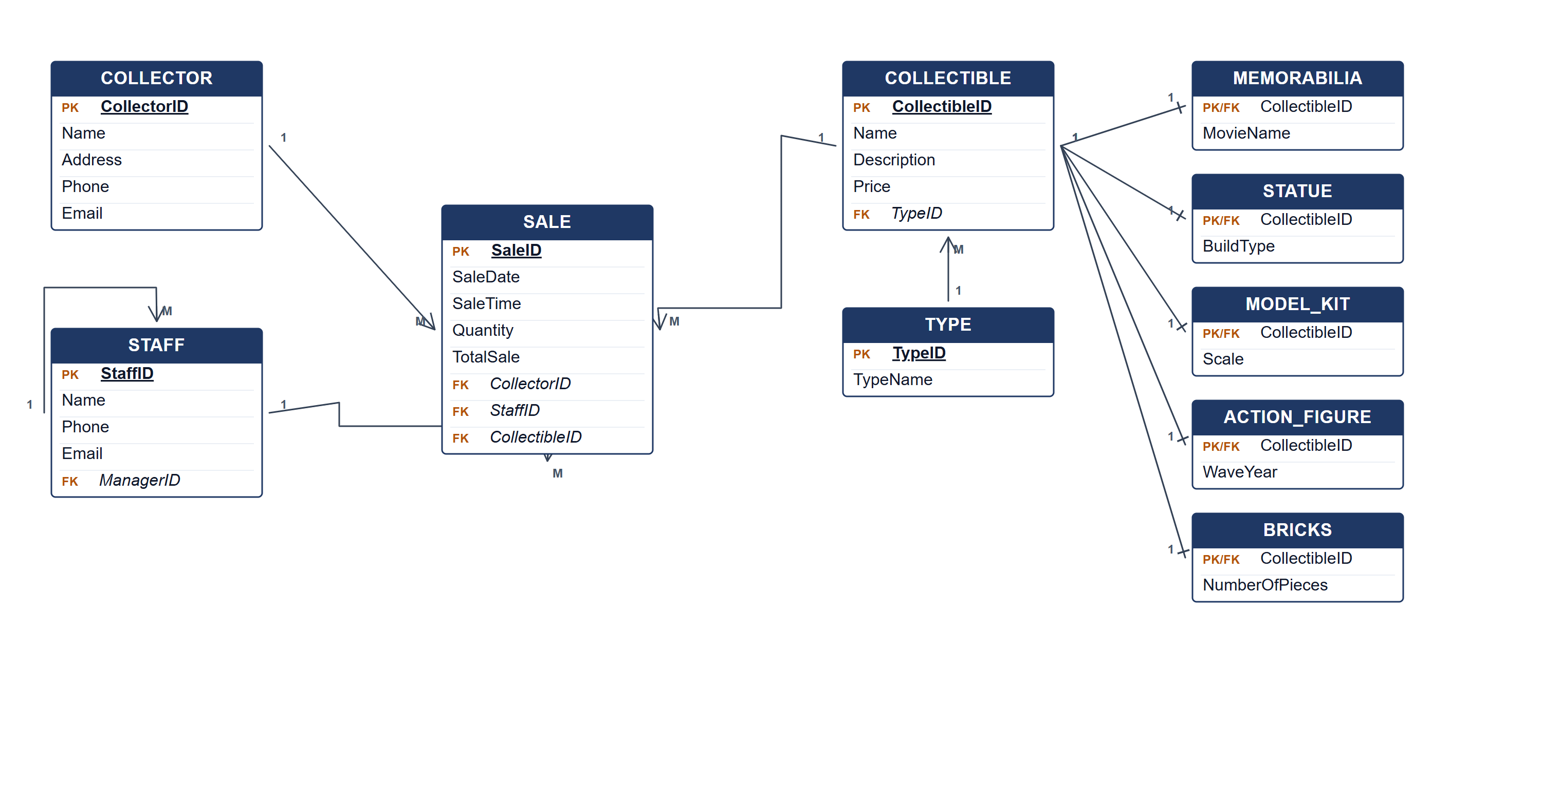
Collector's Hub ERD.
(b) Two reports from the ERD. [4 marks]
• Sales by collectible type — total quantity and sales value per type, with the subtype attributes.
• Staff performance report — number and value of sales managed by each staff member, grouped by manager.
Marking guide
• a) 16 marks: collector, staff, sale and collectible entities (6); type and five subtype entities (4); relationships and cardinalities (4); keys (2).
• b) 2 marks for each report (4).
Provenance: model_unofficial · confidence medium · Model-authored from the approved question text, the supplied source assets and the ICT200/ICT450 knowledge base; no official ICT450 marking scheme was supplied.
Knowledge base basis: TOPIC 4 ERD_stu (2).pdf; TOPIC 3 RELATIONAL DATA MODELstu.pdf
Assumptions / notes
• A sale transaction records one collectible line; the manager relationship is recursive on STAFF.

