CONFIDENTIAL  CS/MOCK NOV 2026/CSC429

UNIVERSITI TEKNOLOGI MARA
MARKING SCHEME

COURSE :
COURSE CODE :
EXAMINATION :
TIME :
COMPUTER ORGANIZATION AND ARCHITECTURE
CSC429
NOVEMBER 2026 (MOCK)
3 HOURS

MARKING SCHEME NOTES

- This marking scheme accompanies the CSC429 mock paper (November 2026).
All answers are computed deterministically. Worked answers are shown for data representation and assembly; descriptive marking points come from a fixed bank.

- No placeholders are used; every slot has a worked or descriptive answer.

- Part A = 10 questions (80 marks); Part B = 1 assembly question (20 marks); total = 100 marks.
- Computed slots: 4; descriptive slots: 7; placeholders: 0.
Questions and answers are for local study use only.

- Fingerprint based on 20 unique CSC429 papers; output is deterministic for seed 1.

FOR MARKERS' USE ONLY

This marking scheme consists of 5 printed pages
PART A — MARKING SCHEME
Worked answers and marking points.

QUESTION A1 (5 marks)
Study Figure 1 and answer the following questions.
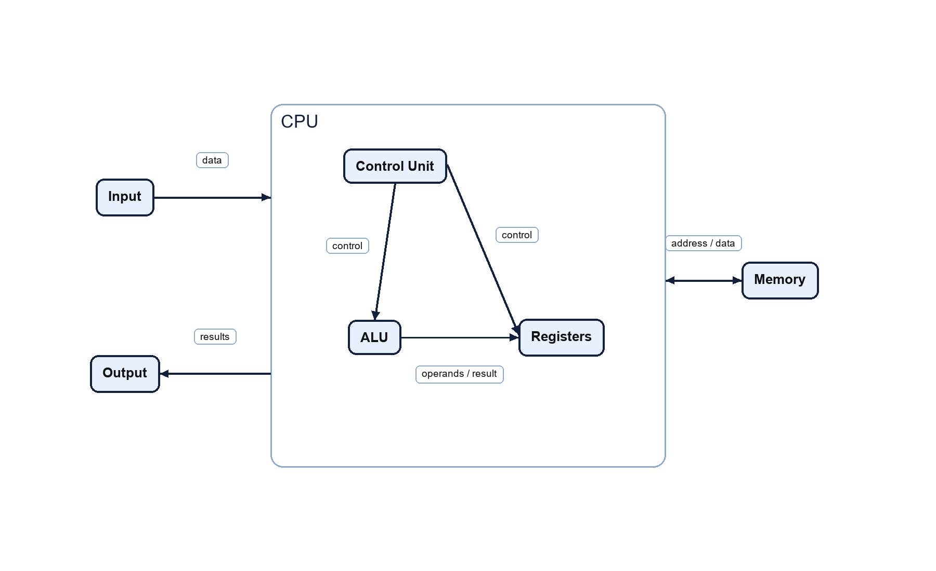
Figure 1: Stored-program computer organization.
(a) (2 marks) Name the computer organization shown in the figure and state its two key principles.
Answer: Von Neumann architecture. Instructions and data are stored in the same memory, and the CPU executes instructions sequentially unless a branch changes the control flow.
(b) (3 marks) Explain the function of the control unit and the arithmetic logic unit in this organization.
Answer: The control unit fetches and decodes instructions and generates the control signals. The ALU performs arithmetic and logical operations and records status flags.

QUESTION A2 (5 marks)
The CPU contains a control unit and an arithmetic logic unit.
(a) (2 marks) Explain the function of the control unit.
Answer: It fetches and decodes instructions and generates control signals that coordinate the datapath and other components.
(b) (3 marks) Explain the function of the ALU.
Answer: It performs arithmetic and logical operations on operands and records status flags such as zero, carry, overflow and sign.

QUESTION A3 (5 marks)
Answer the following data-representation questions. Show your complete workflow.
(a) (5 marks) Convert 43.046875 to IEEE 754 single-precision format. Give the result in hexadecimal and show the sign, exponent and mantissa fields.
Answer: sign=0, exponent=10000100, mantissa=01011000011000000000000 -> 422C3000.

QUESTION A4 (5 marks)
Answer the following data-representation questions. Show your complete workflow.
(a) (2 marks) Represent -16 in 8-bit sign-magnitude form.
Answer: 10010000 (sign bit 1, magnitude 16).
(b) (3 marks) Represent -16 in 8-bit two's complement form.
Answer: 11110000.

QUESTION A5 (10 marks)
Answer the following data-representation questions. Show your complete workflow.
(a) (5 marks) Calculate 25 - (-84) using 8-bit sign-magnitude. Show the complete workflow and the result in byte form.
Answer: 25 - (-84) = 109. Sign-magnitude result: 01101101.
(b) (5 marks) Calculate 25 - (-84) using 8-bit two's complement. Show the complete workflow and the result in byte form.
Answer: 25 - (-84) = 109. Two's complement result: 01101101.

QUESTION A6 (10 marks)
Study Figure 2 and answer the following questions.
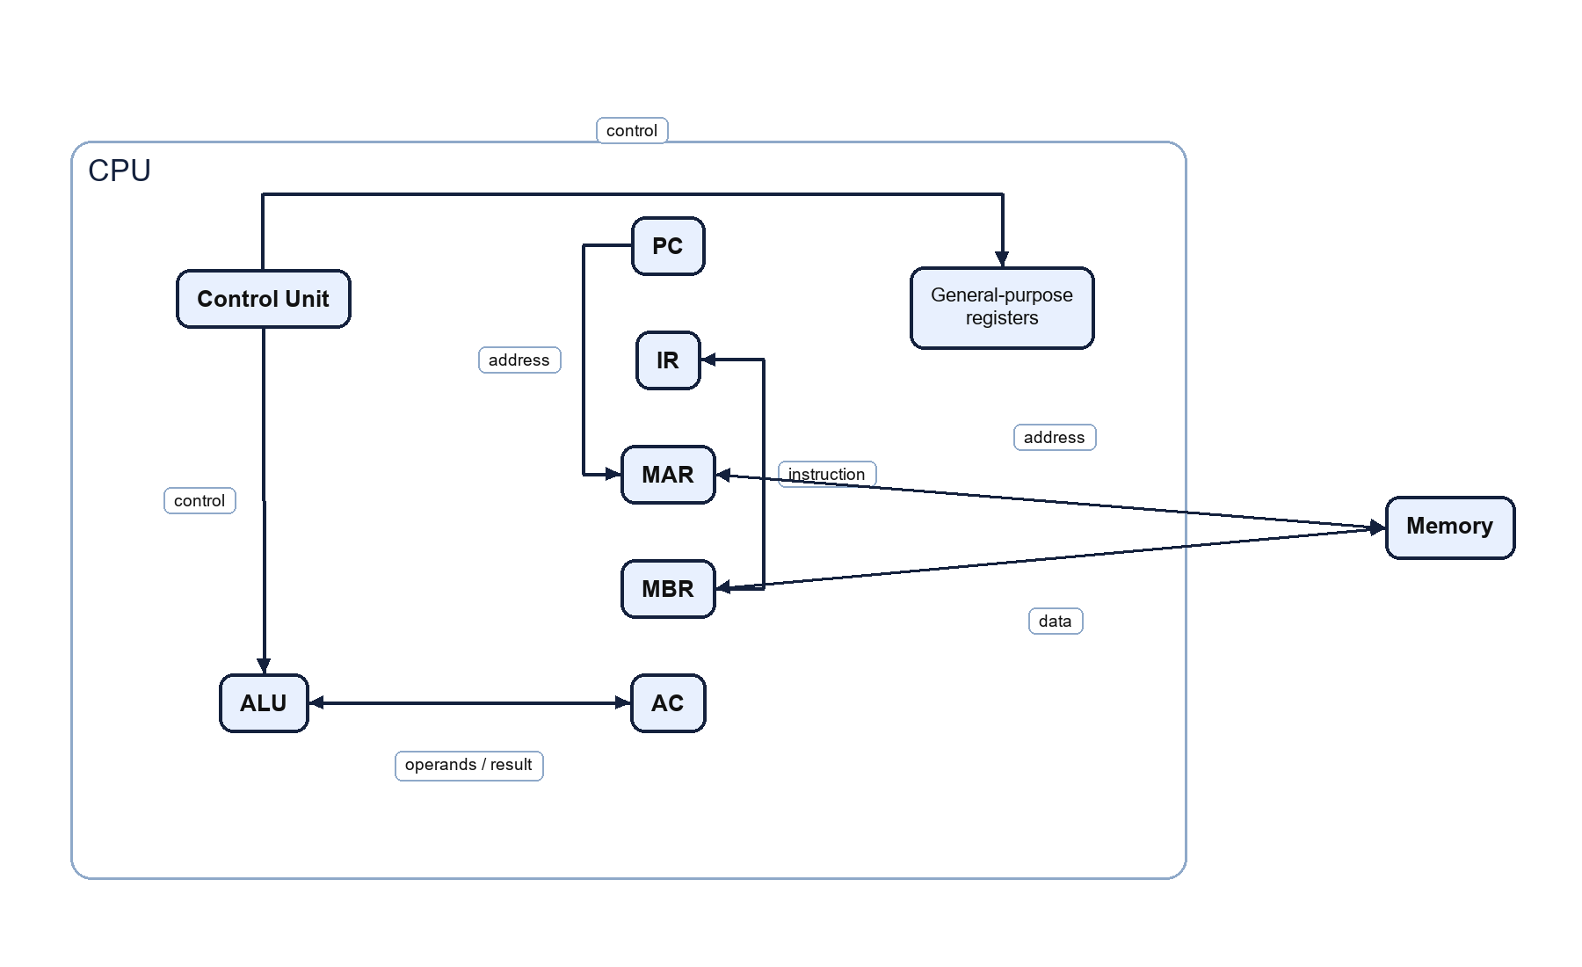
Figure 2: CPU, memory and system bus organization.
(a) (2 marks) Identify the register that holds the address of the next instruction and the register that holds the instruction currently being decoded.
Answer: PC holds the address of the next instruction; IR holds the instruction currently being decoded.
(b) (3 marks) Explain the roles of MAR and MBR during a memory read.
Answer: The MAR holds the address to be accessed. The memory places the selected word in the MBR, which then supplies it to the CPU (for example, to the IR).
(c) (5 marks) Describe the fetch-decode-execute cycle using the components shown in the figure.
Answer: Fetch: PC -> MAR; memory read; MBR -> IR; PC is incremented. Decode: the CU interprets the opcode in IR and issues control signals. Execute: operands are read, the ALU performs the operation, the result and flags are written back, and the next instruction is fetched.

QUESTION A7 (10 marks)
Study Figure 3 and answer the following questions.
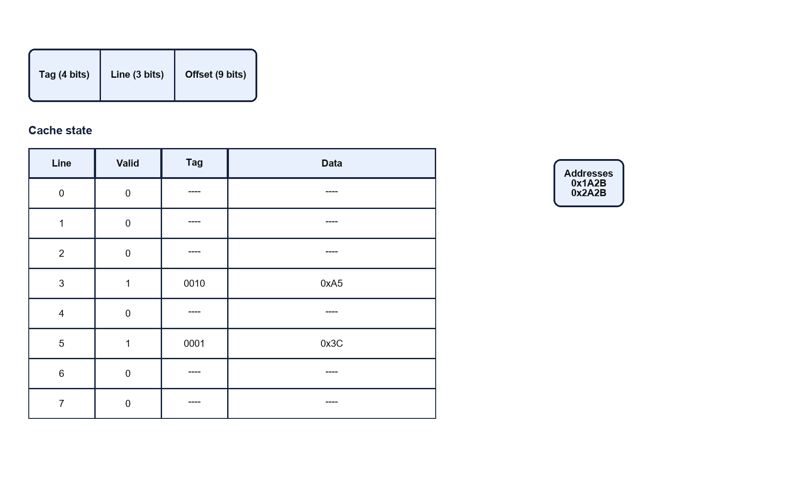
Figure 3: Direct-mapped cache organization and address fields.
(a) (2 marks) The cache uses a 16-bit address split into a 4-bit tag, a 3-bit line number and a 9-bit offset. For address 0x1A2B, give the tag, line number and offset in binary.
Answer: 0x1A2B = 0001 1010 0010 1011; tag = 0001, line = 101, offset = 000101011.
(b) (4 marks) Using the cache state shown in the figure, determine whether each address is a hit or a miss: (i) 0x1A2B, (ii) 0x2A2B. Explain your reasoning.
Answer: (i) Hit: tag 0001 and line 101; line 5 is valid with tag 0001. (ii) Miss: tag 0010 and line 101; line 5 is valid but its tag is 0001, so the tags do not match.
(c) (4 marks) Explain why the cache compares tags and how temporal and spatial locality improve the hit rate.
Answer: The tag identifies which memory block occupies a line; comparing tags prevents returning data from a different block. Temporal locality means recently used data is likely reused, and spatial locality means nearby addresses are likely used, so keeping blocks in cache raises the hit rate.

QUESTION A8 (10 marks)
The CPU can use programmed I/O, interrupt-driven I/O or DMA.
(a) (2 marks) Describe programmed I/O.
Answer: The CPU repeatedly checks the device status and transfers data itself, so it wastes time polling.
(b) (3 marks) Describe interrupt-driven I/O.
Answer: The device signals the CPU with an interrupt when it is ready; the CPU services the device in an ISR instead of polling.
(c) (5 marks) Explain how DMA improves I/O performance and state ONE advantage over interrupt-driven I/O.
Answer: A DMA controller transfers a block directly between the device and memory while the CPU continues other work; one interrupt is needed at completion, so there is less CPU overhead per transfer.

QUESTION A9 (10 marks)
Multiple interrupts can arrive while the CPU is servicing another interrupt.
(a) (3 marks) Explain nested interrupts.
Answer: A higher-priority interrupt can interrupt a lower-priority ISR; the CPU saves the lower ISR context and services the higher-priority one first.
(b) (3 marks) Describe how interrupt priority determines the order of service.
Answer: The interrupt controller compares priorities and presents the highest-priority pending request to the CPU first.
(c) (4 marks) Explain the sequence of events when a higher-priority interrupt arrives during an ISR.
Answer: The CPU finishes the current instruction, saves the current context, acknowledges the higher-priority interrupt and jumps to its ISR; the lower ISR resumes after the higher one returns.

QUESTION A10 (10 marks)
Flynn's taxonomy classifies computer architectures by instruction and data streams.
(a) (4 marks) Describe SISD, SIMD, MISD and MIMD.
Answer: SISD: one instruction/one data stream. SIMD: one instruction/ multiple data streams. MISD: multiple instructions/one data stream. MIMD: multiple instructions/multiple data streams.
(b) (2 marks) Give ONE example of SIMD and ONE example of MIMD.
Answer: SIMD: GPU/vector processor. MIMD: multicore CPU or cluster.
(c) (4 marks) Explain the difference between shared-memory and distributed-memory MIMD.
Answer: Shared-memory MIMD uses one address space accessible by all processors; distributed-memory MIMD gives each processor local memory and communicates by messages.

PART B — MARKING SCHEME
Worked answers and marking points.

QUESTION B1 (20 marks)
Write appropriate programs using zero-, one- and three-address instructions to compute Z = A + B * C - D. Registers A, B, C, D and E must not be modified; X, Y and Z are temporary registers; the final answer must be stored in Z. Available instructions: zero-address PUSH, POP, ADD, SUB, MUL, DIV; one-address LOAD, STORE, ADD, SUB, MUL, DIV; three-address ADD, SUB, MUL, DIV.
(a) (6 marks) Write a zero-address program for the expression.
Answer: PUSH B
PUSH C
MUL
PUSH A
ADD
PUSH D
SUB
POP Z
(b) (6 marks) Write a one-address program for the expression.
Answer: LOAD B
MUL C
ADD A
SUB D
STORE Z
(c) (8 marks) Write a three-address program for the expression.
Answer: MUL X, B, C
ADD X, A, X
SUB Z, X, D

