CONFIDENTIAL CS/OCT 2026/MAT133

UNIVERSITI TEKNOLOGI MARA FINAL EXAMINATION

COURSE
COURSE CODE
EXAMINATION TIME
PRE CALCULUS
MAT133 OCTOBER 2026
2 HOURS

INSTRUCTIONS TO CANDIDATES

- This question paper consists of 5 questions.

- Answer ALL questions in the Answer Booklet. Start each answer on a new page.

- Do not bring any material into the examination room unless permission is given by the invigilator .
- Please check to make sure that this examination pack consists of: i) the Question Paper
  - a one - page Append ix 1
  - an Answer Booklet - provided by the Faculty
  - a graph paper - provided by the Faculty

- Answer ALL questions in English.

/

DO NOT TURN THIS PAGE UNTIL YOU ARE TOLD TO DO SO

This examination paper consists of 6 printed pages

QUESTION 1
a) Solve the compound inequality 1 < x + 3 < 6. Express the answer in interval notation.
(4 marks)
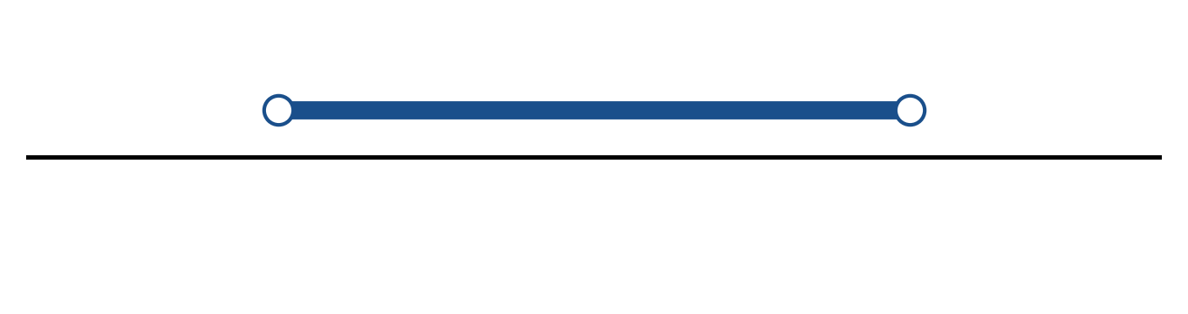
Figure: solution on a number line.
b) Solve the inequality |-x - 6| ≥ 9. Express the answer in interval notation and on a number line.
(5 marks)
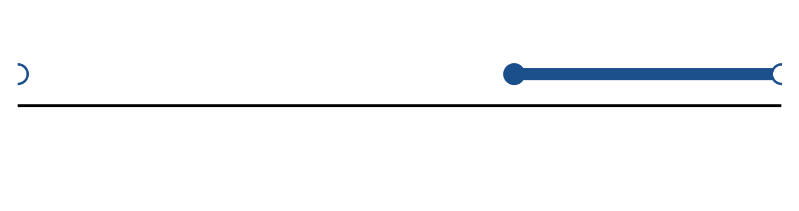
Figure: solution on a number line.
c) Sketch y = -2|x - 3| - 3. State the vertex, the y-intercept and any x-intercepts.
(5 marks)
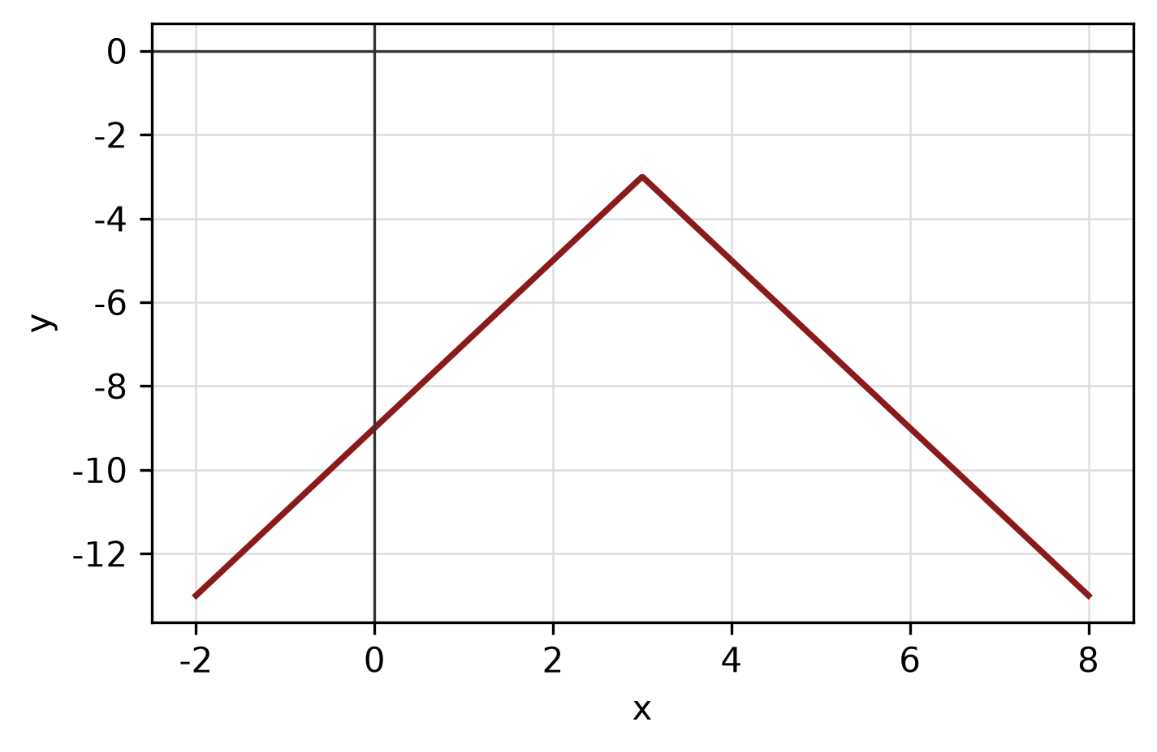
Figure: absolute-value graph.
QUESTION 2
a) Given f(x) = -x - 5 and g(x) = 5 - 3x, find (f + g)(x), (f - g)(x) and (f g)(x). State the domain of each.
(4 marks)
b) Sketch y = |x - 2| + 1 for -2 ≤ x ≤ 6. State the domain and range.
(4 marks)
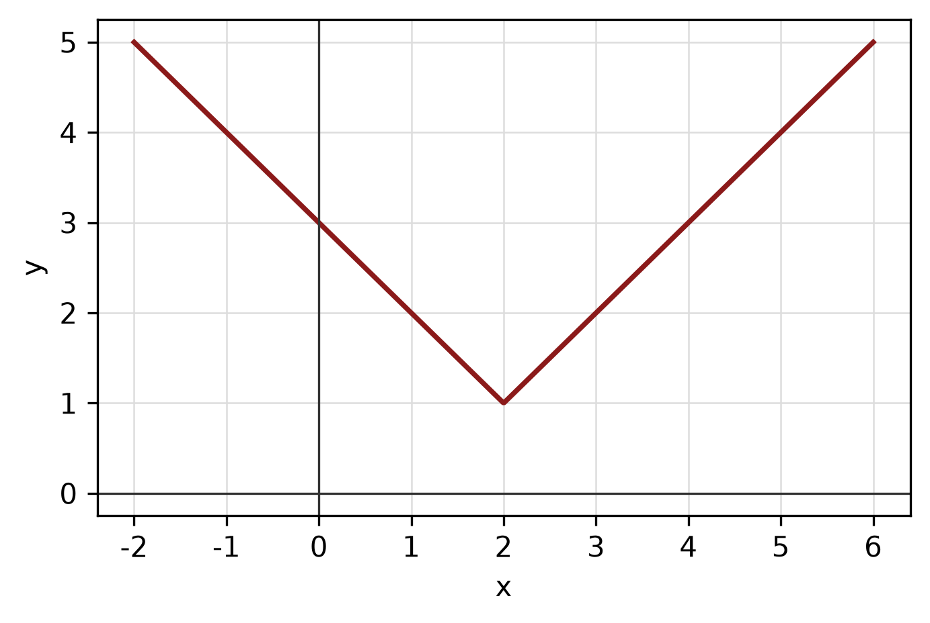
Figure: function graph.
c) Write y = x²/8 + x/2 + 7/2 in standard form. Hence state the vertex, focus and directrix, and sketch the parabola.
(5 marks)
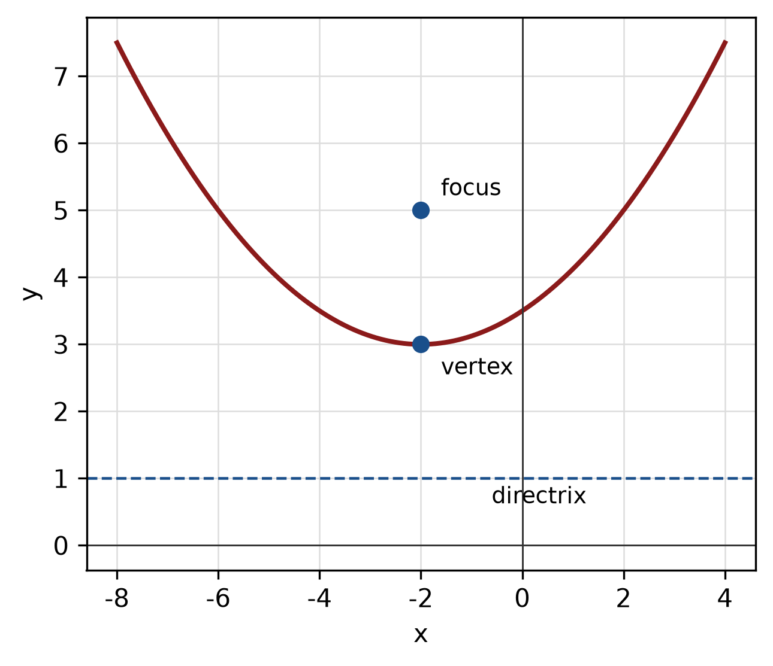
Figure: parabola.
QUESTION 3
a) Given z₁ = -5 + 3i and z₂ = -1 + 5i, express z₁/z₂ in the form a + bi.
(5 marks)
b) Find the modulus and argument of z = 8 + 15i. Give the argument in degrees correct to one decimal place.
(5 marks)
c) Solve the exponential equation 2^(2x - 5) = 2^(4 - 3x).
(5 marks)
QUESTION 4
a) Graph the system of inequalities below and shade the feasible region. State the vertices of the region.
x ≥ 0, y ≥ 0, 2x + 3y ≤ 8.
(5 marks)
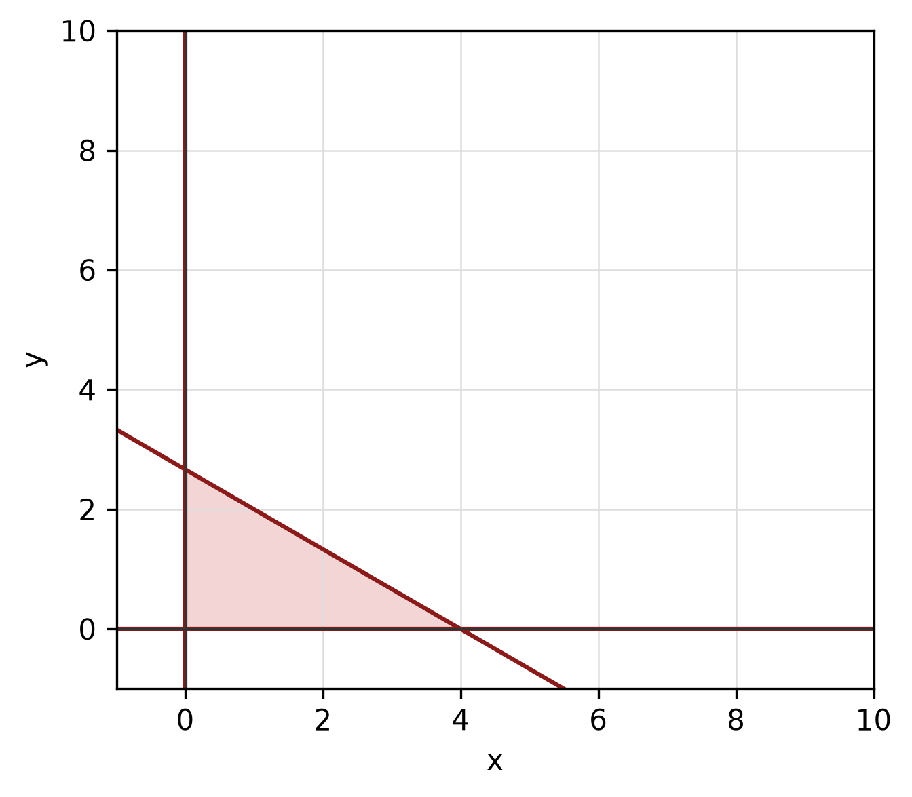
Figure: feasible region.
b) Solve the simultaneous equations
y = x² + 1
y = 3x + 5.
(5 marks)
c) Find the equation of the line with x-intercept 7 and y-intercept -3.
(4 marks)
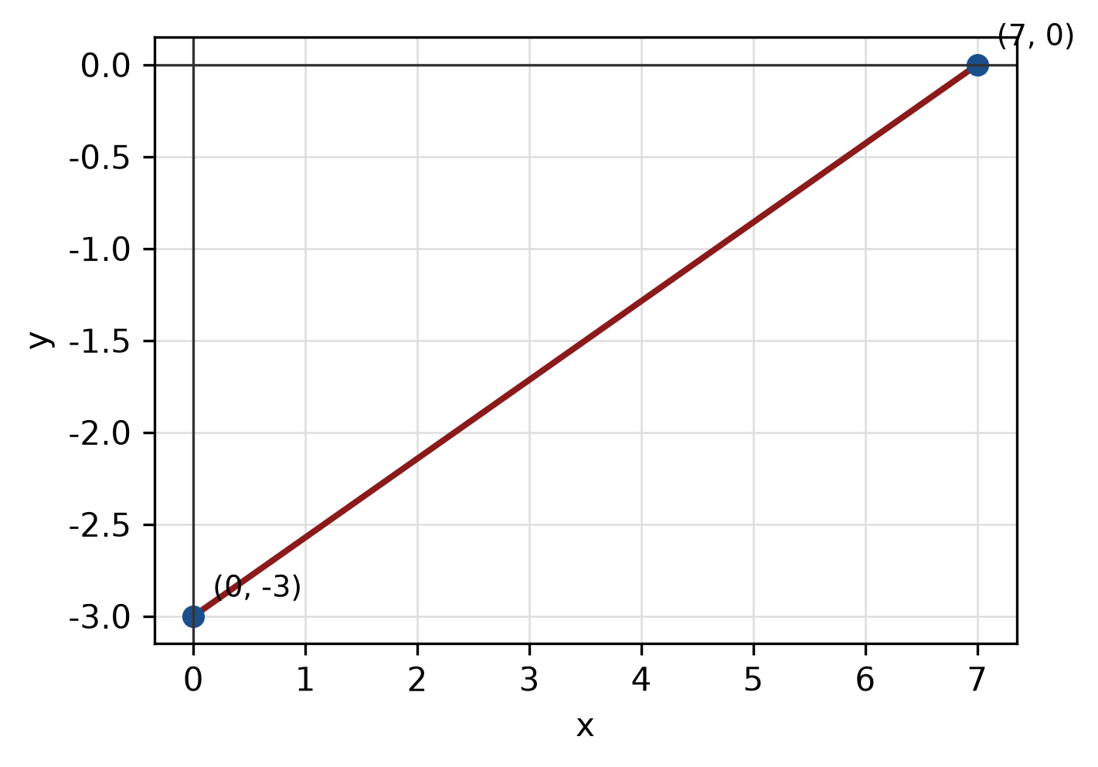
Figure: line and intercepts.
QUESTION 5
a) Solve the trigonometric equation sin² x - 3/4 = 0 for 0° ≤ x < 360°.
(5 marks)
b) Find the perimeter of the sector with radius 7 cm and central angle 90°.
(4 marks)
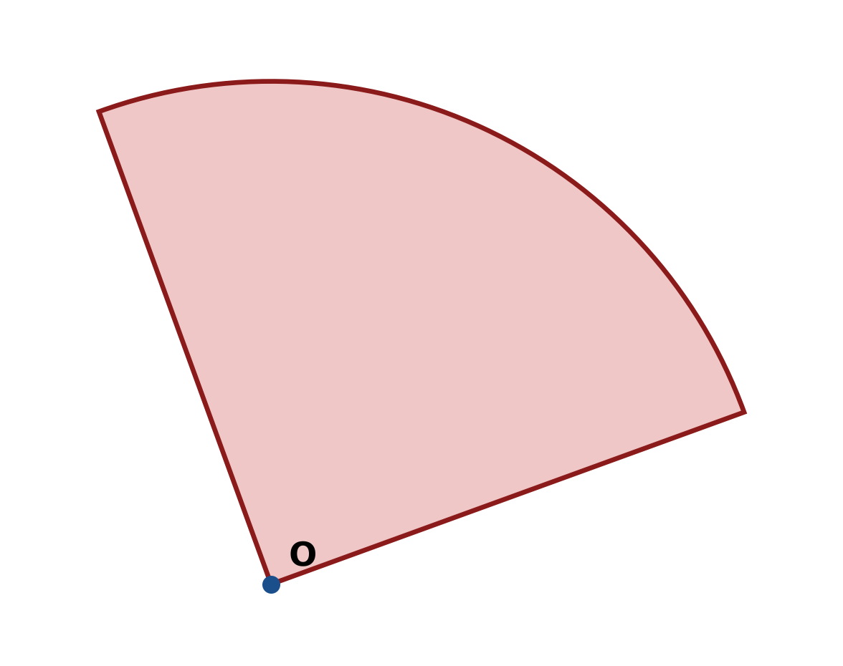
Figure: sector.
c) In triangle ABC, A = 30°, B = 45° and a = 13 cm. Use the sine rule to find b.
(4 marks)
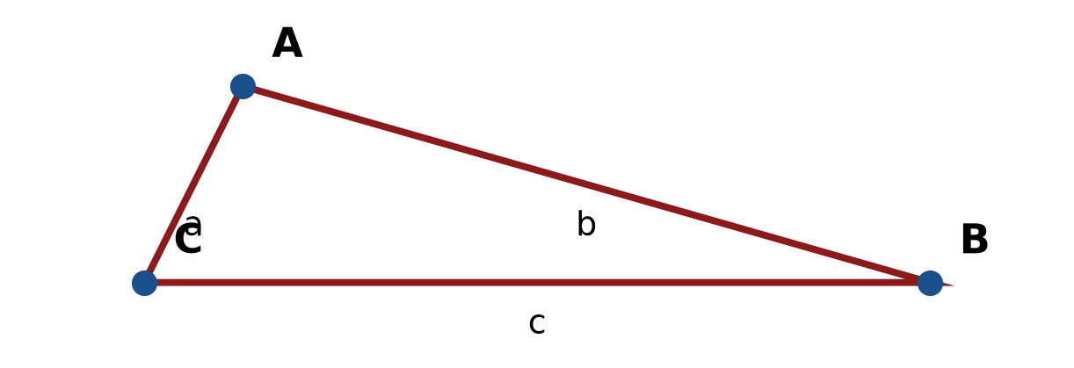
Figure: triangle ABC.
END OF QUESTION PAPER

APPENDIX 1
Formula sheet (as supplied with the paper).
sin² A + cos² A = 1 | tan² A + 1 = sec² A
sin(A + B) = sin A cos B + cos A sin B | tan 2A = 2 tan A / (1 − tan² A)
cos(A + B) = cos A cos B − sin A sin B | Arc length, s = rθ
tan(A − B) = (tan A − tan B) / (1 + tan A tan B) | Area of sector = ½r²θ
cos 2A = cos² A − sin² A | a / sin A = b / sin B = c / sin C
cos 2A = 1 − 2sin² A = 2cos² A − 1 | a² = b² + c² − 2bc cos A
sin 2A = 2 sin A cos A | Area of triangle = ½ab sin C

