CONFIDENTIAL CS/OCT 2026/MAT133

UNIVERSITI TEKNOLOGI MARA FINAL EXAMINATION

COURSE
COURSE CODE
EXAMINATION TIME
PRE CALCULUS
MAT133 OCTOBER 2026
2 HOURS

INSTRUCTIONS TO CANDIDATES

- This question paper consists of 5 questions.

- Answer ALL questions in the Answer Booklet. Start each answer on a new page.

- Do not bring any material into the examination room unless permission is given by the invigilator .
- Please check to make sure that this examination pack consists of: i) the Question Paper
  - a one - page Append ix 1
  - an Answer Booklet - provided by the Faculty
  - a graph paper - provided by the Faculty

- Answer ALL questions in English.

/

DO NOT TURN THIS PAGE UNTIL YOU ARE TOLD TO DO SO

This examination paper consists of 7 printed pages

QUESTION 1
a) Solve the inequality x² - 9 ≤ 0.
(5 marks)
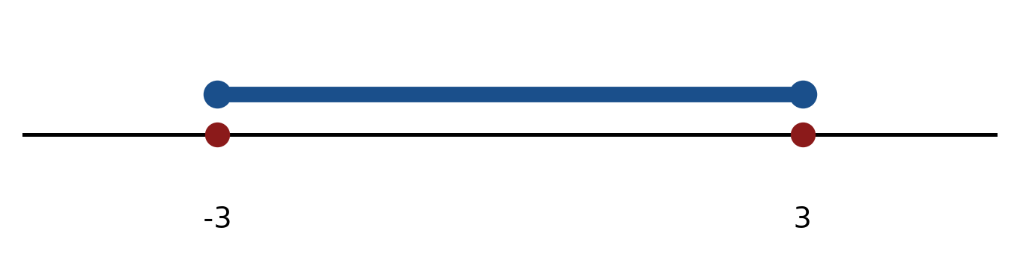
Figure: critical values.
b) Solve the inequality |-3x - 1| ≤ 3. Express the answer in interval notation and on a number line.
(5 marks)
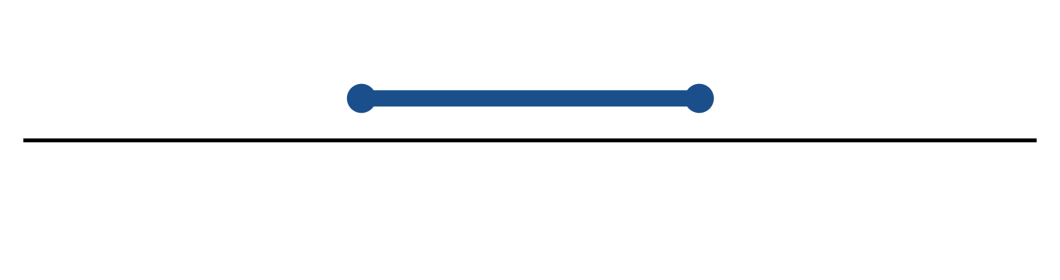
Figure: solution on a number line.
c) Sketch y = 2|x + 3| - 2. State the vertex, the y-intercept and any x-intercepts.
(5 marks)
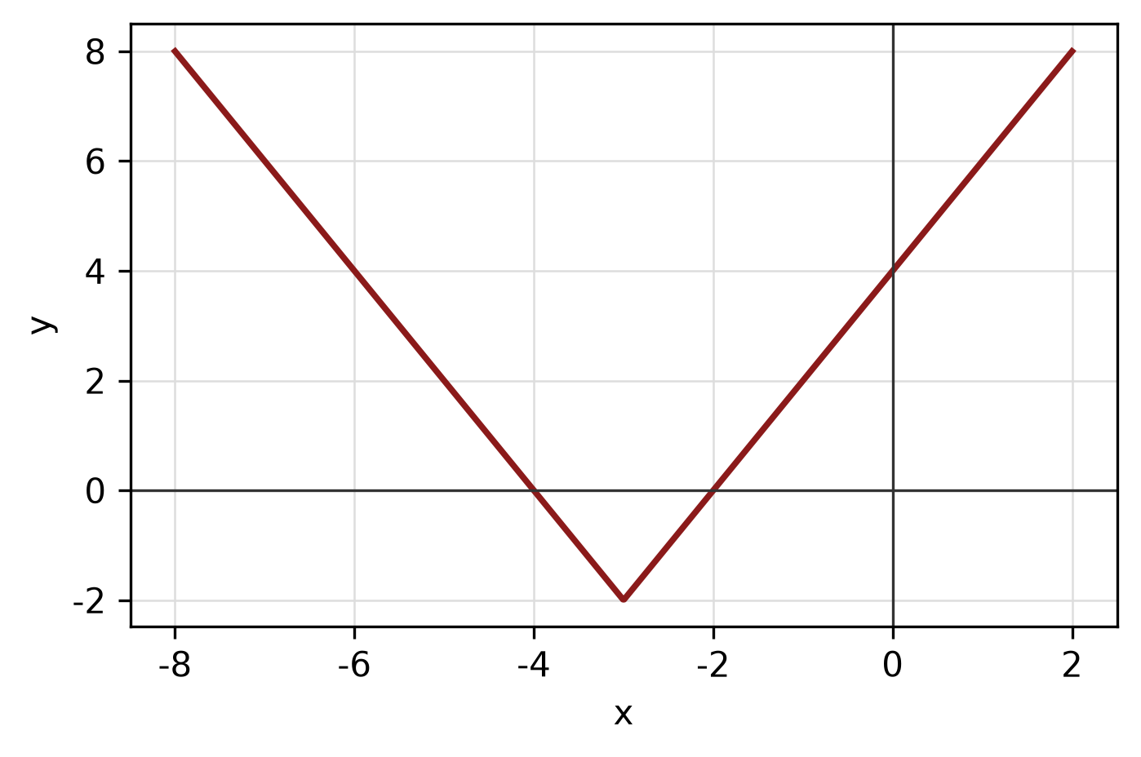
Figure: absolute-value graph.
QUESTION 2
a) The piecewise function is defined by
f(x) = 2x - 1, if x < -1;
f(x) = -3, if -1 ≤ x ≤ 2;
f(x) = x² + 2, if x > 2.
Sketch the graph and find f(-2), f(0) and f(3).
(5 marks)
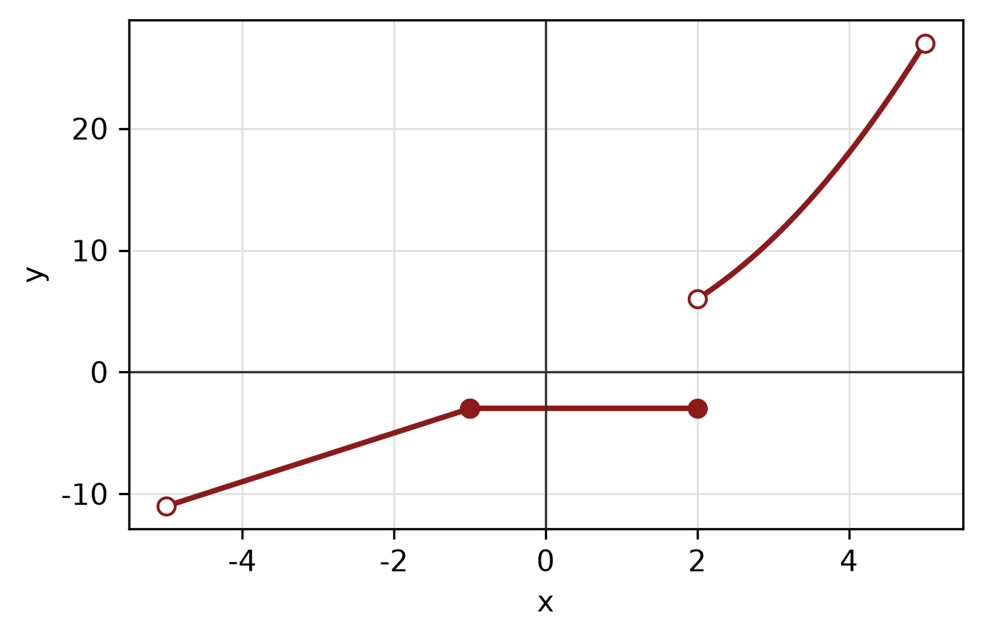
Figure: piecewise graph.
b) Given f(x) = (3x - 5)/(3x + 4) and g(x) = √(4x + 5), state the domain of each function.
(4 marks)
c) Find the equation of the straight line passing through (-1, 1) and (-3, -4).
(4 marks)
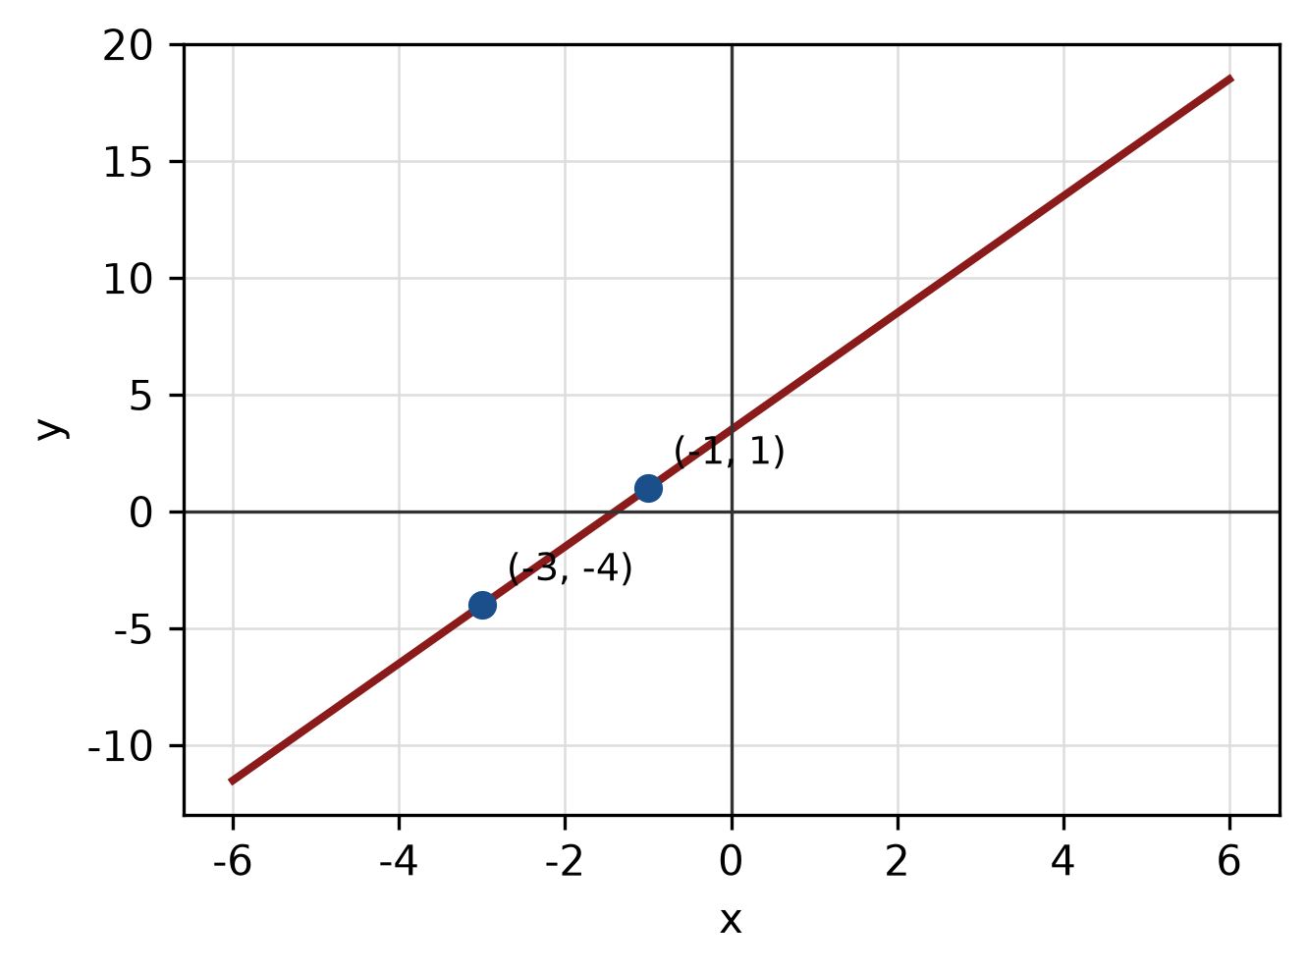
Figure: line through the two points.
QUESTION 3
a) Given z₁ = 2 - 2i and z₂ = -4 - i, express z₁/z₂ in the form a + bi.
(5 marks)
b) Evaluate i^40 and simplify completely.
(3 marks)
c) Use synthetic division to divide f(x) = 3x^3 - 5x² - 2x + 5 by x - 4. State the quotient and remainder.
(5 marks)
QUESTION 4
a) Graph the system of inequalities below and shade the feasible region. State the vertices of the region.
x ≥ 0, y ≥ 0, 3x + 3y ≤ 5.
(5 marks)
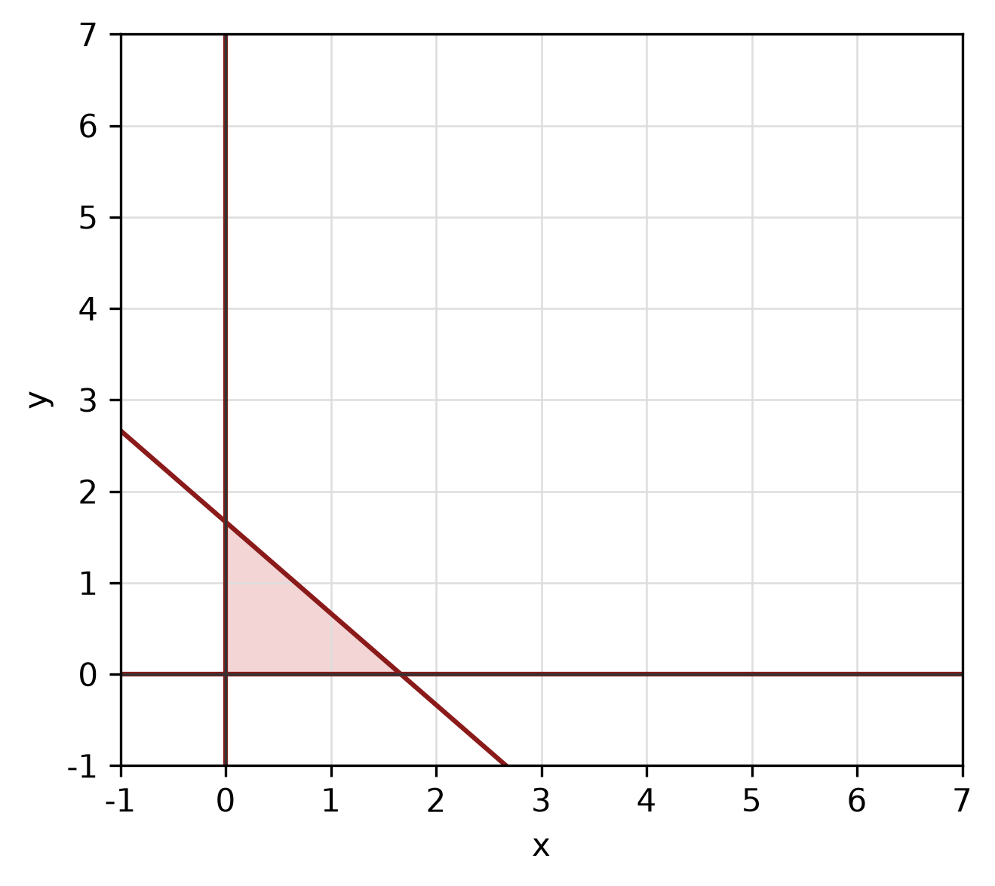
Figure: feasible region.
b) Solve the simultaneous equations
3x + 2y = -2
5x + 3y = -5.
(4 marks)
c) Sketch the parabola (x + 4)² = -4(y + 3). Label the vertex, focus and directrix.
(5 marks)
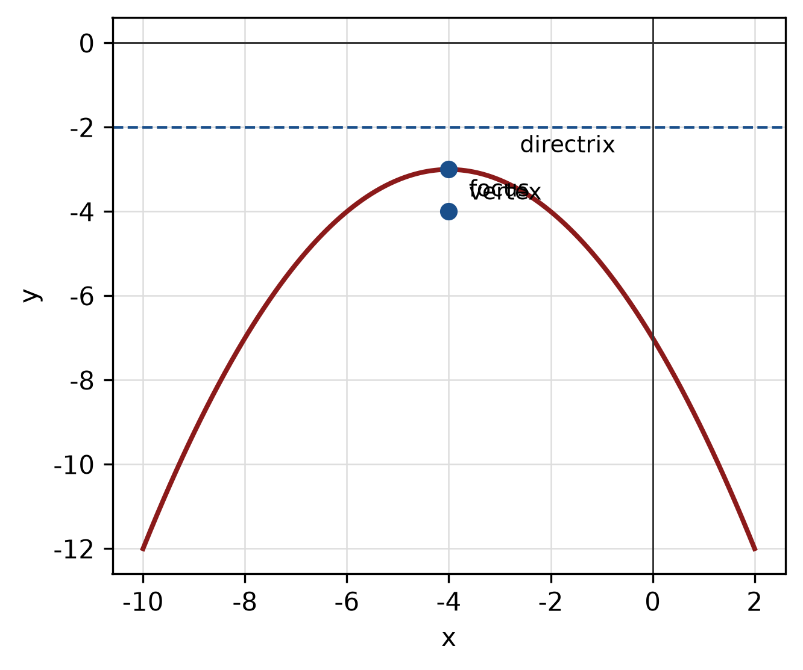
Figure: parabola.
QUESTION 5
a) Given sin A = -8/17 and A is in quadrant 4, find the exact values of cos A, tan A and sec A.
(4 marks)
b) Find the perimeter of the sector with radius 4 cm and central angle 150°.
(4 marks)
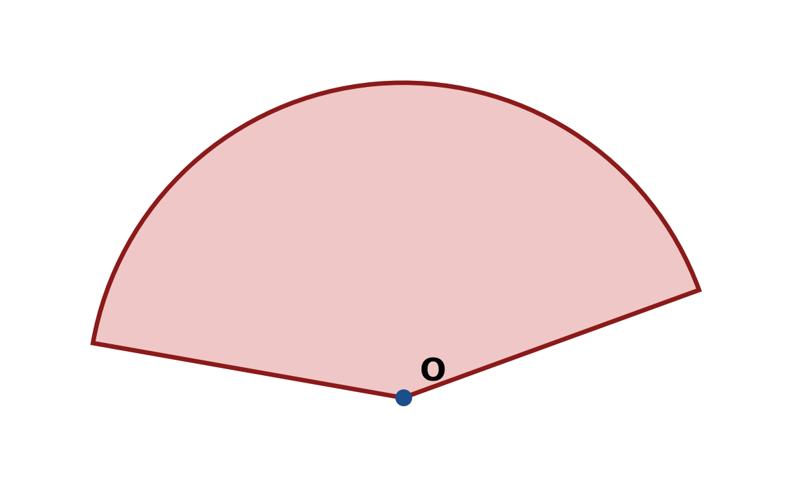
Figure: sector.
c) In triangle ABC, b = 10 cm, c = 6 cm and A = 120°. Use the cosine rule to find a.
(4 marks)
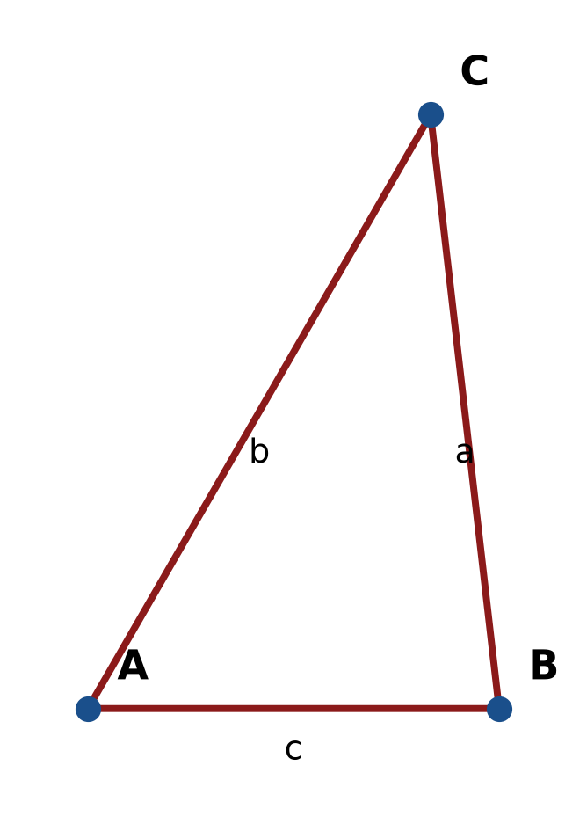
Figure: triangle ABC.
END OF QUESTION PAPER

APPENDIX 1
Formula sheet (as supplied with the paper).
sin² A + cos² A = 1 | tan² A + 1 = sec² A
sin(A + B) = sin A cos B + cos A sin B | tan 2A = 2 tan A / (1 − tan² A)
cos(A + B) = cos A cos B − sin A sin B | Arc length, s = rθ
tan(A − B) = (tan A − tan B) / (1 + tan A tan B) | Area of sector = ½r²θ
cos 2A = cos² A − sin² A | a / sin A = b / sin B = c / sin C
cos 2A = 1 − 2sin² A = 2cos² A − 1 | a² = b² + c² − 2bc cos A
sin 2A = 2 sin A cos A | Area of triangle = ½ab sin C

