CONFIDENTIAL CS/NOV 2026/MAT133

UNIVERSITI TEKNOLOGI MARA FINAL EXAMINATION

COURSE
COURSE CODE
EXAMINATION TIME
PRE CALCULUS
MAT133 NOVEMBER 2026
2 HOURS

INSTRUCTIONS TO CANDIDATES

- This question paper consists of four (4) questions.

- Answer ALL questions in the Answer Booklet. Start each answer on a new page.

- Do not bring any material into the examination room unless permission is given by the invigilator .
- Please check to make sure that this examination pack consists of: i) the Question Paper
  - a one - page Append ix 1
  - an Answer Booklet - provided by the Faculty
  - a graph paper - provided by the Faculty

- Answer ALL questions in English.

/

DO NOT TURN THIS PAGE UNTIL YOU ARE TOLD TO DO SO

This examination paper consists of 5 printed pages

QUESTION 1
a) Solve the inequality 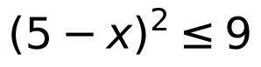 and express the solution in real number line.
(5 marks)
b) Write the equation of circle 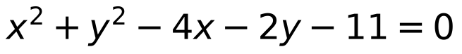 in standard form. Hence, sketch the circle with the correct center and radius.
(5 marks)
QUESTION 2
a) Solve the inequality 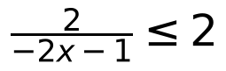 . Express the answer in real number line.
(5 marks)
b) If 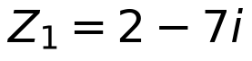 and 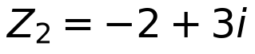 , state 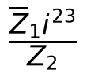 in standard form 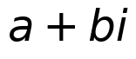 .
(5 marks)

QUESTION 3
a) Given that 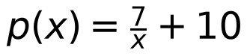 and 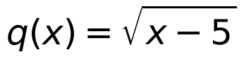 .
i) State the domain of 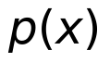 and 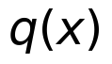 .
(2 marks)
ii) Determine 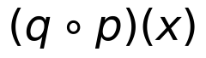 .
(3 marks)
b) Given that 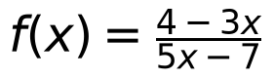 , find the value of 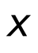 if 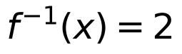 .
(5 marks)

QUESTION 4
a) Given 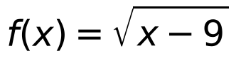 , 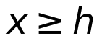 and 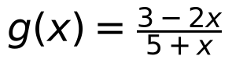 , 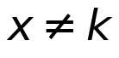 . Find
i) the values of 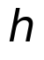 and 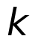
(2 marks)
ii) 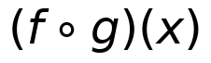
(3 marks)
iii) 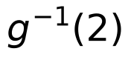
(4 marks)
b) Use long division to find the quotient and remainder when 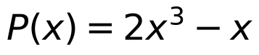 is divided by 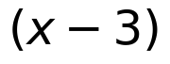 .
(5 marks)
c) Solve the equation 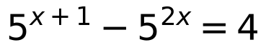 .
(6 marks)
d) Sketch the graph of 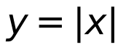 . Hence, sketch the graph of 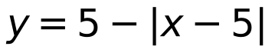 by using transformation techniques.
(5 marks)
END OF QUESTION PAPER

APPENDIX 1
Formula sheet (as supplied with the paper).


