CONFIDENTIAL  CS/MOCK NOV 2026/MAT133

UNIVERSITI TEKNOLOGI MARA
MARKING SCHEME

COURSE :
COURSE CODE :
EXAMINATION :
TIME :
PRE CALCULUS
MAT133
NOVEMBER 2026
2 HOURS

MARKING SCHEME NOTES

- This marking scheme accompanies the MAT133 mock paper (November 2026).
Answers are unofficial model answers generated from the printed past-paper question; they are not an official UTM marking scheme.

- Marking points follow the printed part labels and marks. Verify every model answer against the source page.

- Four questions: 10 + 10 + 10 + 25 marks; total = 55 marks.
- Questions: 4. Real recycled questions: 4. Placeholders: 0.
For local study use only; model answers are unofficial.

- Every question is a real MAT133 past-paper question; its source paper and page are printed with the answer.

FOR MARKERS' USE ONLY

This marking scheme consists of 5 printed pages
QUESTION 1 (10 marks)
Source: MAT133-2025-JUL, page(s) 2
Unofficial model answer — AI-generated, not an official UTM marking scheme.
a) Solve the inequality 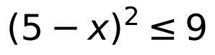 and express the solution in real number line.
(5 marks)
Answer: 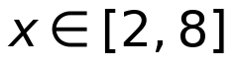; on the real number line, place closed circles at 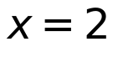 and 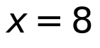 and shade the interval between them.
•
• 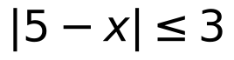
• 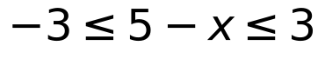
• 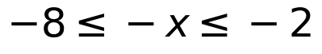
• 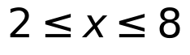
b) Write the equation of circle 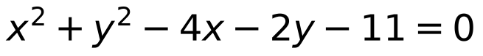 in standard form. Hence, sketch the circle with the correct center and radius.
(5 marks)
Answer: Standard form: 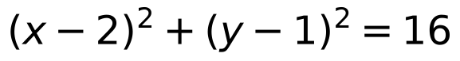. Center: 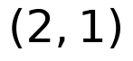; radius: 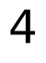. Sketch a circle centered at with radius , passing through 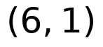, 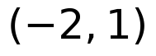, 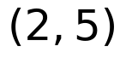 and 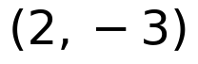.
•
•
•
• Center , radius 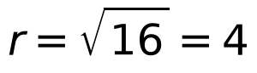
Model confidence: high.
QUESTION 2 (10 marks)
Source: MAT133-2022-FEB, page(s) 2
Unofficial model answer — AI-generated, not an official UTM marking scheme.
a) Solve the inequality 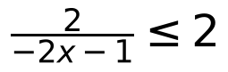 . Express the answer in real number line.
(5 marks)
Answer: 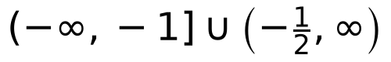
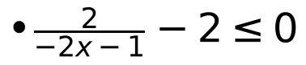
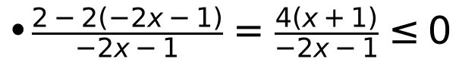
• Critical values: 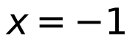 and 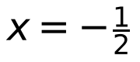
• Sign table gives negative on 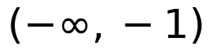 and 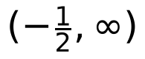, positive on 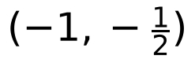
• Include since numerator is zero; exclude since denominator is zero
• Solution:
b) If 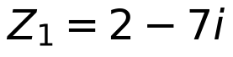 and 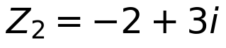 , state 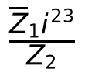 in standard form 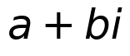 .
(5 marks)
Answer: 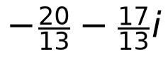
• 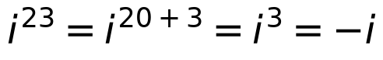
• 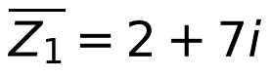
• 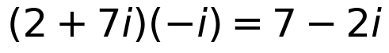
• 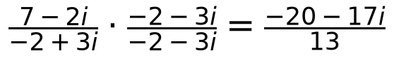
• 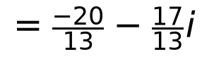
Model confidence: high.
QUESTION 3 (10 marks)
Source: MAT133-2026-FEB, page(s) 2
Unofficial model answer — AI-generated, not an official UTM marking scheme.
a) Given that 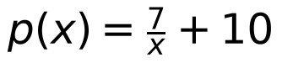 and 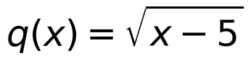 .
i) State the domain of 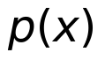 and 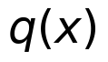 .
(2 marks)
ii) Determine 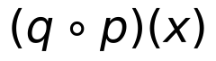 .
(3 marks)
Answer: 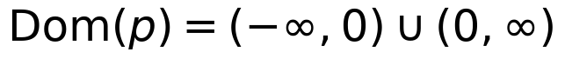; 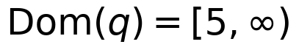 | 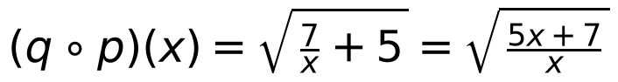, with domain 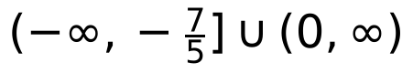
• requires 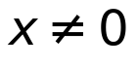
• requires 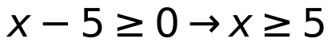
• 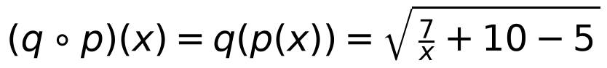
• 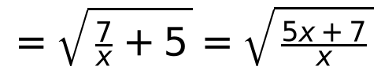
• and
b) Given that 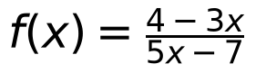 , find the value of 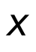 if 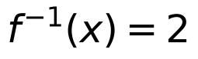 .
(5 marks)
Answer: 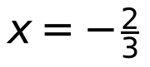
• 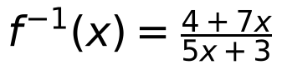
• 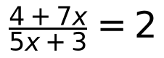
• 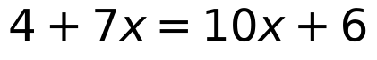
• 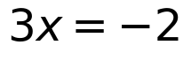
•
Assumptions: The domain of the composite function is stated in addition to the expression, although the subpart only asks to determine .
Model confidence: high.
QUESTION 4 (25 marks)
Source: MAT133-2019-JUN, page(s) 3
Unofficial model answer — AI-generated, not an official UTM marking scheme.
a) Given 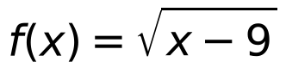 , 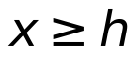 and 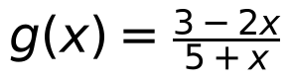 , 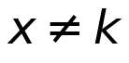 . Find
i) the values of 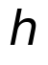 and 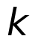
(2 marks)
ii) 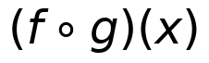
(3 marks)
iii) 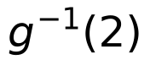
(4 marks)
Answer: i) 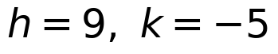; ii) 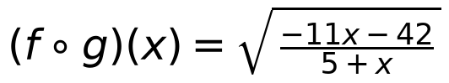; iii) 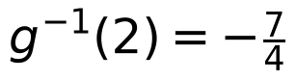
• 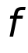 requires 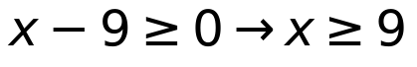, so 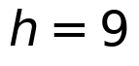.
• 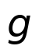 requires 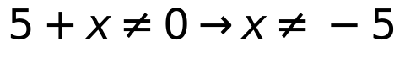, so 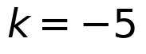.
• 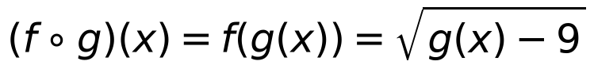.
• .
• Need 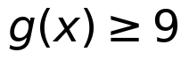, giving 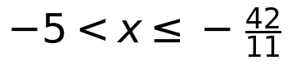.
• Set 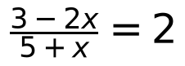.
• 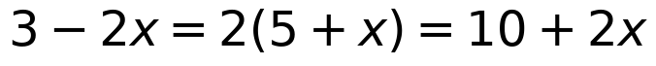.
• 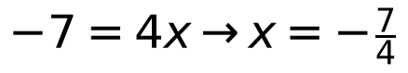.
b) Use long division to find the quotient and remainder when 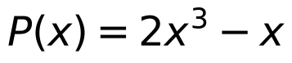 is divided by 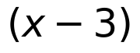 .
(5 marks)
Answer: Quotient 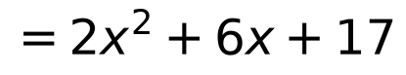; remainder 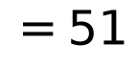.
• 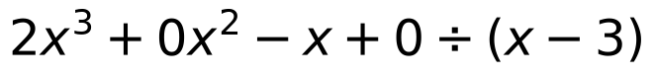.
• 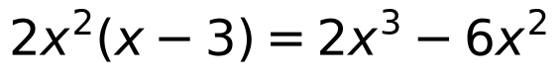, remainder 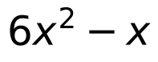.
• 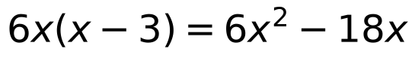, remainder 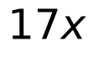.
• 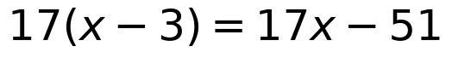, remainder 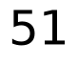.
• .
c) Solve the equation 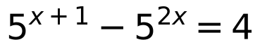 .
(6 marks)
Answer: 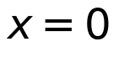 or 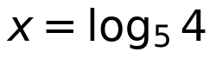
• .
• Let 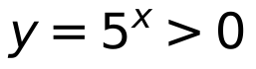: 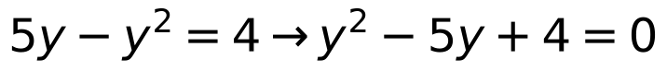.
• 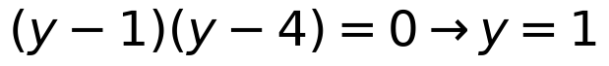 or 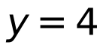.
• 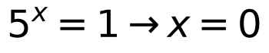; 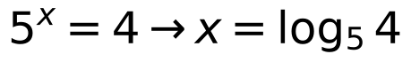.
d) Sketch the graph of 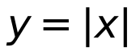 . Hence, sketch the graph of 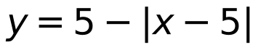 by using transformation techniques.
(5 marks)
Answer: Start with (V-shape, vertex 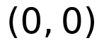). Then 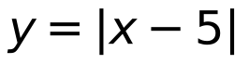 shifts right 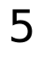; 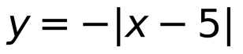 reflects in the -axis; shifts up . The final graph is an inverted V with vertex 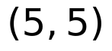, intercepts and 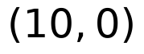, and piecewise 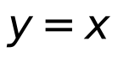 for 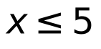, 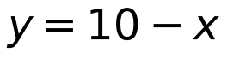 for 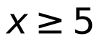.
• : vertex , slopes 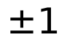.
• : shift right , vertex 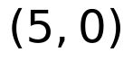.
• : reflect in the -axis.
• : shift up , vertex ; intercepts 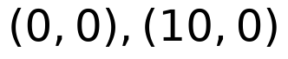.
Assumptions: Take h and k as the lower endpoint and excluded value of the maximal real domains of f and g respectively.
Model confidence: high.
END OF MARKING SCHEME

