CONFIDENTIAL CS/NOV 2026/MAT133

UNIVERSITI TEKNOLOGI MARA FINAL EXAMINATION

COURSE
COURSE CODE
EXAMINATION TIME
PRE CALCULUS
MAT133 NOVEMBER 2026
2 HOURS

INSTRUCTIONS TO CANDIDATES

- This question paper consists of four (4) questions.

- Answer ALL questions in the Answer Booklet. Start each answer on a new page.

- Do not bring any material into the examination room unless permission is given by the invigilator .
- Please check to make sure that this examination pack consists of: i) the Question Paper
  - a one - page Append ix 1
  - an Answer Booklet - provided by the Faculty
  - a graph paper - provided by the Faculty

- Answer ALL questions in English.

/

DO NOT TURN THIS PAGE UNTIL YOU ARE TOLD TO DO SO

This examination paper consists of 5 printed pages

QUESTION 1
a) Given that 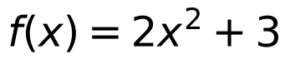 and 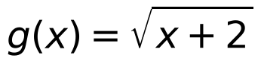 .
i) State the domain of 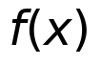 and 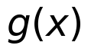 .
(2 marks)
ii) Determine 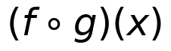 .
(3 marks)
b) Given that 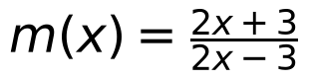 , find the value of x if 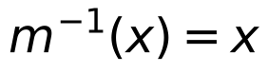 .
(5 marks)
QUESTION 2
a) Solve the inequality 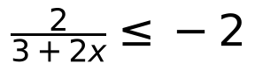 . Express the answer in interval notation.
(5 marks)
b) If 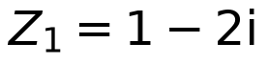 and 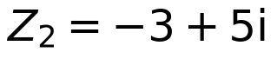 , state 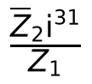 in standard form 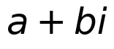 .
(5 marks)

QUESTION 3
a) Given two points 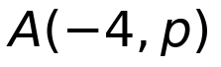 and 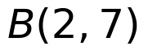 located on the equation 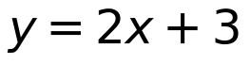 . Find the value of 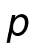 . Hence, find the equation of a straight line which is perpendicular to the line 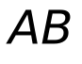 and passes through point 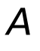 .
(5 marks)
b) Find the standard equation of circle where the diameter has endpoints 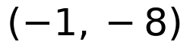 and 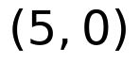 . Hence sketch the graph.
(5 marks)

QUESTION 4
a) Given that 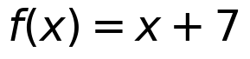 and 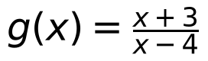 .
i) State the domain of and
(2 marks)
ii) Determine 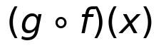 . Hence, find 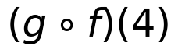 .
(3 marks)
iii) Find the value of 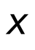 if 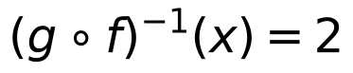
(4 marks)
b) Use synthetic division to show that 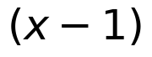 is not a factor of 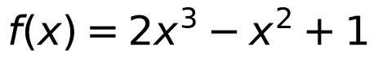 . Hence, state the quotient and remainder of .
(5 marks)
c) Find the value of if 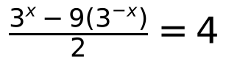 .
(6 marks)
d) Based on the graph of 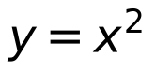 , sketch the graph of 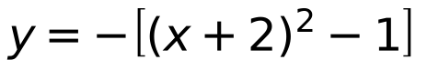 by using transformation technique. Hence, state the and 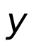 -intercept(s) (if any).
(5 marks)
END OF QUESTION PAPER

APPENDIX 1
Formula sheet (as supplied with the paper).


