CONFIDENTIAL  CS/MOCK NOV 2026/MAT133

UNIVERSITI TEKNOLOGI MARA
MARKING SCHEME

COURSE :
COURSE CODE :
EXAMINATION :
TIME :
PRE CALCULUS
MAT133
NOVEMBER 2026
2 HOURS

MARKING SCHEME NOTES

- This marking scheme accompanies the MAT133 mock paper (November 2026).
Answers are unofficial model answers generated from the printed past-paper question; they are not an official UTM marking scheme.

- Marking points follow the printed part labels and marks. Verify every model answer against the source page.

- Four questions: 10 + 10 + 10 + 25 marks; total = 55 marks.
- Questions: 4. Real recycled questions: 4. Placeholders: 0.
For local study use only; model answers are unofficial.

- Every question is a real MAT133 past-paper question; its source paper and page are printed with the answer.

FOR MARKERS' USE ONLY

This marking scheme consists of 4 printed pages
QUESTION 1 (10 marks)
Source: MAT133-2025-JUL, page(s) 2
Unofficial model answer — AI-generated, not an official UTM marking scheme.
a) Given that 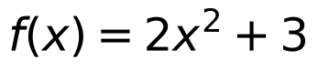 and 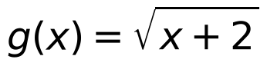 .
i) State the domain of 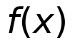 and 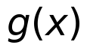 .
(2 marks)
ii) Determine 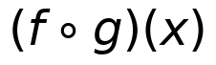 .
(3 marks)
Answer: Domain of 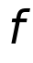: 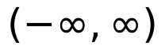; domain of 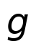: 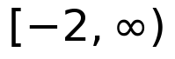 (i.e. 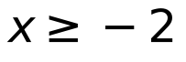). | 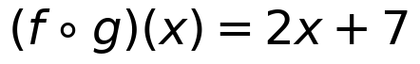 for .
• is a polynomial, so its domain is all real numbers.
• requires 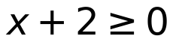, so .
• 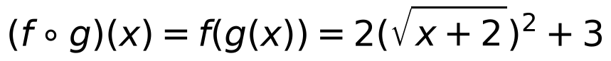
• 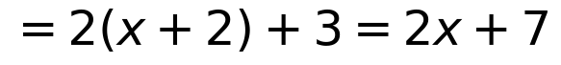
• Domain restriction from : .
b) Given that 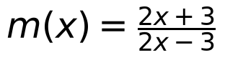 , find the value of x if 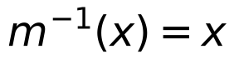 .
(5 marks)
Answer: 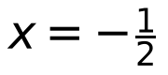 or 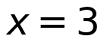
• Let 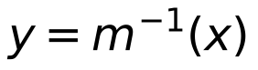. Then 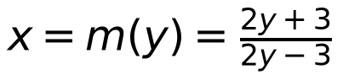.
• Solve for 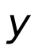: , 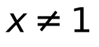.
• Set : 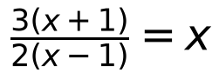.
• .
• 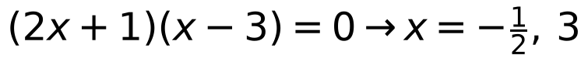. Both satisfy .
Assumptions: For part (a)(ii), the domain of the composite function is taken as the domain of , namely . No figure is required.
Model confidence: high.
QUESTION 2 (10 marks)
Source: MAT133-2021-JUL, page(s) 7
Unofficial model answer — AI-generated, not an official UTM marking scheme.
a) Solve the inequality 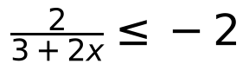 . Express the answer in interval notation.
(5 marks)
Answer: 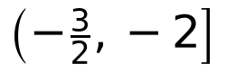
• 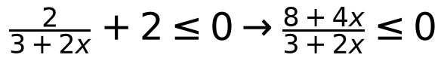
• 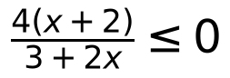
• Critical values: 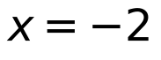 (included), 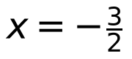 (excluded).
• Sign: positive on 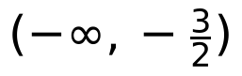, negative on 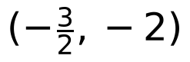, positive on 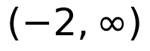.
• Solution: .
b) If 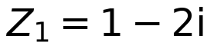 and 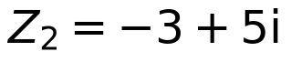 , state 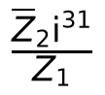 in standard form 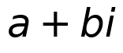 .
(5 marks)
Answer: 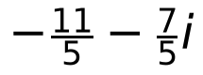
• 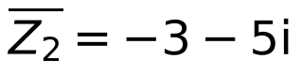
• 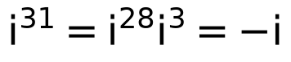
• 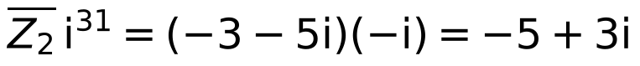
• 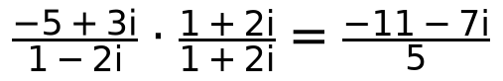
• 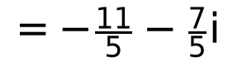
Model confidence: high.
QUESTION 3 (10 marks)
Source: MAT133-2022-FEB, page(s) 2
Unofficial model answer — AI-generated, not an official UTM marking scheme.
a) Given two points 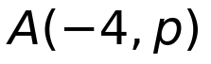 and 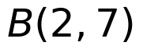 located on the equation 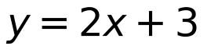 . Find the value of 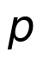 . Hence, find the equation of a straight line which is perpendicular to the line 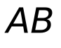 and passes through point 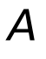 .
(5 marks)
Answer: 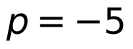. The perpendicular line through 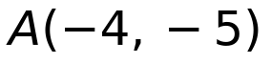 is 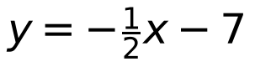, or equivalently 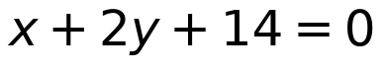.
• Since lies on , .
• Thus and line has slope 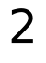 because it is .
• Perpendicular slope 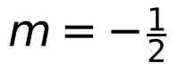.
• Using point-slope through : 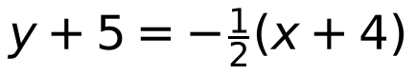.
• Simplify: , i.e. .
b) Find the standard equation of circle where the diameter has endpoints 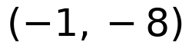 and 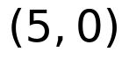 . Hence sketch the graph.
(5 marks)
Answer: Standard equation: 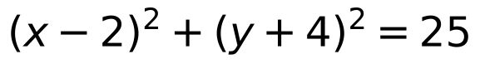. Sketch: circle with centre 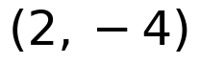 and radius 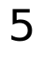, passing through the diameter endpoints and ; 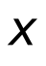-intercepts at 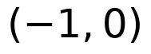 and ; -intercepts at 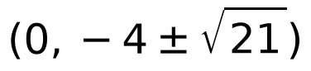.
• Centre 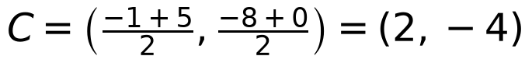.
• Diameter length , so radius 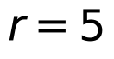.
• Standard form: 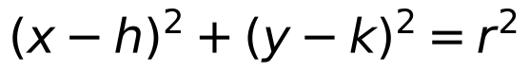 with 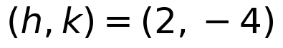, .
• Thus .
• Sketch as a circle centred at with radius ; label endpoints and .
Assumptions: The sketch in part b is described by its centre, radius and labelled diameter endpoints because JSON cannot contain a drawn graph.
Model confidence: high.
QUESTION 4 (25 marks)
Source: MAT133-2023-JUL, page(s) 3
Unofficial model answer — AI-generated, not an official UTM marking scheme.
a) Given that 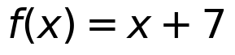 and 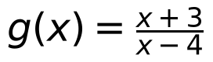 .
i) State the domain of and
(2 marks)
ii) Determine 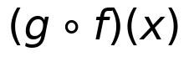 . Hence, find 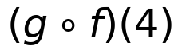 .
(3 marks)
iii) Find the value of if 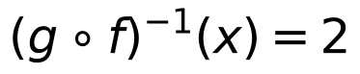
(4 marks)
Answer: i) Domain of : 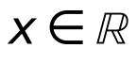; domain of : 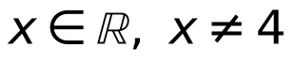. ii) 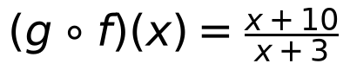 and 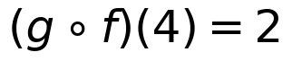. iii) 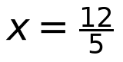.
• f(x)=x+7 is defined for all real x.
• g(x)=(x+3)/(x-4); denominator cannot be 0, so x-4≠0, i.e. x≠4.
• Need x+7≠4, so x≠ -3.
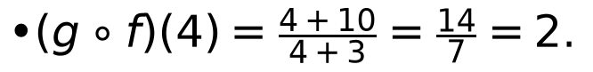
• Let h=g° f. h^-1(x)=2 ⇒ x=h(2).
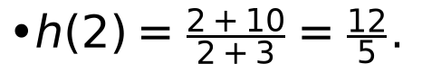
• Thus x=(12)/(5).
b) Use synthetic division to show that 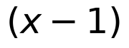 is not a factor of 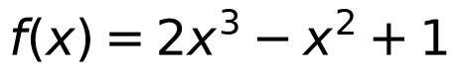 . Hence, state the quotient and remainder of .
(5 marks)
Answer: Quotient: 2x^2+x+1; Remainder: 2; hence (x-1) is not a factor.
• Synthetic division with c=1; coefficients of f(x)=2x^3-x^2+0x+1 are 2,-1,0,1.
• Bring down 2; multiply by 1 and add: 2(1)+(-1)=1; then 1(1)+0=1; then 1(1)+1=2.
• Quotient is 2x^2+x+1 and remainder is 2≠0.
c) Find the value of if 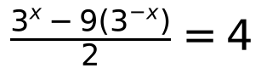 .
(6 marks)
Answer: x=2
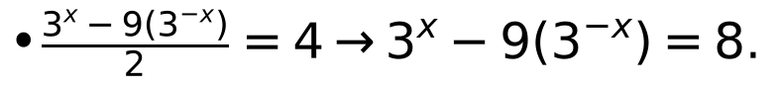
• Let y=3^x>0. Then y-(9)/(y)=8 ⇒ y^2-8y-9=0.
• (y-9)(y+1)=0. Since y>0, y=9.
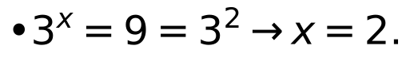
d) Based on the graph of 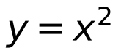 , sketch the graph of 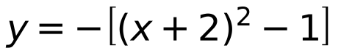 by using transformation technique. Hence, state the and -intercept(s) (if any).
(5 marks)
Answer: y=1-(x+2)^2; vertex (-2,1), opens downward; x-intercepts: (-3,0),(-1,0); y-intercept: (0,-3).
• Rewrite y=-[(x+2)^2-1]=-(x+2)^2+1.
• From y=x^2: shift left 2, reflect in the x-axis, then shift up 1.
• x-intercepts: set y=0 ⇒ (x+2)^2=1 ⇒ x=-3,-1.
Assumptions: For part (d), the sketch is described algebraically from the given equation; no additional graph features are assumed.
Model confidence: high.
END OF MARKING SCHEME

