CONFIDENTIAL CS/NOV 2026/MAT133

UNIVERSITI TEKNOLOGI MARA FINAL EXAMINATION

COURSE
COURSE CODE
EXAMINATION TIME
PRE CALCULUS
MAT133 NOVEMBER 2026
2 HOURS

INSTRUCTIONS TO CANDIDATES

- This question paper consists of four (4) questions.

- Answer ALL questions in the Answer Booklet. Start each answer on a new page.

- Do not bring any material into the examination room unless permission is given by the invigilator .
- Please check to make sure that this examination pack consists of: i) the Question Paper
  - a one - page Append ix 1
  - an Answer Booklet - provided by the Faculty
  - a graph paper - provided by the Faculty

- Answer ALL questions in English.

/

DO NOT TURN THIS PAGE UNTIL YOU ARE TOLD TO DO SO

This examination paper consists of 5 printed pages

QUESTION 1
a) Solve the inequality 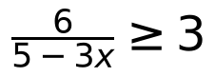 . Express the answer in interval notation.
(5 marks)
b) If 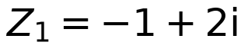 and 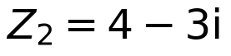 , state 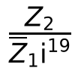 in standard form 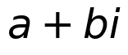 .
(5 marks)
QUESTION 2
a) Solve the inequality 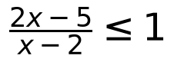 and express the solution in real number line.
(5 marks)
b) Given the equation 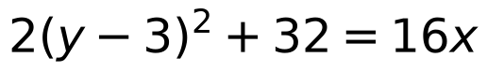 , find the standard form of the parabola, the vertex and the equation of directrix. Hence, sketch the parabola with correct vertex and directrix:
(5 marks)

QUESTION 3
a) Solve the inequality 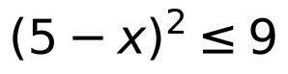 and express the solution in real number line.
(5 marks)
b) Write the equation of circle 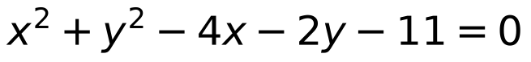 in standard form. Hence, sketch the circle with the correct center and radius.
(5 marks)

QUESTION 4
a) Given that 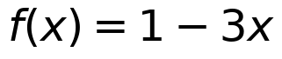 and 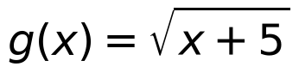 .
i) State the domain of 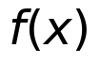 and 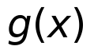 .
(2 marks)
ii) Find 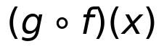 .
(3 marks)
iii) Find the value of 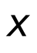 if 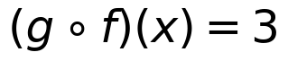 .
(4 marks)
b) Using synthetic division, find the value of 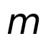 if 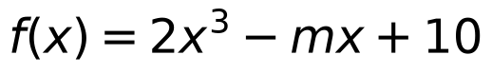 has a remainder of 18 when is divided by 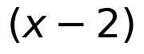 .
(5 marks)
c) Find the value of if .
(6 marks)
d) Based on the graph 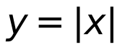 , sketch the graph for 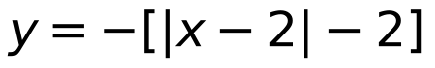 using transformation technique. Hence, state the 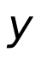 -intercept(s) (if any).
(5 marks)
END OF QUESTION PAPER

APPENDIX 1
Formula sheet (as supplied with the paper).


