CONFIDENTIAL CS/OCT 2026/MAT133

UNIVERSITI TEKNOLOGI MARA FINAL EXAMINATION

COURSE
COURSE CODE
EXAMINATION TIME
PRE CALCULUS
MAT133 OCTOBER 2026
2 HOURS

INSTRUCTIONS TO CANDIDATES

- This question paper consists of 5 questions.

- Answer ALL questions in the Answer Booklet. Start each answer on a new page.

- Do not bring any material into the examination room unless permission is given by the invigilator .
- Please check to make sure that this examination pack consists of: i) the Question Paper
  - a one - page Append ix 1
  - an Answer Booklet - provided by the Faculty
  - a graph paper - provided by the Faculty

- Answer ALL questions in English.

/

DO NOT TURN THIS PAGE UNTIL YOU ARE TOLD TO DO SO

This examination paper consists of 6 printed pages

QUESTION 1
a) Solve the compound inequality -6 < -3x - 5 < 6. Express the answer in interval notation.
(4 marks)
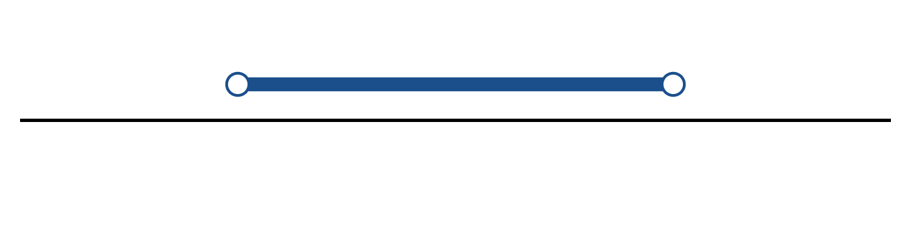
Figure: solution on a number line.
b) Solve the inequality |-4x - 6| > 8. Express the answer in interval notation and on a number line.
(5 marks)
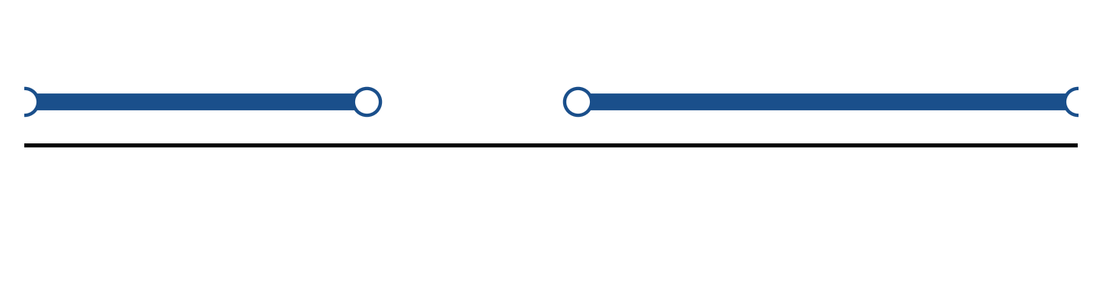
Figure: solution on a number line.
c) Sketch y = 3|x - 3| - 1. State the vertex, the y-intercept and any x-intercepts.
(5 marks)
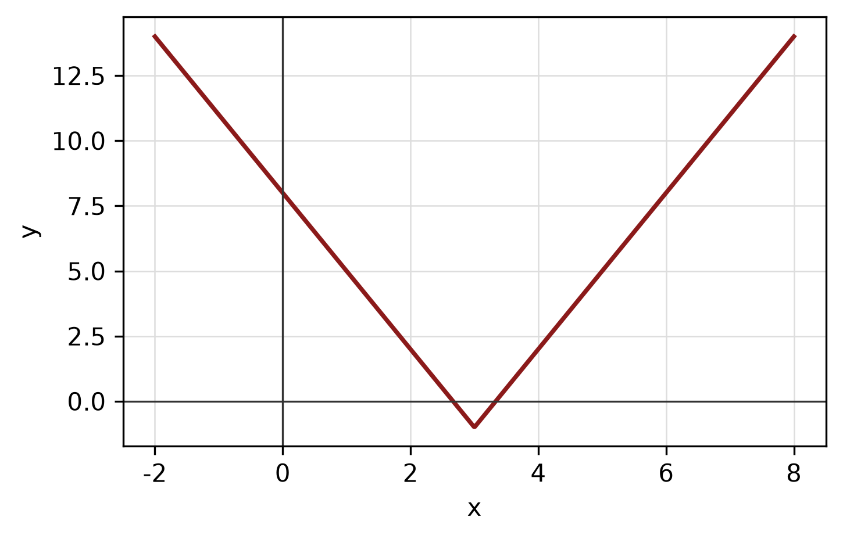
Figure: absolute-value graph.
QUESTION 2
a) Given f(x) = (6 - x)/(3x - 1), x ≠ 1/3, find f⁻¹(x) and state its domain.
(5 marks)
b) Given f(x) = 5 - 3x and g(x) = 1/(4x + 4), find (g ∘ f)(x) and state its domain.
(5 marks)
c) Find the equation of the line with x-intercept -1 and y-intercept -8.
(4 marks)
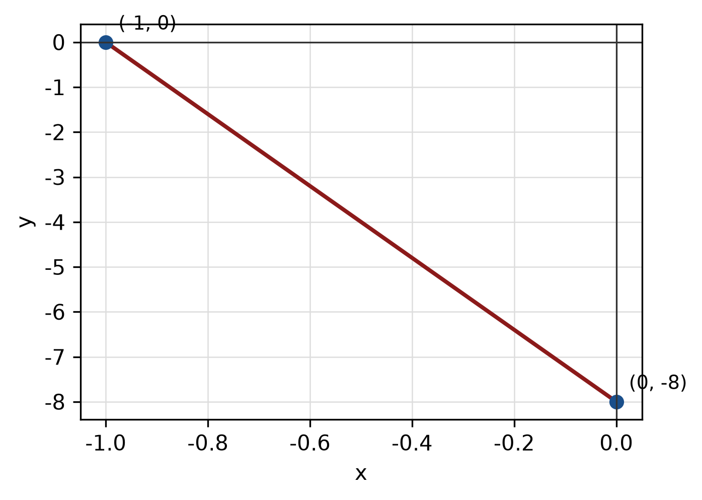
Figure: line and intercepts.
QUESTION 3
a) Given z₁ = -4 - 5i and z₂ = -6 - 4i, find z₁ + z₂ in the form a + bi.
(4 marks)
b) Evaluate i^11 and simplify completely.
(3 marks)
c) Use the remainder theorem to find the remainder when f(x) = 2x^3 + 5x² + x + 3 is divided by x + 4.
(3 marks)
QUESTION 4
a) Solve the simultaneous equations
y = x² + 6
y = x + 8.
(5 marks)
b) Solve the system of equations simultaneously:
-4x + 3y - z = 9
2x - y - 2z = -1
-x - y - 4z = 15
(5 marks)
c) Write the equation of the circle with centre (-3, -3) and radius 5. Hence write its general equation and sketch the circle.
(5 marks)
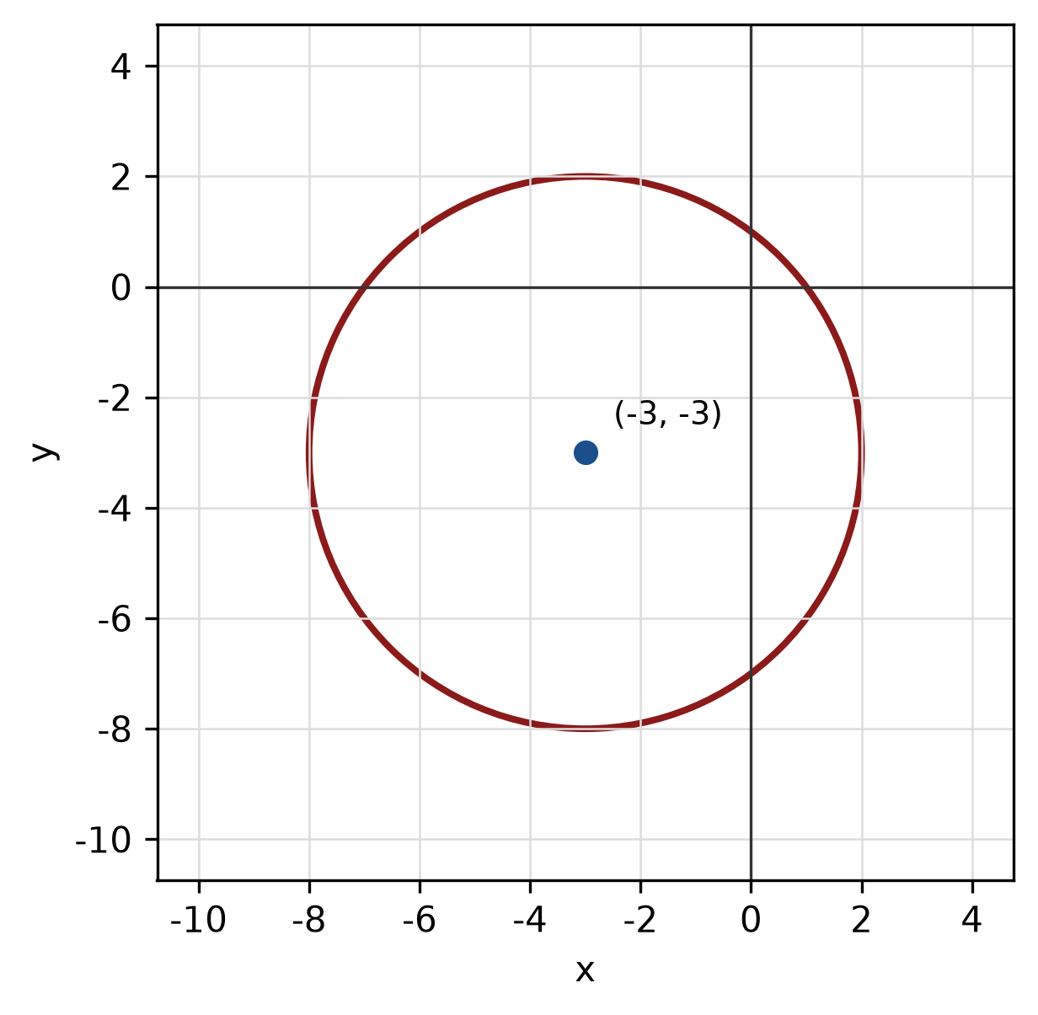
Figure: circle.
QUESTION 5
a) Prove the identity tan x + cos x/(1 + sin x) = sec x.
(5 marks)
b) A circle has radius 6 cm. Find the length of the arc subtended by a central angle of 120°.
(4 marks)
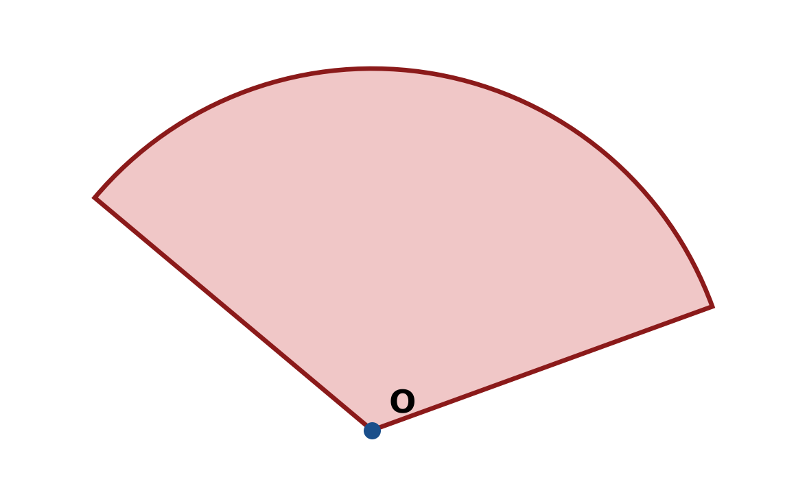
Figure: arc and sector.
c) In triangle ABC, b = 7 cm, c = 5 cm and A = 120°. Use the cosine rule to find a.
(4 marks)
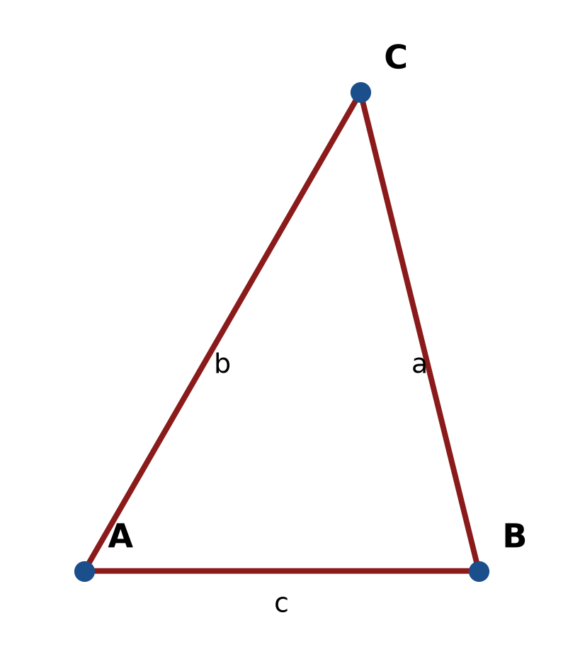
Figure: triangle ABC.
END OF QUESTION PAPER

APPENDIX 1
Formula sheet (as supplied with the paper).
sin² A + cos² A = 1 | tan² A + 1 = sec² A
sin(A + B) = sin A cos B + cos A sin B | tan 2A = 2 tan A / (1 − tan² A)
cos(A + B) = cos A cos B − sin A sin B | Arc length, s = rθ
tan(A − B) = (tan A − tan B) / (1 + tan A tan B) | Area of sector = ½r²θ
cos 2A = cos² A − sin² A | a / sin A = b / sin B = c / sin C
cos 2A = 1 − 2sin² A = 2cos² A − 1 | a² = b² + c² − 2bc cos A
sin 2A = 2 sin A cos A | Area of triangle = ½ab sin C

