CONFIDENTIAL CS/OCT 2026/MAT133

UNIVERSITI TEKNOLOGI MARA FINAL EXAMINATION

COURSE
COURSE CODE
EXAMINATION TIME
PRE CALCULUS
MAT133 OCTOBER 2026
2 HOURS

INSTRUCTIONS TO CANDIDATES

- This question paper consists of 5 questions.

- Answer ALL questions in the Answer Booklet. Start each answer on a new page.

- Do not bring any material into the examination room unless permission is given by the invigilator .
- Please check to make sure that this examination pack consists of: i) the Question Paper
  - a one - page Append ix 1
  - an Answer Booklet - provided by the Faculty
  - a graph paper - provided by the Faculty

- Answer ALL questions in English.

/

DO NOT TURN THIS PAGE UNTIL YOU ARE TOLD TO DO SO

This examination paper consists of 6 printed pages

QUESTION 1
a) Solve the rational inequality (-2x - 3)/(2x + 1) ≤ -2. Express the answer in interval notation.
(5 marks)
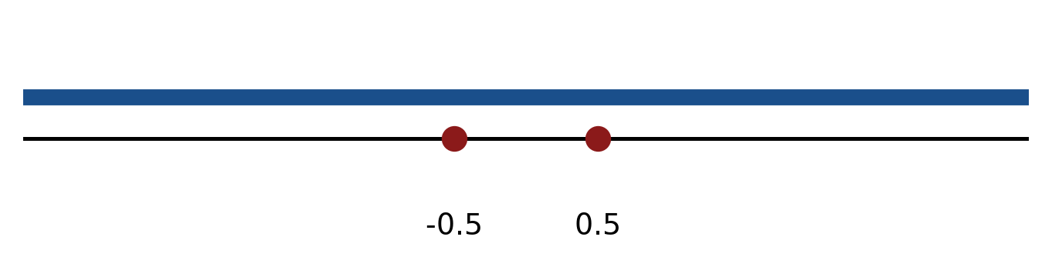
Figure: critical values.
b) Solve the inequality |-2x - 2| > 6. Express the answer in interval notation and on a number line.
(5 marks)
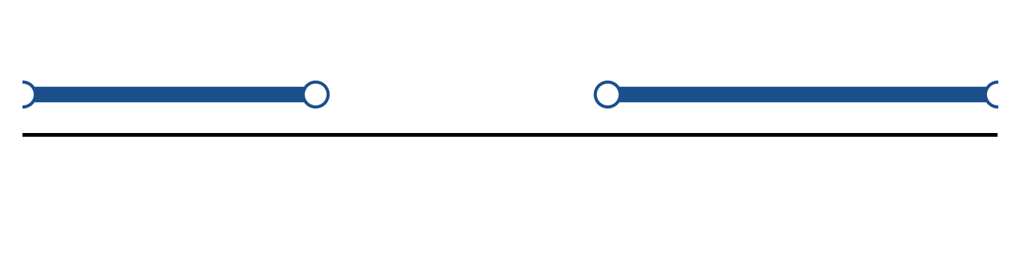
Figure: solution on a number line.
c) Sketch y = 3|x - 4| + 4. State the vertex, the y-intercept and any x-intercepts.
(5 marks)
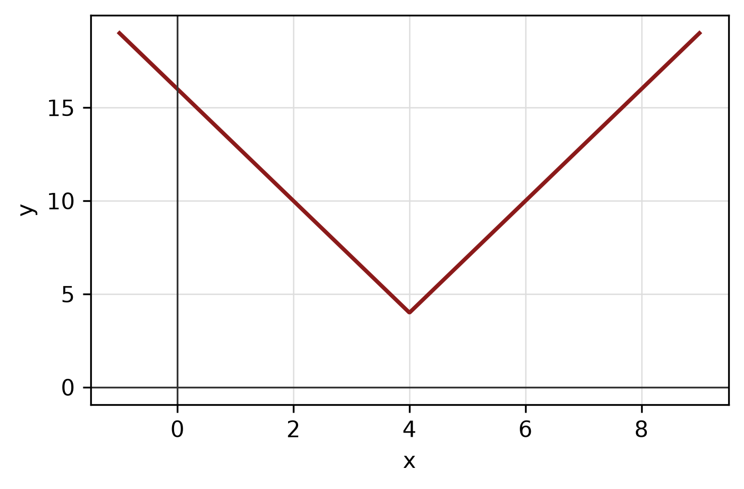
Figure: absolute-value graph.
QUESTION 2
a) Apply graph-transformation techniques to sketch y = -2(x - 5)² - 2. State the vertex and the y-intercept.
(5 marks)
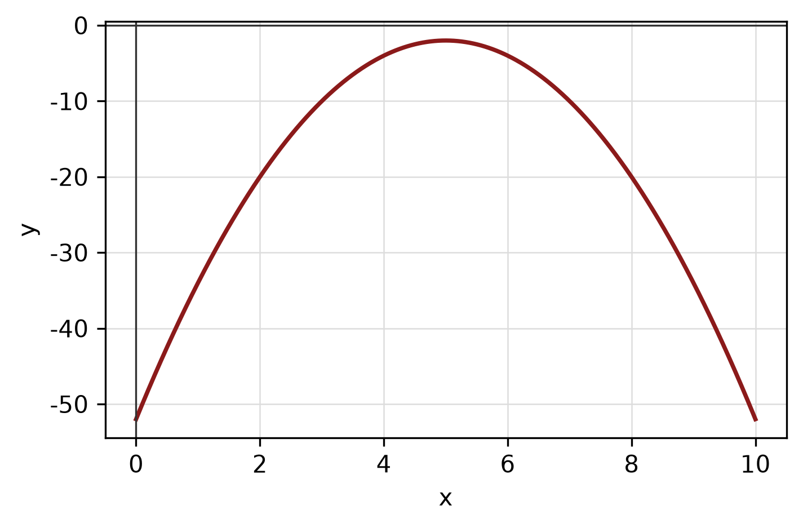
Figure: transformed graph.
b) Determine algebraically whether f(x) = x^4 - x² + 5 is even, odd or neither. State the symmetry of its graph.
(4 marks)
c) Sketch the circle x² - 10x + y² - 10y + 41 = 0. State its centre and radius.
(4 marks)
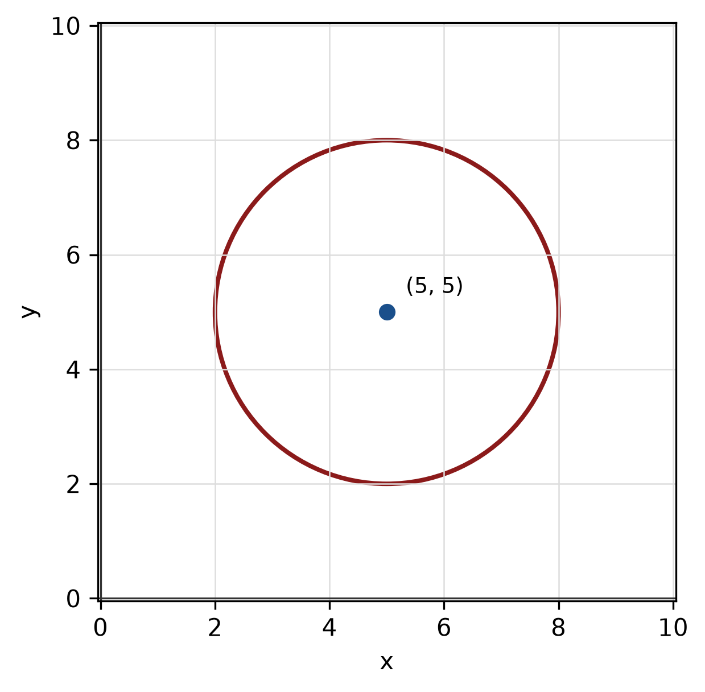
Figure: circle.
QUESTION 3
a) Given z₁ = -3 + 3i and z₂ = -6 - 4i, find z₁ + z₂ in the form a + bi.
(4 marks)
b) Find the modulus and argument of z = -7 + 24i. Give the argument in degrees correct to one decimal place.
(5 marks)
c) Factorise f(x) = -2x^3 + 10x² - 4x - 16 completely.
(5 marks)
QUESTION 4
a) Solve the system of equations simultaneously:
2x - 2y - z = 9
2x + 2y - z = -7
2x + y + 2z = 6
(5 marks)
b) Solve the simultaneous equations
y = x² - 6
y = -3x - 8.
(5 marks)
c) Write y = -x²/8 - x/4 + 23/8 in standard form. Hence state the vertex, focus and directrix, and sketch the parabola.
(5 marks)
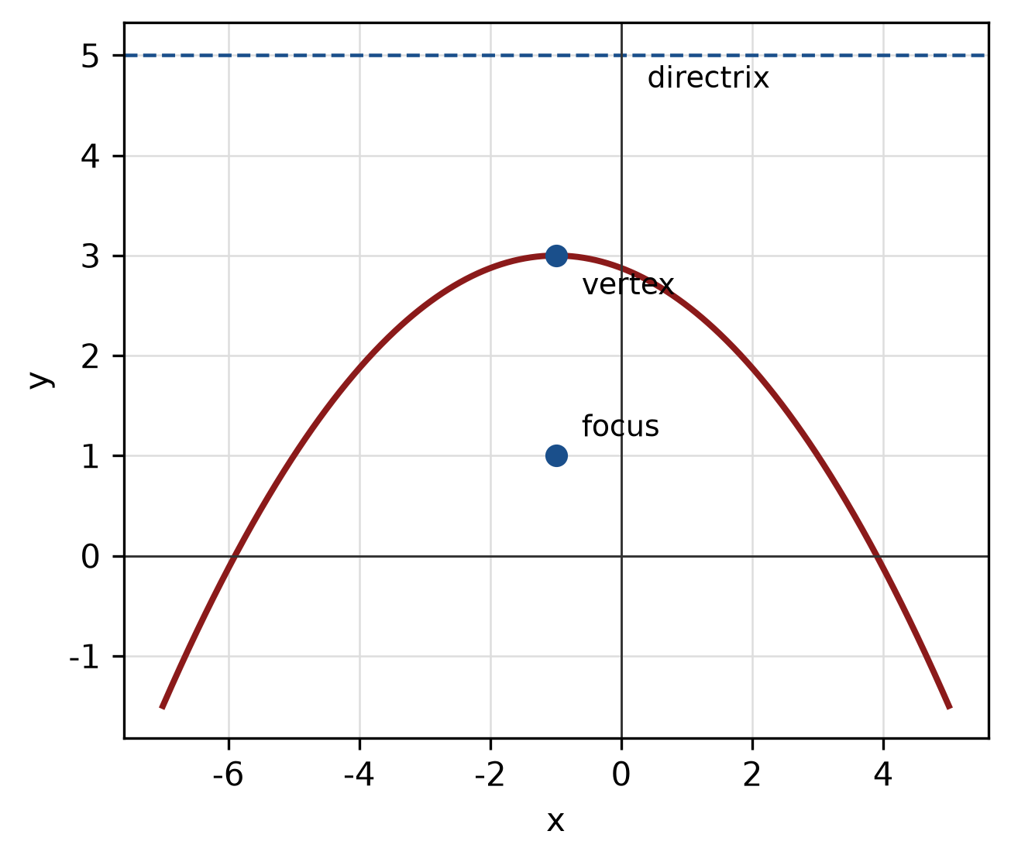
Figure: parabola.
QUESTION 5
a) Prove the identity sin² x/(1 - cos x) = 1 + cos x.
(5 marks)
b) Find the area of the sector of a circle with radius 6 cm and central angle 150°.
(4 marks)
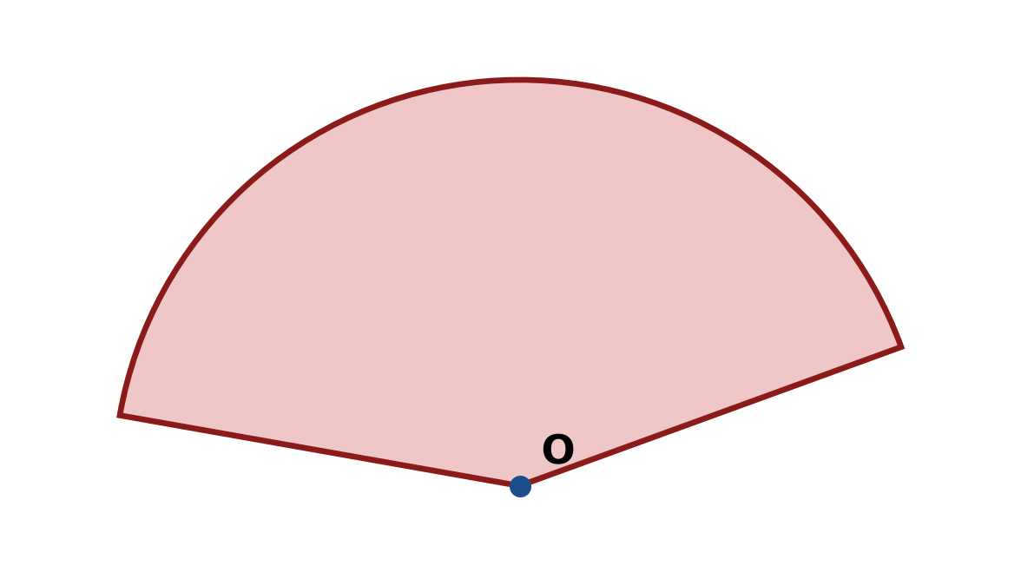
Figure: sector.
c) Find the area of triangle ABC with a = 7 cm, b = 12 cm and included angle C = 30°.
(4 marks)
END OF QUESTION PAPER

APPENDIX 1
Formula sheet (as supplied with the paper).
sin² A + cos² A = 1 | tan² A + 1 = sec² A
sin(A + B) = sin A cos B + cos A sin B | tan 2A = 2 tan A / (1 − tan² A)
cos(A + B) = cos A cos B − sin A sin B | Arc length, s = rθ
tan(A − B) = (tan A − tan B) / (1 + tan A tan B) | Area of sector = ½r²θ
cos 2A = cos² A − sin² A | a / sin A = b / sin B = c / sin C
cos 2A = 1 − 2sin² A = 2cos² A − 1 | a² = b² + c² − 2bc cos A
sin 2A = 2 sin A cos A | Area of triangle = ½ab sin C

