CONFIDENTIAL CS/OCT 2026/MAT133

UNIVERSITI TEKNOLOGI MARA FINAL EXAMINATION

COURSE
COURSE CODE
EXAMINATION TIME
PRE CALCULUS
MAT133 OCTOBER 2026
2 HOURS

INSTRUCTIONS TO CANDIDATES

- This question paper consists of 5 questions.

- Answer ALL questions in the Answer Booklet. Start each answer on a new page.

- Do not bring any material into the examination room unless permission is given by the invigilator .
- Please check to make sure that this examination pack consists of: i) the Question Paper
  - a one - page Append ix 1
  - an Answer Booklet - provided by the Faculty
  - a graph paper - provided by the Faculty

- Answer ALL questions in English.

/

DO NOT TURN THIS PAGE UNTIL YOU ARE TOLD TO DO SO

This examination paper consists of 6 printed pages

QUESTION 1
a) Solve the inequality 2 - 4x < -6. Express the answer in interval notation.
(4 marks)
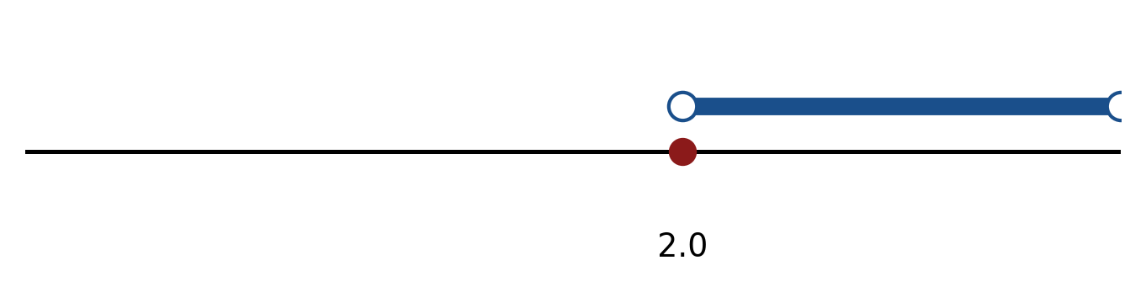
Figure: solution on a number line.
b) Solve the inequality |5x + 2| < 3. Express the answer in interval notation and on a number line.
(5 marks)
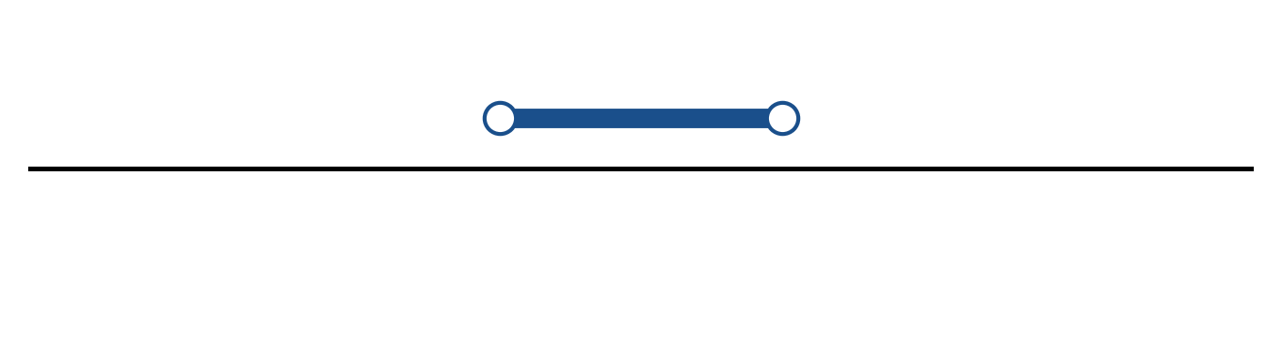
Figure: solution on a number line.
c) Sketch y = 2|x - 3| + 5. State the vertex, the y-intercept and any x-intercepts.
(5 marks)
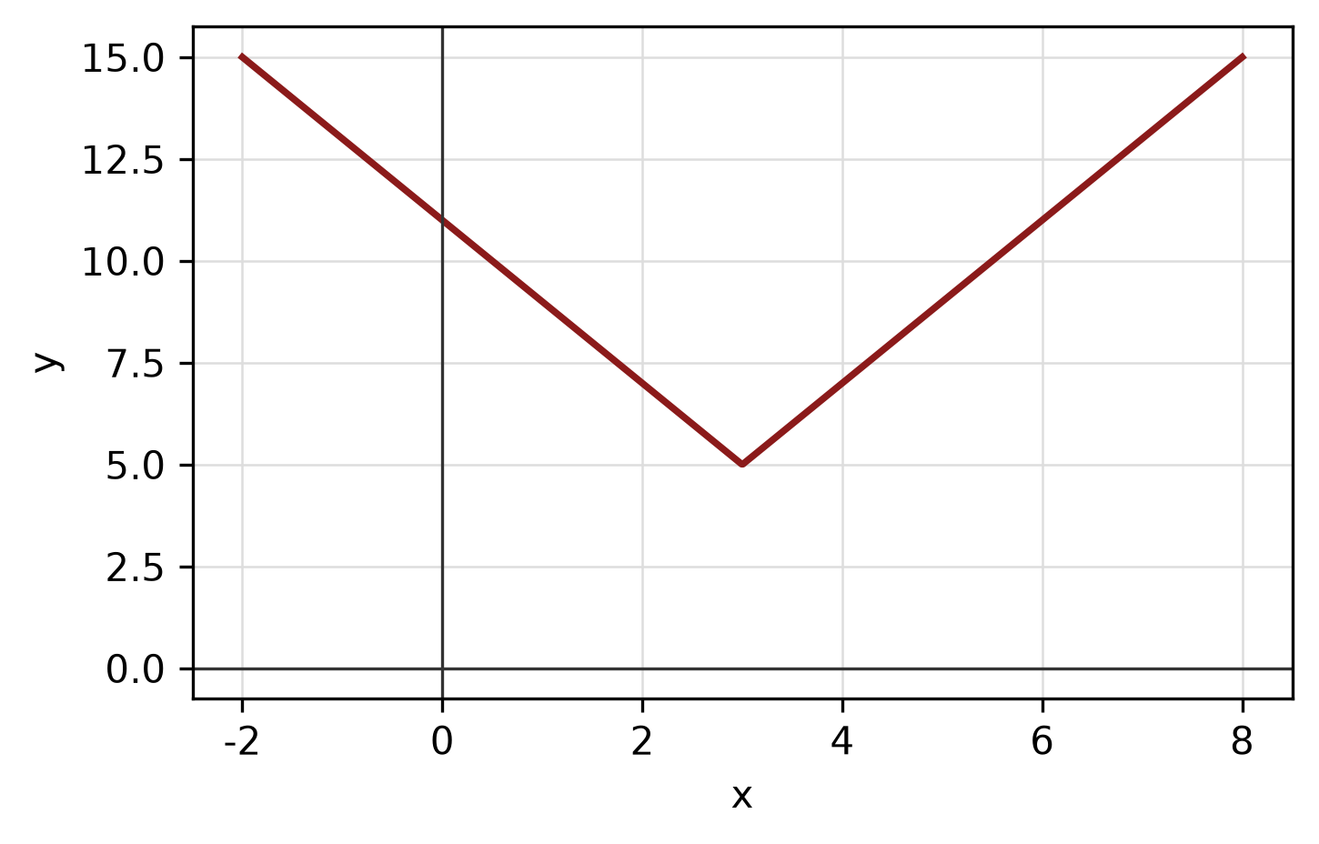
Figure: absolute-value graph.
QUESTION 2
a) Given f(x) = 2x - 6 and g(x) = -5/(x - 5), find (g ∘ f)(x) and state its domain.
(5 marks)
b) Given f(x) = (1 - 4x)/(x + 3) and g(x) = √(3x + 3), state the domain of each function.
(4 marks)
c) Find the equation of the straight line passing through (1, -3) and (5, 0).
(4 marks)
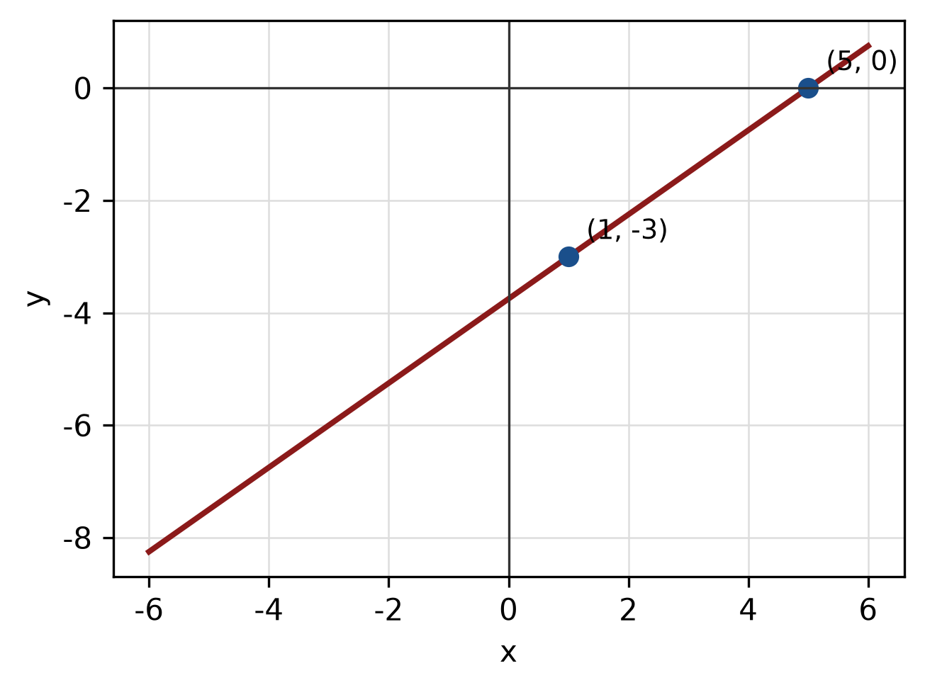
Figure: line through the two points.
QUESTION 3
a) Given z₁ = 2 - 4i and z₂ = 5 + i, find z₁ - z₂ in the form a + bi.
(4 marks)
b) Evaluate i^33 and simplify completely.
(3 marks)
c) Solve the logarithmic equation log_2(x) + log_2(x - 14) = 5.
(5 marks)
QUESTION 4
a) Solve the simultaneous equations
y = x² - 4
y = x + 8.
(5 marks)
b) Write a system of inequalities that describes the shaded triangular region with vertices (0, 0), (4, 0) and (0, 5).
(5 marks)
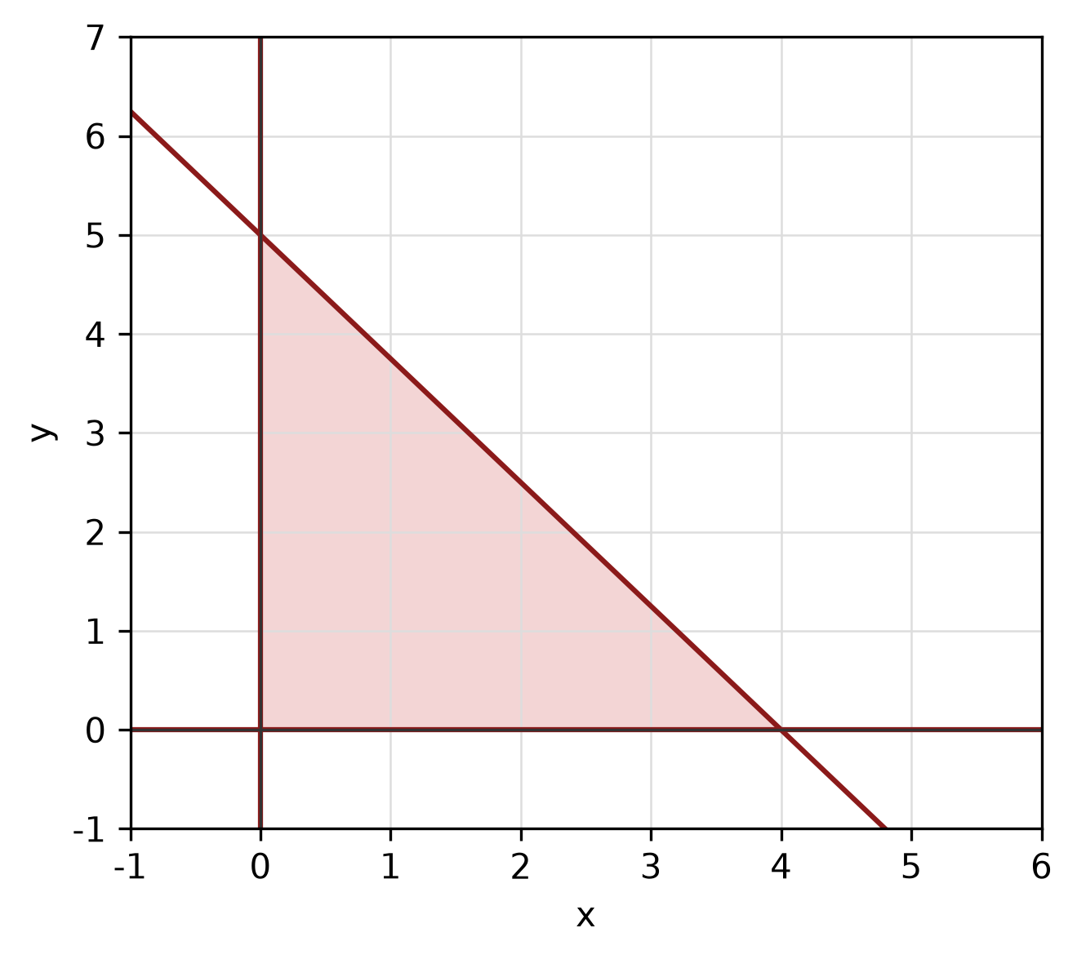
Figure: shaded triangular region.
c) Write the equation of the circle with centre (-4, -2) and radius 4. Hence write its general equation and sketch the circle.
(5 marks)
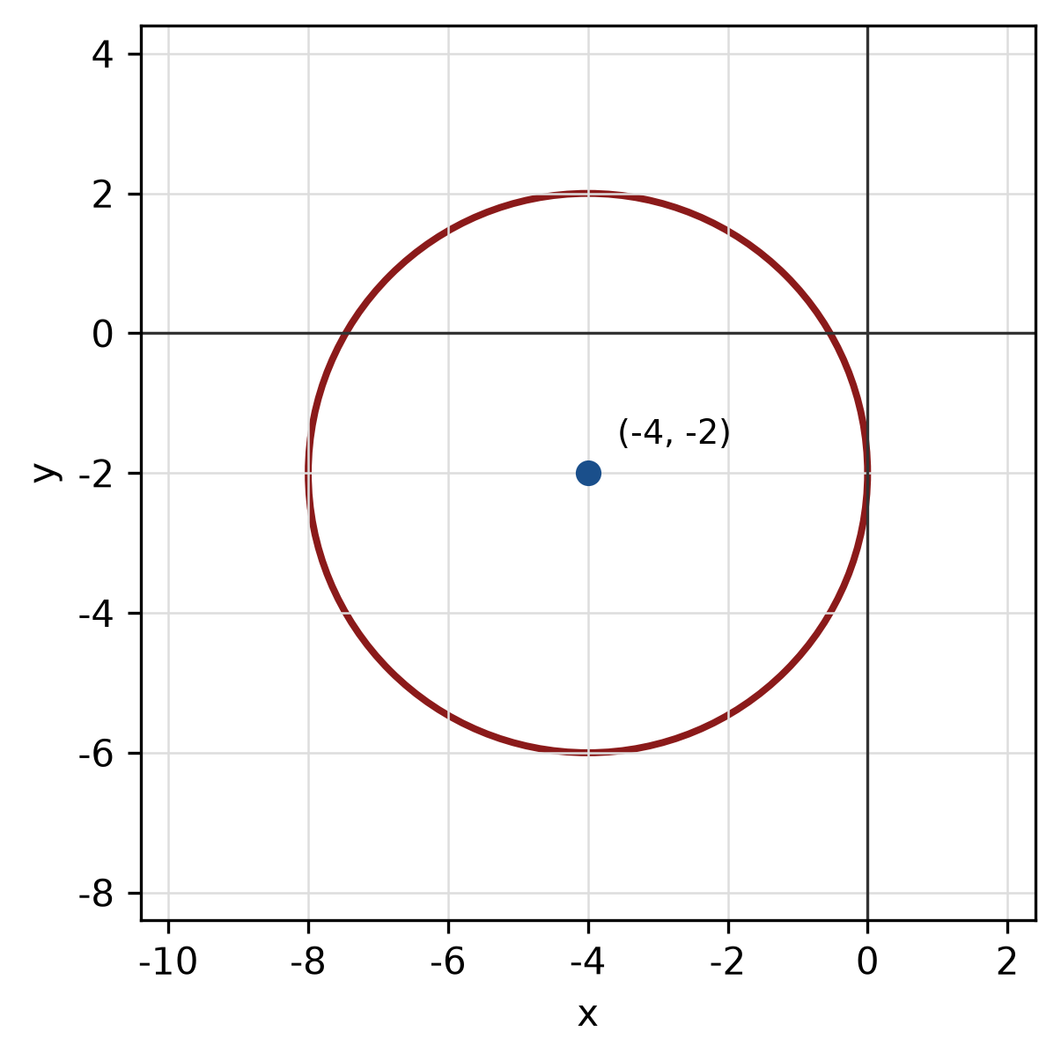
Figure: circle.
QUESTION 5
a) Prove the identity sin² x/(1 - cos x) = 1 + cos x.
(5 marks)
b) Find the perimeter of the sector with radius 9 cm and central angle 120°.
(4 marks)
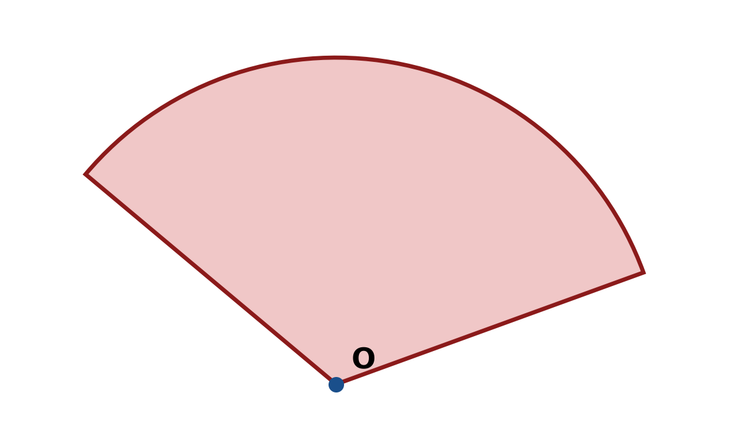
Figure: sector.
c) A right triangle has legs 9 cm and 8 cm. A sector of radius 3 cm and angle 90° is cut from it. Find the area of the remaining shaded region.
(5 marks)
END OF QUESTION PAPER

APPENDIX 1
Formula sheet (as supplied with the paper).
sin² A + cos² A = 1 | tan² A + 1 = sec² A
sin(A + B) = sin A cos B + cos A sin B | tan 2A = 2 tan A / (1 − tan² A)
cos(A + B) = cos A cos B − sin A sin B | Arc length, s = rθ
tan(A − B) = (tan A − tan B) / (1 + tan A tan B) | Area of sector = ½r²θ
cos 2A = cos² A − sin² A | a / sin A = b / sin B = c / sin C
cos 2A = 1 − 2sin² A = 2cos² A − 1 | a² = b² + c² − 2bc cos A
sin 2A = 2 sin A cos A | Area of triangle = ½ab sin C

