CONFIDENTIAL CS/OCT 2026/MAT133

UNIVERSITI TEKNOLOGI MARA FINAL EXAMINATION

COURSE
COURSE CODE
EXAMINATION TIME
PRE CALCULUS
MAT133 OCTOBER 2026
2 HOURS

INSTRUCTIONS TO CANDIDATES

- This question paper consists of 5 questions.

- Answer ALL questions in the Answer Booklet. Start each answer on a new page.

- Do not bring any material into the examination room unless permission is given by the invigilator .
- Please check to make sure that this examination pack consists of: i) the Question Paper
  - a one - page Append ix 1
  - an Answer Booklet - provided by the Faculty
  - a graph paper - provided by the Faculty

- Answer ALL questions in English.

/

DO NOT TURN THIS PAGE UNTIL YOU ARE TOLD TO DO SO

This examination paper consists of 7 printed pages

QUESTION 1
a) Solve the inequality -x² + 2x + 15 ≥ 0.
(5 marks)
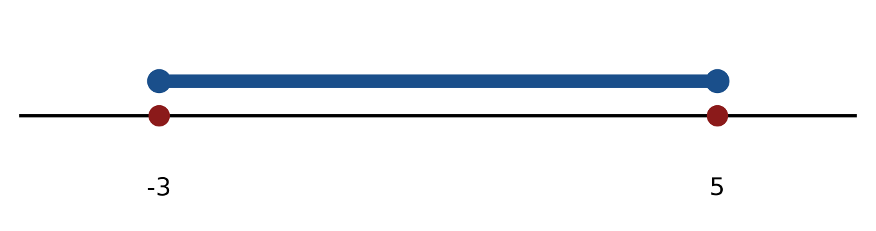
Figure: critical values.
b) Solve the inequality |x + 5| ≤ 2. Express the answer in interval notation and on a number line.
(5 marks)
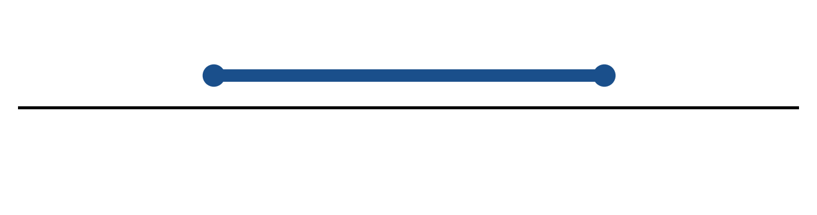
Figure: solution on a number line.
c) Sketch y = 2|x - 3| + 1. State the vertex, the y-intercept and any x-intercepts.
(5 marks)
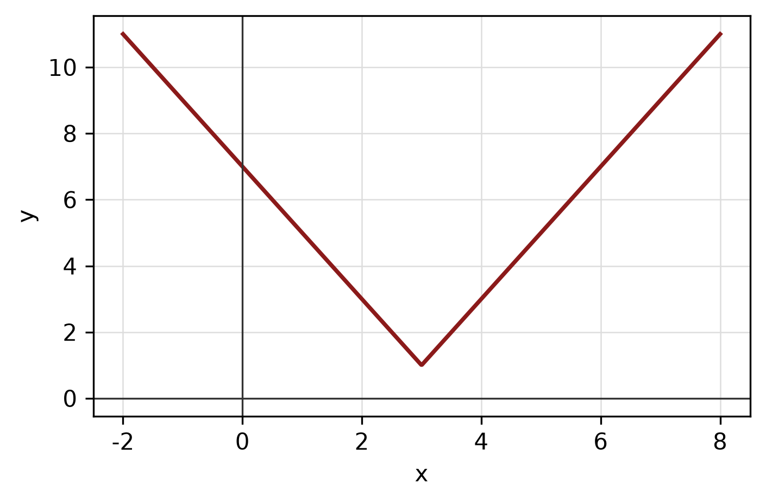
Figure: absolute-value graph.
QUESTION 2
a) Given f(x) = (4x - 6)/(3x + 5), x ≠ -5/3, find f⁻¹(x) and state its domain.
(5 marks)
b) Apply graph-transformation techniques to sketch y = -3(x - 5)² - 3. State the vertex and the y-intercept.
(5 marks)
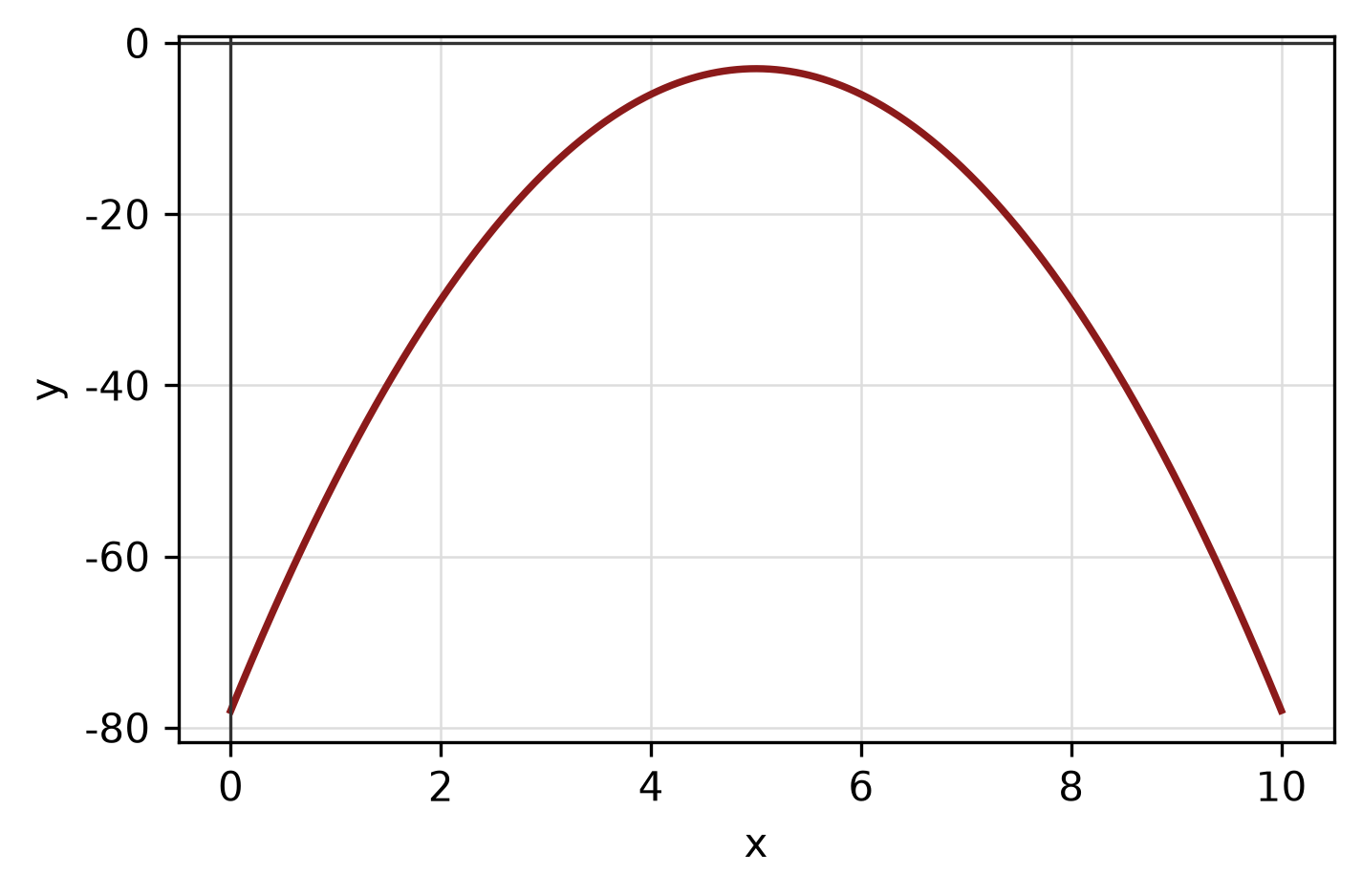
Figure: transformed graph.
c) Write x² + 8x + y² - 4y - 5 = 0 in standard form. Hence state the centre and radius and sketch the circle.
(5 marks)
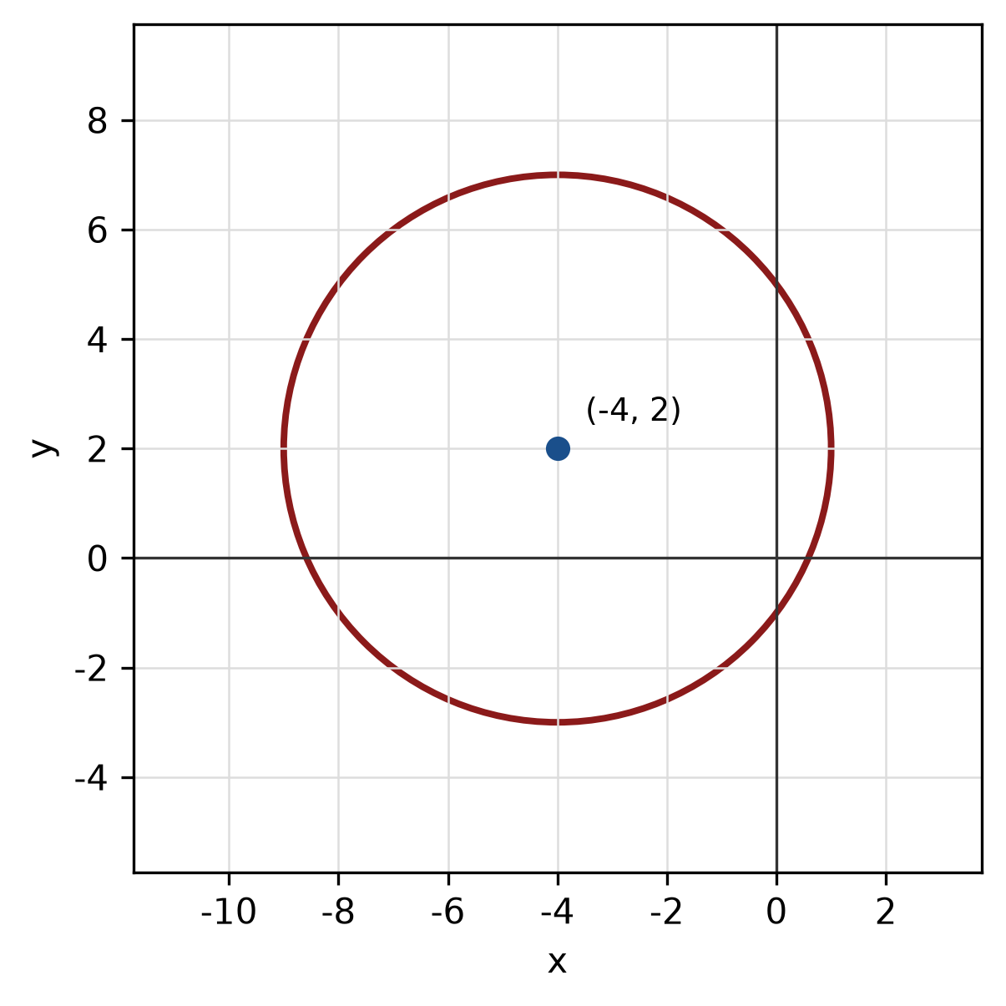
Figure: circle.
QUESTION 3
a) Given z₁ = 4 - 3i and z₂ = 3 - 5i, find z₁ + z₂ in the form a + bi.
(4 marks)
b) Find the modulus and argument of z = 3 + 4i. Give the argument in degrees correct to one decimal place.
(5 marks)
c) Use the remainder theorem to find the remainder when f(x) = 2x^3 + 5x² + 3x + 4 is divided by x - 2.
(3 marks)
QUESTION 4
a) Solve the system of equations simultaneously:
-2x + y - 3z = 5
2x - y + 2z = -1
-x + y + 3z = -17
(5 marks)
b) Graph the system of inequalities below and shade the feasible region. State the vertices of the region.
x ≥ 0, y ≥ 0, 3x + 1y ≤ 5.
(5 marks)
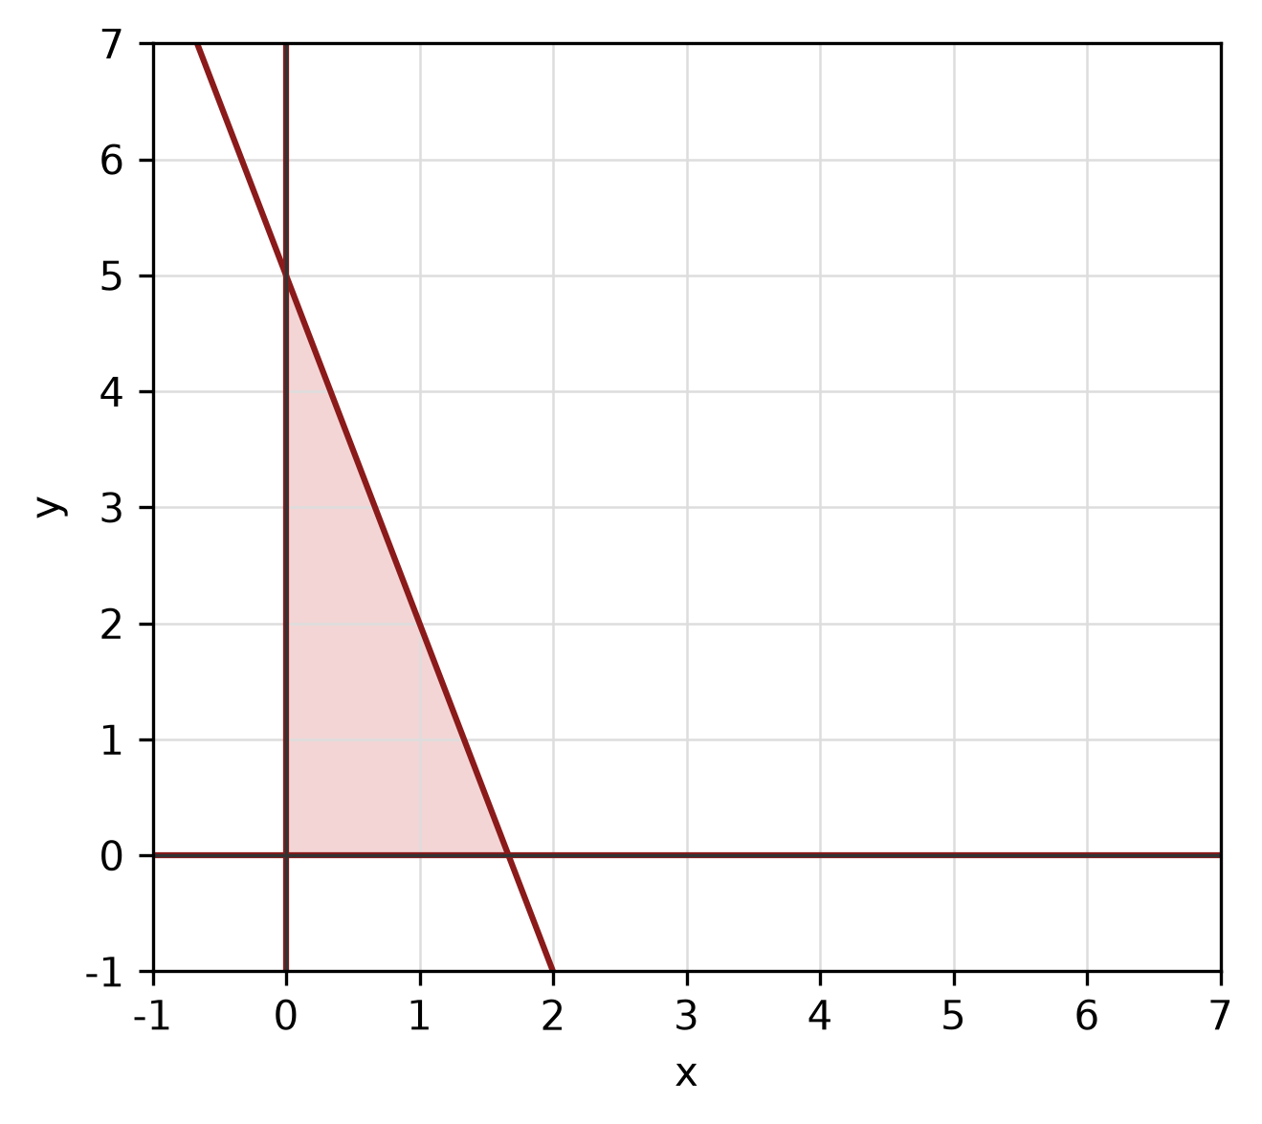
Figure: feasible region.
c) Find the equation of the straight line passing through (0, 0) and (2, -4).
(4 marks)
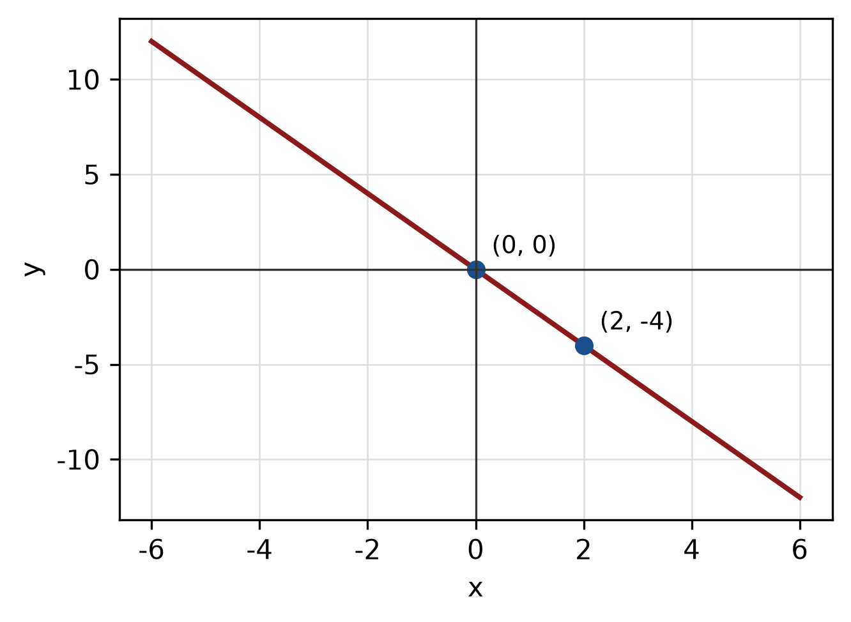
Figure: line through the two points.
QUESTION 5
a) Prove the identity sin² x/(1 - cos x) = 1 + cos x.
(5 marks)
b) Find the perimeter of the sector with radius 11 cm and central angle 30°.
(4 marks)
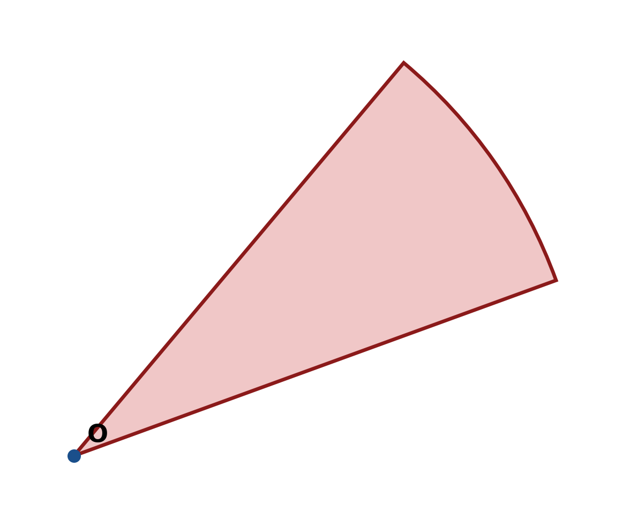
Figure: sector.
c) In triangle ABC, b = 11 cm, c = 7 cm and A = 90°. Use the cosine rule to find a.
(4 marks)
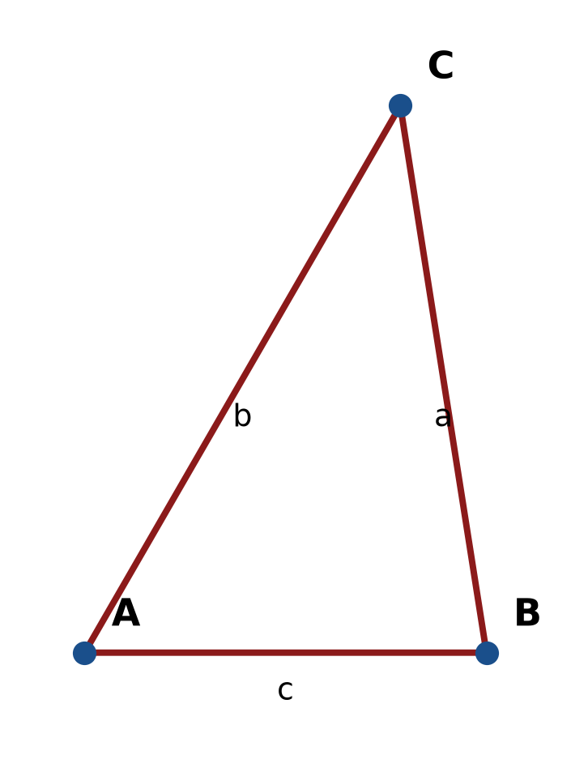
Figure: triangle ABC.
END OF QUESTION PAPER

APPENDIX 1
Formula sheet (as supplied with the paper).
sin² A + cos² A = 1 | tan² A + 1 = sec² A
sin(A + B) = sin A cos B + cos A sin B | tan 2A = 2 tan A / (1 − tan² A)
cos(A + B) = cos A cos B − sin A sin B | Arc length, s = rθ
tan(A − B) = (tan A − tan B) / (1 + tan A tan B) | Area of sector = ½r²θ
cos 2A = cos² A − sin² A | a / sin A = b / sin B = c / sin C
cos 2A = 1 − 2sin² A = 2cos² A − 1 | a² = b² + c² − 2bc cos A
sin 2A = 2 sin A cos A | Area of triangle = ½ab sin C

