
CONFIDENTIAL CS/NOV 2026/CSC429

UNIVERSITI TEKNOLOGI MARA FINAL EXAMINATION

COURSE
COURSE CODE
EXAMINATION TIME
COMPUTER ORGANIZATION AND ARCHITECTURE

CSC429
NOVEMBER 2026
3 HOURS

INSTRUCTIONS TO CANDIDATES

- This question paper consists of two (2) parts: PART A (10 Questions) PART B (1 Question)

- Answer ALL questions in the Answer Booklet. Start each answer on a new page.

- Do not bring any material into the examination room unless permission is given by the invigilator .
- Please check to make sure that this examination pack consists of: i) the Question Paper
  - an Answer Booklet - provided by the Faculty

- Answer ALL questions in English.

DO NOT TURN THIS PAGE UNTIL YOU ARE TOLD TO DO SO

This examination paper consists of 5 printed pages.

PART A (80 MARKS)
Answer ALL questions in this part.

QUESTION A1 (5 marks)
- List TWO (2) advantages of SMP organization.
- Define cluster organization.
- Give ONE (1) benefit of cluster organization.

QUESTION A2 (5 marks)
Convert 2.5 to IEEE 754 single-precision format. Give the answer in hexadecimal and show the sign, exponent and mantissa fields.

QUESTION A3 (5 marks)
Given the following Figure 2.

- Label the addressing technique illustrated in Figure 2.
- Explain how the addressing technique in 9(a) is used.
List ONE (1) advantage and ONE (1) disadvantage of the addressing technique in

QUESTION A4 (5 marks)
Identify the correct generation based on the following descriptions.
- The production of personal computer marks the main feature of this generation. The price of computer during this period is the lowest compared to the other generation. It provides fast processing ability with less power consumption.
- Machines that emulate human intelligence which can process and respond to natural language is developed in this generation.
- In this generation, air condition is no longer required because the heat produced by the machine is reduced. However, fan is needed for heat discharging.
- Integrated circuit comprises of a number of transistors, resistors and capacitors are invented by Jack Kilby in this generation.
- Assembly language is introduced during this generation to replace machine language for more reliable and improved performance.

QUESTION A5 (10 marks)
- Why input/output problem occurs?
- Describe THREE (3) categories for input/output module and provide an appropriate example each.

QUESTION A6 (10 marks)
- When is an l/O module installed?
- What will happen if the l/O module is not installed?
- Explain ONE (1) category of l/O module
- What does it mean by 'hot connection'?
- List THREE (3) common interfaces to external devices.

QUESTION A7 (10 marks)
Answer both parts for the same expression. Assume an 8-bit byte.
Expression: -35 - 24
- Calculate -35 - 24 using sign and magnitude.
- Calculate -35 - 24 using 1's and 2's complement.

QUESTION A8 (10 marks)
Computer consists of four main components as illustrated in Figure 1. Each component has its own function in ensuring that the computer system works well. Question 4 is based on
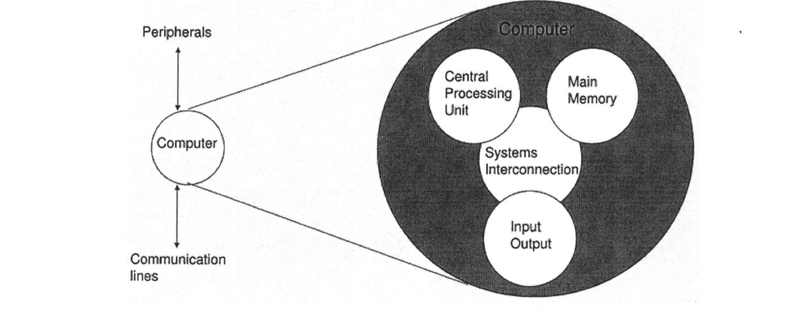
- Explain THREE (3) types of system interconnection.
- State TWO (2) sub-components of central processing unit and its function.

QUESTION A9 (10 marks)
- What is a cache?
- Elaborate on what will happen if there is no cache in the computer system,
- Comparing L1 and L2 cache, discuss which cache would have faster speed with relevant justification.
- Discuss TWO (2) policies to write data to the cache to ensure consistency between the cache and the main memory (RAM).

QUESTION A10 (10 marks)
- Draw a complete machine cycle by giving the exact location of each phase.
- Briefly, describe each phase in the machine cycle.

PART B (20 MARKS)
Answer the question in this part.

QUESTION B1 (20 marks)
Question 1 is based on Figure 2 and Table 1.

Write the appropriate programs using correct assembly language notations and comments to compute the equation represented in Figure 1 using zero-, one-, and three-address instructions. The instructions available for use are provided in Table 1. Register A, B, C, and D cannot be modified, and registers x, y, and z can be used as temporary registers. However, the final answer must be stored in Register y.
Zero-address | One-address | Three-address
PUSHp | LOADp | ADD (p,q,r)
POPp | STORp | SUB (p,q,r)
ADD | ADDp | MUL (p.q.r)
SUB | SUBp | DIV(p,q,r)
MUL | MULp
DIV | DIVp

