
CONFIDENTIAL CS/NOV 2026/CSC429

UNIVERSITI TEKNOLOGI MARA FINAL EXAMINATION

COURSE
COURSE CODE
EXAMINATION TIME
COMPUTER ORGANIZATION AND ARCHITECTURE

CSC429
NOVEMBER 2026
3 HOURS

INSTRUCTIONS TO CANDIDATES

- This question paper consists of two (2) parts: PART A (10 Questions) PART B (1 Question)

- Answer ALL questions in the Answer Booklet. Start each answer on a new page.

- Do not bring any material into the examination room unless permission is given by the invigilator .
- Please check to make sure that this examination pack consists of: i) the Question Paper
  - an Answer Booklet - provided by the Faculty

- Answer ALL questions in English.

DO NOT TURN THIS PAGE UNTIL YOU ARE TOLD TO DO SO

This examination paper consists of 5 printed pages.

PART A (80 MARKS)
Answer ALL questions in this part.

QUESTION A1 (5 marks)
The integrated circuit is an important milestone that marks the achievement in the history of computer development.
- ln which computer generation that the integrated circuil was first introduced?
- State the name of the inventor of the integrated circuit.
- What are the THREE (3) main components of integrated circuits?

QUESTION A2 (5 marks)
Convert 12.5 to IEEE 754 single-precision format. Give the answer in hexadecimal and show the sign, exponent and mantissa fields.

QUESTION A3 (5 marks)
Given the following Figure 2.

- Label the addressing technique illustrated in Figure 2.
- Explain how the addressing technique in 9(a) is used.
List ONE (1) advantage and ONE (1) disadvantage of the addressing technique in

QUESTION A4 (5 marks)
- List TWO (2) advantages of SMP organization.
- Define cluster organization.
- Give ONE (1) benefit of cluster organization.

QUESTION A5 (10 marks)
Keyboard is the most common means for computer interaction.
- Explain TWO (2) types of keyboard characters.
- Describe THREE (3) categories of input and output module. Give an appropriate example for each category.

QUESTION A6 (10 marks)
Answer both parts. Show your complete workflow.
a) Convert 291010 to hexadecimal.
b) Convert 29016 to decimal.
- Convert 291010 to hexadecimal.
- Convert 29016 to decimal.

QUESTION A7 (10 marks)
- List FOUR (4) types of access method for storage device with ONE (1) example for each of them.
- Calculate the total of memory location using 11 address bit.
- Calculate the address bits required for 2MB of RAM.

QUESTION A8 (10 marks)
Given that the size of the data bus is 32 bits, the size of the address bus is 8 bits, and the size of the control bus is 4 bits.
- Determine the size of the word and provide relevant justification.
- Determine the size of the register and provide relevant justification.
- Discuss what will happen if system interconnection is blocked from the perspective of the machine cycle.
- Elaborate the role of CPU interconnection.

QUESTION A9 (10 marks)
Question 7 is based on Figure 2.
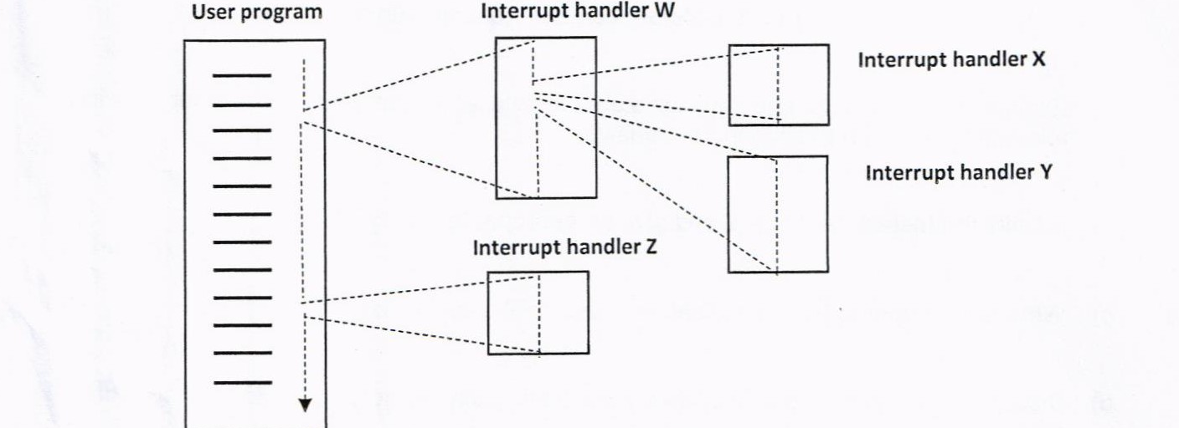
Define intenupt.
- ldentify the intemrpt that has the highest priority with relevant justification
- ldentify the interrupt that has the lowest priority with relevant justification
- Rank the sequence of the intem.rpt process completed ff the computer system applies the
- defined priority concept to handle multiple intemrpts. Rank the sequence of the interrupt process completed if the co mputer system aPPlies the
- disable nested interrupt concept to handle multiple interrupts'

QUESTION A10 (10 marks)
- List TWO (2) buses types that are available in the computer system.
- Differentiate TWO (2) characteristics of system interconnection and CPU interconnection.
- Explain the different types of data transfer timing.

PART B (20 MARKS)
Answer the question in this part.

QUESTION B1 (20 marks)
Question 1 is based on Figure 2 and Table 1.
Write an appropriate program using correct assembly language notations to compute the equation shown in Figure 2 using instructions for one-address, two-address, and three- address. The available instructions are provided in Table 1. The register labeled A, B, C, and D are fixed, while registers x, y, and z can be used temporarily. The final answer must be stored in register y.
One-address | Two-address | Three-address
LOADp | MOV (p,q) | ADD (p.q.r)
STORp | ADD (p,q) | SUB (p,q,r)
ADDp | SUB (p,q) | MUL (p.q.r)
SUBp | MUL (p,q) | DIV(p,q,r)
MULp | DIV(p,q)
DIVp

