
CONFIDENTIAL CS/NOV 2026/CSC429

UNIVERSITI TEKNOLOGI MARA FINAL EXAMINATION

COURSE
COURSE CODE
EXAMINATION TIME
COMPUTER ORGANIZATION AND ARCHITECTURE

CSC429
NOVEMBER 2026
3 HOURS

INSTRUCTIONS TO CANDIDATES

- This question paper consists of two (2) parts: PART A (10 Questions) PART B (1 Question)

- Answer ALL questions in the Answer Booklet. Start each answer on a new page.

- Do not bring any material into the examination room unless permission is given by the invigilator .
- Please check to make sure that this examination pack consists of: i) the Question Paper
  - an Answer Booklet - provided by the Faculty

- Answer ALL questions in English.

DO NOT TURN THIS PAGE UNTIL YOU ARE TOLD TO DO SO

This examination paper consists of 6 printed pages.

PART A (80 MARKS)
Answer ALL questions in this part.

QUESTION A1 (5 marks)
Artificial intelligence (A1) is the computer ability to exhibit human intelligent behaviors such as smart home applications, robots, intelligent tutoring systems and others.
- In which generation is A1 introduced?
- What is the programming language used for this technology?
- What is the advantage of embedding A1 in our everyday life?
- A1 can also posed as a threat to community. Discuss ONE (1) possible scenario when A1 can harm people.

QUESTION A2 (5 marks)
Given the following Figure 2.

- Label the addressing technique illustrated in Figure 2.
- Explain how the addressing technique in 9(a) is used.
List ONE (1) advantage and ONE (1) disadvantage of the addressing technique in

QUESTION A3 (5 marks)
Convert 277410 to binary. Show your complete workflow.

QUESTION A4 (5 marks)
Given the following Non Uniform Memory Access (NUMA) diagram.
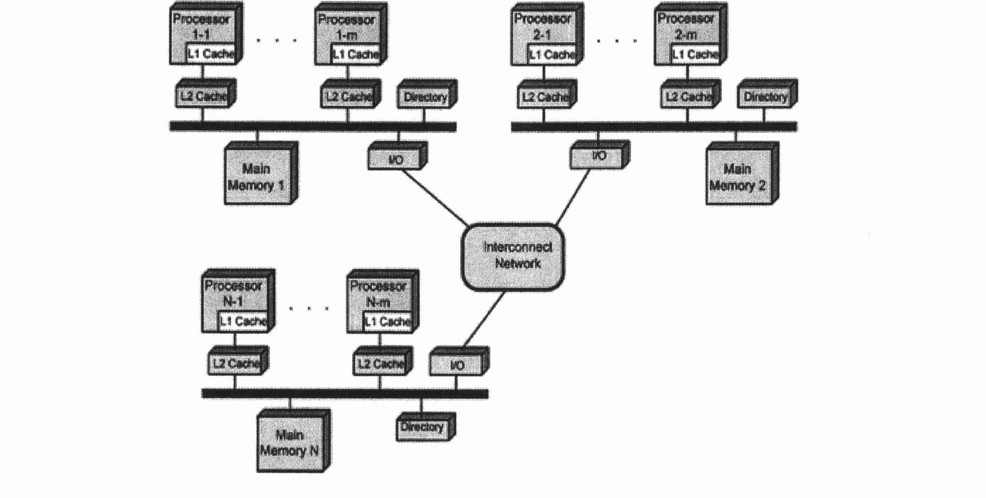
- State ONE (1) advantage of Symmetric Multi-Processor (SMP) that is applied in NUMA architecture.
- Describe ONE (1) disadvantage of cluster architecture.
- Draw a possible architecture for cluster architecture based on Figure 3.

QUESTION A5 (10 marks)
Question 9 is based on Figure 1. computer system.
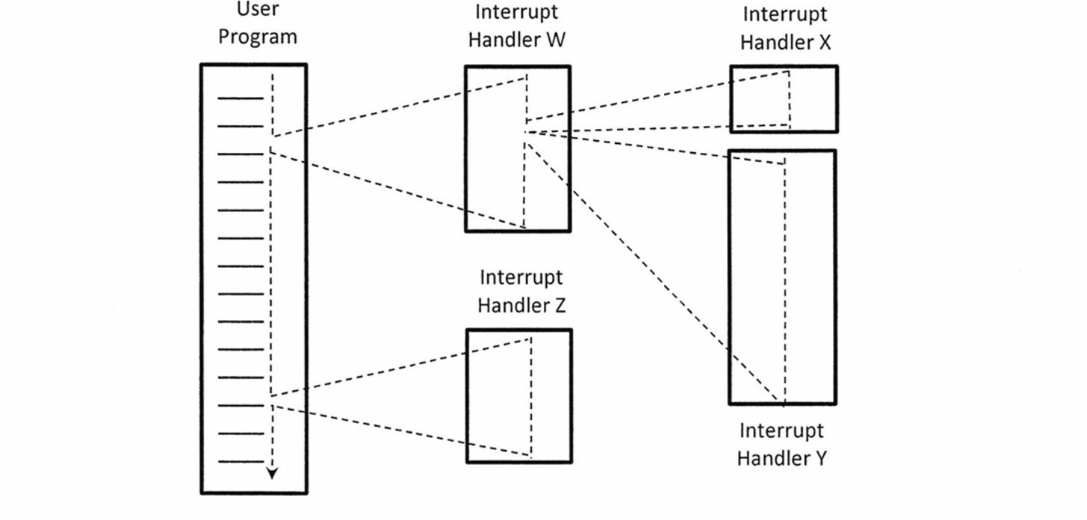
- Define interrupt.
- Rank the interrupts based on their priority from the most important to the least important.
- Rank the interrupts from the most important to the least important if disable interrupt is applied.

QUESTION A6 (10 marks)
- Compare system interconnection and CPU interconnection in terms of:
- function
- physical appearance.
- Describe the function of the THREE (3) different bus types in a computer system.

QUESTION A7 (10 marks)
- Why replacement algorithm for cache is needed?
- Discuss all different types of available replacement.

QUESTION A8 (10 marks)
- Compare TWO (2) system bus timing approach with appropriate examples.
- Discuss ONE (1) reason why an I/O module is needed.
- List TWO (2) interfaces to external devices

QUESTION A9 (10 marks)
Processor contains a number of registers used for temporary storage of data. Describe FIVE (5) types of registers.

QUESTION A10 (10 marks)
Answer both parts for the same expression. Assume an 8-bit byte.
Expression: -24 - 63
- Calculate -24 - 63 using sign and magnitude.
- Calculate -24 - 63 using 1's and 2's complement.

PART B (20 MARKS)
Answer the question in this part.

QUESTION B1 (20 marks)
Question 1 is based on Figure 5 and Table 1
Write an appropriate program using conect assembly language notations to compute the equation shown in Figure 5 using instructions for zero-address, one-address, and three- address. The available instructions are provided in Table 1. The registers labeled A, B, C, and D are fixed, while registers x, y, and z can be used temporarily. The final answer must be stored in register z.
Zero-address | One-address | Three-address
PUSH p | LOAD p | ADD (p,q,r)
POP p | STOR p | SUB (p,q,r)
ADD | ADD p | MUL (p,q,r)
SUB | SUB p | DIV (p,q,r)
MUL | MUL p
DIV | DIV p

