
CONFIDENTIAL CS/NOV 2026/CSC429

UNIVERSITI TEKNOLOGI MARA FINAL EXAMINATION

COURSE
COURSE CODE
EXAMINATION TIME
COMPUTER ORGANIZATION AND ARCHITECTURE

CSC429
NOVEMBER 2026
3 HOURS

INSTRUCTIONS TO CANDIDATES

- This question paper consists of two (2) parts: PART A (10 Questions) PART B (1 Question)

- Answer ALL questions in the Answer Booklet. Start each answer on a new page.

- Do not bring any material into the examination room unless permission is given by the invigilator .
- Please check to make sure that this examination pack consists of: i) the Question Paper
  - an Answer Booklet - provided by the Faculty

- Answer ALL questions in English.

DO NOT TURN THIS PAGE UNTIL YOU ARE TOLD TO DO SO

This examination paper consists of 6 printed pages.

PART A (80 MARKS)
Answer ALL questions in this part.

QUESTION A1 (5 marks)
The X machine was the first automatic electronic digital computer that uses binary system. It has 30 arithmetic/logic unit that can add and subtract, a rotating drum memory that can held thirty binary numbers of fifty digits each and input/output components. Figure 1 shows the architecture of X machine.
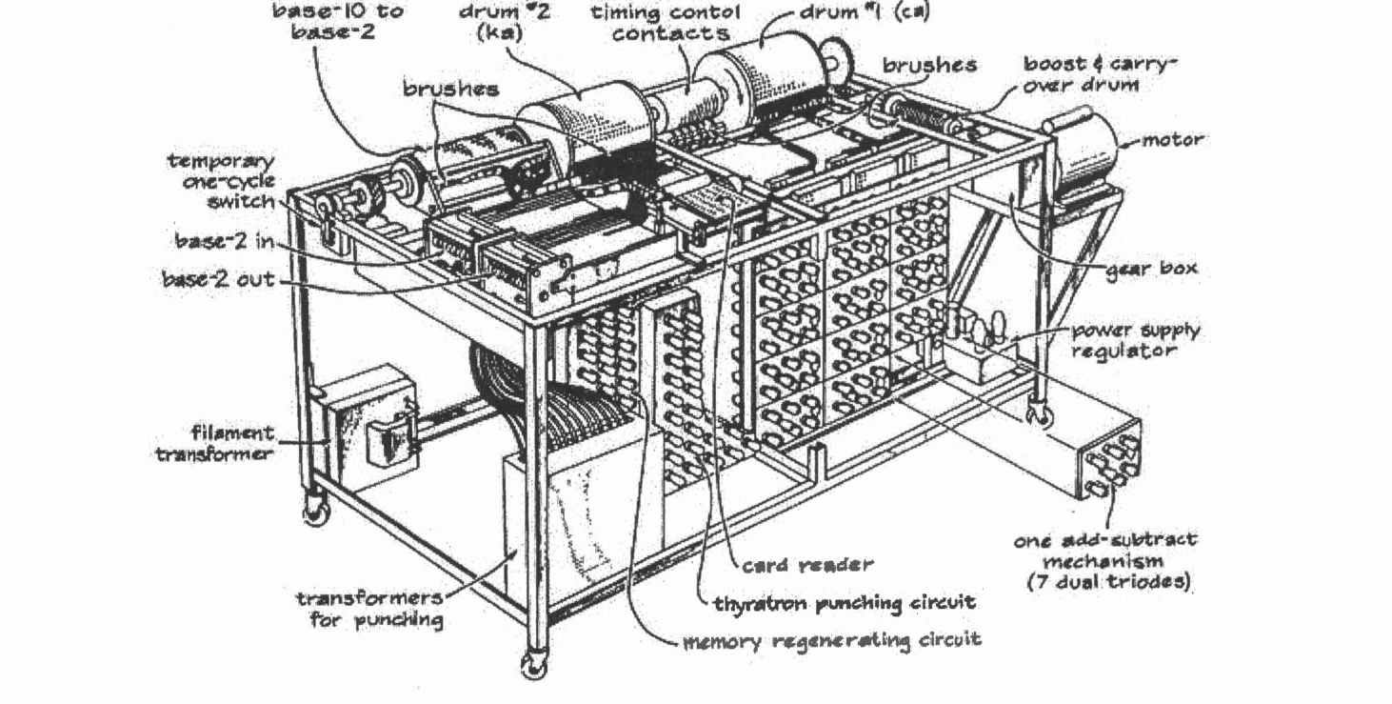
- What is X machine?
- Name the inventor of X machine.
- Based on Figure 1, identify the input and output components for X machine.

QUESTION A2 (5 marks)
Complete the following taxonomy of parallel processor architecture with appropriate example.
Single Instruction Multiple Data Stream ii Processor Organization Multiple Instruction Multiple Data Stream
v

QUESTION A3 (5 marks)
Given the following Figure 2.

- Label the addressing technique illustrated in Figure 2.
- Explain how the addressing technique in 9(a) is used.
List ONE (1) advantage and ONE (1) disadvantage of the addressing technique in

QUESTION A4 (5 marks)
Convert -20.125 to IEEE 754 single-precision format. Give the answer in hexadecimal and show the sign, exponent and mantissa fields.

QUESTION A5 (10 marks)
Describe FOUR (4) type of access methods based on hardware implementation of the storage device. Provide ONE (1) appropriate example for each access type.

QUESTION A6 (10 marks)
- Discuss the TWO (2) processes in the machine cycle that are governed by the main memory.
- List TWO (2) operations that are comprised in the Execute phase.
- Explain what happens in the Program Counter (PC) and Instruction Register (IR) during the Fetch cycle.

QUESTION A7 (10 marks)
- Describe THREE (3) types of interfaces to external devices.
- Explain TWO (2) types of interrupt.

QUESTION A8 (10 marks)
- State TWO (2) different types of bus.
- The size of a word is 32 bits and the size of the block is 256 bits. Determine of the following:
- The byte for word
- The byte for block,
- Size of the register,
- Size of the data bus.

QUESTION A9 (10 marks)
Question 5 is based on the following scenario. "Nurathia Farhana browses the UiTM4fly.com website to book for a return flight from KLIA to LAX. While comparing for a better price, two messages popped up in her screen. Figure 1 (a) and (b) illustrate the conveyed messages.

(b)
(a)
- Which message is the non-maskable interrupt? Justify your answer by giving appropriate reason.
- Differentiate between maskable and non-maskable interrupt?
- Outline the common way to handle multiple interrupts as happened in the given scenario.

QUESTION A10 (10 marks)
Answer both parts. Show your complete workflow.
- Convert 100.5 to IEEE 754 single precision. Give the answer in hexadecimal.
- Convert the IEEE 754 single-precision value 0x3EC00000 to decimal.

PART B (20 MARKS)
Answer the question in this part.

QUESTION B1 (20 marks)
Question 1 is based on Figure 2 and Table 1.

Write the appropriate programs using correct assembly language notations and comments to compute the equation represented in Figure 1 using zero-, one-, and three-address instructions. The instructions available for use are provided in Table 1. Register A, B, C, and D cannot be modified, and registers x, y, and z can be used as temporary registers. However, the final answer must be stored in Register y.
Zero-address | One-address | Three-address
PUSHp | LOADp | ADD (p,q,r)
POPp | STORp | SUB (p,q,r)
ADD | ADDp | MUL (p.q.r)
SUB | SUBp | DIV(p,q,r)
MUL | MULp
DIV | DIVp

