
CONFIDENTIAL CS/NOV 2026/CSC429

UNIVERSITI TEKNOLOGI MARA FINAL EXAMINATION

COURSE
COURSE CODE
EXAMINATION TIME
COMPUTER ORGANIZATION AND ARCHITECTURE

CSC429
NOVEMBER 2026
3 HOURS

INSTRUCTIONS TO CANDIDATES

- This question paper consists of two (2) parts: PART A (10 Questions) PART B (1 Question)

- Answer ALL questions in the Answer Booklet. Start each answer on a new page.

- Do not bring any material into the examination room unless permission is given by the invigilator .
- Please check to make sure that this examination pack consists of: i) the Question Paper
  - an Answer Booklet - provided by the Faculty

- Answer ALL questions in English.

DO NOT TURN THIS PAGE UNTIL YOU ARE TOLD TO DO SO

This examination paper consists of 6 printed pages.

PART A (80 MARKS)
Answer ALL questions in this part.

QUESTION A1 (5 marks)
Given the following Figure 2.

- Label the addressing technique illustrated in Figure 2.
- Explain how the addressing technique in 9(a) is used.
List ONE (1) advantage and ONE (1) disadvantage of the addressing technique in

QUESTION A2 (5 marks)
Calculate -10 - 74 using the sign-and-magnitude method. Assume an 8-bit byte. Show your complete workflow.

QUESTION A3 (5 marks)
Given the following Non Uniform Memory Access (NUMA) diagram.
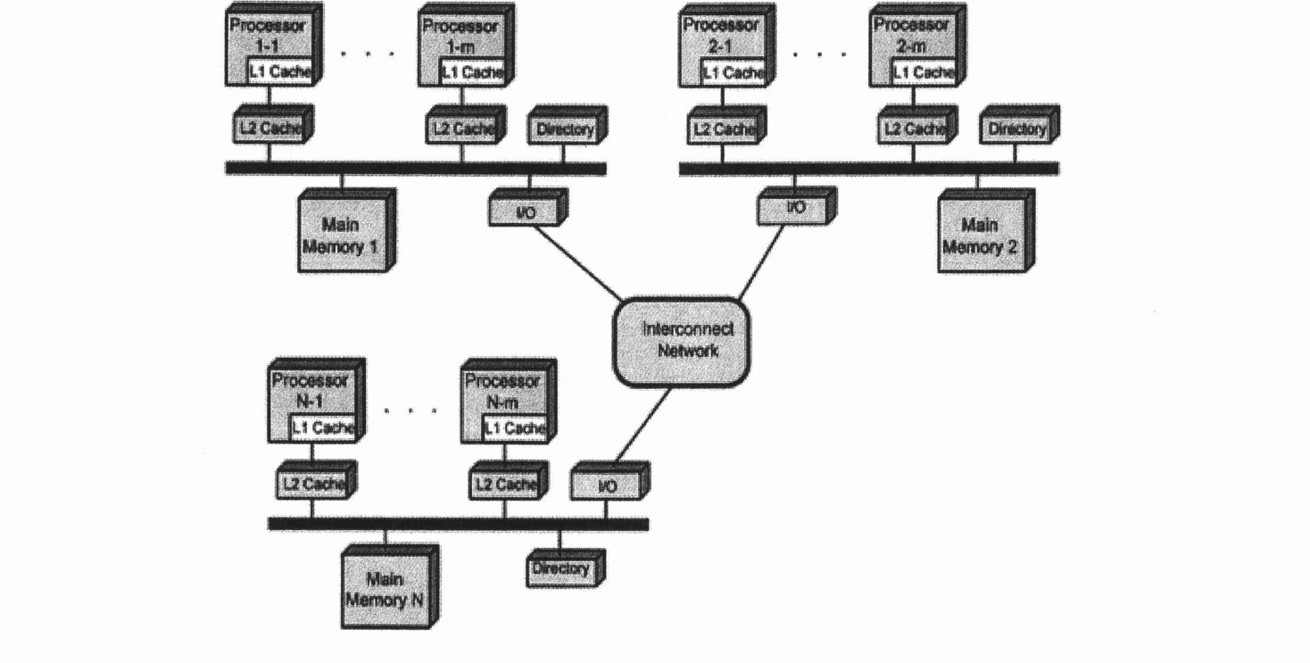
- State ONE (1) advantage of Symmetric Multi-Processor (SMP) that is applied in NUMA architecture.
- Describe ONE (1) disadvantage of cluster architecture.
- Draw a possible architecture for cluster architecture based on Figure 3.

QUESTION A4 (5 marks)
Question 1 is based on the following snippet garnered from a computer science web page.
Henry Edward "Ed" Roberts
(September 13, 1941 -April 1, 2010)
was an American engineer, entrepreneur and
medical doctor who invented the first
commercially successful personal computer in
1975. He is most often known as "the father of
the personal computer". The computer was
available as a kit for $439 or assembled for
$621 and had several additional add-ons such
as a memory board and interface boards. By
August 1975, over 5,000 Altair 8800 personal
computers were sold; starting the personal
computer revolution.

- In which computer generation that a personal computer is introduced?
- Discuss ONE (1) other major discovery that is found in this generation.
- Advances in laptop and hand-held devices are accelerating during this computer generation. How such technology is feasible as compared to previous computer generation?

QUESTION A5 (10 marks)
- Explain the problem in polling 1/0 method.
- Explain how buffering can help to improve the device overall performance?
- Discuss how DMA technique can help the 1/0 transfer performance instead of using polling method and interrupt 1/0 method?

QUESTION A6 (10 marks)
- Discuss the whole operation of the machine cycle and its respective responsible computer components.
- Elaborate on what will happen in the machine cycle if the main memory is corrupted.

QUESTION A7 (10 marks)
Question 5 is based on the following scenario. "Nurathia Farhana browses the UiTM4fly.com website to book for a return flight from KLIA to LAX. While comparing for a better price, two messages popped up in her screen. Figure 1 (a) and (b) illustrate the conveyed messages.

(b)
(a)
- Which message is the non-maskable interrupt? Justify your answer by giving appropriate reason.
- Differentiate between maskable and non-maskable interrupt?
- Outline the common way to handle multiple interrupts as happened in the given scenario.

QUESTION A8 (10 marks)
Replacement algorithm is used to determine which entry in a cache to flush to main memory when it is desired to cache a new block of data.
- Which mapping function does not need to have a replacement algorithm?
- Describe FOUR (4) types of replacement algorithm.

QUESTION A9 (10 marks)
- Compare system interconnection and CPU interconnection in terms of:
- function
- physical appearance.
- Describe the function of the THREE (3) different bus types in a computer system.

QUESTION A10 (10 marks)
Answer both parts. Show your complete workflow.
a) Convert 314510 to hexadecimal.
b) Convert ED116 to decimal.
- Convert 314510 to hexadecimal.
- Convert ED116 to decimal.

PART B (20 MARKS)
Answer the question in this part.

QUESTION B1 (20 marks)
Question 1 is based on Figure 1 and Table 1.

write an appropriate program using correct assembly language notations to compute the equation snbwn in Figure 1 using instructions for zero-address, one-address, and three- address. The available instructioni are provided in Tabte 1. The register labeled A, B, C, and D are fixed, white registers x, y, and z can be used temporarily. The final answer must be stored in register z.
Zero-address | One-address | Three-address
PUSH p | LOAD p | ADD (p,q,r)
POP p | STOR p | suB (p,q,r)
ADD | ADD p | MUL (p,q,r)
SUB | SUB p | DIV (p,q,r)
MUL | MUL p
DIV | DIV p

