
CONFIDENTIAL CS/NOV 2026/CSC429

UNIVERSITI TEKNOLOGI MARA FINAL EXAMINATION

COURSE
COURSE CODE
EXAMINATION TIME
COMPUTER ORGANIZATION AND ARCHITECTURE

CSC429
NOVEMBER 2026
3 HOURS

INSTRUCTIONS TO CANDIDATES

- This question paper consists of two (2) parts: PART A (10 Questions) PART B (1 Question)

- Answer ALL questions in the Answer Booklet. Start each answer on a new page.

- Do not bring any material into the examination room unless permission is given by the invigilator .
- Please check to make sure that this examination pack consists of: i) the Question Paper
  - an Answer Booklet - provided by the Faculty

- Answer ALL questions in English.

DO NOT TURN THIS PAGE UNTIL YOU ARE TOLD TO DO SO

This examination paper consists of 5 printed pages.

PART A (80 MARKS)
Answer ALL questions in this part.

QUESTION A1 (5 marks)
- Describe ONE (1) major difference between a tightly coupled multiprocessor system and a loosely coupled multiprocessor system.
- State the THREE (3) types of cluster architecture.

QUESTION A2 (5 marks)
Convert 100.5 to IEEE 754 single-precision format. Give the answer in hexadecimal and show the sign, exponent and mantissa fields.

QUESTION A3 (5 marks)
Question 1 is based on the following Figure 1.
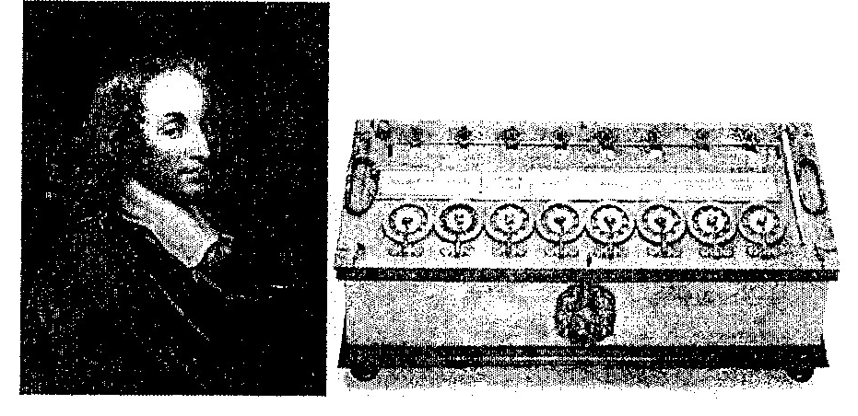
Figure 1: Inventor 'Y' and his calculating machine.
Inventor 'Y' was France's most celebrated mathematician and physicist. In 1642, inventor 'Y' invented and build the first working calculating machine as a means of helping his father to perform tedious tax accounting.
- Who is inventor 'Y'?
- Name another calculating machine that was invented in the same generation as inventor Y's calculating machine.
- Which programming language is named after inventor 'Y'?
- State TWO (2) mathematical operationsthat can be performed byinventor Y's calculating machine.

QUESTION A4 (5 marks)
Given the following Figure 2.

Figure 2
- Label the addressing technique illustrated in Figure 2.
- Explain how the addressing technique in 9(a) is used.
- List ONE (1) advantage and ONE (1) disadvantage of the addressing technique in 9(a).

QUESTION A5 (10 marks)
- Differentiate the involvement of CPU in the interrupt-driven I/O technique and Direct Manipulation Access
- Define interrupt.
- Discuss what happens during a context switch.
- Elaborate on the benefit of a context switch.

QUESTION A6 (10 marks)
Answer both parts. Show your complete workflow.
a) Convert 159910 to hexadecimal.
b) Convert FD916 to decimal.
- Convert 159910 to hexadecimal.
- Convert FD916 to decimal.

QUESTION A7 (10 marks)
- Discuss THREE (3) types of interfaces to external devices.
- Classify the following input/output devices to their respective 1/0 module:
- Network interface card Scanner Touch Screen
- Register

QUESTION A8 (10 marks)
Describe the specific function of each registers in the CPU.

QUESTION A9 (10 marks)
- List FOUR (4) types of access method for storage device with ONE (1) example for each of them.
- Calculate the total of memory location using 11 address bit.
- Calculate the address bits required for 2MB of RAM.

QUESTION A10 (10 marks)
- Discuss the function of each Central Processing Unit (CPU) component'
- Elaborate on what will happen in the machine cycle if the bus system is faulty

PART B (20 MARKS)
Answer the question in this part.

QUESTION B1 (20 marks)
Question 1 is based on Figure 2 and Table 1.
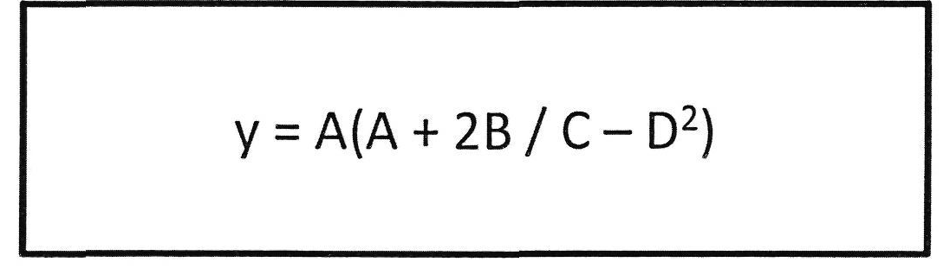
Figure 2
Write the appropriate programs using correct assembly language notations and comments to compute the equation represented in Figure 1 using zero-, one-, and three-address instructions. The instructions available for use are provided in Table 1. Register A, B, C, and D cannot be modified, and registers x, y, and z can be used as temporary registers. However, the final answer must be stored in Register y.
Table 1: Machine Instruction
Zero-address | One-address | Three-address
PUSHp | LOADp | ADD (p,q,r)
POPp | STORp | SUB (p,q,r)
ADD | ADDp | MUL (p.q.r)
SUB | SUBp | DIV(p,q,r)
MUL | MULp
DIV | DIVp

