
CONFIDENTIAL CS/NOV 2026/CSC429

UNIVERSITI TEKNOLOGI MARA FINAL EXAMINATION

COURSE
COURSE CODE
EXAMINATION TIME
COMPUTER ORGANIZATION AND ARCHITECTURE

CSC429
NOVEMBER 2026
3 HOURS

INSTRUCTIONS TO CANDIDATES

- This question paper consists of two (2) parts: PART A (10 Questions) PART B (1 Question)

- Answer ALL questions in the Answer Booklet. Start each answer on a new page.

- Do not bring any material into the examination room unless permission is given by the invigilator .
- Please check to make sure that this examination pack consists of: i) the Question Paper
  - an Answer Booklet - provided by the Faculty

- Answer ALL questions in English.

DO NOT TURN THIS PAGE UNTIL YOU ARE TOLD TO DO SO

This examination paper consists of 5 printed pages.

PART A (80 MARKS)
Answer ALL questions in this part.

QUESTION A1 (5 marks)
Given the following Figure 2.

Figure 2
- Label the addressing technique illustrated in Figure 2.
- Explain how the addressing technique in 9(a) is used.
- List ONE (1) advantage and ONE (1) disadvantage of the addressing technique in 9(a).

QUESTION A2 (5 marks)
Complete the following taxonomy of parallel processor architecture with appropriate example.
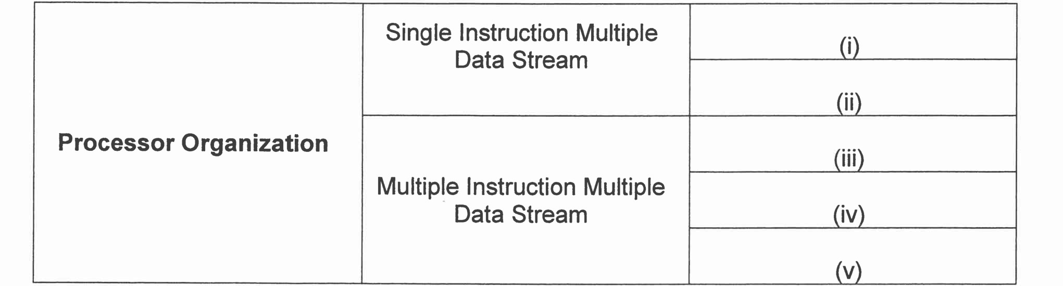

QUESTION A3 (5 marks)
Convert -6.75 to IEEE 754 single-precision format. Give the answer in hexadecimal and show the sign, exponent and mantissa fields.

QUESTION A4 (5 marks)
John von Neumann was a brilliant mathematician, physicist, and computer scientist. He made groundbreaking contributions to mathematics, game theory, quantum mechanics, and computer science. Von Neumann's work laid the foundation for modern computing, and his ideas continue to shape the fields of mathematics and computer science today.
- Name the TWO (2) prominent machines that were inspired by John von Neumann during the first computer generation.
- What is the name of the machine developed by John von Neumann himself?
- Explain the function of the machine developed by John von Neumann.

QUESTION A5 (10 marks)
- Discuss TWO (2) types of bus timing.
- Describe THREE (3) Central Processing Unit (CPU) components.

QUESTION A6 (10 marks)
System interconnection is a mechanism that provides communication among computer components.
- What is the size of a bus if the word size is 64 bit?
- List the TWO (2) types of bus.
- Illustrate the location of a bus between CPU and memory.
- Differentiate between system interconnection and CPU interconnection.
- Discuss ONE (1) drawback each for the different types of bus timing.

QUESTION A7 (10 marks)
- Differentiate between interrupt-driven 1/0 and programmed 1/0.
- Discuss ONE (1) benefit of programmed 1/0.
- Discuss TWO (2) disadvantages of multiple interrupts.

QUESTION A8 (10 marks)
Question 5 is based on the following scenario. "Nurathia Farhana browses the UiTM4fly.com website to book for a return flight from KLIA to LAX. While comparing for a better price, two messages popped up in her screen. Figure 1 (a) and (b) illustrate the conveyed messages.
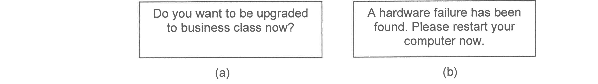
Figure 1: The pop-up messages
(b)
(a)
- Which message is the non-maskable interrupt? Justify your answer by giving appropriate reason.
- Differentiate between maskable and non-maskable interrupt?
- Outline the common way to handle multiple interrupts as happened in the given scenario.

QUESTION A9 (10 marks)
- Explain how the bits are stored in the SRAM and DFiAM.
- Why is SRAM technology faster than DRAM technology?
- Compare SRAM and DRAM in terms of cost and power consumption.

QUESTION A10 (10 marks)
Answer both parts. Show your complete workflow.
a) Convert 137710 to hexadecimal.
b) Convert 4B816 to decimal.
- Convert 137710 to hexadecimal.
- Convert 4B816 to decimal.

PART B (20 MARKS)
Answer the question in this part.

QUESTION B1 (20 marks)
Question 1 is based on Figure 2 and Table 1.

Figure 2
Write an appropriate program using correct assembly language notations to compute the equation shown in Figure 2 using instructions for one-address, two-address, and three- address. The available instructions are provided in Table 1. The register labeled A, B, C, and D are fixed, while registers x, y, and z can be used temporarily. The final answer must be stored in register y.
Table 1 : Machine instruction
One-address | Two-address | Three-address
LOADp | MOV (p,q) | ADD (p.q.r)
STORp | ADD (p,q) | SUB (p,q,r)
ADDp | SUB (p,q) | MUL (p.q.r)
SUBp | MUL (p,q) | DIV(p,q,r)
MULp | DIV(p,q)
DIVp

