
CONFIDENTIAL CS/NOV 2026/CSC429

UNIVERSITI TEKNOLOGI MARA FINAL EXAMINATION

COURSE
COURSE CODE
EXAMINATION TIME
COMPUTER ORGANIZATION AND ARCHITECTURE

CSC429
NOVEMBER 2026
3 HOURS

INSTRUCTIONS TO CANDIDATES

- This question paper consists of two (2) parts: PART A (10 Questions) PART B (1 Question)

- Answer ALL questions in the Answer Booklet. Start each answer on a new page.

- Do not bring any material into the examination room unless permission is given by the invigilator .
- Please check to make sure that this examination pack consists of: i) the Question Paper
  - an Answer Booklet - provided by the Faculty

- Answer ALL questions in English.

DO NOT TURN THIS PAGE UNTIL YOU ARE TOLD TO DO SO

This examination paper consists of 5 printed pages.

PART A (80 MARKS)
Answer ALL questions in this part.

QUESTION A1 (5 marks)
- List TWO (2) advantages of SMP organization.
- Define cluster organization.
- Give ONE (1) benefit of cluster organization.

QUESTION A2 (5 marks)
Convert 2.5 to IEEE 754 single-precision format. Give the answer in hexadecimal and show the sign, exponent and mantissa fields.

QUESTION A3 (5 marks)
Given the following Figure 2.

Figure 2
- Label the addressing technique illustrated in Figure 2.
- Explain how the addressing technique in 9(a) is used.
- List ONE (1) advantage and ONE (1) disadvantage of the addressing technique in 9(a).

QUESTION A4 (5 marks)
Question 1 is based on the following statement.
Mr. X is known as Father of Computer. He developed Analytical Machine in 1837 which has four main components, namely; memory, the mill, punch card reader and the punch and printed section. Analytical Machine is the successor of Y machine. Y machine is used to compute tables of numbers for naval navigation.
- Name the inventor of Mr. X.
- Identify the name of Y machine.
- What is the function of Analytical Machine?
- Map the components Analytical Machine to Von Neumann architecture

QUESTION A5 (10 marks)
- Why input/output problem occurs?
- Describe THREE (3) categories for input/output module and provide an appropriate example each.

QUESTION A6 (10 marks)
- When is an l/O module installed?
- What will happen if the l/O module is not installed?
- Explain ONE (1) category of l/O module
- What does it mean by 'hot connection'?
- List THREE (3) common interfaces to external devices.

QUESTION A7 (10 marks)
Answer both parts for the same expression. Assume an 8-bit byte.
Expression: -35 - 24
- Calculate -35 - 24 using sign and magnitude.
- Calculate -35 - 24 using 1's and 2's complement.

QUESTION A8 (10 marks)
- Given the size of an address bus is 16 bit and the size of the data bus is 64 bit.
- Determine the size of data block. Give appropriate justification for such answer.
- What is the usage of address bus?
- What happens if a wider address bus is set?
- Discuss TWO (2) types of bus timing.

QUESTION A9 (10 marks)
- ldentify the correct access method based on the following scenario Scenario Access method Readi files. I Accessi c file from a folder. a Streami files line line. AS ecific file block usi an index in a la e file. Accessin toas Jum cific frame or a timestam in the video. tn
- Rank the following memory types based on the most to the least storage capacity' Main memory, Tape, Ll Cache, Hard drive, ReBister, L3 Cache
- Discuss the term volatile from the perspective of computer memory.

QUESTION A10 (10 marks)
Computer consists of four main components as illustrated in Figure 1. Each component has its own function in ensuring that the computer system works well. Question 4 is based on
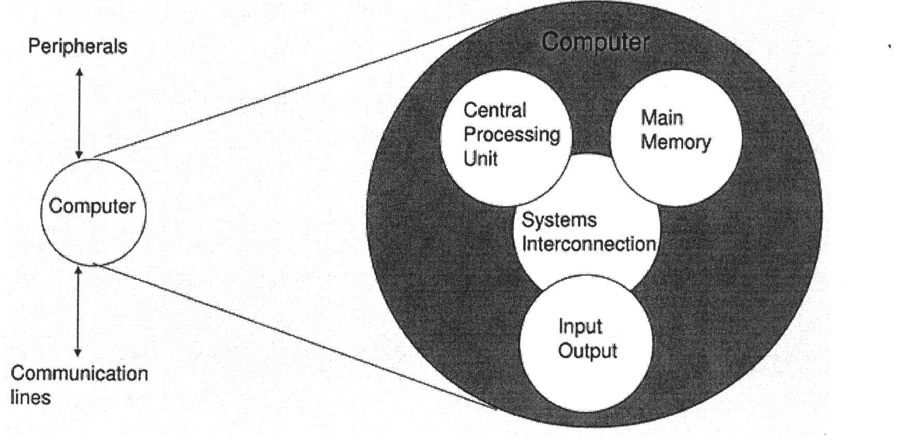
Figure 1 : Components of computer
- Explain THREE (3) types of system interconnection.
- State TWO (2) sub-components of central processing unit and its function.

PART B (20 MARKS)
Answer the question in this part.

QUESTION B1 (20 marks)
Question 1 is based on Figure 4 and Table 3.
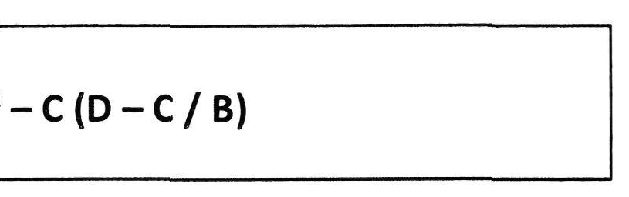
Figure 4
Write the appropriate programs using correct assembly language notations and comments to compute the equation represented in Figure 4 using zero-, one-, and two-address instructions. The instructions available for use are provided in Table 3. Note that Register A, B, C, and D cannot be modified, and Register x, y, and z can be used as temporary registers. However, the final answer must be stored in Register z.
Table 3: Machine Instruction
Zero-address | One-address | T\vr.-address
PUSHx | LOADx | MOVE (x,y)
POPx | STORx | ADD (x,y)
ADD | ADDx | SUB (x,y)
SUB | SUBx | MUL (x,y)
MUL | MULx | DIV(x,y)
DIV | DIVx

