
CONFIDENTIAL CS/NOV 2026/CSC429

UNIVERSITI TEKNOLOGI MARA FINAL EXAMINATION

COURSE
COURSE CODE
EXAMINATION TIME
COMPUTER ORGANIZATION AND ARCHITECTURE

CSC429
NOVEMBER 2026
3 HOURS

INSTRUCTIONS TO CANDIDATES

- This question paper consists of two (2) parts: PART A (10 Questions) PART B (1 Question)

- Answer ALL questions in the Answer Booklet. Start each answer on a new page.

- Do not bring any material into the examination room unless permission is given by the invigilator .
- Please check to make sure that this examination pack consists of: i) the Question Paper
  - an Answer Booklet - provided by the Faculty

- Answer ALL questions in English.

DO NOT TURN THIS PAGE UNTIL YOU ARE TOLD TO DO SO

This examination paper consists of 6 printed pages.

PART A (80 MARKS)
Answer ALL questions in this part.

QUESTION A1 (5 marks)
Question 2 is based on the following statement. "The introduction of graphical user interface (GUI) and mouse technology remark the beginning of a new computer generation. In this generation, there are many great developments in the field of computer networks leading to the birth of internet concept".
- Name the computer generation described.
- What are the TWO (2) main technologies available in this computer generation?
- List TWO (2) main features of this computer generation.

QUESTION A2 (5 marks)
Calculate 86 - (-30) using the sign-and-magnitude method. Assume an 8-bit byte. Show your complete workflow.

QUESTION A3 (5 marks)
Given the following Figure 2.

Figure 2
- Label the addressing technique illustrated in Figure 2.
- Explain how the addressing technique in 9(a) is used.
- List ONE (1) advantage and ONE (1) disadvantage of the addressing technique in 9(a).

QUESTION A4 (5 marks)
Complete the following taxonomy of parallel processor architecture with appropriate example.
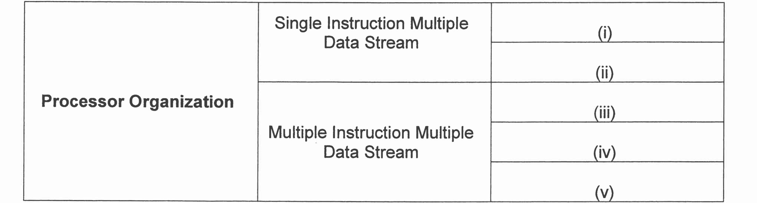

QUESTION A5 (10 marks)
Keyboard is the most common means for computer interaction.
- Explain TWO (2) types of characters that keyboard provides.
- Describe THREE (3) categories of input and output module. Give an appropriate example for each category.

QUESTION A6 (10 marks)
Question 8 is based on Figure 2.
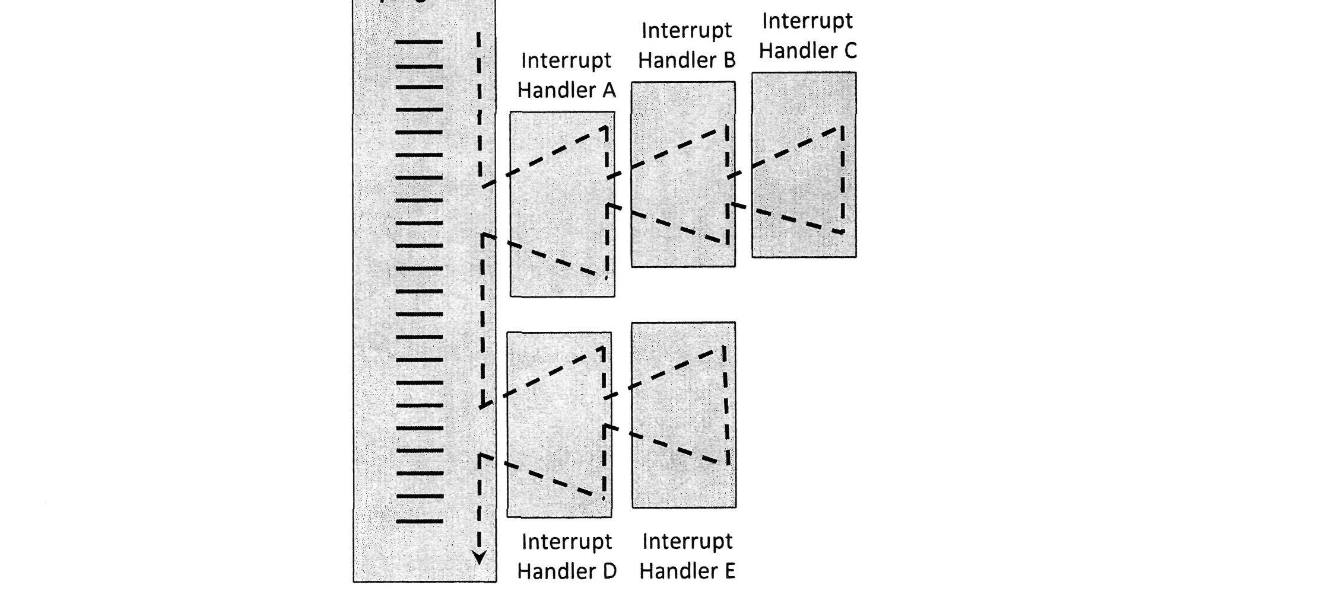
Figure 2: Multiple interrupts diagram
- Describe maskable interrupt.
- What is the sequence of the program execution if the defined priority is implemented in
- What is the sequence of the program execution if the disable interrupt is implemented in
- Which of the interruption method between defined priority or disable interrupt can finish Interrupt C earlier? Give your justification.

QUESTION A7 (10 marks)
Describe the specificfunction ofdifferent types of registers.

QUESTION A8 (10 marks)
- List FOUR (4) types of access method for storage device with ONE (1) example for each of them.
- Calculate the total of memory location using 11 address bit.
- Calculate the address bits required for 2MB of RAM.

QUESTION A9 (10 marks)
- Discuss the TWO (2) processes in the machine cycle that are governed by the main memory.
- List TWO (2) operations that are comprised in the Execute phase.
- Explain what happens in the Program Counter (PC) and Instruction Register (IR) during the Fetch cycle.

QUESTION A10 (10 marks)
Answer both parts. Show your complete workflow.
a) Convert 256610 to hexadecimal.
b) Convert 7E816 to decimal.
- Convert 256610 to hexadecimal.
- Convert 7E816 to decimal.

PART B (20 MARKS)
Answer the question in this part.

QUESTION B1 (20 marks)
Question 1 is based on Figure 2 and Table 1.

Figure 2
Write an appropriate program using correct assembly language notations to compute the equation shown in Figure 2 using instructions for one-address, two-address, and three- address. The available instructions are provided in Table 1. The register labeled A, B, C, and D are fixed, while registers x, y, and z can be used temporarily. The final answer must be stored in register y.
Table 1 : Machine instruction
One-address | Two-address | Three-address
LOADp | MOV (p,q) | ADD (p.q.r)
STORp | ADD (p,q) | SUB (p,q,r)
ADDp | SUB (p,q) | MUL (p.q.r)
SUBp | MUL (p,q) | DIV(p,q,r)
MULp | DIV(p,q)
DIVp

