
CONFIDENTIAL CS/NOV 2026/CSC429

UNIVERSITI TEKNOLOGI MARA FINAL EXAMINATION

COURSE
COURSE CODE
EXAMINATION TIME
COMPUTER ORGANIZATION AND ARCHITECTURE

CSC429
NOVEMBER 2026
3 HOURS

INSTRUCTIONS TO CANDIDATES

- This question paper consists of two (2) parts: PART A (10 Questions) PART B (1 Question)

- Answer ALL questions in the Answer Booklet. Start each answer on a new page.

- Do not bring any material into the examination room unless permission is given by the invigilator .
- Please check to make sure that this examination pack consists of: i) the Question Paper
  - an Answer Booklet - provided by the Faculty

- Answer ALL questions in English.

DO NOT TURN THIS PAGE UNTIL YOU ARE TOLD TO DO SO

This examination paper consists of 5 printed pages.

PART A (80 MARKS)
Answer ALL questions in this part.

QUESTION A1 (5 marks)
Given the following Figure 2.

Figure 2
- Label the addressing technique illustrated in Figure 2.
- Explain how the addressing technique in 9(a) is used.
- List ONE (1) advantage and ONE (1) disadvantage of the addressing technique in 9(a).

QUESTION A2 (5 marks)
Give suitable example for each processor organization.

QUESTION A3 (5 marks)
Calculate -43 - 23 using the sign-and-magnitude method. Assume an 8-bit byte. Show your complete workflow.

QUESTION A4 (5 marks)
- Why is the machine in zero computer generation known as a mechanical computer?
- Complete the following table with the appropriate answer.
Mechanical Calculatin Machine Difference Machine Inventor Function

QUESTION A5 (10 marks)
System interconnection is a mechanism that provides communication among computer components.
- What is the size of a bus if the word size is 64 bit?
- List the TWO (2) types of bus.
- Illustrate the location of a bus between CPU and memory.
- Differentiate between system interconnection and CPU interconnection.
- Discuss ONE (1) drawback each for the different types of bus timing.

QUESTION A6 (10 marks)
Answer both parts for the same expression. Assume an 8-bit byte.
Expression: -39 - (-71)
- Calculate -39 - (-71) using sign and magnitude.
- Calculate -39 - (-71) using 1's and 2's complement.

QUESTION A7 (10 marks)
Question 7 is based on the following scenarios. While cleaning his house, Ahmad found an old cassette tape of a popular 80's band. He played the tape and listened to several songs according to the listed tracks. Hafiz was tasked to research on the history of Malay culture by his professor. He went to the National Archive to search for information and manage to access one the resources which was stored in a floppy disk. Sara is planning to buy a new computer. She aims to get one with good processing speed. While researching for computer specifications, she found out that larger cache space has a direct effect towards processing performance. Hana loves playing role-playing games (RPG) and is planning to buy a newly released game that requires a high-speed RAM. But, she is devastated when she found out that her game console does not support the minimum RAM requirement of the game.
- Based on the above scenarios, identify the access method for each storage devices/memory mentioned in (i), (ii), (iii) and (iv).
- Describe SRAM and DRAM.
- Which level of cache is the fastest in a three-level cache architecture? Which type of RAM is used to implement the cache?

QUESTION A8 (10 marks)
- Differentiate the involvement of CPU in the interrupt-driven I/O technique and Direct Manipulation Access
- Define interrupt.
- Discuss what happens during a context switch.
- Elaborate on the benefit of a context switch.

QUESTION A9 (10 marks)
- Discuss the whole operation of the machine cycle and its respective responsible computer components.
- Elaborate on what will happen in the machine cycle if the main memory is corrupted.

QUESTION A10 (10 marks)
Illustration in Figure 1 shows an interrupt that happen during the execution of a program. Question 4 is based on Figure 1.
Update status
The program can't check for definition updates. Error found: 0)C0072ee7. The server name or address
could not be resolved
Go online to view troubleshooting tips
Start time
Time elapsed:

Figure 1 . Example of interrupt
- Define interrupt.
- Why interrupt is important?
- Explain TWO (2) types of interrupt.
- Discuss ONE (1) option to handle multiple interrupts that happen simultaneously.

PART B (20 MARKS)
Answer the question in this part.

QUESTION B1 (20 marks)
Question 1 is based on Figure 2 and Table 1.
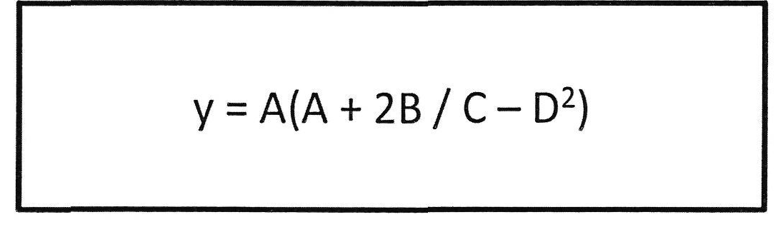
Figure 2
Write the appropriate programs using correct assembly language notations and comments to compute the equation represented in Figure 1 using zero-, one-, and three-address instructions. The instructions available for use are provided in Table 1. Register A, B, C, and D cannot be modified, and registers x, y, and z can be used as temporary registers. However, the final answer must be stored in Register y.
Table 1: Machine Instruction
Zero-address | One-address | Three-address
PUSHp | LOADp | ADD (p,q,r)
POPp | STORp | SUB (p,q,r)
ADD | ADDp | MUL (p.q.r)
SUB | SUBp | DIV(p,q,r)
MUL | MULp
DIV | DIVp

