
CONFIDENTIAL CS/NOV 2026/CSC429

UNIVERSITI TEKNOLOGI MARA FINAL EXAMINATION

COURSE
COURSE CODE
EXAMINATION TIME
COMPUTER ORGANIZATION AND ARCHITECTURE

CSC429
NOVEMBER 2026
3 HOURS

INSTRUCTIONS TO CANDIDATES

- This question paper consists of two (2) parts: PART A (10 Questions) PART B (1 Question)

- Answer ALL questions in the Answer Booklet. Start each answer on a new page.

- Do not bring any material into the examination room unless permission is given by the invigilator .
- Please check to make sure that this examination pack consists of: i) the Question Paper
  - an Answer Booklet - provided by the Faculty

- Answer ALL questions in English.

DO NOT TURN THIS PAGE UNTIL YOU ARE TOLD TO DO SO

This examination paper consists of 5 printed pages.

PART A (80 MARKS)
Answer ALL questions in this part.

QUESTION A1 (5 marks)
Identify the correct generation based on the following descriptions.
- The production of personal computer marks the main feature of this generation. The price of computer during this period is the lowest compared to the other generation. It provides fast processing ability with less power consumption.
- Machines that emulate human intelligence which can process and respond to natural language is developed in this generation.
- In this generation, air condition is no longer required because the heat produced by the machine is reduced. However, fan is needed for heat discharging.
- Integrated circuit comprises of a number of transistors, resistors and capacitors are invented by Jack Kilby in this generation.
- Assembly language is introduced during this generation to replace machine language for more reliable and improved performance.

QUESTION A2 (5 marks)
Given the following Figure 2.

Figure 2
- Label the addressing technique illustrated in Figure 2.
- Explain how the addressing technique in 9(a) is used.
- List ONE (1) advantage and ONE (1) disadvantage of the addressing technique in 9(a).

QUESTION A3 (5 marks)
Convert 277410 to binary. Show your complete workflow.

QUESTION A4 (5 marks)
Complete the following taxonomy of parallel processor architecture with appropriate example.
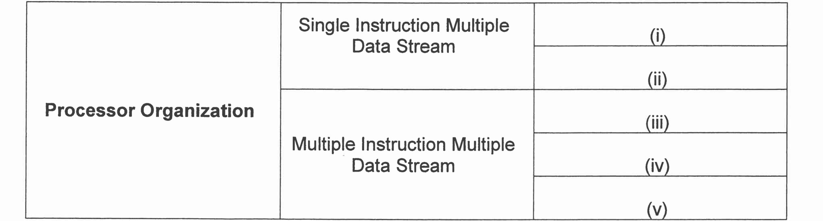

QUESTION A5 (10 marks)
- Explain TWO (2) methods to handle multiple interrupts.
- Give ONE (1) example of a non-maskable interrupt.
- Why Direct Memory Access (DMA) is faster than interrupt-driven and programmed 1/0?
- USB is known as a 'hot' connection. What does it mean by "hot connection"?

QUESTION A6 (10 marks)
- Discuss the function of each Central Processing Unit (CPU) component'
- Elaborate on what will happen in the machine cycle if the bus system is faulty

QUESTION A7 (10 marks)
- Why replacement algorithm for cache is needed?
- Discuss all different types of available replacement.

QUESTION A8 (10 marks)
- Compare TWO (2) system bus timing approach with appropriate examples.
- Discuss ONE (1) reason why an I/O module is needed.
- List TWO (2) interfaces to external devices

QUESTION A9 (10 marks)
Computer consists of four main components as illustrated in Figure 1. Each component has its own function in ensuring that the computer system works well. Question 4 is based on
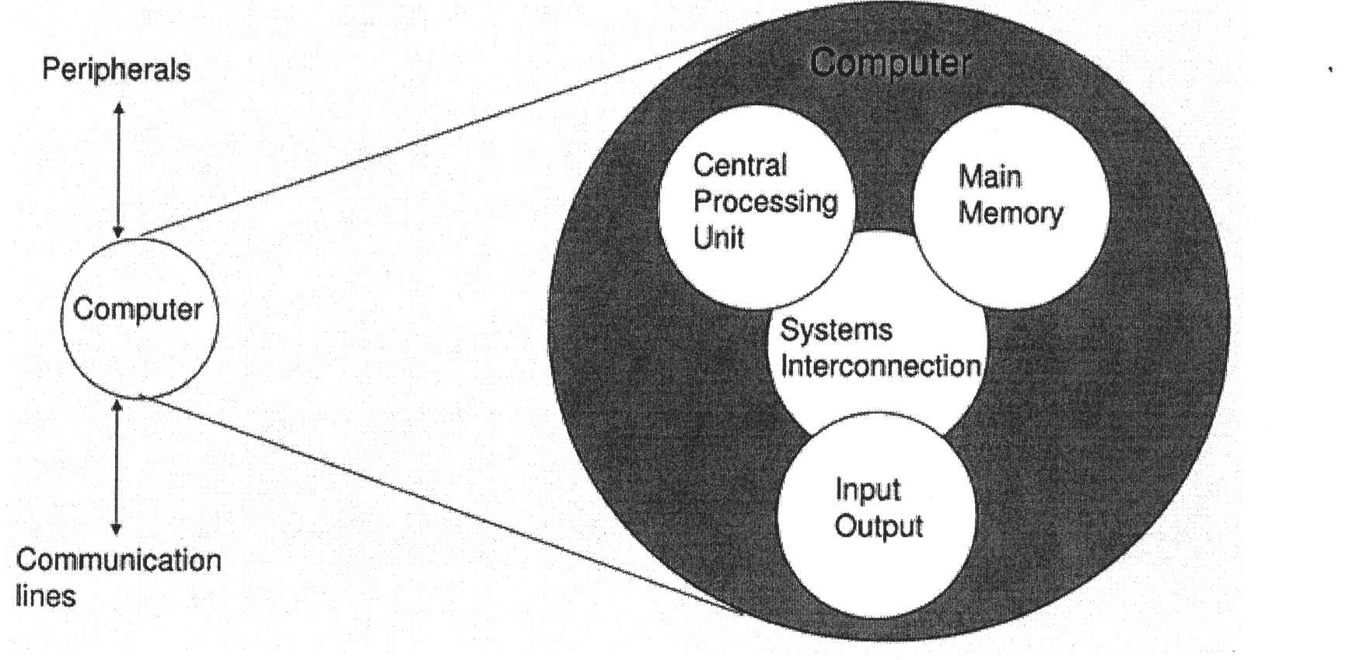
Figure 1 : Components of computer
- Explain THREE (3) types of system interconnection.
- State TWO (2) sub-components of central processing unit and its function.

QUESTION A10 (10 marks)
Answer both parts for the same expression. Assume an 8-bit byte.
Expression: -24 - 63
- Calculate -24 - 63 using sign and magnitude.
- Calculate -24 - 63 using 1's and 2's complement.

PART B (20 MARKS)
Answer the question in this part.

QUESTION B1 (20 marks)
Question 1 is based on Figure 5 and Table 1
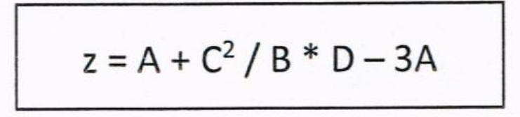
Figure 5
Write an appropriate program using conect assembly language notations to compute the equation shown in Figure 5 using instructions for zero-address, one-address, and three- address. The available instructions are provided in Table 1. The registers labeled A, B, C, and D are fixed, while registers x, y, and z can be used temporarily. The final answer must be stored in register z.
Table 1: lt/achine instruction
Zero-address | One-address | Three-address
PUSH p | LOAD p | ADD (p,q,r)
POP p | STOR p | SUB (p,q,r)
ADD | ADD p | MUL (p,q,r)
SUB | SUB p | DIV (p,q,r)
MUL | MUL p
DIV | DIV p

