
CONFIDENTIAL CS/NOV 2026/CSC429

UNIVERSITI TEKNOLOGI MARA FINAL EXAMINATION

COURSE
COURSE CODE
EXAMINATION TIME
COMPUTER ORGANIZATION AND ARCHITECTURE

CSC429
NOVEMBER 2026
3 HOURS

INSTRUCTIONS TO CANDIDATES

- This question paper consists of two (2) parts: PART A (10 Questions) PART B (1 Question)

- Answer ALL questions in the Answer Booklet. Start each answer on a new page.

- Do not bring any material into the examination room unless permission is given by the invigilator .
- Please check to make sure that this examination pack consists of: i) the Question Paper
  - an Answer Booklet - provided by the Faculty

- Answer ALL questions in English.

DO NOT TURN THIS PAGE UNTIL YOU ARE TOLD TO DO SO

This examination paper consists of 6 printed pages.

PART A (80 MARKS)
Answer ALL questions in this part.

QUESTION A1 (5 marks)
Given the following Figure 2.

Figure 2
- Label the addressing technique illustrated in Figure 2.
- Explain how the addressing technique in 9(a) is used.
- List ONE (1) advantage and ONE (1) disadvantage of the addressing technique in 9(a).

QUESTION A2 (5 marks)
Calculate -10 - 74 using the sign-and-magnitude method. Assume an 8-bit byte. Show your complete workflow.

QUESTION A3 (5 marks)
Given the following Non Uniform Memory Access (NUMA) diagram.
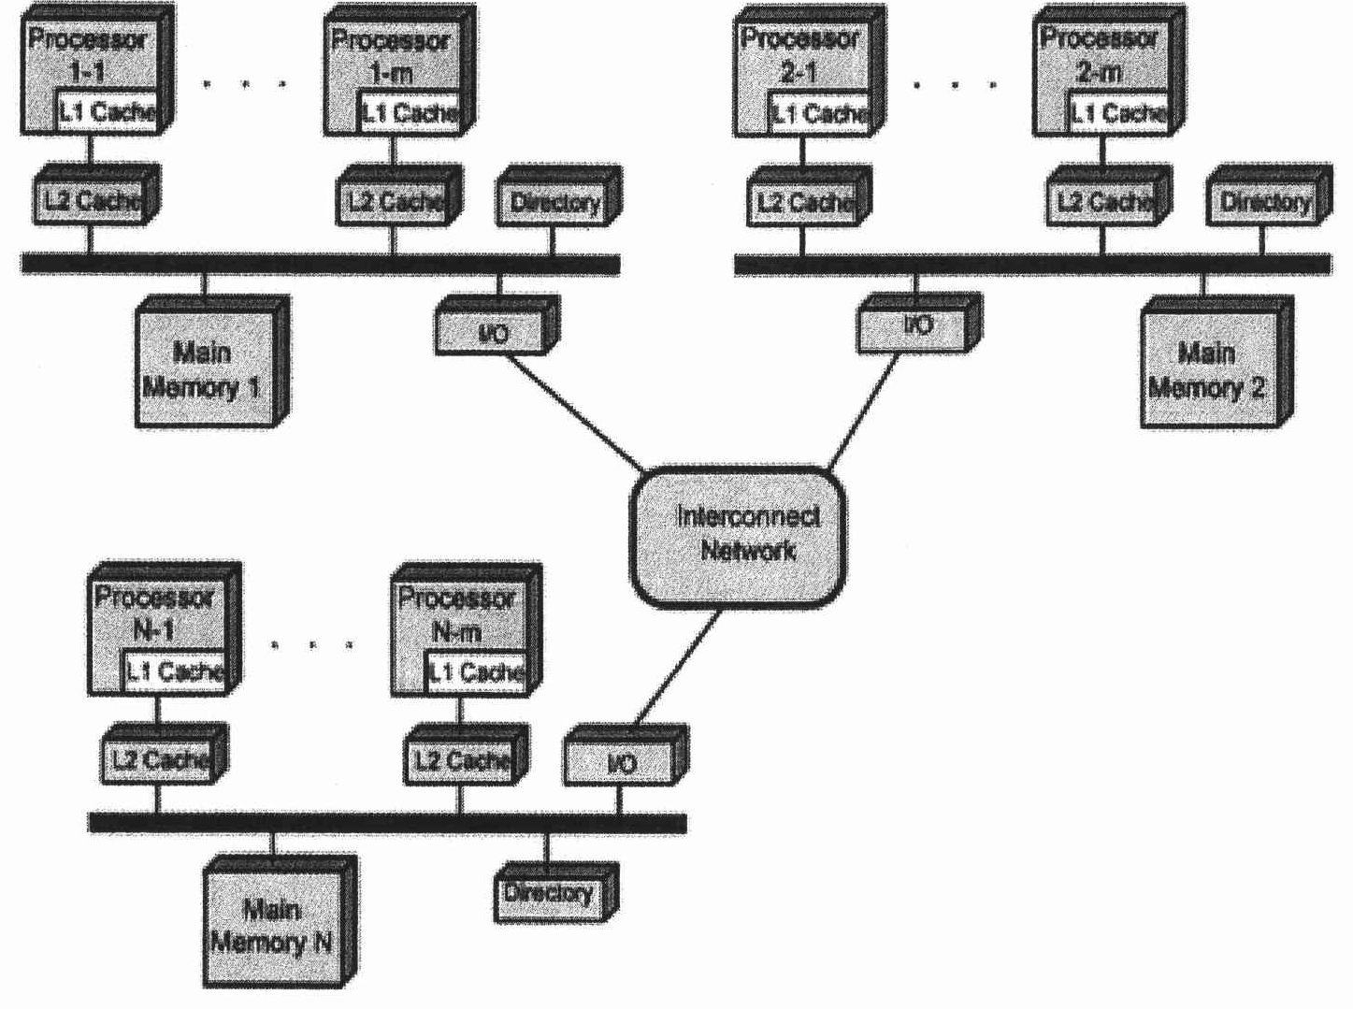
Figure 3: NUMA Architecture
- State ONE (1) advantage of Symmetric Mufti-Processor (SMP) that is applied in NUMA architecture.
- Describe ONE (1) disadvantage of cluster architecture.
- Draw a possible architecture for cluster architecture based on Figure 3.

QUESTION A4 (5 marks)
Question 2 is based on the following statement. "The introduction of graphical user interface (GUI) and mouse technology remark the beginning of a new computer generation. In this generation, there are many great developments in the field of computer networks leading to the birth of internet concept".
- Name the computer generation described.
- What are the TWO (2) main technologies available in this computer generation?
- List TWO (2) main features of this computer generation.

QUESTION A5 (10 marks)
Question 5 is based on the following scenario. "Nurathia Farhana browses the UiTM4fly.com website to book for a return flight from KLIA to LAX. While comparing for a better price, two messages popped up in her screen. Figure 1 (a) and (b) illustrate the conveyed messages.

Figure 1: The pop-up messages
(b)
(a)
- Which message is the non-maskable interrupt? Justify your answer by giving appropriate reason.
- Differentiate between maskable and non-maskable interrupt?
- Outline the common way to handle multiple interrupts as happened in the given scenario.

QUESTION A6 (10 marks)
- Discuss the function of each Central Processing Unit (CPU) component'
- Elaborate on what will happen in the machine cycle if the bus system is faulty

QUESTION A7 (10 marks)
- Explain the problem in polling 1/0 method.
- Explain how buffering can help to improve the device overall performance?
- Discuss how DMA technique can help the 1/0 transfer performance instead of using polling method and interrupt 1/0 method?

QUESTION A8 (10 marks)
Replacement algorithm is used to determine which entry in a cache to flush to main memory when it is desired to cache a new block of data.
- Which mapping function does not need to have a replacement algorithm?
- Describe FOUR (4) types of replacement algorithm.

QUESTION A9 (10 marks)
- List the phases in the machine cycle,
- Discuss the function of the different CPU components in the machine cycle.
- What will happen in the machine cycle if access to the main memory is blocked?

QUESTION A10 (10 marks)
Answer both parts. Show your complete workflow.
a) Convert 314510 to hexadecimal.
b) Convert ED116 to decimal.
- Convert 314510 to hexadecimal.
- Convert ED116 to decimal.

PART B (20 MARKS)
Answer the question in this part.

QUESTION B1 (20 marks)
Question 1 is based on Figure 2 and Table 1.
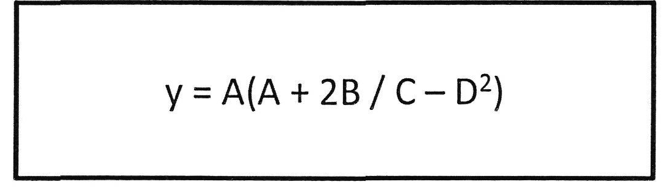
Figure 2
Write the appropriate programs using correct assembly language notations and comments to compute the equation represented in Figure 1 using zero-, one-, and three-address instructions. The instructions available for use are provided in Table 1. Register A, B, C, and D cannot be modified, and registers x, y, and z can be used as temporary registers. However, the final answer must be stored in Register y.
Table 1: Machine Instruction
Zero-address | One-address | Three-address
PUSHp | LOADp | ADD (p,q,r)
POPp | STORp | SUB (p,q,r)
ADD | ADDp | MUL (p.q.r)
SUB | SUBp | DIV(p,q,r)
MUL | MULp
DIV | DIVp

