
CONFIDENTIAL CS/NOV 2026/CSC429

UNIVERSITI TEKNOLOGI MARA FINAL EXAMINATION

COURSE
COURSE CODE
EXAMINATION TIME
COMPUTER ORGANIZATION AND ARCHITECTURE

CSC429
NOVEMBER 2026
3 HOURS

INSTRUCTIONS TO CANDIDATES

- This question paper consists of two (2) parts: PART A (10 Questions) PART B (1 Question)

- Answer ALL questions in the Answer Booklet. Start each answer on a new page.

- Do not bring any material into the examination room unless permission is given by the invigilator .
- Please check to make sure that this examination pack consists of: i) the Question Paper
  - an Answer Booklet - provided by the Faculty

- Answer ALL questions in English.

DO NOT TURN THIS PAGE UNTIL YOU ARE TOLD TO DO SO

This examination paper consists of 6 printed pages.

PART A (80 MARKS)
Answer ALL questions in this part.

QUESTION A1 (5 marks)
- Give ONE (1) characteristic of Symmetric Multiprocessor (SMP).
- Discuss the meaning of "symmetric" in Symmetric Multiprocessor.
- Give ONE (1) advantage of Symmetric Multiprocessor organization.

QUESTION A2 (5 marks)
Convert 282810 to octal. Show your complete workflow.

QUESTION A3 (5 marks)
Given the following Figure 2.

Figure 2
- Label the addressing technique illustrated in Figure 2.
- Explain how the addressing technique in 9(a) is used.
- List ONE (1) advantage and ONE (1) disadvantage of the addressing technique in 9(a).

QUESTION A4 (5 marks)
- Name the inventor of the integrated circuit.
- ln which computer generation was the integrated circuit first introduced?
- List THREE (3) main components of an integrated circuit.

QUESTION A5 (10 marks)
Describe FOUR (4) type of access methods based on hardware implementation of the storage device. Provide ONE (1) appropriate example for each access type.

QUESTION A6 (10 marks)
Answer both parts for the same expression. Assume an 8-bit byte.
Expression: 38 - (-28)
- Calculate 38 - (-28) using sign and magnitude.
- Calculate 38 - (-28) using 1's and 2's complement.

QUESTION A7 (10 marks)
Question 8 is based on Figure 2.
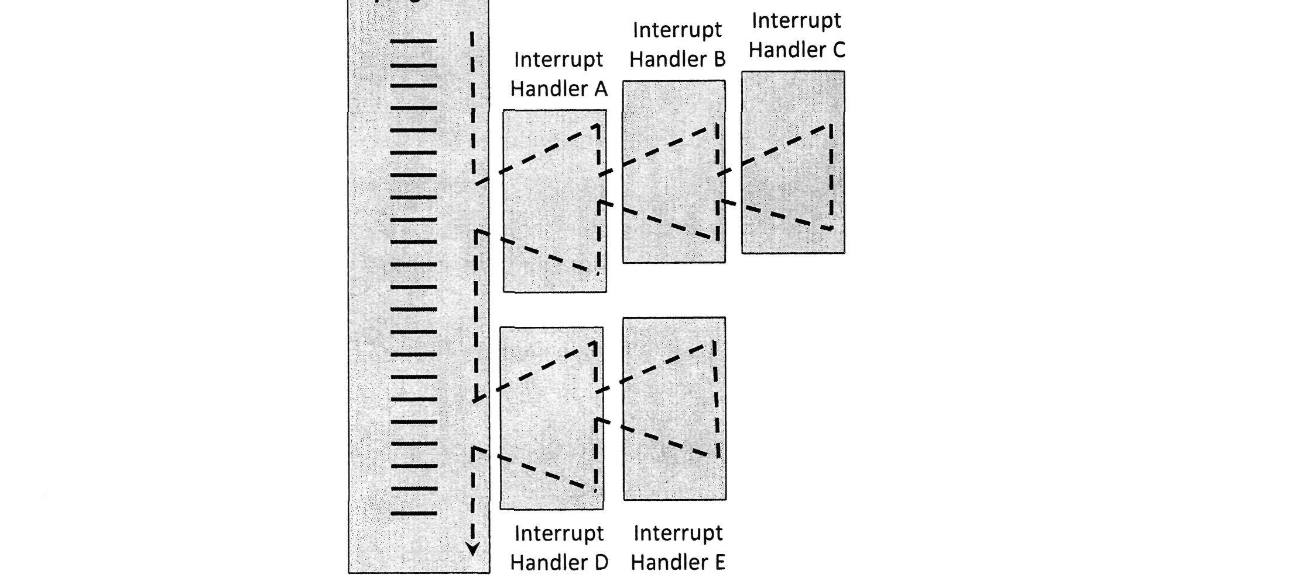
Figure 2: Multiple interrupts diagram
- Describe maskable interrupt.
- What is the sequence of the program execution if the defined priority is implemented in
- What is the sequence of the program execution if the disable interrupt is implemented in
- Which of the interruption method between defined priority or disable interrupt can finish Interrupt C earlier? Give your justification.

QUESTION A8 (10 marks)
Computer consists of four main components as illustrated in Figure 1. Each component has its own function in ensuring that the computer system works well. Question 4 is based on
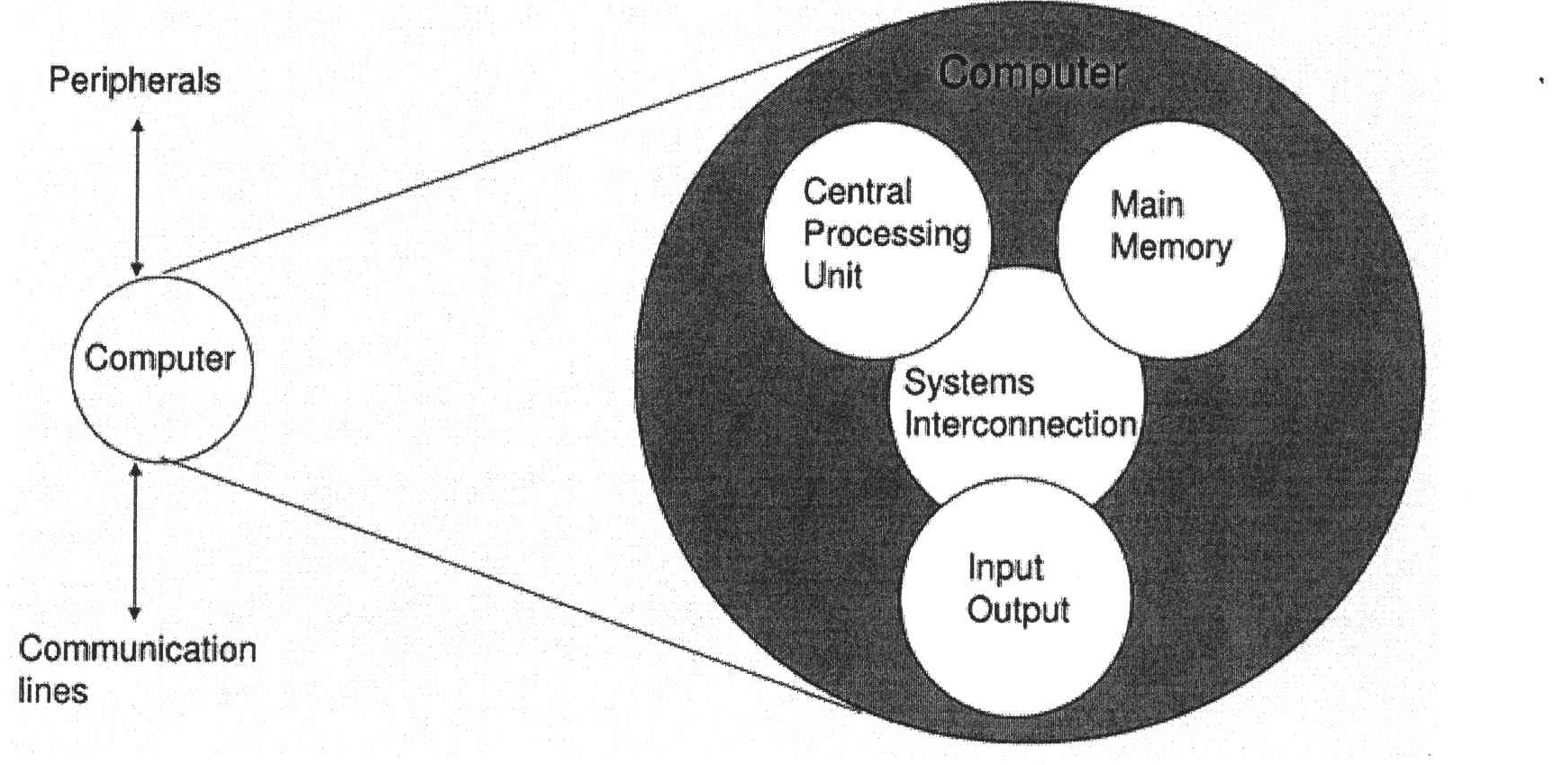
Figure 1 : Components of computer
- Explain THREE (3) types of system interconnection.
- State TWO (2) sub-components of central processing unit and its function.

QUESTION A9 (10 marks)
- Given the size of an address bus is 16 bit and the size of the data bus is 64 bit.
- Determine the size of data block. Give appropriate justification for such answer.
- What is the usage of address bus?
- What happens if a wider address bus is set?
- Discuss TWO (2) types of bus timing.

QUESTION A10 (10 marks)
- Discuss TWO (2) functions of an input/output module.
- External input/output devices can be broadly categorized into three categories. List TWO (2) of the categories and provide an appropriate example of devices for each categories.
- Name ONE (1) input/output technique that requires active CPU intervention and ONE (1) technique that does not require CPU intervention.

PART B (20 MARKS)
Answer the question in this part.

QUESTION B1 (20 marks)
Question 1 is based on Figure 1 and Table 1.
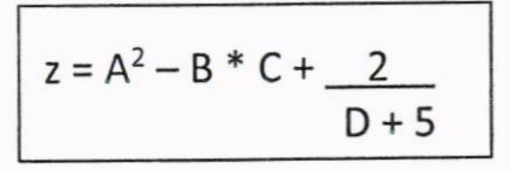
Figure 1
write an appropriate program using correct assembly language notations to compute the equation snbwn in Figure 1 using instructions for zero-address, one-address, and three- address. The available instructioni are provided in Tabte 1. The register labeled A, B, C, and D are fixed, white registers x, y, and z can be used temporarily. The final answer must be stored in register z.
Table 1: Machine instruction
Zero-address | One-address | Three-address
PUSH p | LOAD p | ADD (p,q,r)
POP p | STOR p | suB (p,q,r)
ADD | ADD p | MUL (p,q,r)
SUB | SUB p | DIV (p,q,r)
MUL | MUL p
DIV | DIV p

