
CONFIDENTIAL CS/NOV 2026/CSC429

UNIVERSITI TEKNOLOGI MARA FINAL EXAMINATION

COURSE
COURSE CODE
EXAMINATION TIME
COMPUTER ORGANIZATION AND ARCHITECTURE

CSC429
NOVEMBER 2026
3 HOURS

INSTRUCTIONS TO CANDIDATES

- This question paper consists of two (2) parts: PART A (10 Questions) PART B (1 Question)

- Answer ALL questions in the Answer Booklet. Start each answer on a new page.

- Do not bring any material into the examination room unless permission is given by the invigilator .
- Please check to make sure that this examination pack consists of: i) the Question Paper
  - an Answer Booklet - provided by the Faculty

- Answer ALL questions in English.

DO NOT TURN THIS PAGE UNTIL YOU ARE TOLD TO DO SO

This examination paper consists of 5 printed pages.

PART A (80 MARKS)
Answer ALL questions in this part.

QUESTION A1 (5 marks)
Convert -20.125 to IEEE 754 single-precision format. Give the answer in hexadecimal and show the sign, exponent and mantissa fields.

QUESTION A2 (5 marks)
Question 1 is based on the following statement.
Step Reckoner and Mechanical Calculating Machine are introduced in Zero generation. Both machines are used for simple calculation and mechanically operated using manual intervention throughout each step of their operation.
- Name the inventors for each machine.
- Describe the main difference in term of the machines' functions.
- Which machine that uses binary numbering system that is fundamental in modern computers' operation?

QUESTION A3 (5 marks)
- Give ONE (1) characteristic of Symmetric Multiprocessor (SMP).
- Discuss the meaning of "symmetric" in Symmetric Multiprocessor.
- Give ONE (1) advantage of Symmetric Multiprocessor organization.

QUESTION A4 (5 marks)
Given the following Figure 2.

Figure 2
- Label the addressing technique illustrated in Figure 2.
- Explain how the addressing technique in 9(a) is used.
- List ONE (1) advantage and ONE (1) disadvantage of the addressing technique in 9(a).

QUESTION A5 (10 marks)
- Draw a complete machine cycle by giving the exact location of each phase.
- Briefly, describe each phase in the machine cycle.

QUESTION A6 (10 marks)
Answer both parts for the same expression. Assume an 8-bit byte.
Expression: 24 - (-83)
- Calculate 24 - (-83) using sign and magnitude.
- Calculate 24 - (-83) using 1's and 2's complement.

QUESTION A7 (10 marks)
Processor contains a number of registers used for temporary storage of data. Describe FIVE (5) types of registers.

QUESTION A8 (10 marks)
- Discuss TWO (2) functions of an input/output module.
- External input/output devices can be broadly categorized into three categories. List TWO (2) of the categories and provide an appropriate example of devices for each categories.
- Name ONE (1) input/output technique that requires active CPU intervention and ONE (1) technique that does not require CPU intervention.

QUESTION A9 (10 marks)
- Why input/output problem occurs?
- Describe THREE (3) categories for input/output module and provide an appropriate example each.

QUESTION A10 (10 marks)
Replacement algorithm is used to determine which entry in a cache to flush to main memory when it is desired to cache a new block of data.
- Which mapping function does not need to have a replacement algorithm?
- Describe FOUR (4) types of replacement algorithm.

PART B (20 MARKS)
Answer the question in this part.

QUESTION B1 (20 marks)
Question 1 is based on Figure 2 and Table 1.
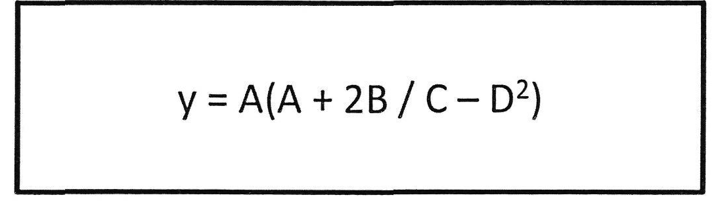
Figure 2
Write the appropriate programs using correct assembly language notations and comments to compute the equation represented in Figure 1 using zero-, one-, and three-address instructions. The instructions available for use are provided in Table 1. Register A, B, C, and D cannot be modified, and registers x, y, and z can be used as temporary registers. However, the final answer must be stored in Register y.
Table 1: Machine Instruction
Zero-address | One-address | Three-address
PUSHp | LOADp | ADD (p,q,r)
POPp | STORp | SUB (p,q,r)
ADD | ADDp | MUL (p.q.r)
SUB | SUBp | DIV(p,q,r)
MUL | MULp
DIV | DIVp

