
CONFIDENTIAL CS/NOV 2026/CSC429

UNIVERSITI TEKNOLOGI MARA FINAL EXAMINATION

COURSE
COURSE CODE
EXAMINATION TIME
COMPUTER ORGANIZATION AND ARCHITECTURE

CSC429
NOVEMBER 2026
3 HOURS

INSTRUCTIONS TO CANDIDATES

- This question paper consists of two (2) parts: PART A (10 Questions) PART B (1 Question)

- Answer ALL questions in the Answer Booklet. Start each answer on a new page.

- Do not bring any material into the examination room unless permission is given by the invigilator .
- Please check to make sure that this examination pack consists of: i) the Question Paper
  - an Answer Booklet - provided by the Faculty

- Answer ALL questions in English.

DO NOT TURN THIS PAGE UNTIL YOU ARE TOLD TO DO SO

This examination paper consists of 7 printed pages.

PART A (80 MARKS)
Answer ALL questions in this part.

QUESTION A1 (5 marks)
Label the correct computer generation based on the characteristics given in Table 1.
Table 1
Scenario | Computer Generation
High level language such as FORTRAN and COBOL were introduced and highly in demand.
Punched cards, paper tape and magnetic tape input and output devices were widely used.
Hundred thousand on circuits were integrated in a single chip where a concept of personal computing was being developed.
Computers start to incorporate artificial intelligence capability to make decision based on prior knowledge.
Computers in this generation have a fast processing power with no requirement for air conditioning to cool the hardware.

QUESTION A2 (5 marks)
- Identify the Von Neumann architecture input and output components based on the excerpts from the web.
The Jacquard Loom is a mechanical loom invented by Joseph Marie Jacquard in
1801, which simplifies the process of manufacturing textiles with complex
patterns. The loom is controlled by punched cards with punched holes, each row
corresponding to one design row. Multiple rows of holes are punched on each
card, and the many cards that compose the textile design are strung together in
an orderly manner.

Figure 1: Excerpt from https://en.wikipedia.org/wiki/Loom
- Identify ONE (1) similarity and ONE (1) dissimilarity between the mechanical calculating machine and Atanasoff Berry Computer.

QUESTION A3 (5 marks)
- Calculate the byte content shown in Figure 1.
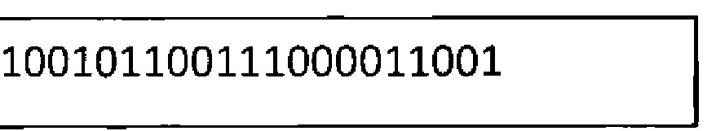
Figure 1
- Calculate 2D.5h + ED.2h in binary. Show your complete workflow.

QUESTION A4 (5 marks)
- What is a cache?
- Describe TWO (2) ways to store data in cache.

QUESTION A5 (10 marks)
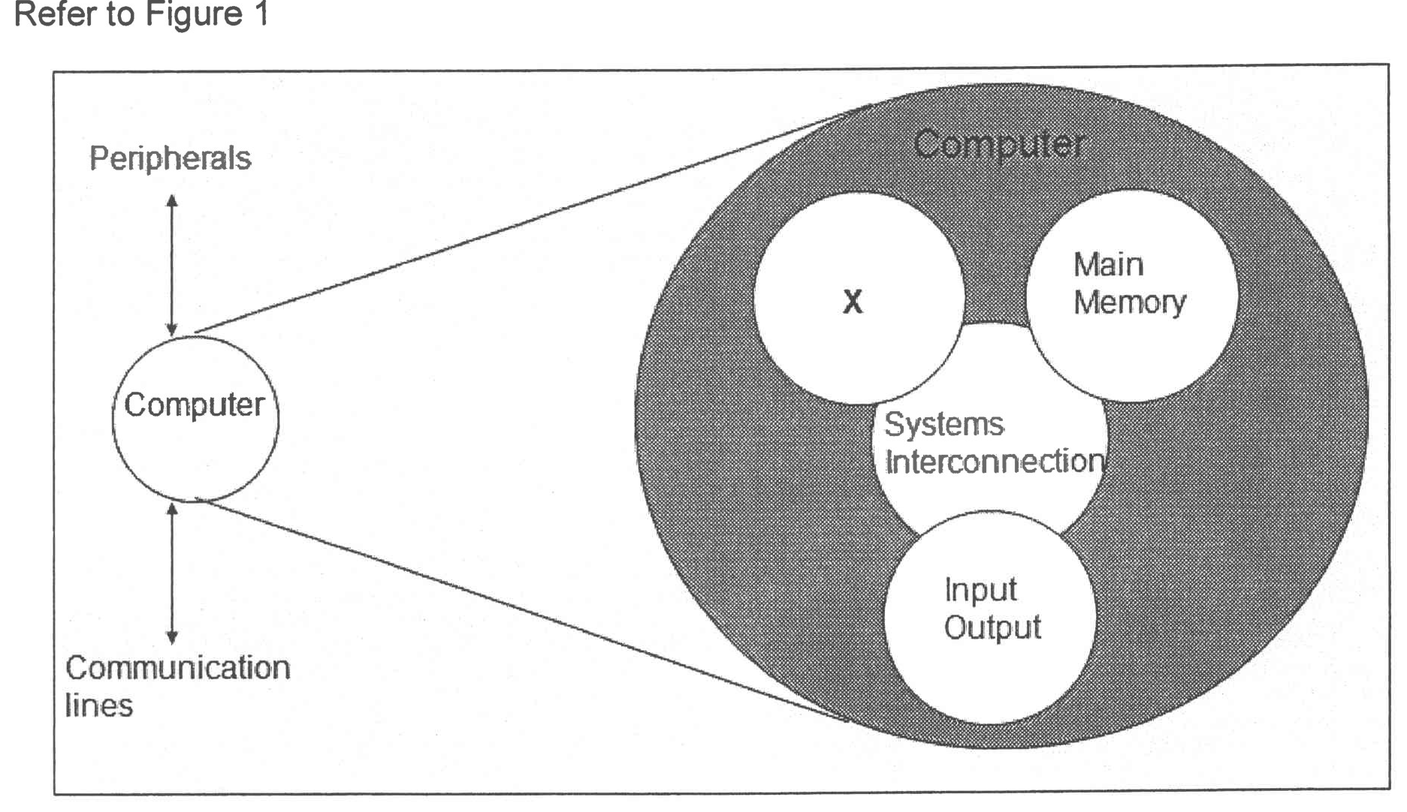
Figure 1
- Identify what is X.
- Briefly describe the function of X.
List the sub-structural component of X.

- In your opinion, why X is very important to the computer system?

QUESTION A6 (10 marks)
Question 9 is based on Figure 2.
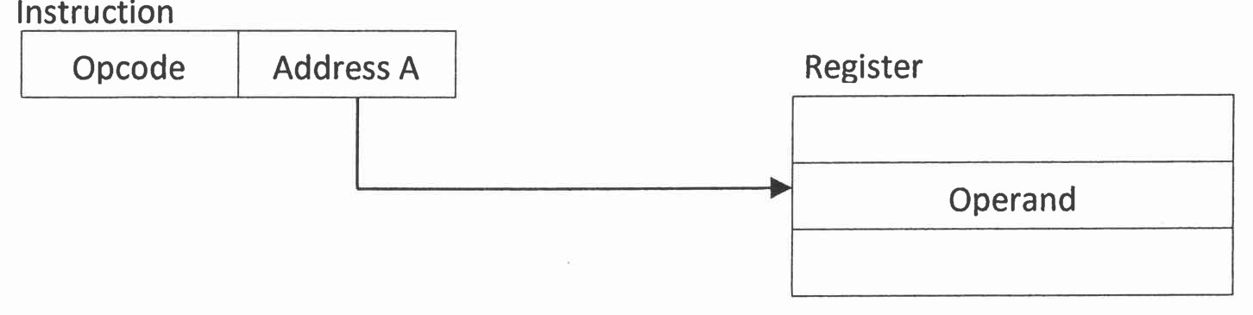
Figure 2: Addressing mode type x.
- Identify addressing mode in Figure 2.
- Which register will be involved in Figure 2 addressing mode?
- If register in Figure 2 is replaced with memory, what is the new addressing mode?
- Addressing mode in (a) is using register and addressing mode in (c) is using memory. Discuss which addressing mode will be executed faster with appropriate justification.

QUESTION A7 (10 marks)
Question 9 is based on Figure 1. Figure 1 illustrates the multiple interrupts that occur in a computer system.
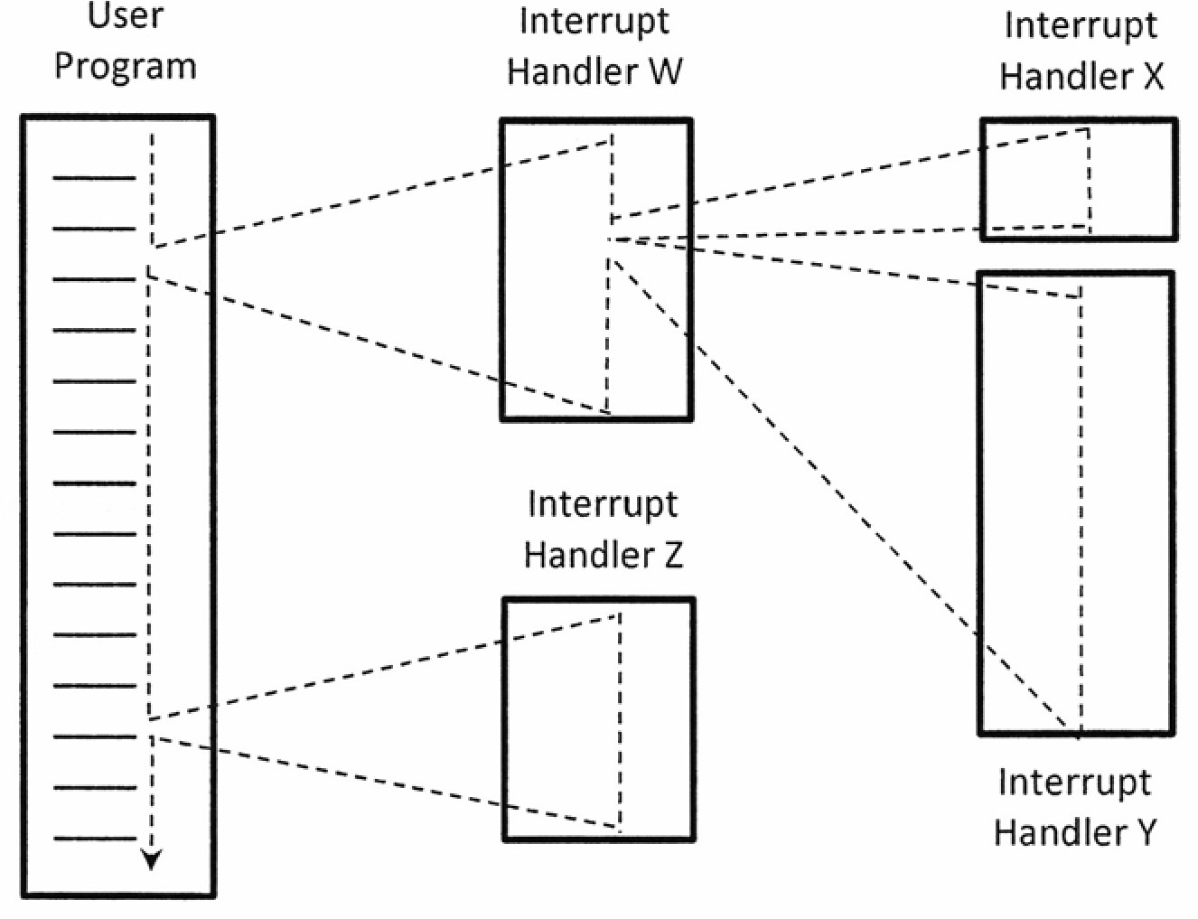
Figure 1: Multiple interrupts
- Define interrupt.
- Rank the interrupts based on their priority from the most important to the least important.
- Rank the interrupts from the most important to the least important if disable interrupt is applied.

QUESTION A8 (10 marks)
- List the FOUR (4) classifications of parallel processors and provide examples for each.
- Discuss ONE (1) advantage of using cluster computer architecture.

QUESTION A9 (10 marks)
- State TWO (2) different types of bus.
- The size of a word is 32 bits and the size of the block is 256 bits. Determine of the following:
- The byte for word
- The byte for block,
- Size of the register,
- Size of the data bus.

QUESTION A10 (10 marks)
- Convert -156.1562510 to a floating-point number in IEEE single precision format in hexadecimal value form. Show your workflow.
- Convert BD40 0000H in IEEE single precision floating point number to decimal value form. Show your workflow.

PART B (20 MARKS)
Answer the question in this part.

QUESTION B1 (20 marks)
Question 1 is based on Figure 5 and Table 1
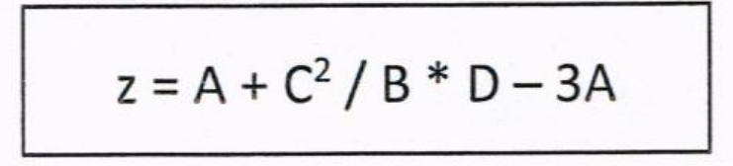
Figure 5
Write an appropriate program using conect assembly language notations to compute the equation shown in Figure 5 using instructions for zero-address, one-address, and three- address. The available instructions are provided in Table 1. The registers labeled A, B, C, and D are fixed, while registers x, y, and z can be used temporarily. The final answer must be stored in register z.
Table 1: Machine instruction
Zero-address | One-address | Three-address
PUSH p | LOAD p | ADD (p,q,r)
POP p | STOR p | SUB (p,q,r)
ADD | ADD p | MUL (p,q,r)
SUB | SUB p | DIV (p,q,r)
MUL | MUL p
DIV | DIV p

