
CONFIDENTIAL CS/NOV 2026/CSC429

UNIVERSITI TEKNOLOGI MARA FINAL EXAMINATION

COURSE
COURSE CODE
EXAMINATION TIME
COMPUTER ORGANIZATION AND ARCHITECTURE

CSC429
NOVEMBER 2026
3 HOURS

INSTRUCTIONS TO CANDIDATES

- This question paper consists of two (2) parts: PART A (10 Questions) PART B (1 Question)

- Answer ALL questions in the Answer Booklet. Start each answer on a new page.

- Do not bring any material into the examination room unless permission is given by the invigilator .
- Please check to make sure that this examination pack consists of: i) the Question Paper
  - an Answer Booklet - provided by the Faculty

- Answer ALL questions in English.

DO NOT TURN THIS PAGE UNTIL YOU ARE TOLD TO DO SO

This examination paper consists of 7 printed pages.

PART A (80 MARKS)
Answer ALL questions in this part.

QUESTION A1 (5 marks)
The X machine was the first automatic electronic digital computer that uses binary system. It has 30 arithmetic/logic unit that can add and subtract, a rotating drum memory that can held thirty binary numbers of fifty digits each and input/output components. Figure 1 shows the architecture of X machine.
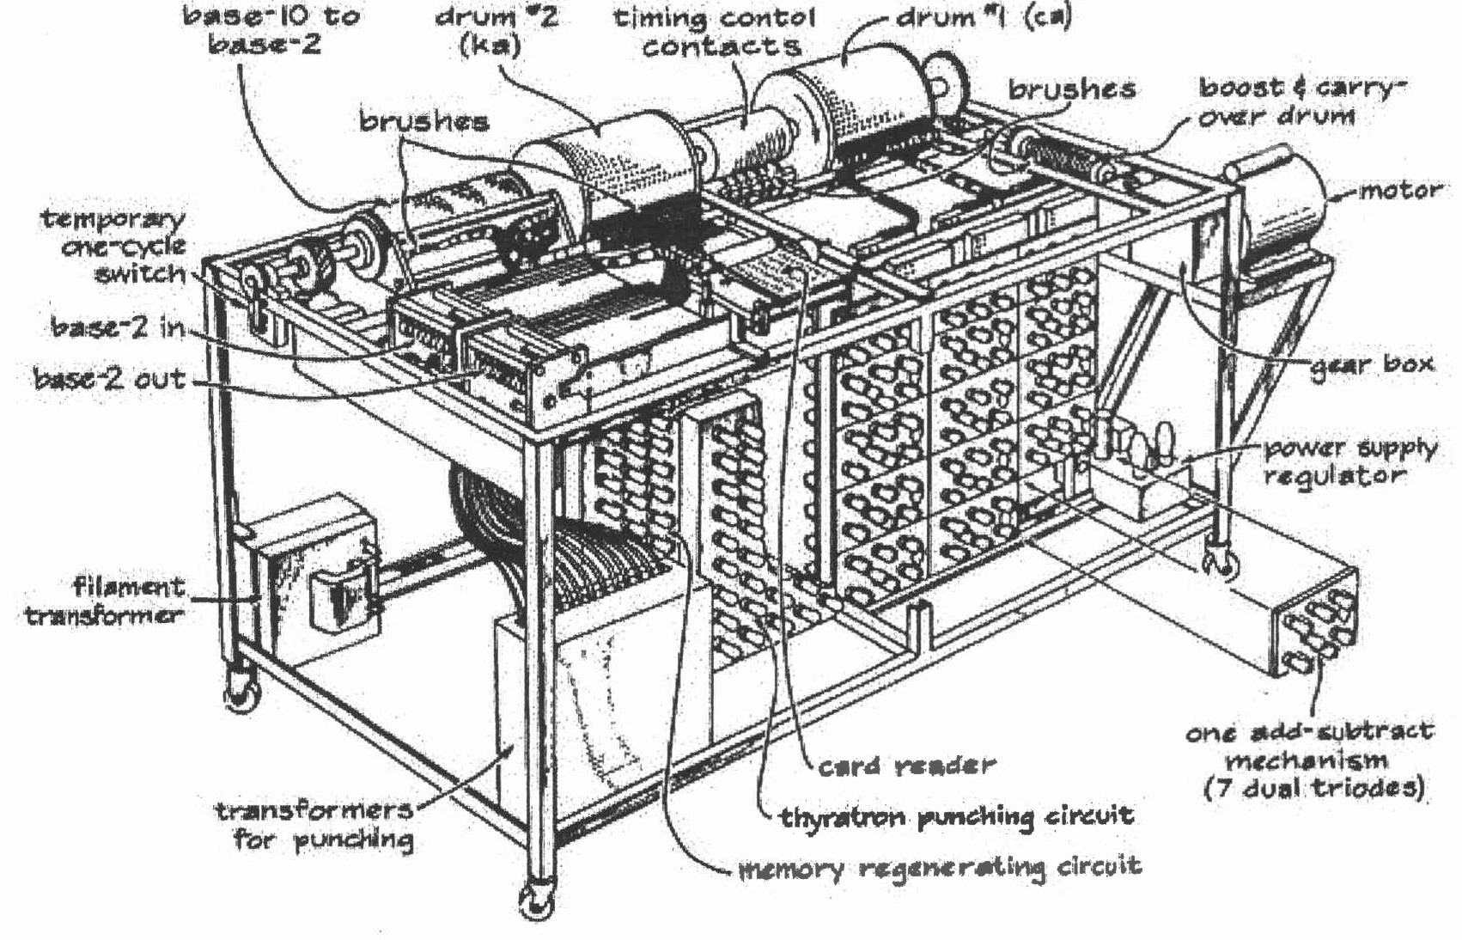
Figure 1: Machine X
- What is X machine?
- Name the inventor of X machine.
- Based on Figure 1, identify the input and output components for X machine.

QUESTION A2 (5 marks)
Question 1 is based on the following image and statements in Figure 1.
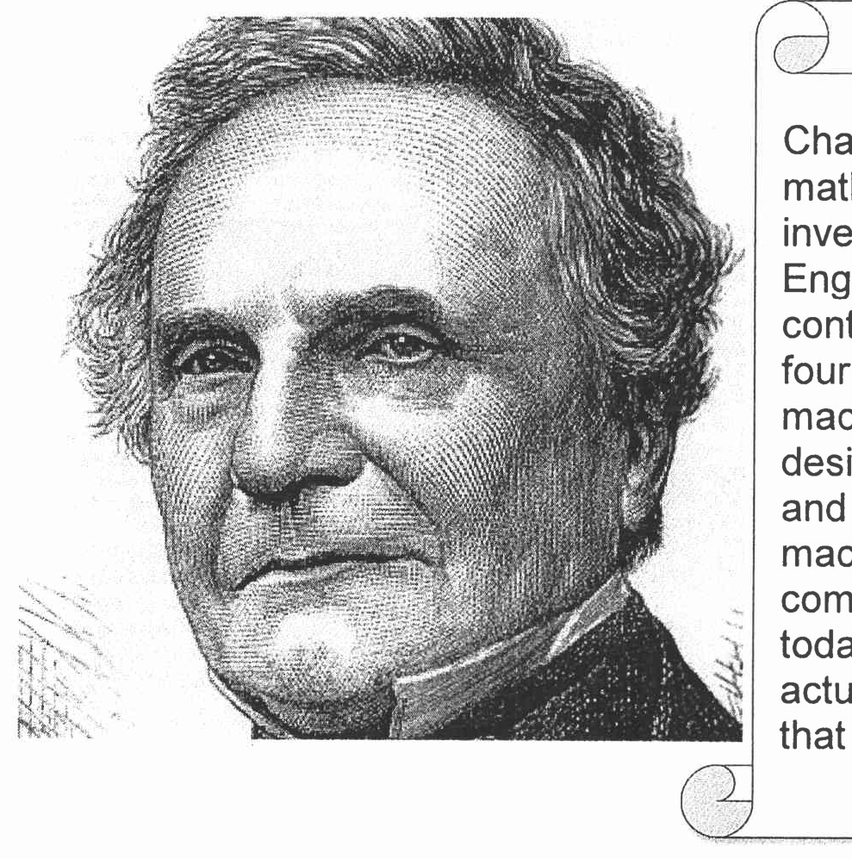
Figure 1: A snippet from biography web page
Charles Babbage was an English mathematician, a philosopher and also an inventor. He was born on 1791 in London England. He was known for his contributions to invent machine X to solve four basic arithmetic functions. The machine X has improved its calculations design from Stepped Reckoner machine and early mechanical calculator. The machine X has introduced a number of computing concepts which are still in use today. Although this machine was not actually completed, it is the first machine that deserved to be called as a computer.
- What is the machine X name?
- In which generation does the machine X introduced?
- What is the function of machine X?
- Name the machine that has been invented prior to machine X?
- What is the title given to Charles Babbage due to his success to invent machine X?

QUESTION A3 (5 marks)
Question 3 is based on Figure 1. For a 16-bit computer system, assume that one character, including space, is equal to one byte and a word is equal to two bytes.
Figure 1
- What is a block?
- What is the smallest addressable unit?
- ldentify the number of:
- byte.

- word. bit.

QUESTION A4 (5 marks)
The Von Neumann Architecture was first described in a seminal First Draft of a Report on the EDVAC. The document describes a design architecture of a general- purpose electronic computer that serves as the basis for almost all of modern computers.
- List TWO (2) main components of a Von Neumann Architecture.
- Von Neumann computers are general purpose computers. Define the term general- purpose computers.
- Name ONE (1) of the earliest computers built based on the Von Neumann Architecture.

QUESTION A5 (10 marks)
Based on Figure 2 (p) - (r):
Figure 2: Interfaces to external devices
- Identify the following interfaces to external devices in Figure 2 (p), (q) and (r) with appropriate label.
- What is the meaning of 'hot' connection?
- Which interfaces to external devices that have 'hot' connection with devices?

QUESTION A6 (10 marks)
- Given the architecture of Single Instruction, Single Data Stream (SISD) is in Figure 3, with CU representing Control Unit, PU representing the Processing Unit, and MU representing the Memory Unit. Draw the following multiple processor organization with an appropriate label. Clearly show the Instruction Stream (IS) and Data Stream (DS).
- Multiple Instructions Multiple Data streams (MIMD) with shared memory,
- Multiple Instructions Multiple Data streams (MIMD) with distributed memory.
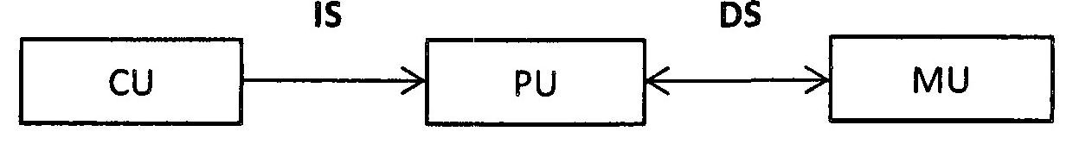
Figure 3: Single Instruction, Single Data Stream (SISD)
- Give ONE (1) example for the following multiple-processor organization.
- Multiple Instructions Multiple Data streams (MIMD) with shared memory,
- Multiple Instructions Multiple Data streams (MIMD) with distributed memory.
- Discuss ONE (1) advantage of using Multiple Instructions Multiple Data stream (MIMD) with distributed memory.

QUESTION A7 (10 marks)
Question 10 is based on Figure 2. Figure 2 depicts a Non-uniform Memory Access (NUMA) architecture.
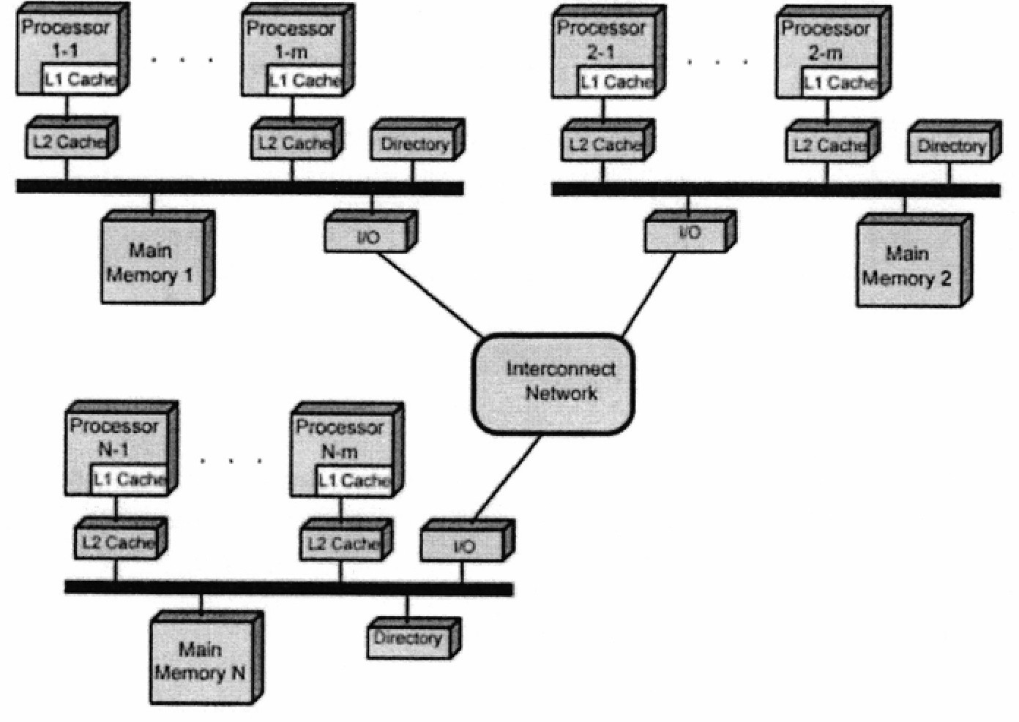
Figure 2: Non-uniform Memory Access (NUMA)
- Redraw a symmetric multiprocessor organization based on Figure 2.
- Give TWO (2) examples of tightly coupled Multiple Instruction, Multiple Data (MIMD) parallel processor architectures.
- Discuss TWO (2) disadvantages of tightly coupled Multiple Instruction, Multiple Data (MIMD) parallel processor architectures.

QUESTION A8 (10 marks)
- What is a cache?
- Elaborate on what will happen if there is no cache in the computer system,
- Comparing L1 and L2 cache, discuss which cache would have faster speed with relevant justification.
- Discuss TWO (2) policies to write data to the cache to ensure consistency between the cache and the main memory (RAM).

QUESTION A9 (10 marks)
- Calculate FIFAie - 664i6 using the following techniques. Showthe complete workflow.
- Sign and magnitude
- 2's complement

QUESTION A10 (10 marks)
- Provide one example for each classification of multiple processor organization.
- Draw a simplified computer architecture of the following: Symmetric Multiprocessors ii. Clusters iii. Non Uniform Memory Access (NUMA)

PART B (20 MARKS)
Answer the question in this part.

QUESTION B1 (20 marks)
Question 1 is based on Figure 1 and Table 1.
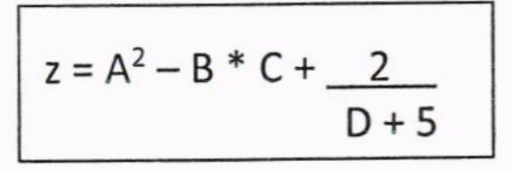
Figure 1
write an appropriate program using correct assembly language notations to compute the equation snbwn in Figure 1 using instructions for zero-address, one-address, and three- address. The available instructioni are provided in Tabte 1. The register labeled A, B, C, and D are fixed, white registers x, y, and z can be used temporarily. The final answer must be stored in register z.
Table 1: Machine instruction
Zero-address | One-address | Three-address
PUSH p | LOAD p | ADD (p,q,r)
POP p | STOR p | suB (p,q,r)
ADD | ADD p | MUL (p,q,r)
SUB | SUB p | DIV (p,q,r)
MUL | MUL p
DIV | DIV p

