
CONFIDENTIAL CS/NOV 2026/CSC429

UNIVERSITI TEKNOLOGI MARA FINAL EXAMINATION

COURSE
COURSE CODE
EXAMINATION TIME
COMPUTER ORGANIZATION AND ARCHITECTURE

CSC429
NOVEMBER 2026
3 HOURS

INSTRUCTIONS TO CANDIDATES

- This question paper consists of two (2) parts: PART A (10 Questions) PART B (1 Question)

- Answer ALL questions in the Answer Booklet. Start each answer on a new page.

- Do not bring any material into the examination room unless permission is given by the invigilator .
- Please check to make sure that this examination pack consists of: i) the Question Paper
  - an Answer Booklet - provided by the Faculty

- Answer ALL questions in English.

DO NOT TURN THIS PAGE UNTIL YOU ARE TOLD TO DO SO

This examination paper consists of 6 printed pages.

PART A (80 MARKS)
Answer ALL questions in this part.

QUESTION A1 (5 marks)
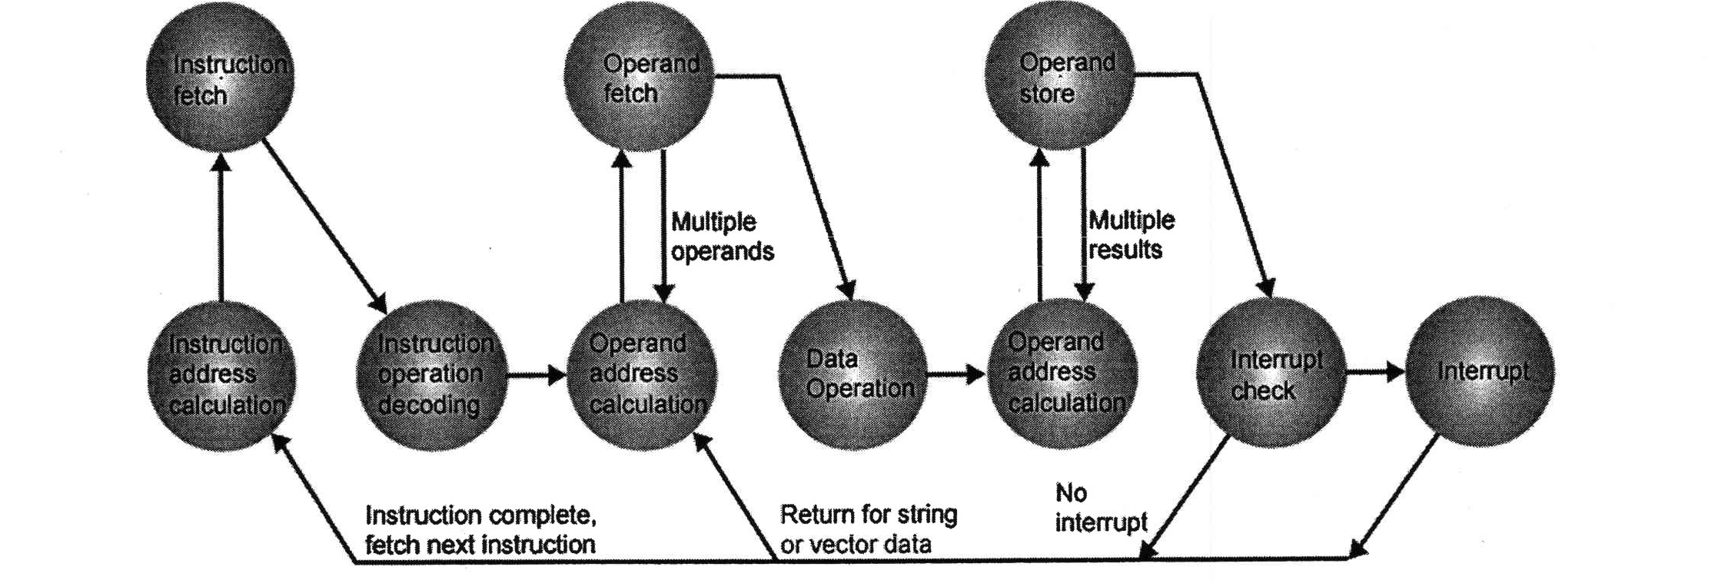
Figure 1
- What is interrupt?
- Discuss TWO (2) ways to handle multiple interrupt.

QUESTION A2 (5 marks)
Question 1 is based on the following snippet garnered from a computer science web page.
Henry Edward "Ed" Roberts
(September 13, 1941 -April 1, 2010)
was an American engineer, entrepreneur and
medical doctor who invented the first
commercially successful personal computer in
1975. He is most often known as "the father of
the personal computer". The computer was
available as a kit for $439 or assembled for
$621 and had several additional add-ons such
as a memory board and interface boards. By
August 1975, over 5,000 Altair 8800 personal
computers were sold; starting the personal
computer revolution.

Figure 1: Snippet from a computer science web page.
- In which computer generation that a personal computer is introduced?
- Discuss ONE (1) other major discovery that is found in this generation.
- Advances in laptop and hand-held devices are accelerating during this computer generation. How such technology is feasible as compared to previous computer generation?

QUESTION A3 (5 marks)
- What is mapping function?
- Differentiate between direct and associative mapping in cache.
- If a 28-bit address is used with word size = 4 bit and line = 10 bit, calculate the tag size of both direct and associative mapping.

QUESTION A4 (5 marks)
- Define byte.
- Why base 10 is not suitable for computer number representation?
- In IEEE floating point representation, why exponent is having maximum value of 127 instead of 128?

QUESTION A5 (10 marks)
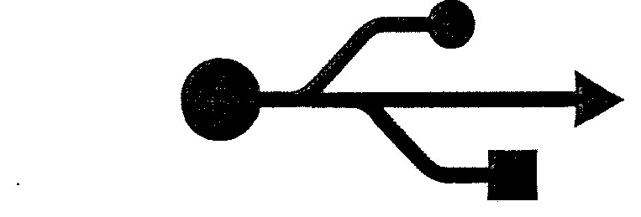
Figure 1: Interface to the external devices
- Identify the type of external device interface based on the icon in Figure 1.
- The external devices interface in (a) can have a "hot connection". Define hot connection.
- Discuss the THREE (3) input-output techniques available in a computer system and elaborate on the Central Processing Unit's involvement in each technique.

QUESTION A6 (10 marks)
- Complete the taxonomy of parallel processor architecture illustrated in Figure 4.
Processor Organization
Multiple lnstruction Single instruction
(d)
(a) Multiple Data (MIMD) Multiple Data (SIMD)
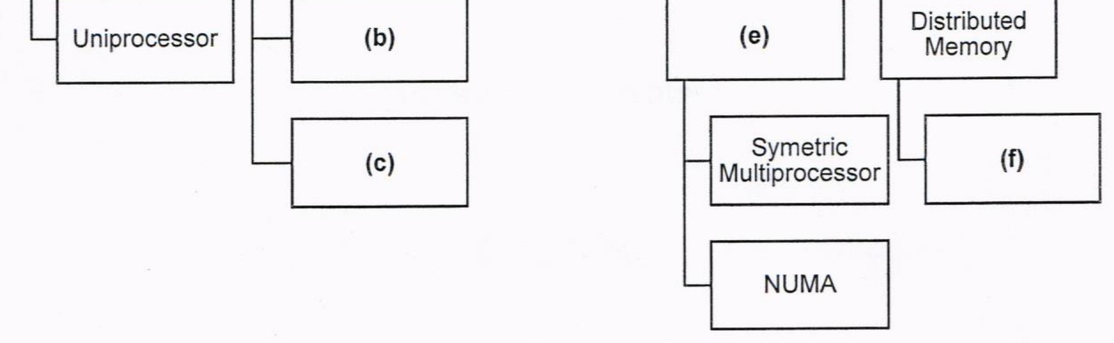
Figure 4: Taxonomy of Parallel Processor Architecture
(e)
(b) l\ilemory
- Discuss TWO (2) disadvantages of symmetric multiprocessor (SMP).

QUESTION A7 (10 marks)
Interrupt-driven 1/0 is more efficient compared to the simple programmed 1/0.
- Define interrupt-driven 1/0.
- Describe TWO (2) modes of addressing when the processor, main memory and 1/0 shared a common bus.
- Discuss ONE (1) advantage and ONE (1) disadvantage of the interrupt-driven 1/0.

QUESTION A8 (10 marks)
- List FOUR (4) classification of multiple processor architecture.
- Symetric Multi Processor (SMP), Non Uniform Memory Access (NUMA) and Cluster are part of the X multiple processor architecture. Identify X?
- Differentiate the multiple processor architecture for SMP and Cluster. In your opinion, which architecture is easier to manage and control by giving appropriate justification.

QUESTION A9 (10 marks)
- Identify the correct concept of computer organization or architecture in the following scenario.
Scenario Concept Deals with the logical aspects of the system, including instruction sets, data formats, and addressing modes. Defines the functionality, capabilities, and programming model. Concerned with how the computer will execute the tasks and implement the functions. Involves the hardware layout, circuits, control signals, memory access, and timing.
- Describe THREE (3) CPU registers involved in data processing, such as arithmetic operations.

QUESTION A10 (10 marks)
- Explain why binary number representation used as machine language.
- Calculate ACEh- BFh in:
- Hexadecimal
- Octal
- Binary

PART B (20 MARKS)
Answer the question in this part.

QUESTION B1 (20 marks)
Question 1 is based on Figure 4 and Table 3.
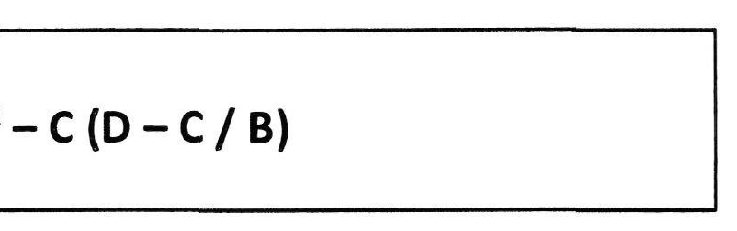
Figure 4
Write the appropriate programs using correct assembly language notations and comments to compute the equation represented in Figure 4 using zero-, one-, and two-address instructions. The instructions available for use are provided in Table 3. Note that Register A, B, C, and D cannot be modified, and Register x, y, and z can be used as temporary registers. However, the final answer must be stored in Register z.
Table 3: Machine Instruction
Zero-address | One-address | T\vr.-address
PUSHx | LOADx | MOVE (x,y)
POPx | STORx | ADD (x,y)
ADD | ADDx | SUB (x,y)
SUB | SUBx | MUL (x,y)
MUL | MULx | DIV(x,y)
DIV | DIVx

