
CONFIDENTIAL CS/NOV 2026/CSC429

UNIVERSITI TEKNOLOGI MARA FINAL EXAMINATION

COURSE
COURSE CODE
EXAMINATION TIME
COMPUTER ORGANIZATION AND ARCHITECTURE

CSC429
NOVEMBER 2026
3 HOURS

INSTRUCTIONS TO CANDIDATES

- This question paper consists of two (2) parts: PART A (10 Questions) PART B (1 Question)

- Answer ALL questions in the Answer Booklet. Start each answer on a new page.

- Do not bring any material into the examination room unless permission is given by the invigilator .
- Please check to make sure that this examination pack consists of: i) the Question Paper
  - an Answer Booklet - provided by the Faculty

- Answer ALL questions in English.

DO NOT TURN THIS PAGE UNTIL YOU ARE TOLD TO DO SO

This examination paper consists of 6 printed pages.

PART A (80 MARKS)
Answer ALL questions in this part.

QUESTION A1 (5 marks)
Question 1 is based on the following Figure 1.
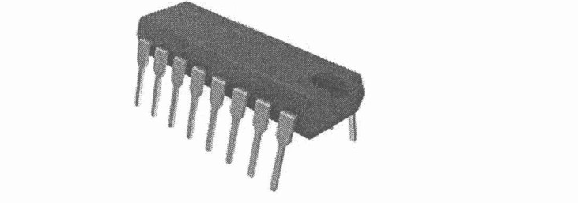
The development of component X led to a drastic increase in speed and efficiency of computers. Component X is a single, complete electronic semiconductor circuits contained on pieces of silicon, and sometimes called as chips.
- What is the name of component X?
- In which computer generation was component X introduced?
- Who is the inventor of component X?
- State ONE (1) input device and ONE (1) output device that was introduced in the same generation as component X.

QUESTION A2 (5 marks)
Given the following Figure 2.

- Label the addressing technique illustrated in Figure 2.
- Explain how the addressing technique in 9(a) is used.
List ONE (1) advantage and ONE (1) disadvantage of the addressing technique in

QUESTION A3 (5 marks)
Convert 2.5 to IEEE 754 single-precision format. Give the answer in hexadecimal and show the sign, exponent and mantissa fields.

QUESTION A4 (5 marks)
- How classification of parallel processor is constructed?
- Give ONE (1) example for each parallel processor architecture.

QUESTION A5 (10 marks)
Answer both parts for the same expression. Assume an 8-bit byte.
Expression: 28 - (-78)
- Calculate 28 - (-78) using sign and magnitude.
- Calculate 28 - (-78) using 1's and 2's complement.

QUESTION A6 (10 marks)
Replacement algorithm is used to determine which entry in a cache to flush to main memory when it is desired to cache a new block of data.
- Which mapping function does not need to have a replacement algorithm?
- Describe FOUR (4) types of replacement algorithm.

QUESTION A7 (10 marks)
Computer consists of four main components as illustrated in Figure 1. Each component has its own function in ensuring that the computer system works well. Question 4 is based on
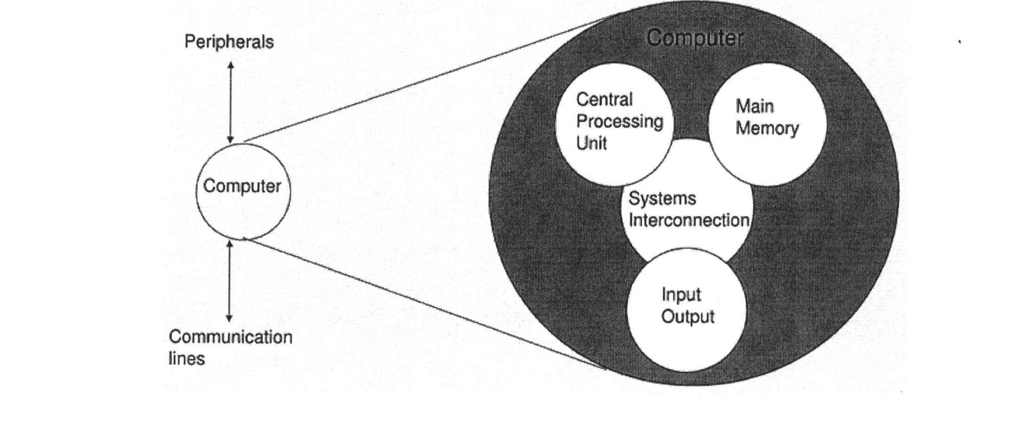
- Explain THREE (3) types of system interconnection.
- State TWO (2) sub-components of central processing unit and its function.

QUESTION A8 (10 marks)
Processor contains a number of registers used for temporary storage of data. Describe FIVE (5) types of registers.

QUESTION A9 (10 marks)
- Define interrupt.
- Differentiate between interrupt and direct manipulation access.
- Given the following scenario. Dilan is surfing woolworth.com to buy groceries online. While he is comparing prices of products in woolworth.com and one other website, two messages popped up onto his screen. Figure 2 (a) and (b) illustrate the conveyed messages.
Are you sure you want to
There is a hardware event failure
in this computer. Please reboot
cancel this request?
this computer now.

(a)
(b)
- Identify the type of interrupt in Figure 2(a) and Figure 2(b) with proper justification.
- While interruptroutinefor Interrupt Ais executing, it is interrupted by interrupt Bwhich has a higher priority than interrupt A. What will happen to interrupt routine A?

QUESTION A10 (10 marks)
- When is an l/O module installed?
- What will happen if the l/O module is not installed?
- Explain ONE (1) category of l/O module
- What does it mean by 'hot connection'?
- List THREE (3) common interfaces to external devices.

PART B (20 MARKS)
Answer the question in this part.

QUESTION B1 (20 marks)
Question 1 is based on Figure 1 and Table 1.

write an appropriate program using correct assembly language notations to compute the equation snbwn in Figure 1 using instructions for zero-address, one-address, and three- address. The available instructioni are provided in Tabte 1. The register labeled A, B, C, and D are fixed, white registers x, y, and z can be used temporarily. The final answer must be stored in register z.
Zero-address | One-address | Three-address
PUSH p | LOAD p | ADD (p,q,r)
POP p | STOR p | suB (p,q,r)
ADD | ADD p | MUL (p,q,r)
SUB | SUB p | DIV (p,q,r)
MUL | MUL p
DIV | DIV p

