
CONFIDENTIAL CS/NOV 2026/CSC429

UNIVERSITI TEKNOLOGI MARA FINAL EXAMINATION

COURSE
COURSE CODE
EXAMINATION TIME
COMPUTER ORGANIZATION AND ARCHITECTURE

CSC429
NOVEMBER 2026
3 HOURS

INSTRUCTIONS TO CANDIDATES

- This question paper consists of two (2) parts: PART A (10 Questions) PART B (1 Question)

- Answer ALL questions in the Answer Booklet. Start each answer on a new page.

- Do not bring any material into the examination room unless permission is given by the invigilator .
- Please check to make sure that this examination pack consists of: i) the Question Paper
  - an Answer Booklet - provided by the Faculty

- Answer ALL questions in English.

DO NOT TURN THIS PAGE UNTIL YOU ARE TOLD TO DO SO

This examination paper consists of 6 printed pages.

PART A (80 MARKS)
Answer ALL questions in this part.

QUESTION A1 (5 marks)
Complete the following taxonomy of parallel processor architecture with appropriate example.
Single Instruction Multiple Data Stream ii Processor Organization Multiple Instruction Multiple Data Stream
v

QUESTION A2 (5 marks)
The X machine was the first automatic electronic digital computer that uses binary system. It has 30 arithmetic/logic unit that can add and subtract, a rotating drum memory that can held thirty binary numbers of fifty digits each and input/output components. Figure 1 shows the architecture of X machine.
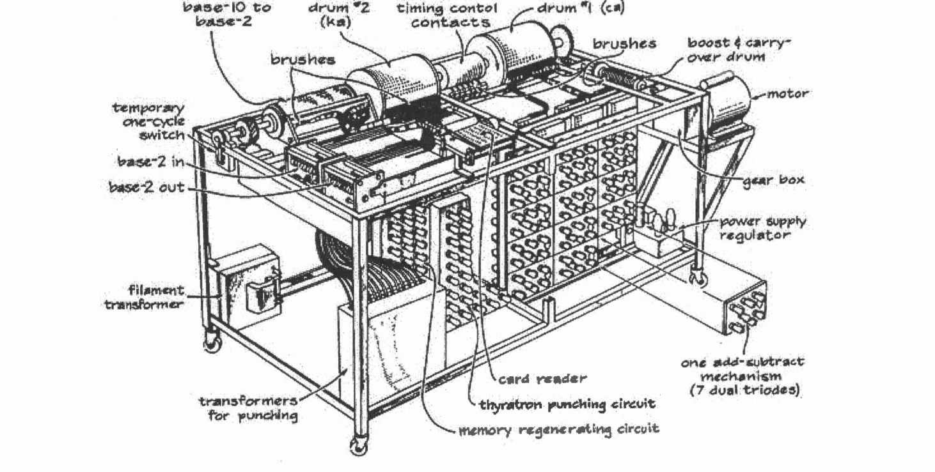
- What is X machine?
- Name the inventor of X machine.
- Based on Figure 1, identify the input and output components for X machine.

QUESTION A3 (5 marks)
Calculate -53 - 31 using the sign-and-magnitude method. Assume an 8-bit byte. Show your complete workflow.

QUESTION A4 (5 marks)
Given the following Figure 2.

- Label the addressing technique illustrated in Figure 2.
- Explain how the addressing technique in 9(a) is used.
List ONE (1) advantage and ONE (1) disadvantage of the addressing technique in

QUESTION A5 (10 marks)

- Identify the type of external device interface based on the icon in Figure 1.
- The external devices interface in (a) can have a "hot connection". Define hot connection.
- Discuss the THREE (3) input-output techniques available in a computer system and elaborate on the Central Processing Unit's involvement in each technique.

QUESTION A6 (10 marks)
- Rank the following memory types based on price ranging from the cheapest to the most expensive. Cache, tape back-up, register, hard drive
- Discuss ONE (1) benefit of cache memory.
- Differentiate between write through and write back mechanisms in order to store data in cache.

QUESTION A7 (10 marks)
- Discuss the whole operation of the machine cycle and its respective responsible computer components.
- Elaborate on what will happen in the machine cycle if the main memory is corrupted.

QUESTION A8 (10 marks)
Input output technique can be segregated into programmed, interrupt-driven and direct memory access (DMA).
- What is DMA?
- How can the DMA technique improve the overall computer performance?
- Discuss TWO (2) major drawbacks of programmed and interrupt-driven input output technique that inspire hardware developer to introduce DMA.
- Conventional access is depicted in Figure 2. Redraw Figure 2 to illustrate DMA architecture.


QUESTION A9 (10 marks)
- List TWO (2) buses types that are available in the computer system.
- Differentiate TWO (2) characteristics of system interconnection and CPU interconnection.
- Explain the different types of data transfer timing.

QUESTION A10 (10 marks)
Answer both parts. Show your complete workflow.
- Convert -31.5 to IEEE 754 single precision. Give the answer in hexadecimal.
- Convert the IEEE 754 single-precision value 0xC1360000 to decimal.

PART B (20 MARKS)
Answer the question in this part.

QUESTION B1 (20 marks)
Question 1 is based on Figure 1 and Table 1.

write an appropriate program using correct assembly language notations to compute the equation snbwn in Figure 1 using instructions for zero-address, one-address, and three- address. The available instructioni are provided in Tabte 1. The register labeled A, B, C, and D are fixed, white registers x, y, and z can be used temporarily. The final answer must be stored in register z.
Zero-address | One-address | Three-address
PUSH p | LOAD p | ADD (p,q,r)
POP p | STOR p | suB (p,q,r)
ADD | ADD p | MUL (p,q,r)
SUB | SUB p | DIV (p,q,r)
MUL | MUL p
DIV | DIV p

